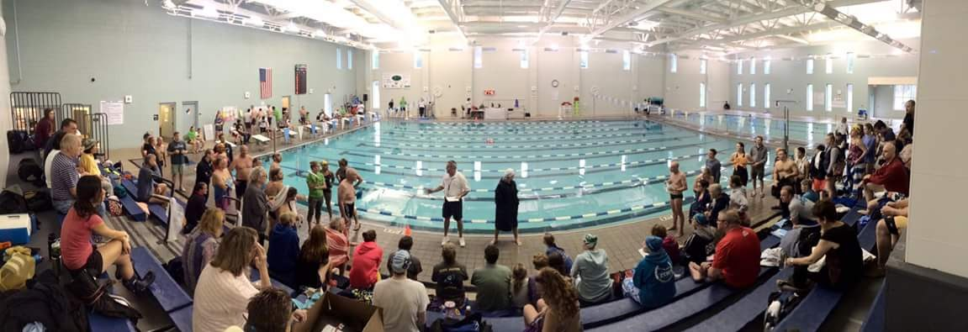

Coastal Masters Fun-vitational

Date: Saturday October 30, 2021

Sanctioned: North Carolina LMSC for USMS, Inc

USMS Sanction #: TBA

Location: UNWC Natatorium
690 Hamilton Dr, Wilmington, NC 28403

Meet Directors: Kristen Jeno - kbs1011@gmail.com, (252) 412-5453
Alicia Uhl - auhl@ec.rr.com, (910) 547-7575
Celia Wolff - ikeepswimming@gmail.com, 910-723-7665

Meet Referee: Bill Luse - wclswim@ec.rr.com. (910) 376-1575

Course:
8 lane, 25 yard indoor heated pool will be in use. All 8 lanes will be used for competition. The Colorado System 6 will be used along with stopwatch timing with two watches per lane. The length of the competition course without a bulkhead is in compliance and on file with USMS in accordance with USMS articles 105.1.7 and 106.2.1. You can expect pool temperatures to be between 80-82 degrees.

Schedule:
Warm-up begins at 9:00am. You will have access to all 8 lanes for warm-up and scheduled meet breaks. Meet starts at 10:00am. No swimming equipment (paddles, kickboard, etc.) will be allowed during warm-up. Swimmers not swimming the 500 can expect to warm-up around 10:45am at the conclusion of the 500. Cool down lanes will be available in the diving well right next to the competition pool. This will also be available for warm-up as well.

Scheduled Meet Breaks:
- 25 minute additional warm up following the final heat of the 500y
- 5 minute break after the 100y Back
- 5 minute break after the 200y Back
- 10 minute break after the 50y Back
- 10 minute break after the 25y Free
- 5 minute break after the 100y Medley Relay
- 10 minute break after the 100y Free Relay
Rules:
USMS rules will govern this meet. A current USMS card is required. Swimmers must be registered with USMS for 2021. One day USMS registration will be available. When warming up, you must enter the pool feet first except in sprint lanes. No paddles or kickboards are allowed. NO DIVING will be allowed during ANY breaks.

One-event registration is strictly for insurance coverage for the event. One-event participants are not eligible for Event Rankings, Top 10, USMS records, or other honors (either individual or relay) achieved in that event. Per Article 301.3.1 of the USMS Rule Book.

Additional Information: The times recorded from the 25’s are not eligible for USMS records.

Entries:
Online entries only by 11:59pm EST Tuesday October 26th, 2020. No paper entries will be accepted, and no deck entries will be accepted at the meet.

Fees:
$35.00 flat fee which includes a FREE USMS cap and sticker. No extra charge for relays. There will be no refunds unless the meet is cancelled, in which case $20.00 of the fee paid will be retained and $15.00 will be refunded. If inclement weather occurs, the meet staff will determine by 2:00 pm Friday March 13, if the pool will or will not open the following morning. If it opens, the meet will be held.

Seeding:
All events will be seeded by time from slow to fast. The 500 will be capped at 56 swimmer and will include a positive check-in which will close at 9:30 am.

Scoring: Points will be awarded as follows:
Individuals: 9-7-6-5-4-3-2-1
Relays: 22-18-16-14-12-10-8-6-4-2
All team awards must be picked up from Clerk of Course the day of the meet. No awards will be mailed.

Limit and Order of Events: Limit is 6 individual events and 2 relay events.
W M Event Seed Time
1 1 500y Free
25 Minute Warm up
2 2 200y IM
3 3 50y Breast
4 4 100y Fly
5 5 50y Free
6 6 100y Back
5 Minute Break
7 7 100 Breast
8 8 200y Free
9 9 100y IM
10 10 200y Back
5 Minute Break
11 11 50y Fly
12 12 100y Free
13 13 200y Breast
14 14 50y Back
10 Minute Break
15 15 25y Breast
16 16 25y Fly
17 17 25y Back
18 18 25y Free
10 Minute Break
19 19 100 Medley Relay
5 Minute Break
20 20 100 Free Relay
10 Minute Break
21 21 Floaty Relay

