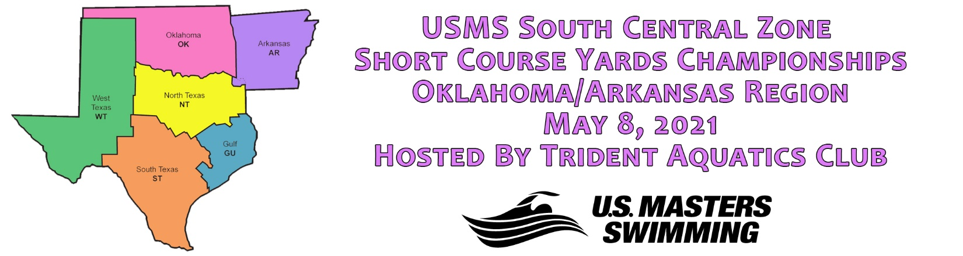

Administive Oﬃcial: Kirsten Hoﬀman, khoﬀman@interworks.com
Meet Director: Sean Callan, spcallan@gmail.com
Date: Saturday, May 8, 2021
Facility: Trident Aquatic Center, 10001 N 127th East Ave, Owasso, OK 74055
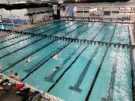
•Indoor 25 yard 8 – lane course. Lanes 1 and 2 will be reserved for continuous warm-up/cool down throughout the meet. Lane lines are non-turbulent.
•Omega timing system, multiple television monitors with scoreboard. Hy Tek
Meet Manager Software. Club Assistant online entries.

Directions can be found here: Directions

Pool Length: The length of the complete course is in compliance and on ﬁle with USMS in accordance with articles
105.1.7 and 107.2.1
Oﬃcial Times: Times from this competition will be eligible for USMS records and Top 10 consideration, but not for world records.
Timing System: The primary timing system will be automatic timing with a backup timing system using semiautomatic timing consisting of one button and a tertiary system of one watch.

Warm Up:

Session 1 | Saturday | Warm Up: 8:00am | Meet Start: 9:00am
Session 2 | Saturday | Warm Up: 1:00pm | Meet Start: 2:00pm
Warmups will be conducted in accordance with the current USMS policies and procedures. Feet ﬁrst entry only. No equipment may be used in the warmup pool.
Rules: Current USMS Rules will govern the conduct of the meet
Swim Wear: Swimsuits may be in one or two pieces. Swim wear must comply with FINA specifications. NOTE: no Bes, zippers or any other fastener system with the exception of a waist tie.
Parking: Extensive surface lot next to Natatorium
Sanction: Sanctioned by Oklahoma Master Swim Committee for USMS, Inc. Sanction Number is XXX-XXXX.
Eligibility: Open to all currently USMS registered Oklahoma swimmers. Oklahoma swimmers not currently registered with USMS will be given an opportunity to do so during registration. USMS registered swimmers outside of Oklahoma

should contact Kirsten Hoﬀman, Administrative Oﬃcial khoﬀman@interworks.com to see if they are eligible to enter the swim meet.
Age: Athlete age at the meet is determined by their age on May 16, 2021. Swimmers must be at least 18 years of age. Age Groups: 18-24,25-29,30-34,35-39,40-44,45-49,50-54,55-59,60-64,65-69,70-74,75-79, etc.
Number of Events Allowed: Maximum of 6 individual events per day. You may swim all of them in one session, or six events over the course of one session.
Swimmer Cap: The swimmer cap per session is 100. Once the swimmer cap is reached for that session, entries will be closed for the day. Entries will be taken on a ﬁrst come, ﬁrst served basis.
IMPORTANT: Swimmers are asked to voluntarily notify the Meet Director by email at spcallan@gmail.com of their intent to scratch any events by 5 PM on the Thursday, May 6th. Psych sheet will be emailed and posted no later than Thursday AM. Final seeding of all pre-seeded events will occur after the early scratch deadline has passed.
There are no penalties for swimmers who no show/scratch at the meet. No refunds given for no shows.

Entry Deadline: Sunday, May 2nd at 11:59 PM. Entries will be online only at:
https://www.ClubAssistant.com/club/meet_information.cfm?c=2573&smid=13677

NO ENTRIES WILL BE ACCEPTED AFTER MAY 2nd. NO INDIVIDUAL DECK/DAY OF ENTRIES ALLOWED.
**The South Central Zone SCY Championships is being held in multiple pools on two consecutive weekends. No swimmer can enter more than one of the competitions. Any swimmer found to be entered in more than one meet will have to drop one of their registrations. No refund will be given**
Seeding: Events 200 yards and shorter will be swim slowest to fastest. Events 400 yards and longer will be swum fastest to slowest. Ages and gender will be combined for seeding but separated for scoring. All events EXCEPT 400 IM, 500, 1000
& 1650 Free will be pre-seeded.
Distance Event Check In: Swimmers must check in by the following days/times for these events or they will be scratched from the event.
500 Free 45 minutes before the start of Session 1 on Saturday 1000 Free By the beginning of the 50 Back in Session 1 on Saturday 400 IM 45 minutes before the start of Session 2 on Saturday
1650 Free By the beginning of the 50 Free in Session 2 on Saturday
Lap Counters: Swimmers in the 500, 1000 & 1650 Free must supply their own lap counter. Scoring: Individual through 8th place. Points: 9, 7, 6, 5, 4, 3, 2, 1
Awards: No Awards

Facebook: https://www.facebook.com/USMSSouthCentralZoneChamps
Psych & Heat Sheets: Psych and Heat Sheets will be available online before the meet at hXps://www.waves-swim- academy.com/?lightbox=dataItem-jt4tl0b6. They will also be emailed directly to each registered swimmer. Heat Sheets will also be posted in multiple places on the walls around the venue.
Results: This is a Multi-Pool Champs meet. Results from this meet will be merged with the results from the other locations hosting the Champs meet in our Zone. All meets will occur between May 8 – 16,2 2021. Merged Results will be posted on the South Central Zone website at h\ps://usmssouthcentralzone.org/ and on the Facebook page. Results will be on Meet Mobile throughout the meet and on the Gulf Masters Swimming web site and after the results are processed will be posted at www.USMS.org after the meet. Hard copy results will be posted continuously throughout the meet. Records will be submitted with proper paperwork and electronic ﬁles ASAP after the meet to all appropriate parties.
Concessions: Concessions will not be available. Swimmers may bring their own food supplies.

Order of Events:

2021 South Central Zone SCY Multi-Pool Champs
Order of Events
Saturday – Session I  500 Free  200 Back  50 Fly  200 IM  100 Free  50 Back  200 Fly  100 Breast  1000 Free | Saturday – Session 2  400 IM  100 Back  50 Breast  200 Free  100 IM  50 Free  200 Breast  100 Fly  1650 Free

- Age groups and genders in all events will be combined for seeding but separated for scoring
- All events 200 yards and shorter will be pre-seeded
- Distance events (400 IM, 500 Free, 1000 Free and 1650 Free) require positive check in. They will be seeded after check in is closed.
- Swimmers must supply their own lap counters for the 500, 1000 and 1650 Free

