7th Annual Snag Holmes Masters Invitational

Saturday, March 27th – Sunday, March 28th, 2021
Hosted by the Palm Beach Masters
Sanctioned by the Florida Gold Coast LMSC for USMS, Inc
Sanction #: TBD, submitted

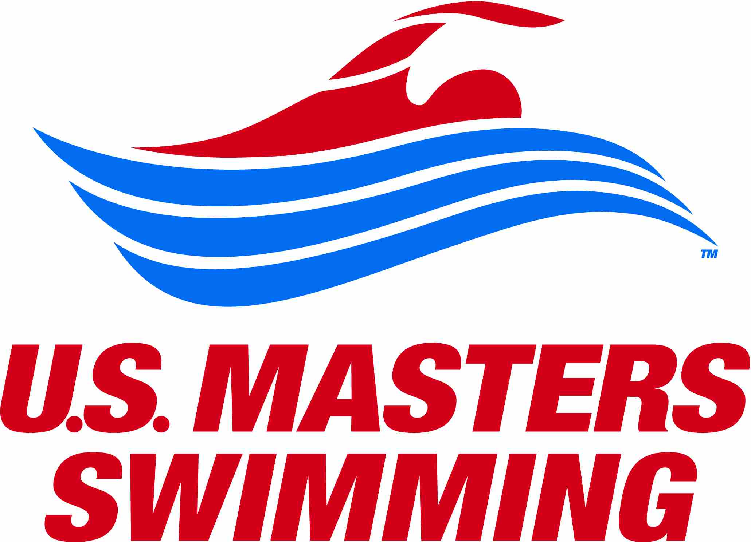
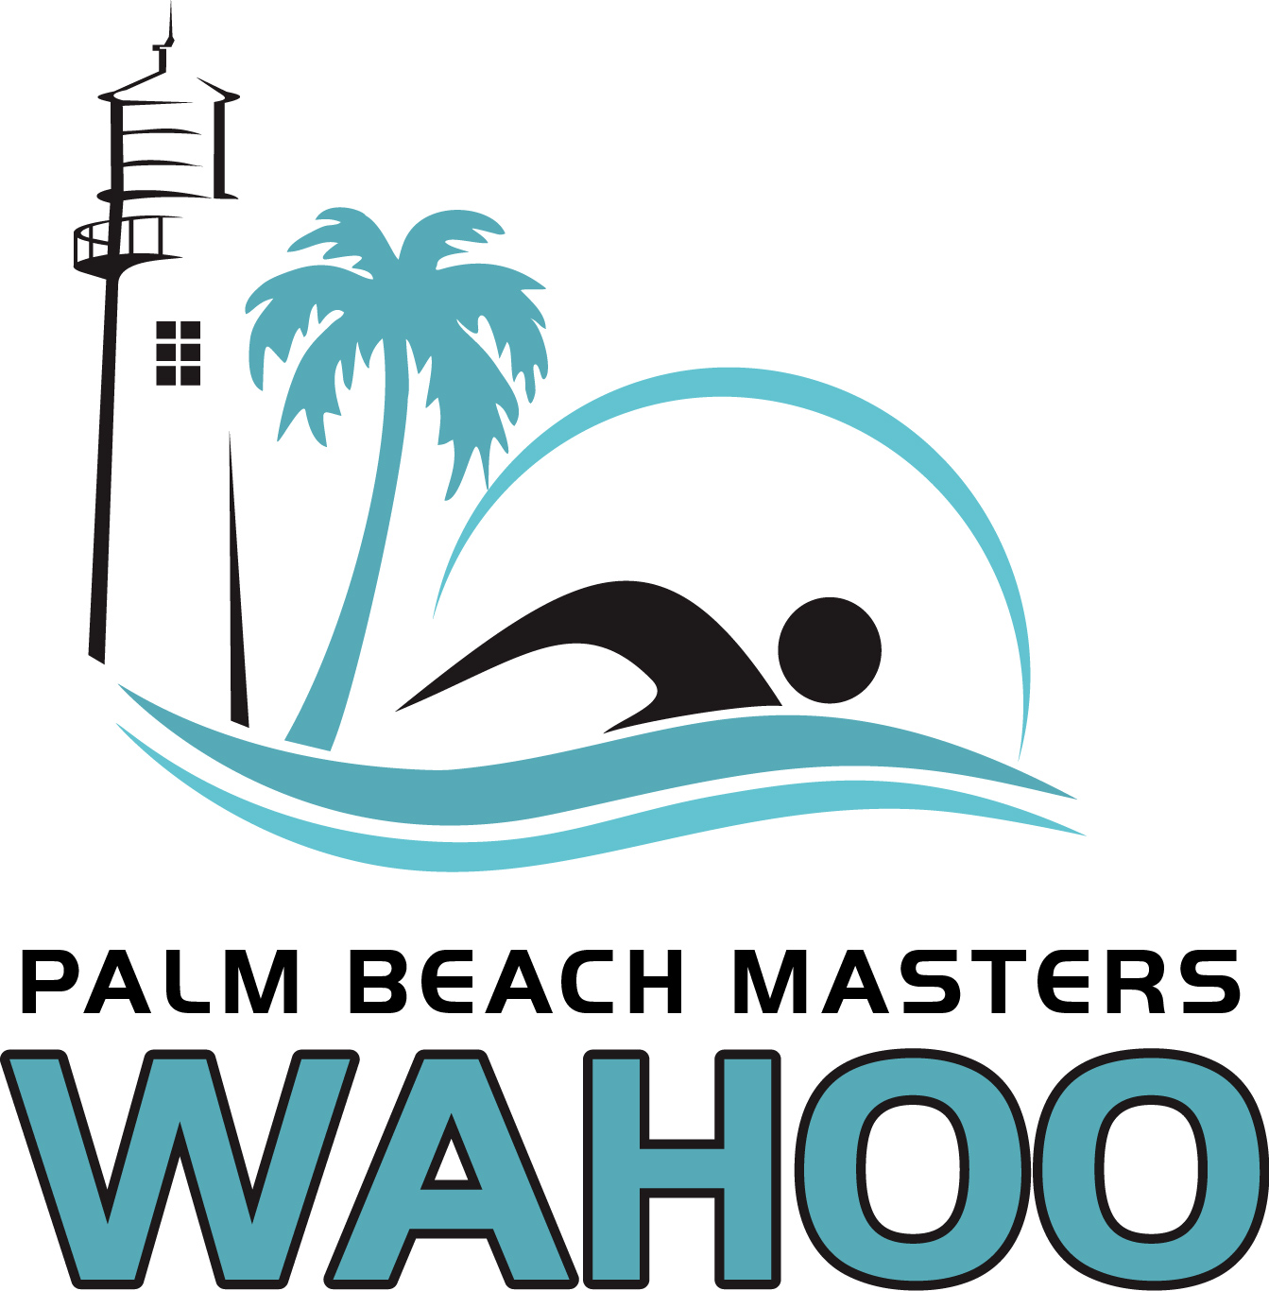

DATES & TIMES:
Saturday, March 27th: Warm-up 10:00am; Meet begins at 11:00am
Sunday, March 28th: Warm-up 10:00am; Meet begins at 11:00am

MEET DIRECTOR: Linda Irish Bostic, 561-373-1440, palmbeachmasters@gmail.com

FACILITY & COURSE: North County Aquatic Complex, 801 Toney Penna Dr., Jupiter, FL, 33458. Google Map
Eight (8) 25-yard lanes with electronic timing will be provided for the competition. Pool heaters & chillers keep the pool at an optimum temperature for competition. Eight (8) 25-meter lanes will be available for warm-up & warm-down at all times. The length of the competition course without a bulkhead is in compliance and on file with USMS in accordance with articles 105.1.7 and 106.2.1. The primary time system will be Daktronics automatic timing with touchpads.
ELIGIBILITY & RULES: 2021 USMS rules will govern this meet. Safety rules will be in effect as outlined by the CDC, USMS Swimming, Palm Beach County and as recommended by the Meet Director & Referee.
Age of swimmer is determined as of March 28, 2021.
The meet will be limited to current USMS members in the Florida Gold Coast LMSC (your USMS membership number starts with “50”). Exceptions may be made for other swimmers who are South Florida seasonal residents and have previously swam in a Snag Homes Meet in the past. Please contact the Meet Director, for an exception to participate.
ENTRY CAP: The total number of swimmers entered in the meet will be limited to 150. This is based upon PBC’s requirement of limiting to 50% of the North County Aquatic Center’s capacity of 356 persons.

ENTRY FEES: Entry fee of $30 plus $3 per event. All entries include a meet recognition gift

ENTRY LIMIT: Swimmers may enter a maximum of five (5) individual events per day. All entries must be received online by Tuesday, March 23rd, at 11:59pm. All entry & event fees are nonrefundable.
TIMELINE & BREAKS: There will be a published timeline which we will adhere to with breaks. Swimmers should arrive just in time for their first event and depart promptly after their last event of the day. Breaks between events may be inserted at the Meet Director and Meet Referee’s discretion.
HEAT SHEETS: Heat sheets will be available online on Meet Mobile and will be emailed to all entrants prior to the meet. Please print and bring with you.
DECK ENTRIES: No deck entries this year.
RELAYS: No relay events will be offered this year.
AWARDS: No awards will be given this year.
SOCIAL: No social is planned this year.

RESULTS: Results will be available online at PalmBeachMasters.org and on the Meet Mobile app.

The health and safety of our swimmers, coaches, officials, and volunteers, amid COVID-19 is our utmost concern and priority. Therefore, we will adhere to the current Center for Disease Control’s (CDC) guidelines, Florida Department of Health guidelines, and Palm Beach County Parks & Recreation requirements in our best effort to minimize the risk of exposure and continued spread of the virus.

GENERAL PROCEDURES:
- Everyone must wear a mask at all times except when in the water.
- Every effort must be made to maintain 6 feet of social distance.
- Please bring your own chair, umbrellas, tents, beverages, & snacks and space out seating areas.
- If you do not feel well, stay home.
- Palm Beach Masters will provide hand sanitizer around facility.
- The Meet Director will be the point of contact for any safety concerns.

ARRIVAL PROCEDURES:
- Everyone (swimmers, volunteers, officials) must stop at the check-in table at the entrance. Your name must be on the list to be allowed entry. Everyone will be temperature checked before entry to the facility.
- You must turn in your completed USMS COVID-19 Attendee Screening. Please be sure to print and fill out the form prior to arriving at the pool.
- Heat Sheets will be not be provided. They will be emailed prior to the meet. If you want a printed copy, please print it and bring with you. Heat Sheets will also be available on Meet Mobile.

WARM UP/DOWN PROCEDURES:
- In accordance with Palm Beach County COVID regulations, warmup will limit swimmers to no more than 4 per lane. Please spread out and attempt to fill 2 swimmers in all lanes before adding a 3rd swimmer, and then fill 3 swimmers in all lanes before adding a 4th swimmer. A safety guard will manage the warmup pool.
- Please limit your warmup in the pool to 15 minutes and complete cool down efficiently.
- Swimmers must enter warm up/down lanes feet first, unless practicing starts during the designated warmup time and in the designated lane.

RACE PROCEDURES:
- During the swim meet, there will be 1 timer per lane. Masks are mandatory for timers.
- Sufficient time will be allowed between heats to allow swimmers to exit the pool.
- Swimmers in the next heat should remain 6 feet behind the timer chairs until after the timers have pushed buttons & returned to their chairs and after previous swimmer has exited lane.

LOCKER ROOMS AND SHOWERS:
- The locker rooms may be used to change your swimsuit. Toilets will be available for use. Indoor and outdoor showers are available for use.
- Please maintain social distance in the locker rooms and wear your mask at all times.

SPECTATORS
- NO Spectators will be allowed due to PB County deck limitations & Covid precautions. However, volunteers are needed at the meet. Spouses and companions are encouraged to signup as meet volunteers.
- Club coaches who plan to attend the meet and not swim, should contact the Meet Director prior to the meet to be added to the attendee list.
- Swimmers with disabilities who require someone to attend with them should contact the Meet Director prior to the meet.

Failure to follow the procedures may result in removal from the facility and disqualification from the meet.

7th Annual Snag Holmes Masters Invitational
Sanctioned by the Florida Gold Coast LMSC for USMS, Inc
Sanction #: TBD, submitted

Saturday, March 27th, 2021 Sunday, March 28th, 2021
F/M Event F/M Event
1 / 2 200 Free 17 / 18 500 Free
3 / 4 100 Fly 19 / 20 50 Fly
5 / 6 50 Breast 21 / 22 100 Breast
7 / 8 100 IM 23 / 24 200 Back
9 / 10 100 Back 25 / 26 100 Free
11 / 12 200 Breast 27 / 28 200 Fly
13 / 14 50 Free 29 / 30 50 Back
15 / 16 400 IM 31 / 32 200 IM

