Swim a mile and help find a cure for lung cancer.  Tamalpais Aquatic Master’s  2021 MIRACLE MILE POSTAL SWIM  50% of all proceeds will be donated to:  Go2 Foundation  for Lung Cancer  (previously the Bonnie J. Addario Lung Cancer Foundation)  Jon Steiner was a long- time member of Tamalpais Aquatic Masters and active with local and national Masters Swimming committees. Jon lost his battle with lung cancer in 2006. He originated the TAM 1650 “Don’t Waste Your Base” swim in 1996 with just a few participants. Today the event, renamed the Miracle Mile, attracts close to 200 swimmers each year. TAM has donated more than $14,000 over the past seven years.  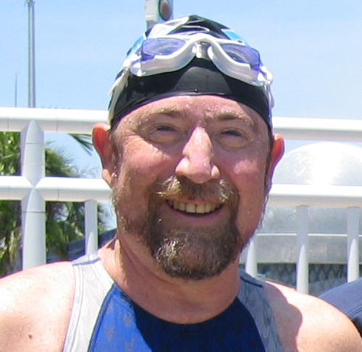 |  | HOW TO PARTICIPATE  WHAT YOU’LL NEED:  A pool at least 25 yards in length and someone to time you  D  DISTANCE:  1650 yards or 1500 meters (swum in a 50m or 25m pool)  :  DATE:  Anytime between January 1, 2021 and February 28, 2021. Entries must be postmarked by Saturday, March 14, 2021.  AGE DIVISIONS:  18-24, 25-29, 30-34…100+, male and female  TAMALPAIS AQUATIC MASTERS  www.tammasters.org  USMS/PMS SANCTION:  ABOUT  The Go2 Foundation for Lung Cancer  www.go2foundation.org  Tamalpais Aquatic Masters  www.tammasters.org

ELIGIBILITY  All swimmers registered with USMS for 2021 are eligible to participate.  MASS TEAM ENTRIES  In order to make entering easier for teams with many participants, an excel spreadsheet can be provided that indicates the information required and that is prepopulated for swimmers on the team who have participated in past Postal 1650 swims. Contact Lynn Sondag, lynn.sondag@dominican.edu for a spreadsheet for your team.  RULES  All USMS and Pacific Masters rules apply. A split sheet with 50 yard/meter splits must be signed by at least by one timer. Times not entered to the 1/100 will be rounded up. Drafting/circle swimming not permitted. Meters times may be converted to yards times by dividing by 1.02.  Participants must follow their facility guidelines for physical distancing and COVID-19 precautions during the event. For your reference, the CDC guidelines for aquatic venues can be found at https://www.cdc.gov/coronavirus/2019-ncov/community/parks-rec/aquatic-venues.html.”  Note: We are not requiring that you submit split sheets. However, please hold onto your split sheet so that we may verify records, if necessary.  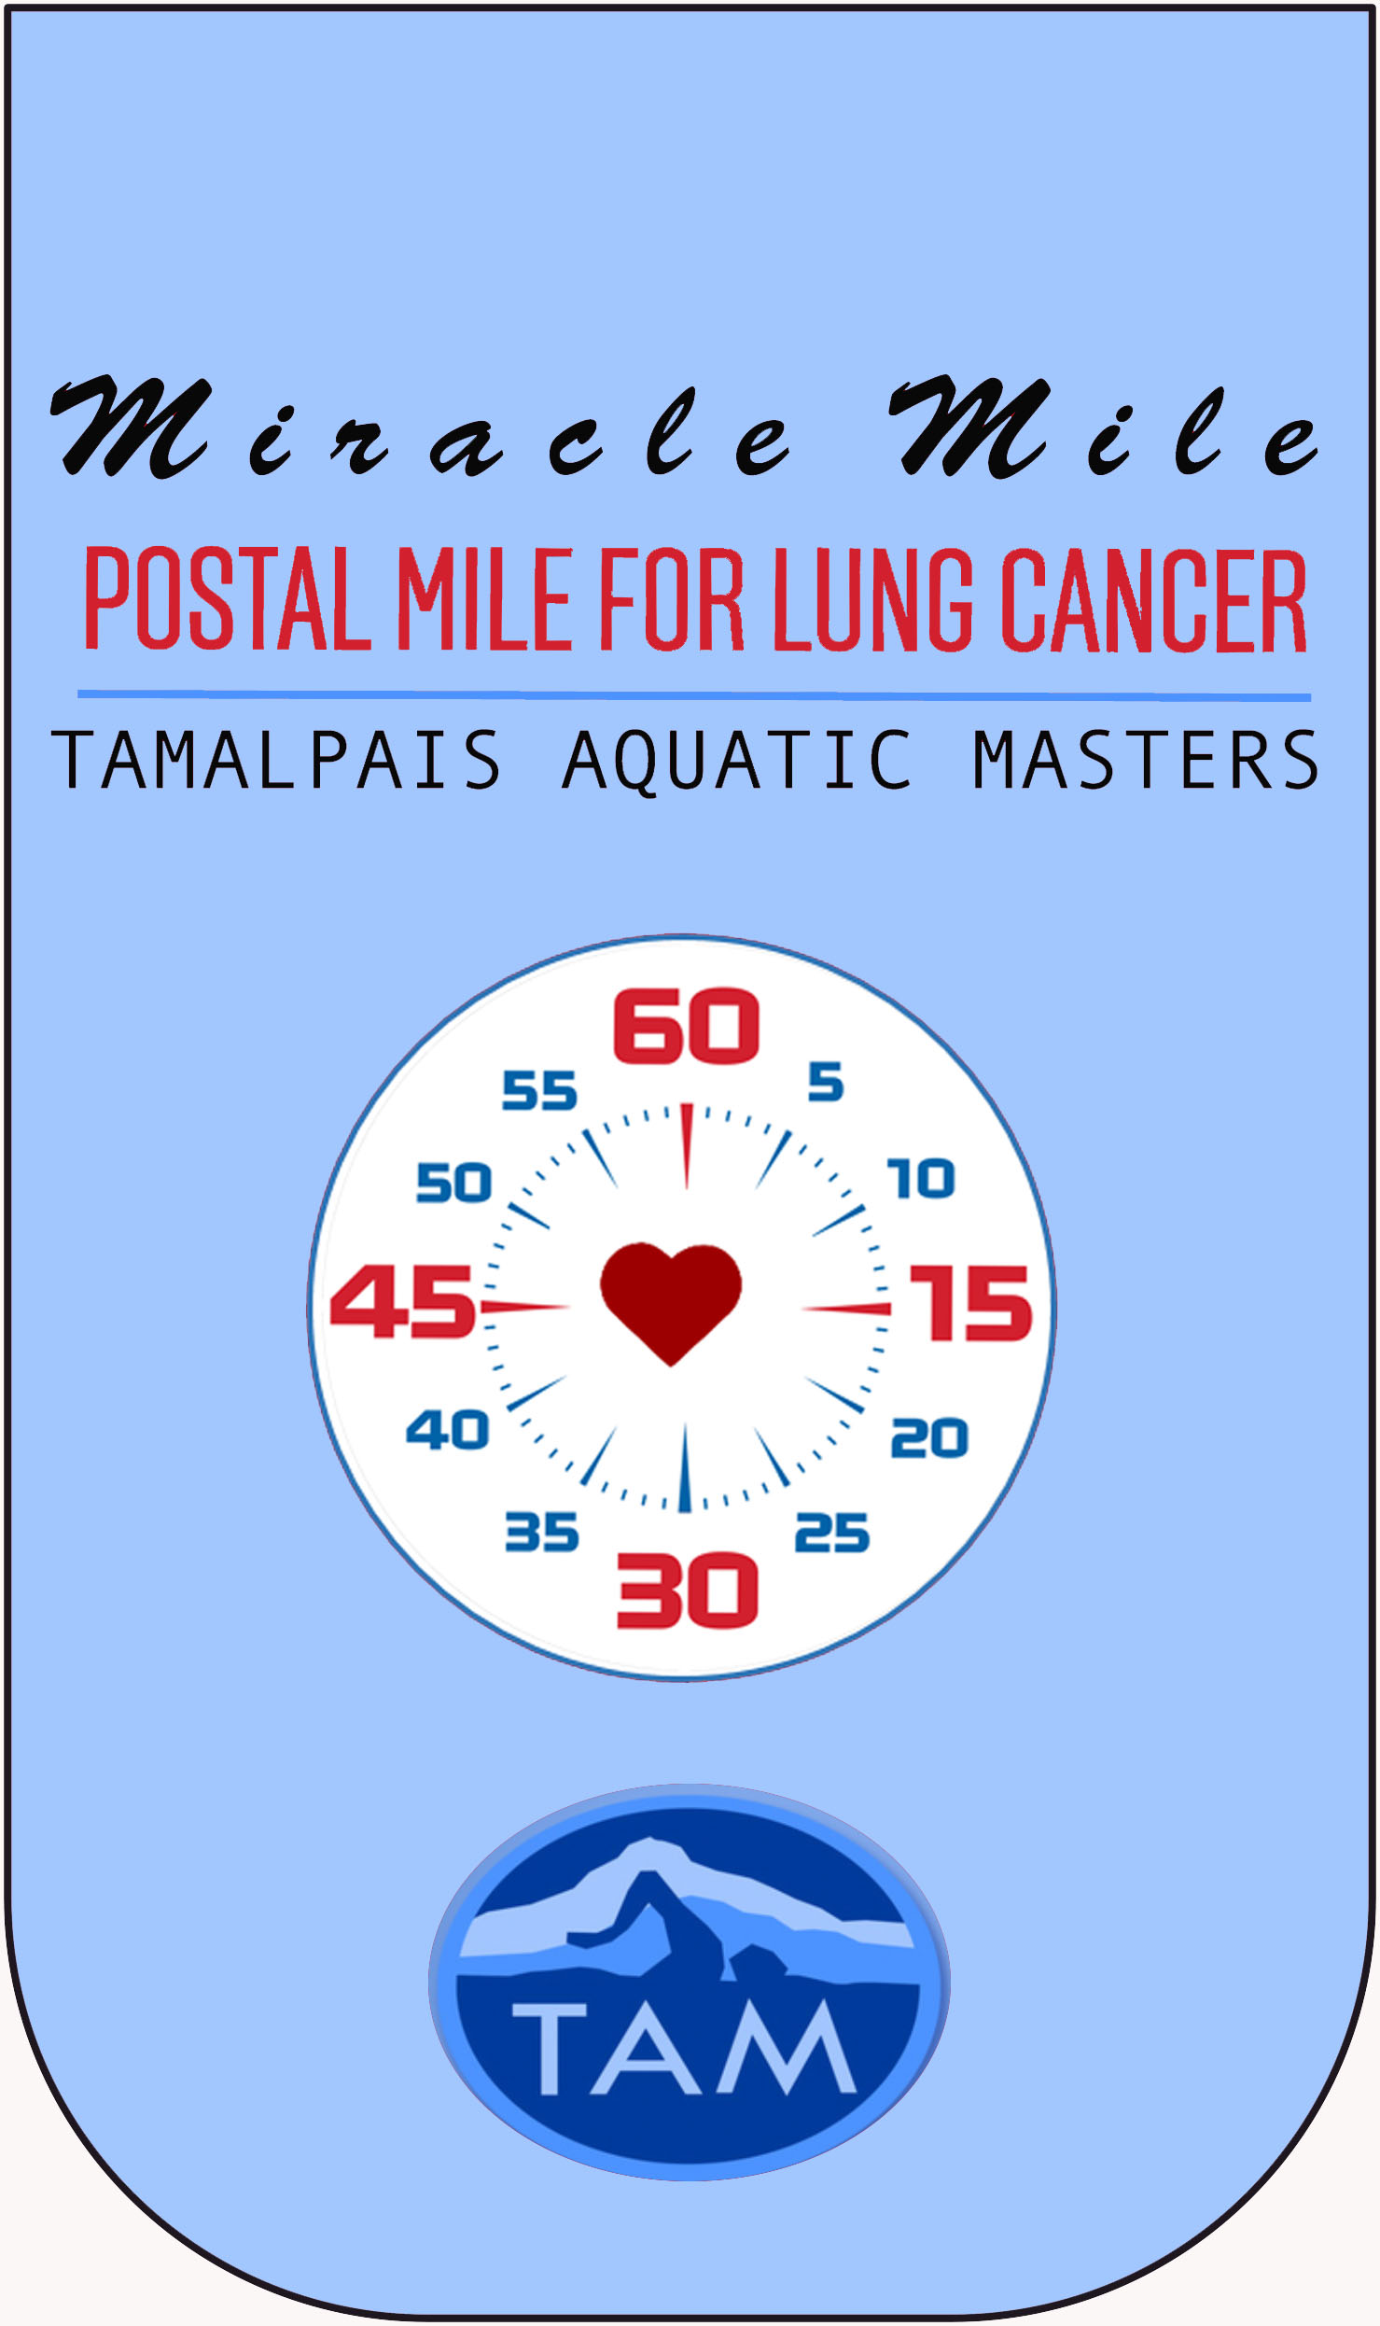  A handy stick-on pocket made from recycled bottles. Visit gopocketgo.com  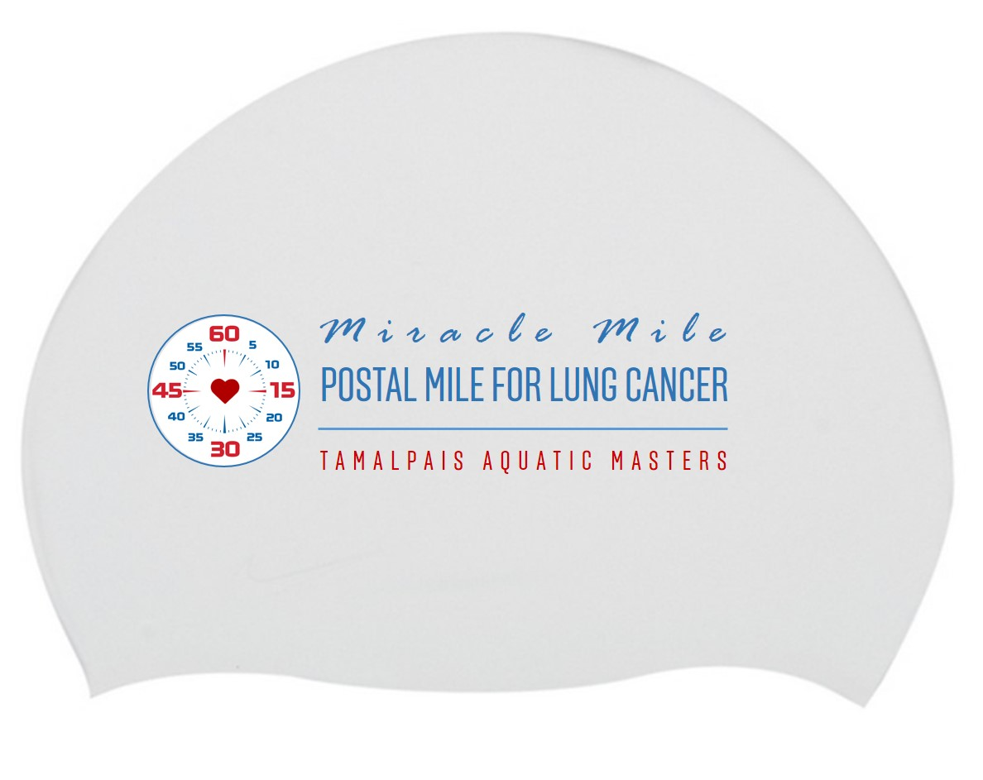  Celebrate your swim with a Miracle Mile Swim Cap (super soft silicone). | 2021 MIRACLE MILE ENTRY FORM  Must be postmarked by Saturday, March 14, 2021.  Swimmers can enter online through Club Assistant or by mail.  USE THIS FORM FOR MAIL-IN ENTRIES ONLY.  Make checks payable to: TAM  SUBMIT A COPY OF YOUR USMS REGISTRATION CARD.  Mail entry form to:  Lynn Sondag 143 21st Avenue, San Francisco, CA 94121.  Questions: 415-254-5080, lynn.sondag@dominican.edu  Name____________________________________________________  Address__________________________________________________  _________________________________________________________  Email____________________________________________________  Phone:______-_______-____________  Date of Birth:__________________ Age at time of swim _________  - Male  - Female  Team Name_______________________________________________  Team Abbreviation___________ USMS#_______________________  Time: _____:_____._____ Date Swum: (mm/dd/yy)______________  Please enter time to the 100th of a second. (Example: 24:12.12)  Did you swim in a pool that was:  - 25 yards  - 25 meters  - 50 meters  Donation  What you pay is completely up to you. 50% of your payment is tax-deductible and will go to Go2 Foundation for Lung Cancer. If you donate $100 or more, you will receive a Special Edition silicone swim cap.  $10 $25 $50 $100 Other: _________________  I am making this donation as a gift in honor or in memory of a loved one:  ________________________________________________________  Your honoree’s name will be given to Go2 Foundation for Lung Cancer.  Yes, help me celebrate my swim:  $10 Miracle Mile Go Pocket  $12 Miracle Mile Swim Cap  _________ Total Enclosed  Please make checks payable to TAM. Thank you!

