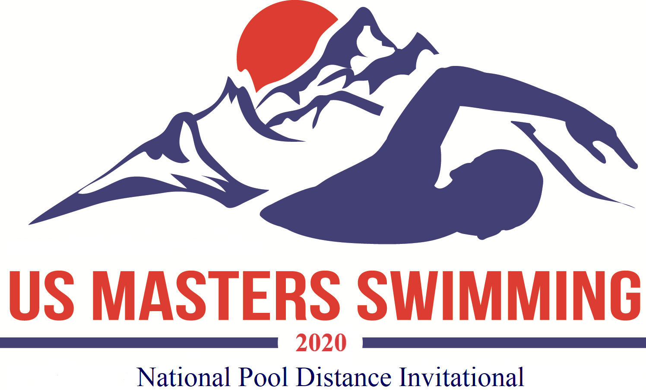

USMS National Pool Distance Invitational LCM
1500 meters
October 25, 2020, Oro Valley, Arizona

Host: SaddleBrooke Swim Club
Meet Director: Doug Springer
Meet Referee: Judy Gillies
Sanction: Sanctioned by AZ LMSC for USMS Inc. Sanction #480-0003

Rules: 2020 FINA rules apply. All events are timed finals. Swimmers may enter this 1500 on Day 2 and also compete in one or two events on Day 1/SCY day (See flier for Day 1). Swimmers age will be as of December 31.2020.

Timing: The primary timing system will be automatic timing. Times can be submitted for world records. USMS records, and USMS Top 10 consideration.” Split times may be requested in writing and the request forms will be available at registration.

Seeding: All events will be seeded fastest to slowest based on entry times. Seed times must be current. They may be verified and adjusted by the meet director.

Eligibility: Any swimmer with a valid 2020 USMS registration. USMS will also offer a one event membership for a fee of $15. Times swum under one-event registration are not eligible for USMS Top 10 or records consideration. International entries must include a copy of the swimmer’s FINA recognized Masters Swimming registration card and fees in U.S. dollars. Each swimmer must submit a copy of their 2020 USMS registration card or FINA-recognized Masters Swimming card. Failure to submit proof of registration will result in the entry being rejected. For further information on registration contact Doug Springer atdspringer@wbhsi.net.

Awards: Male and female age group awards for each age group will be awarded based on total time for all three events (Including Day 1 events). Standard 5 year age groupings. (60 – 64, etc.) based on age as of December 31, 2020. Swimmers completing all 3 events (including Day 1 events) will receive the “Conquistador” medal.

Results: Available through Club Assistant at www.swimphone.com

Entries and fees: Online registration only. Flat entry fee of $25 per event or $60 for all 3 events for online entries plus $15 USMS for non USMS members for the one event membership. Fee includes a meet T-shirt for participants entering all three events.
No deck entries, mail or fax entries will be accepted.

- For online registration please visit: Club Assistant at:
- Online registration closes on October 20, 2020.

Facility: The Oro Valley Aquatic Center (OVAC) is located next to Canyon del Oro High School in the James D. Kriegh Park, 23 W. Calle Concordia, Oro Valley, AZ 85704. OVAC is an outdoor 10 lane 50 meter pool operated at 80º F with non turbulent lane lines and electronic timing. The length of the competition course without a bulkhead is in compliance and on file with USMS in accordance with articles 105.1.7 and 106.2.1. We will run 8 lanes for competition.

Location: Directions from I-10: Ina Rd. exit #125, east on Ina to Oracle Rd., left (north) on Oracle to Calle Concordia, left (west) on Calle Concordia, pool is on your right in ¼ mile. There is a parking lot available directly east of the pool off of Calle Concordia.

More Information: Email questions to Doug Springer at dspringer@wbhsi.net

Meet Sessions and Order of Events
Friday night: OVAC pools will be open to the public for use as a warm-up from 5:30 to 8:00 for the daily admission fee of $5.

Day 1 (see Sanction number 480-0009)
Saturday am: warm-up 7:00 to 8:00* 1650 short course yards starts at 8:00 (fastest to slowest)

Saturday pm: warm-up will be available 15 minutes following am session. 1000 short course yards starts 1:00 (fastest to slowest)

Day 2
Sunday am: warm-up 7:00 to 8:00* 1500 long course meters (fastest to slowest)

*lanes will be available for warm-up and cool down during the meet.

