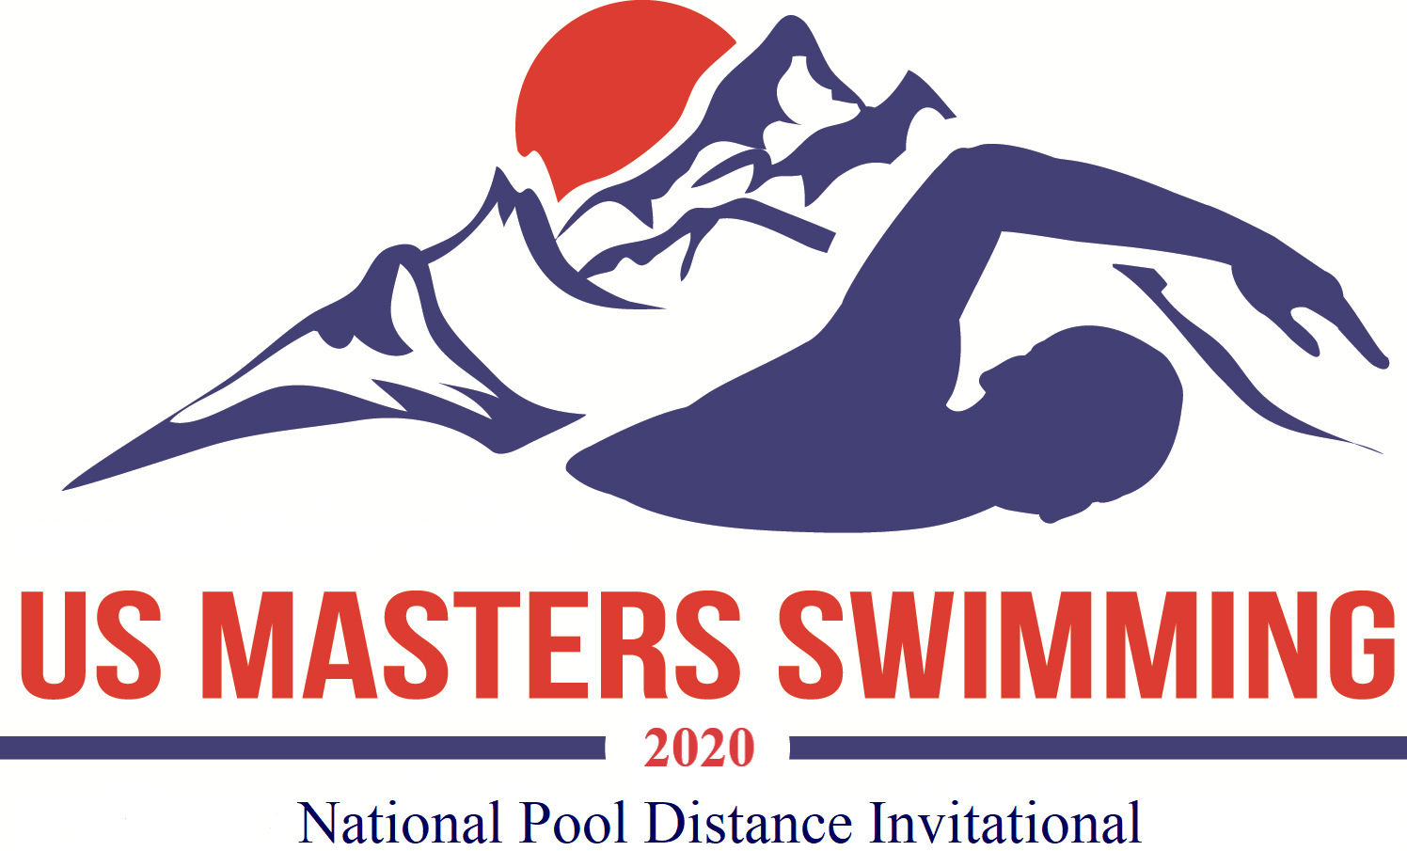

USMS National Pool Distance Invitational
Day 1: 1650 yards and 1000 yards
October 24, 2020, Oro Valley, Arizona

Host: SaddleBrooke Swim Club
Meet Director: Doug Springer
Meet Referee: Judy Gillies
Sanction: Sanctioned by AZ LMSC for USMS Inc. Sanction #480-S002

Rules: 2020 USMS rules apply. All events are timed finals. Swimmers may swim one or two (and also compete in the 1500 meter race on Day 2. Competitors age group will be determined by their age on October 24, 2020.

Timing: Short course yards (1650 & 1000): The primary timing system will be automatic timing. Times may be submitted for USMS records and USMS Top 10 consideration.

Seeding: All events will be seeded fastest to slowest based on entry times. Seed times must be current. They may be verified and adjusted by the meet director.

Eligibility: Any swimmer with a valid 2020 USMS registration. USMS will also offer a one event membership for a fee of $15. Times swum under one-event registration are not eligible for USMS Top 10 or records consideration. International entries must include a copy of the swimmer’s FINA recognized Masters Swimming registration card and fees in U.S. dollars. Each swimmer must submit a copy of their 2020 USMS registration card or FINA-recognized Masters Swimming card. Failure to submit proof of registration will result in the entry being rejected. For further information on registration contact Doug Springer atdspringer@wbhsi.net.

Awards: Male and female age group awards for each age group will be awarded based on total time for all three events (including 1500 free on Day 2). Standard 5 year age groupings. (60 – 64, etc.) based on age as of October 24, 2020. Swimmers completing all 3 events (including the 1500 free on Day 2) will receive the “Conquistador” medal.

Results: Available through Club Assistant at www.swimphone.com

Entries and fees: Online registration only. Flat entry fee of $25 per event or $60 for all 3 events (including the 1500 free on Day 2) for online entries plus $15 USMS for non USMS members for the one event membership. Fee includes a meet T-shirt for participants entering all three events.
No deck entries, mail or fax entries will be accepted.

- For online registration please visit: Club Assistant at:
- Online registration closes on October 20, 2020.

Facility: The Oro Valley Aquatic Center (OVAC) is located next to Canyon del Oro High School in the James D. Kriegh Park, 23 W. Calle Concordia, Oro Valley, AZ 85704. OVAC is an outdoor 18-lane 25-yard pool operated at 80º F with non turbulent lane lines and electronic timing. The length of the competition course without a bulkhead is in compliance and on file with USMS in accordance with articles 105.1.7 and 106.2.1. We will run 8 lanes for competition.

Location: Directions from I-10: Ina Rd. exit #125, east on Ina to Oracle Rd., left (north) on Oracle to Calle Concordia, left (west) on Calle Concordia, pool is on your right in ¼ mile. There is a parking lot available directly east of the pool off of Calle Concordia.

More Information: Email questions to Doug Springer at dspringer@wbhsi.net

Meet Sessions and Order of Events
Friday night: OVAC pools will be open to the public for use as a warm-up from 5:30 to 8:00 for the daily admission fee of $5.

Day 1
Saturday am: warm-up 7:00 to 8:00* 1650 short course yards starts at 8:00 (fastest to slowest)

Saturday pm: warm-up will be available 15 minutes following am session. 1000 short course yards starts 1:00 (fastest to slowest)

Day 2 (see meet info for sanction number 480-S010, National Pool Distance Invitational Day 2)
Sunday am: warm-up 7:00 to 8:00* 1500 long course meters (fastest to slowest)

*lanes will be available for warm-up and cool down during the meet.

