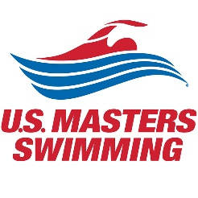
U.S. Masters Swimming and the USMS Coaches Committee
present the 2020 National Coaches Clinic

Save the date !
October 16-18, 2020

Las Vegas, Nevada

The NCC is specifically tailored for Masters coaches and presented by award-winning U.S. Masters Swimming coaches.
We hope you can join us for this event designed specifically to meet the needs of today's Masters coach.

