

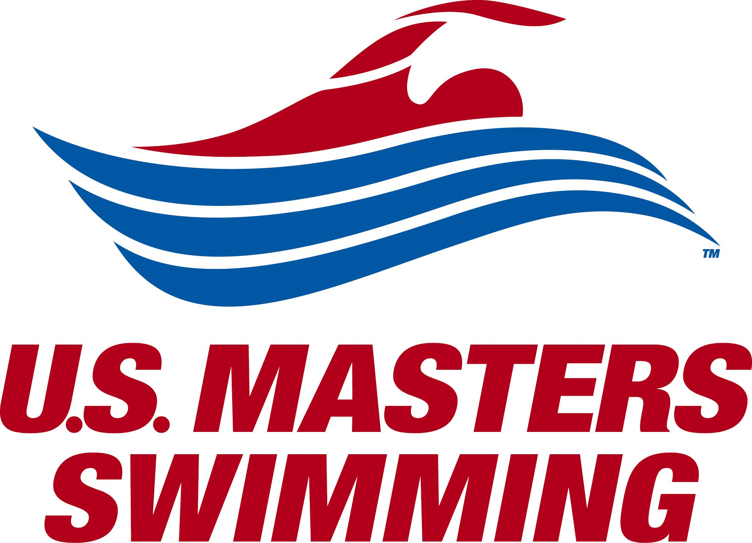

The 2018 Huntsman World Senior Games Swimming event is Sanctioned by
Utah Masters for USMS, Inc.

USMS

Last Name: | First Name: | Initial: |  | Date:
Street Address:

City: | State: | Zip: |  | Phone:
Birth Date: | Competition Age: | Gender: |  | Cell Phone:
Are you a coach?  Y N | Are you a meet official?  Y N |  | Club (please circle):  UTAH QUAC UNAT
Workout group or Team (please circle or specify):

SMAC – Steiner Masters MM – Murray Masters
SDM – South Davis Masters WAM – Wasatch Area Masters
PC – Park City Masters SH – Sand Hollow Masters
AFM – American Fork Masters OCM – Olympus Cove Masters
OTHER: ___________________________ USUM – Utah State University Masters
NONE

Email address:

Do you want email from the USMS National office? Y N
Do you want email from Utah Masters? Y N
Do you want email from vendors? Y N

The length of the competition course without a bulkhead is in compliance and on file with USMS in accordance with articles 105.1.7 and 107.2.1

Registered Events | Payment
50M Backstroke 50M Freestyle  100M Backstroke 100M Freestyle  200M Backstroke 200M Freestyle  50M Breaststroke 400M Freestyle  100M Breaststroke 800M Freestyle  200M Breaststroke 1500M Freestyle  50M Butterfly 100M IM  100M Butterfly 200M IM  200M Butterfly 400M IM | USMS License #_______________ $ N/C  One Event Fee ($15.00) $_____  Contribute (USMS Foundation) $_____  Contribute (ISHOF Foundation) $_____  Contribute (Utah Masters): $_____  TOTAL DUE $_____

I, the undersigned participant, intending to be legally bound, hereby certify that I am physically fit and have not been otherwise informed by a physician. I acknowledge that I am aware of all the risks inherent in Masters Swimming (training and competition), including possible permanent disability or death, and agree to assume all of those risks. AS A CONDITION OF MY PARTICIPATION IN THE MASTERS SWIMMING PROGRAM OR ANY ACTIVITIES INCIDENT THERETO, I HEREBY WAIVE ANY AND ALL RIGHTS TO CLAIMS FOR LOSS OR DAMAGES, INCLUDING ALL CLAIMS FOR LOSS OR DAMAGES CAUSED BY THE NEGLIGENCE, ACTIVE OR PASSIVE, OF THE FOLLOWING: UNITED STATES MASTERS SWIMMING, INC., THE LOCAL MASTERS SWIMMING COMMITTEES, THE CLUBS, HOST FACILITIES, MEET SPONSORS, MEET COMMITTEES, OR ANY INDIVIDUALS OFFICIATING AT THE MEETS OR SUPERVISING SUCH ACTIVITIES. In addition, I agree to abide by and be governed by the rules of USMS.

Use of Image/Likeness
I grant permission to U.S. Masters Swimming and its affiliates to use my likeness and/or image in photographs, video, motion pictures, recordings, or any other record for legitimate purpose.

Signature: Date:

Benefits of Annual Membership include:
- USMS Membership from registration date through Dec. 31, 2018
- $8.00 goes to a subscription for the USMS magazine for the 2018 membership year.
- 10% discounts at Poco Loco and Pool ‘N Patio swim shops
- Periodic mailings from Local Masters Swimming Committee
- Secondary accident insurance coverage in:
  - Practices supervised by a USMS member or USA Swimming certified coach where all swimmers are USMS registered.
  - USMS sanctioned meets where all competitors are USMS registered.

Make check payable to Utah Masters. Mail to: Katy Kessinger, 8755 S Grand Oak Dr., Salt Lake City, Utah 84121

