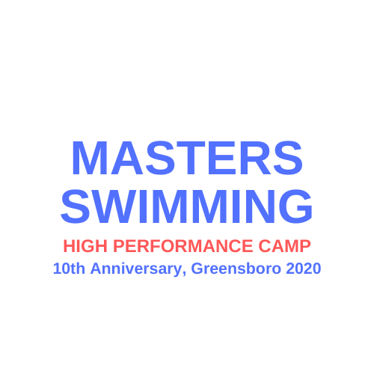
Masters Swimming High Performance Camp
2020 Application
Saturday, August 22 to Thursday, August 27, 2020

- NAME _________________________________________________________

- GENDER _________________________________________________________
- ADDRESS _________________________________________________________
- E-MAIL _________________________________________________________
- PHONE (Cell)_______________________ (Home)_____________________
(Work) ______________________
- AGE _________________________________________________________
- DATE OF BIRTH ____________________________________________ (MM/DD/YYYY)
- OCCUPATION ___________________________________________________

_______________________________________________________________________
- TEAM __________________________________________________________
- Reasons for wanting to attend the camp:
- List recent swimming workout/training regimen (if you do additional training beyond pool workouts – such as open water, weights, yoga, cross training, etc – please include):
- If you participate in competitions, please indicate some of these competitions and a few examples of times, events, and/or achievements:
- What is your preferred stroke or event?
- How will you share what you learn at camp?
- Date of application: ____________________________________________________

Camp Fee Incentive: The 2020 Masters Swimming HPC all-inclusive registration fee is $2,200 (same since 2018). If, however, your application is submitted, confirmed (takes less than 24 hours for HPC confirmation), and a $500 non-refundable deposit (which will be applied against the camp fee)) of your discounted camp fee is paid (via check or credit card) by December 31, 2019, there is a $200 discount off the camp fee.

Please email your completed Masters Swimming HPC application to Collins Lowder at clowder@trianglesportscommission.com

Questions?: Call us at 919.678.1651 or info@trianglesportscommission.com

