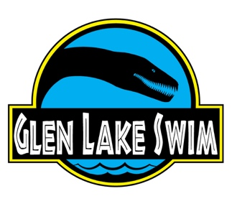
The Glen Lake Swim
www.glenlakeswim.com

Granite State Health & Fitness Foundation
PO Box 933
Manchester, NH 03105
Tel: (603) 494-8774
Email: info@glenlakeswim.com

Contact: Gary Girolimon, Race Director
Date: September 7, 2019

Registration Information
Online registration is via RunSignUp: https://runsignup.com/glenlakeswim/
There will be no paper registration. There will be no day-of registration.

