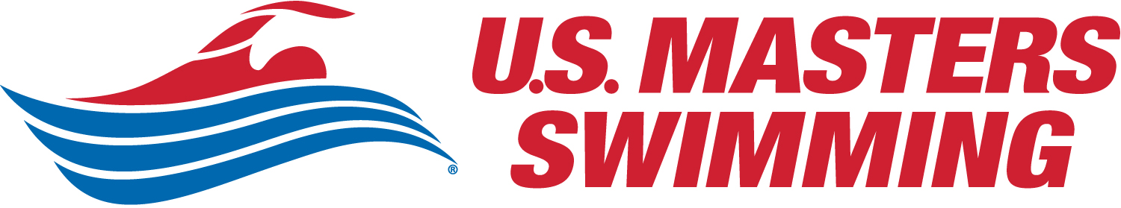



Applegate Lake Open Water Weekend 2020
Featuring 10K, 5K, 2.5K, & 1500M Swims
and the popular & fun 3 x 500M Pursuit Sprint Relay
At Applegate Lake on July 18 & 19, 2020

Hosted by Rogue Valley Masters,
Sanctioned by Oregon Masters Swimming for U.S. Masters Swimming,
Sanction Number TBD
Operating under special use authorization from the Rogue River Nat’l Forest

LOCATION & COURSE: Applegate Lake is located in the heart of the Siskiyou Mountains in southwestern Oregon. The course for the longer races will consist of multiple 2.5K loops, while the 1500m course will be a single loop. Water temperature on race day has ranged from 71-77 degrees Fahrenheit and will be posted.
RACES:
- Saturday: 10K, 5K, and 2.5K swims (swum simultaneously)
- Sunday: 1500M and 3 x 500M Pursuit Relay
ELIGIBILITY: This event is open ONLY to 2020 USMS members or foreign equivalents. Eligibility will be automatically verified for online entries. USMS “One-Event” membership—good for all swims this weekend—will be available for adults 18+ for all swims for $21.
RULES: Current USMS rules will govern this event. In all swims, Category II suits—including wetsuits—are allowed but will be scored in a separate category. Swimmers may not make deliberate contact with craft, craft operators, and/or physical features on or near the course during the swim, except at the start, finish, and feeding area.
START/FINISH: All swims will start in the water and finish on the beach near the water’s edge. Each loop roughly follows the shoreline of the lake on the way out and follows a straight line back to the start/finish area.
SAFETY—OUR PRIMARY CONCERN: Safety boats will monitor the entire course and medical personnel will be on-site. Swimmers must wear the swim cap provided, must have their race number on their arms, and must follow all announced safety rules without exception. 10K & 5K swimmers may provide their own feedings which may be placed on a table in 4-foot deep water near the starting line.

Time Limit: Swimmers who cannot complete the 10K in 4.5 hours or the 5K in 2.5 hours should NOT enter these swims; swimmers on the course after these time limits may be stopped and listed as DNF in the results.
RACE SCHEDULE (subject to change if conditions warrant):
Saturday, July 18:
6:45am Check-in/Registration opens for 10K, 5K, & 2.5K
7:45am Check-in/Registration closes
7:55am Pre-race instructions for all three races
8:15am Start of 10K
8:25am Start of 5K & 2.5K
Sunday, July 19:
8:00am Check-in/Registration opens for 1500M
8:40am Check-in/Registration closes
8:45am Pre-race instructions for 1500M
9:00am Start of 1500M
10:15am Pre-race instructions for Pursuit Relay
10:30am Start of 3 x 500M Pursuit Relay

RACE DIRECTOR: Todd Lantry, lantryt@gmail.com, 541-842-0362
REGISTRATION: Online registration: XXXXX. All entries for all events MUST be submitted by 11:59pm PDT, July 13. Submit your entry on time!
ENTRY FEES: The 10K swim is $75. The 5K & 2.5K swims are $50 each. The 1500M swim is $15 additional if swimming one of the Saturday races, otherwise $30 for the 1500 only. Race-day entries (for individual swims) are an additional $10. The Pursuit Relay is free. Entry fee includes swims, a souvenir swim cap, and a post-swim lunch for the entrant. NO REFUNDS after the entry deadline.
RESULTS: Results will be posted at the check-in area promptly after each race, and at www.swimoregon.org after the weekend.
AWARDS:
- 10K: Special awards for overall male and female winners and stemless wine glasses top three finishers in each male/female age group.
- 5K/2.5K/1500M: Stemless wine glasses to the top three finishers in each male/female age group (18-24, 25-29, 30-34, etc.), including both wetsuit & non-wetsuit categories. Special awards for overall male and female winners.
- Pursuit Sprint Relay: Bragging rights.
OREGON OPEN WATER SERIES: All swims count towards the cumulative season series. The 10K and the 1500M are featured swims (22-18-16-14-12-10-8-6-4-2 points). The 5K and the 2.5K swims are qualifying swims (11-9-8-7-6-5-4-3-2-1 points). The relay is a participation swim (7 points).
T-SHIRTS: Swimmers may pre-order commemorative t-shirts for $20. A limited number of shirts will be for sale at the event.
DIRECTIONS (Mapping Apps Search: Applegate Lake, Jacksonville, OR) From either north or south on I-5, take exit #30 in Medford and go west, following the signs to Hwy 238 west to Medford and Jacksonville. After passing through Jacksonville, Hwy 238 continues to Ruch. Turn left onto Applegate Road and follow the signs to Applegate Lake (18 miles from Ruch). Proceed past the Applegate dam for another .7 miles until you reach Hart-Tish Park, and turn left into the park. Driving time from the I-5 exit to Hart-Tish Park is approximately 45 minutes. NO DOGS ALLOWED AT RACE SITE. Please note that there is no cell coverage at Applegate Lake.
PARKING: Cost is $5 per car/per day & will be collected at the entrance to Hart-Tish Park on race morning or at Hart-Tish Park Store near the boat ramp.
LODGING/CAMPING/PLACES OF INTEREST: To camp at Hart-Tish (race site), you MUST contact Jocelyn Sanford: 541-210-0088 or jocelynjune23@gmail.com.

For additional local information visit:
http://www.visitmedford.org/
http://www.jacksonvilleoregon.org/
http://www.osfashland.org/
http://applegatewinetrail.com/
http://www.ashlandchamber.com/

