Supporting Documents for Fat Salmon Open Water Swim
July 11, 2020
- Race Schedule
- Course Map
- Course Buoy Placement and Course Evacuation Points
- Boater Placement
- Patrol and Rescue Plan
- Swimmer Finish Route and Bouy Setup
- Race Finish Layout
- Wave Cap Colors and Start Times
- Pre-Race Swimmer Briefing
- Pre-Race Safety Meeting Agenda
- Course Evacuation
Race Schedule
Date of event: Saturday, 7/11/2020
Name of Event: Fat Salmon Open Water Swim

DATE – 7/7/2020
TIME | ACTIVITY
1700 | Temporary No Parking Street Signs put in place and verified online that evening and affixed with official public notice

DATE – 7/11/2020
TIME | ACTIVITY
0500 | Volunteers setup checkin area (Madison Park) and prepare bouys – block/label parking – Timing services set-up / Finish Chute construction
0600 | Check in Opens
0600 | Gentle Giant Truck arrived and parked
0630 | Lifeguards do bouy placement within Madison Park Swim area
0645 | Remaining lifeguards arrive - load paddleboards on Gentle Giant Truck
0700 | Check-in Closes
0700 | Any kayaks needing transport also get loaded on Gentle Giant truck
0700 | Ham Radio Group briefing
0700 | Kayakers begin assembling at Day St  Truck departs Madison Park for Day street
0705 | Swimmer Safety meeting (Madison Park)
0715 | Motor boat + lifeguard safety briefing meeting (Madison St Pier)
0720 | Carpool start to Day Street
0730 | Transition set-up of Madison Park for Refreshments and Awards Tables
0730 | Kayak safety meeting (Day Street)  Lifeguards depart with motor boats for Day Street (Madison St. Pier)
0730 | Swimmers begin bringing bags to be loaded on truck
0800 | Stage Wave 1 Swimmers to begin single file swimmer check-in
0815 | Wave 1 Start; additional waves 3 minutes apart (Day Street)
0830 | Gentle Giant Truck leaves Day St with bags
0845 | Truck arrives back to Madison Park, Stage Swimmer bags on grass  Refreshment setup (Madison Park)
0900 ~ | Begin announcements on progress of swimmers for people waiting at Madison Park
0920 | Swimmers not yet at 1.5 mile mark will be asked to finish their swim to nearby boat due to not on target for 2 hour completion
0920-0935 | First swimmer arriving
0957 | Any swimmers not past 2.5 mile mark pulled by boats
1000 | Preliminary Results Posted
1005 | Begin reconciling outstanding swimmer lists
1020 | Final Results Posted – may be a swimmer or two not yet included
1030 | Expect all swimmers to be done by this time – swimmer reconciliation completed
1020-1040 | Awards presentation (Madison Park)- may begin before last swimmers finish  - Announce availability of water bottle age group awards – (we do not announce each winner by age goup)  - Salmon prizes for overall winners  - Drawings for prizes
1040-1100 | Clean-up Madison Park / Pack Fat Salmon Supplies
Course Map
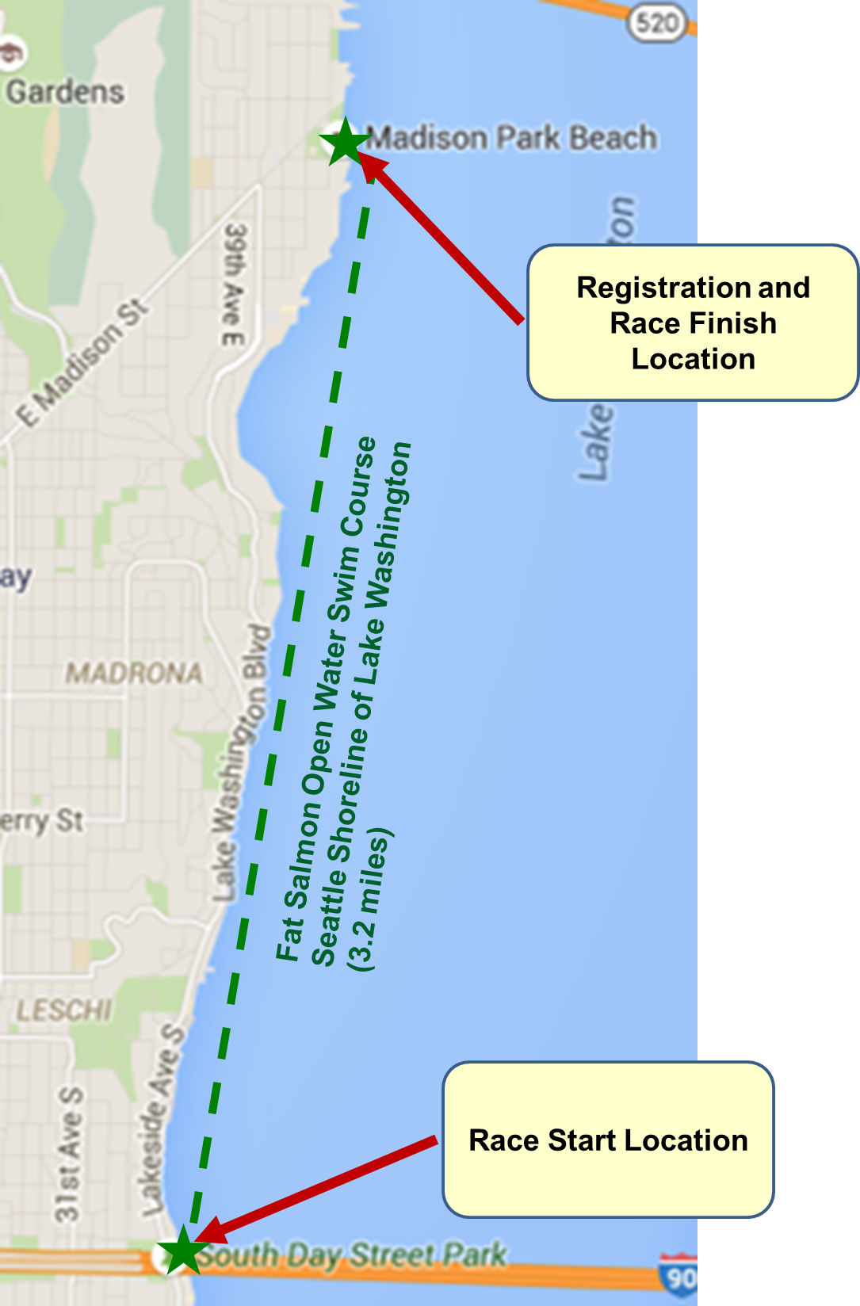
Course Buoy Placement and Course Evacuation Points
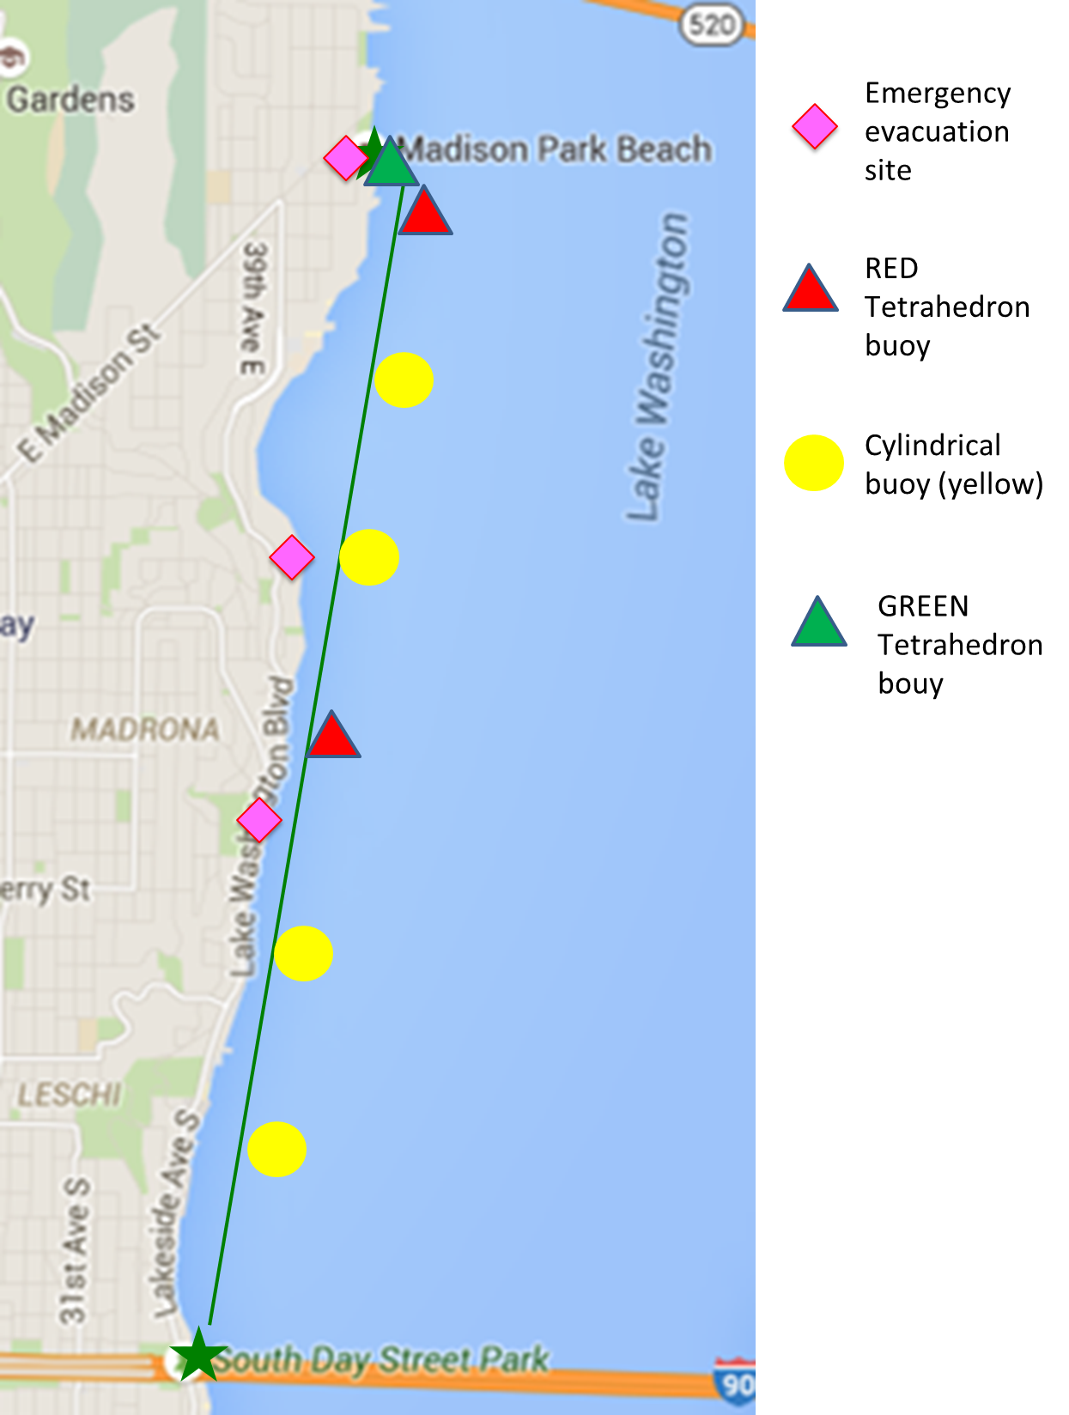

Boater Placement
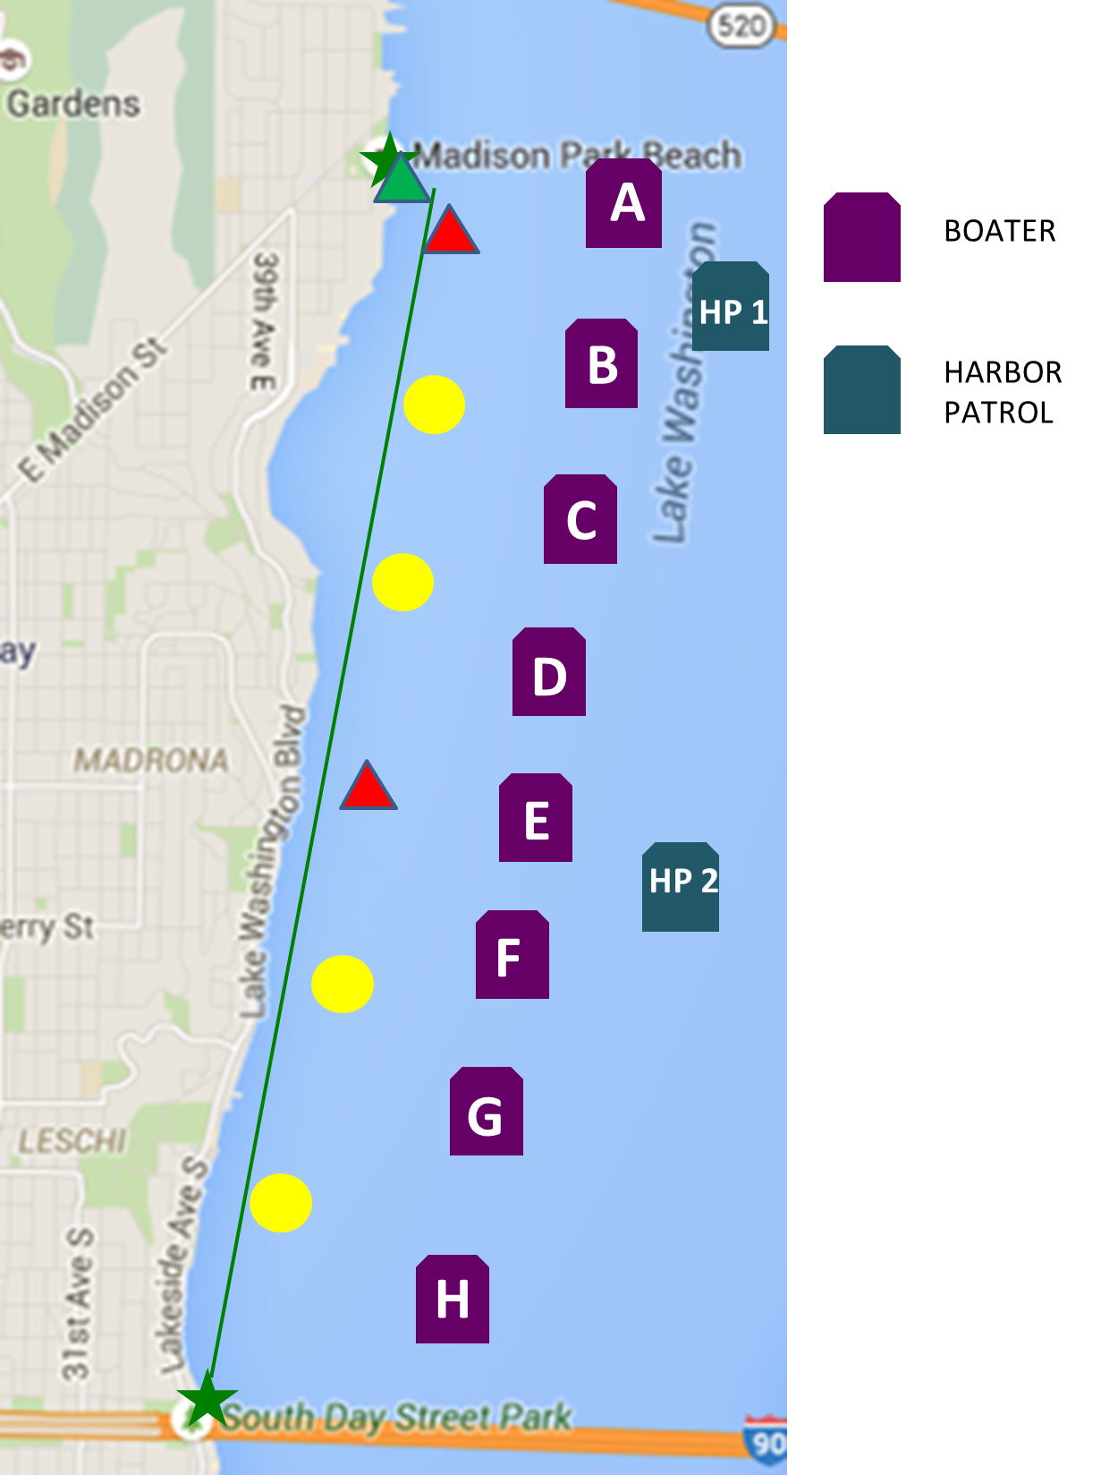

Patrol and Rescue Plan

Course Patrol

Lifeguards
Lifeguards will disperse along swim course and monitor for swimmers showing sign of distress. Follow lifeguards instruction detailed in Swimmer Rescue for coordinated rescues with kayaks, stand up paddleboarders/ power boats/Jet Skis.
Lifeguards shall return to the race start and check in with their group focal after the swimmers have all finished.

Kayakers / Stand Up Paddleboarders (SUPs)
One kayak will lead the swim and should be approximately 100 feet in front/side of the swimmers at the 8:15 start. The lead kayak should maintain that gap through the duration of the swim. The lead kayak must not be too close to the lead swimmer or else we entertain complaints that the winner was paced or escorted.
The remaining kayaks will be divided into two groups. One will patrol the east half of the course, and the other the west half. The two rows of kayaks should stay within 100 feet of each other.
As the race proceeds, each group of kayaks will spread out into a column along the length of the swimmers. East (Bellevue) side kayaks are between the swimmers and the power boats. Faster kayakers should go with the lead group of swimmers. One kayak will be designated to bring up the rear. Kayaks should not bunch up along the course and should not plan on paddling next to anyone.
Adjust positioning as directed by lead kayak, harbor patrol and head lifeguard.
Kayakers who see a swimmer heading off course should use their flag, paddle or shout to get the swimmer’s attention. Do not be shy about herding them back onto the course, but please try your best to not harm the swimmer in your attempt to redirect them.
Swimmers who are in line with the anchored motor boats are OFF COURSE and they should be directed to their left (west) toward shore.
Avoid following swimmers off the course unless necessary to redirect them back to the course. In other words, don’t keep moving out just because they are. Swimmers will follow you, right or wrong. Be a good guidepost for swimmers, encourage (and/or herd) the errant swimmers back on course.
If someone wants to abandon the race, please ask them to hold on to your kayak and escort or direct them to a motor boat for pick up. Do not allow them to swim to shore if at all possible. If they insist, please try to get their name and race number and relay that to a motor boat, again, if at all possible.
If a swimmer needs urgent help from a lifeguard, use your whistle to get the attention of lifeguards. Whistle use is for EMERGENCY USE ONLY.
Please remember that you are watching all the swimmers in your area. Do NOT follow an individual swimmer; you are not a personal escort.
In past events, some swimmers have insisted on having a kayak accompany them along the entire race course. This is not allowed. It jeopardizes everyone’s safety.

Power Boats
The primary role is to prevent general boat traffic from entering the course, and to monitor a section of the course. Boats are the boundary between the lake and the course.
Each boat is responsible for monitoring a 500-yards section of the course. Boaters should be watching for any swimmers in distress and alert their Ham radio operator and nearby kayaks and lifeguards. Radio operator shall notify the Safety Officer/Race Director/Central Command.
When ANY boat (power, sail or paddle) approaches from the east (Bellevue) side of the course, the nearest power boat should (1) get the boat operator’s attention, (2) explain the event, and (3) tell them to keep 300 yards from the race course. If the boat operator does not respond or presents any problem whatsoever, contact Harbor Patrol. This is their job, let them do it.
Any boat approaching from shoreline will be the responsibility of kayakers.

Jet Skis
Jet Skis are not required to immediately follow the swim race but will join while the race is in progress no later than 9:15. At that point, Jet Skis will remain near the rear of the swimming pack.
As the race progresses, Jet Skis should periodically drive to the front of the swimmer pack, moving from power boat to power boat, before returning to the rear of the pack. Observe swimmers, and alternate to ensure one watercraft remains at the rear of the swimmer pack at all times

Swimmer Patrol

Swimmer Rescue
If a swimmer is panicking or appears in trouble, signal a kayak, Jet Ski and/or lifeguard.
If you witness a medical emergency or if a kayaker, paddleboard or swimmer notifies or approaches you with a medical emergency, NOTIFY THE RACE DIRECTOR/SAFETY OFFICER IMMEDIATELY!! This is the fastest, most reliable communication to initiate a rescue.
Lifeguards are intended to be the first response to rescues if they are available.
If a lifeguard is unable to reach the swimmer, a kayaker should quickly approach the swimmer.
Allow the swimmer to hold onto your kayak. Use caution. A panicked swimmer can dump a kayak easily and quickly. Signal a Jet Ski or lifeguard for swimmer pickup. The Jet Skis are permitted to enter the swim course and can pick up and transport rescued swimmers to power boats. The Jet Ski or lifeguard will:
- Approach to ensure visibility by swimmer and, if present, kayak/paddleboard.
- Shut off engine (for Jet Skis)
- Help swimmer aboard.
- Start engine (for Jet Skis) and proceed slowly to nearest power boat. Do not cross swimmer course if possible, proceed thru rear of pack and then exit to the east.
- Remind boat operator to notify Race Director/Safety Director that a swimmer was pulled.
- When swimmer is on the motor boat, resume course patrol
If a Jet Ski is not available, signal the nearest power boat that you have a swimmer that needs to be picked up, get the swimmer to the stern of the kayak and tow them to the edge of the course for transfer to a power boat.
When notified of a swimmer requiring rescue, the nearest boat will move toward course edge, reverse as necessary to stop at course edge, and take engine out of gear.
When approached by a Jet Ski or kayak with a swimmer needing transfer, the power boat will:
- Idle engine and remain perpendicular to Jet Ski, kayak or paddleboard.
- The pilot should expect to operate at dead-slow speed, idling in and out of gear at approx. 2 mph. For outboards: Boat should come to a stop near the swimmer and turn off the engine to fully disengage the propeller while swimmers are near the boat.
- DO NOT ENTER THE SWIM COURSE!
- Any swimmer rescued by a paddle board, Jet Ski, or kayak will be removed from the race. If a swimmer must be rescued by a power boat for any reason, the power boat will notify the Safety Director immediately. It may be necessary to fill out an incident report. Obtain swimmer name and number and general condition. Relay information to Race Director and Command Boat, also noting time and boat number/ watch station.
If the swimmer needs medical attention, the swimmer will be evacuated by Harbor Patrol. When Kayak or board approaches, hold it near power boat until Harbor Patrol arrives. Guide Harbor Patrol to swimmer via radio, phone, hand signals, etc. If Harbor Patrol anticipates a delayed response, get the swimmer out of the water if possible to do so without causing injury. Relay information to Harbor Patrol and Race Director/Safety Officer. Notify Race Director/Safety Director when swimmer is transferred to Harbor Patrol.
If the rescued swimmer does not need medical care (e.g. fatigue), get the swimmer into the boat and comfortable. Offer a blanket and keep the swimmer on board until docked at the race finish.
When the rescue is complete, notify Safety Director that the rescue has concluded and that the boat has returned to position. Note that swimmer has withdrawn. Restate the swimmer’s name, number, condition, and time of rescue.
If required by Race Director, fill out incident report at conclusion of race.

Tired swimmers
A rest is different than needing help. Ask the swimmer if they need a rest or need help.
If a short rest is needed, allow swimmers to hang onto the bow (preferably) or the stern, but not the sides. If you find yourself doing this more than a couple times for the same individual, they probably need to be pulled.

Pulling a swimmer
When to pull a swimmer
- If a swimmer demands you paddle next to them.
- If a swimmer is incapable of staying on course and you are spending all of your time corralling one individual
- A power boat will be on hand to oversee stragglers and determine if the last swimmer needs to be pulled.
- Use your discretion.
- Boats will pull swimmers from the race to control the overall duration and safety of the event
- Any swimmer that falls more than 100 to 125 yards behind the second-to-last swimmer will be pulled from the race. This stretches swimmer pack over too great a distance.
- Any swimmer who fails to reach the 1.5 mile and 2.5-mile marks before the prescribed cut-off times will be pulled from the race
Procedure for pulling swimmers should generally follow that for non-medical emergencies. Swimmers pulled from the race will remain with the pick-up boat until the end of the race. Notify the Safety Director of pulled swimmer noting swimmer’s name and number and approximate time.
- Clearly explain your decision. Tell, don’t ask. And don’t argue.
- If a Jet Ski is visible, transfer swimmer to the Jet Ski. They will shuttle swimmer to a Power Boat.
- Direct the swimmer to follow you outside of the course to the nearest power boat.
- When swimmer is on the boat, move back to your place on the edge of the course.

Swimmers abandoning the course:
If a boater sees a swimmer heading toward shore and clearly abandoning the race, notify the Safety Director of the location and time. Attempt to get the swimmer’s name and number.
If unable to obtain name and number, direct the nearest kayak to attempt to do so.
Notify safety and Race Director if swimmer’s ID unknown.

Slow Swimmer Cut-Off
All swimmers must complete the race in two hours. This time may be increased slightly by the Race Director/Safety Officer to reflect day-of-race conditions, but in no case will the projected finish time exceed 2 hours 30 minutes.
Swimmers must reach the 1.5-mile mark by 9:20am and the 2.5 mile mark by 9:57am.
Jet Skis or two kayakers should be at the 1.5 mile mark by 9:20am. A boat will be stationed near the 1.5-mile mark and communicating with the Race Director/Safety Officer who will give the direction to pull swimmers. On direction of race director or safety officer all swimmers not yet at 1.5 mile marker should be pulled.
If no Jet Ski is available, two kayaks will be designated as the notification kayaks/pull kayaks. One designated kayak will become the last swimmer kayak and begin to follow the last swimmer to make the 1.5-mile mark. The second designated pull kayak and last kayak will direct the last swimmers to the pull boat at the 1.5-mile mark.
When directed by the 1.5-mile boat to begin pulling swimmers, the Jet Ski or pull kayak should approach swimmers nearest the 1.5-mile mark and instruct them to swim to the pull boat. Alternately, shuttle the swimmers to the boat, before returning to the next swimmer until all remaining swimmers are on the pull boat.
If the pull boat becomes full and unable to accommodate additional swimmers, the Jet Ski will shuttle swimmers to the next nearest boat. If no Jet Ski is present on race day, pull boat will communicate with the second to last power boat and become the second pull boat. DO NOT shuttle swimmers to the finish area or other location where their location cannot be relayed to the Race Director/Safety Officer.
The above process is repeated at the 2.5 mile mark at 9:57am.
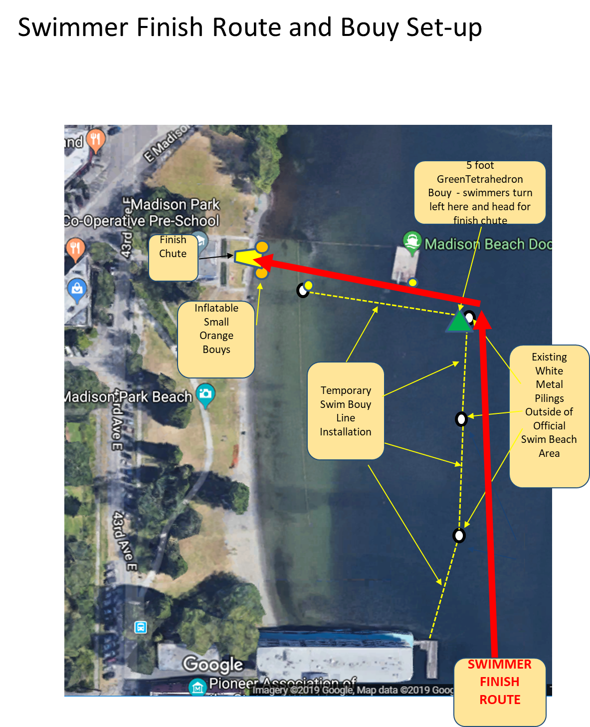
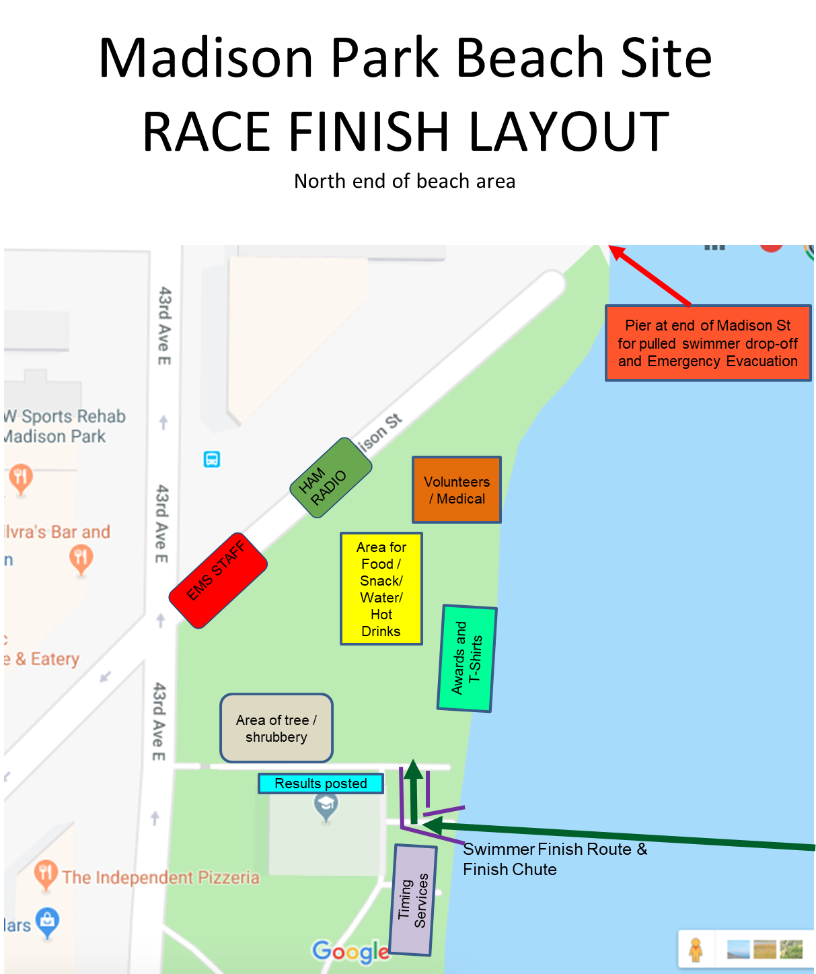
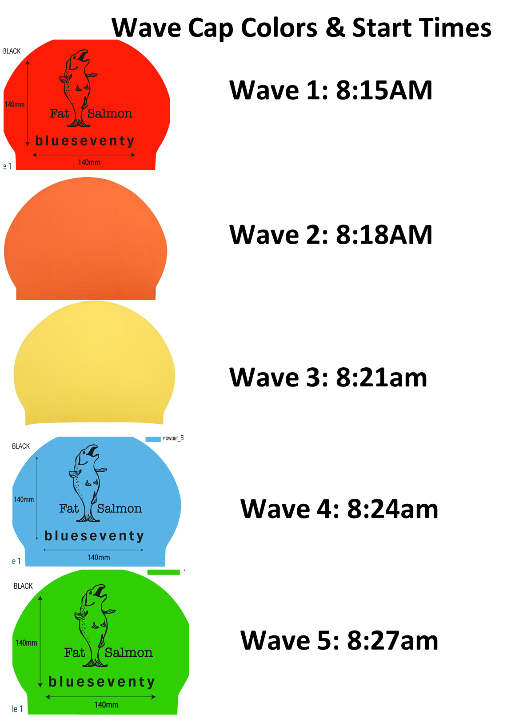
Pre-Race Swimmer Briefing
The event’s success requires the swimmers accept certain responsibilities. In addition to recognizing the risk inherent to exercise in cold water (e.g., heart attack, hypothermia, drowning), every participant is expected to abide by the following:
- No guide is available. The kayaks, boats and paddleboards are there for the safety of the group, not as individual escorts or safety marshals. Expect to follow the course with the help of adjacent swimmers and buoys, not with the personal aid of the boaters.
- Do not swim in the proximity of the power boats, THEY ARE OFF COURSE.
- Do keep an eye out for your fellow swimmers. Help them stay on course. If you see another swimmer clearly in distress, summon a kayak or paddleboard and stay in contact with the swimmer.
- If you decide to abandon the event midway, DO NOT swim to the closest shore. Rather, notify a kayak and they will escort you to a power boat.
- If you are tired or injured and need assistance, summon help from a kayak or paddleboard; this is why they are here.
- When a board or boat approaches, clearly explain the nature of your problem. Be accurate when assessing your condition or circumstance. Don’t sugar coat it, don’t cry wolf.
- If you are injured or have a medical emergency, enlist the help of a paddleboard. They are piloted by lifeguards with first aid and lifesaving training. If unable to do so, explain your situation to the nearest kayak or swimmer. If urgent, BE VERY EXPLICIT.
- If you need a rest or simply want a break, look for a kayak.
- Listen to whatever direction or instructions are provided by kayak, paddleboard or boat operators.
- If injured or needing medical attention, you will be transported to a Harbor Patrol boat. If uninjured but withdrawing from the race, a kayak will escort or transport you to one of the power boats.
- If you are showing signs of distress, are obviously unable to follow the course, or will clearly finish outside of the 2 hour race time limit, you will be pulled from the event.
- If you are pulled, do not argue with boat, kayak or board operator. They are looking after the safety of all the swimmers, not one.
- You will either be picked up by a lifeguard to transfer to a power boat, or a kayak will escort you to one.
- If transported or escorted to a power boat or harbor patrol, you will remain on the boat until that boat is authorized to return to the finish area. When you return to the finish area, you must check in with the Safety Director, Race Director or Finish Line crew and return your electronic time chip. If you start the race but do not check in at the finish, we will conclude you are still on course. If the race is over and your time chip has not been returned, we will assume the worst.
- If injured but able to remain at the finish area, notify the Race Director. You will be expected to complete an incident report describing the nature of your accident, illness or condition.
- REPEATED FIVE SHORT BLASTS from the air horn indicates an evacuation is in progress. Please proceed to the closest evacuation point (Denny Blaine Beach, Lake Washington Tennis Club, Madrona Park, or finish/start lines) quickly and safely unless picked up by a power boat.

Pre-Race Safety Meeting Agenda
- Lifeguard responsibilities
- Kayaker responsibilities
- Swimmer Rescue
- Tired swimmers
- Pulling a Swimmer – non-rescue
- Time Cutoffs
- Evacuation Plan

Course Evacuation
In the case of an immediate threat to swimmers like lightning storms or other hazardous events the Race Director and Safety Officer will proceed with canceling the event and directing boaters, lifeguards and kayaks to clear the swimmers to evacuation locations.
Three evacuation points have been identified:
- Madrona Beach located 1.25 miles from race start.
- Denny Blaine Park 2 miles from Race start and 1.33 miles from the finish.
- Madison Park
Safety Officer will notify Harbor Patrol and Power Boat pilots immediately by radio and/or cell phone that the event has been canceled and proceed with course evacuation. Boaters will sound air horns with 5 one second blasts to notify kayakers and lifeguards immediately. Kayakers and lifeguards shall inform swimmers of cancellation and direct swimmers to closest course evacuation sites. Those swimmers nearest the finish line will be directed Madison Park.
Upon course evacuation kayakers and lifeguards will also leave the water. Power Boats will continue to monitor the course until all swimmers are cleared. Upon clearing of course power boats will return to the docks at Madison Park. Verify that all swimmers who checked in and entered the water have been accounted for. Race Director and Safety Director will work with the City of Seattle to transport all swimmers to the finish at Madison Park. Verification that all swimmers who checked in and entered the water have been accounted for will occur at the finish line at Madison Park.

