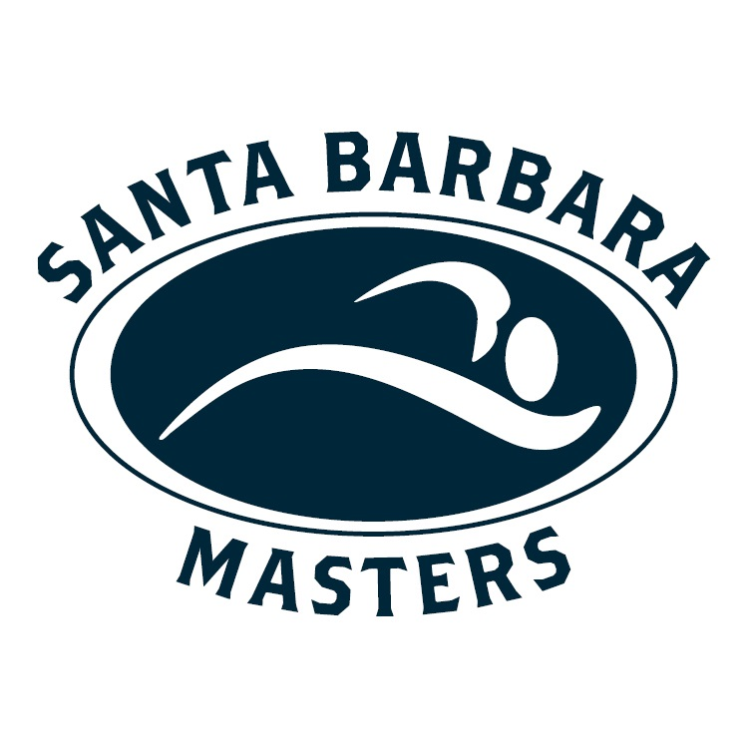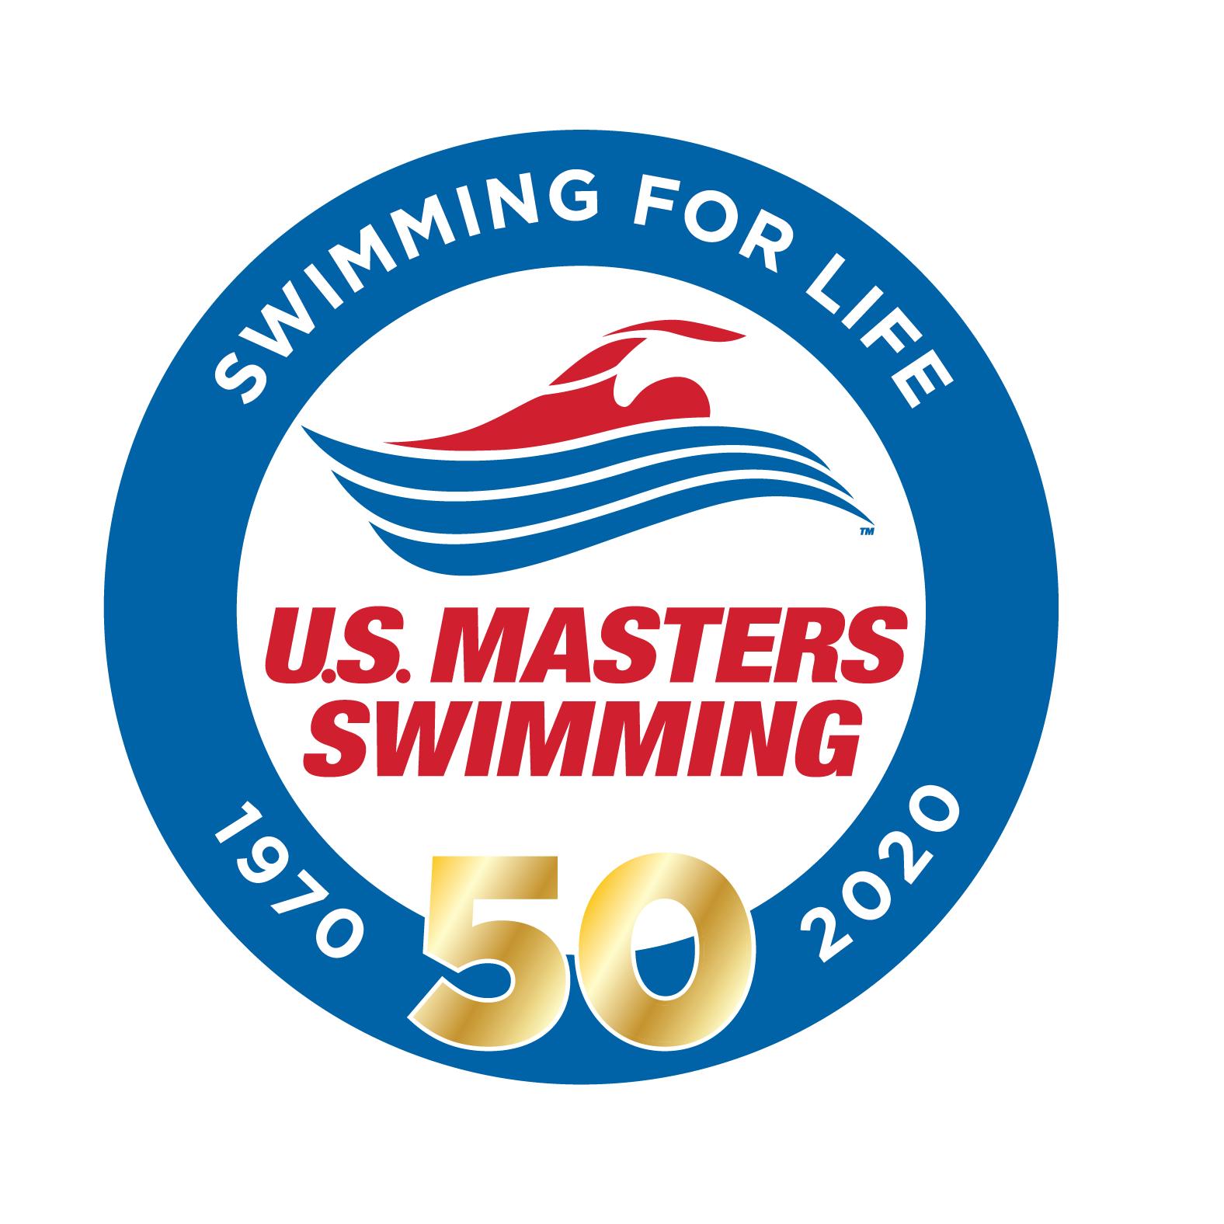
U.S. Masters Swimming
Sprint-Distance
Open Water National Championship

American Riviera Open Water Swims
Braverman Mile
Santa Barbara, CA August 29-30, 2020

SANCTIONED BY: Southern Pacific Masters Swimming for USMS Inc. - SANCTION # 330-W001

LOCATION: East Beach, 1118 East Cabrillo Blvd Santa Barbara, CA 93101. . From the 101 Freeway going North, exit at Cabrillo Blvd (exit 94C), the exit is on the LEFT. Left on East Cabrillo Blvd. East Beach and PAY parking lots will be on your Left. From the 101 Freeway going South, exit at Garden Street (Exit 96C). Right onto Garden Street to East Cabrillo Blvd. Left on East Cabrillo Blvd. East Beach and PAY parking lots will be on your Right.

RULES: The current USMS open water rules as outlined in Part 3 of the 2020 USMS Rule Book will govern the Meet.

ELIGIBILITY: All swimmers must be registered with USMS for 2020 or FINA foreign equivalents. Age as of December 31, 2020 shall determine the swimmer’s age for the race, except for 18 year olds who must be 18 on the day that they swim. You must submit a copy of your 2020 USMS card or FINA foreign equivalent at check-in. Single event registration (OEVT) will be available at this meet. FINA equivalent and Single Event (OEVT) registrants are not eligible to compete in the 2020 USMS Sprint-Distance Open Water National Championship and will swim in the Non-championship wave(s).

SCHEDULE: One mile Saturday August 29. Sequential 4 X 500M Relay, Sunday August 30
Check-In Begins: 7:30 AM
Pre-Race Briefing/Safety Meeting: 10 minutes prior to the start of each race.
Competition starts: 9:00 AM Multiple waves will leave 5 minutes apart. Non-championship swimmers will be in separate wave(s) following the 2020 USMS Sprint-Distance Open Water National Championship wave(s).

COURSE: The One Mile will be a one loop rectangular course. The relay course will be four laps of a 500M rectangular course – each relay swimmer will enter and exit the water in sequential order. We reserve the right to revise this course description based on changing water conditions.

START TIMES: Start times are as listed above, but may be adjusted based on the number of entrants. Pre-registered athletes will be informed of any changes via email. Details of the competition schedule will be discussed during the pre-race briefing.

CHECK-IN: Swimmers must report to the check-in table appropriate for their age and gender for check-in packet, numbering and chips. Chips must be worn. Participants will be required to show Photo ID at check-in to confirm their identity.

SAFETY PROCEDURES: There will be a mandatory Pre-Race Briefing held 10 minutes before the competition begins to discuss the course, rules and safety procedures. The Referee will remove any swimmer from competition who does not attend the pre-race briefing or is found to be inattentive during the briefing. Course will be patrolled by qualified safety personnel. For safety reasons, participants should be adequately trained for open water competition. City of Santa Barbara Lifeguards reserve the right to remove any swimmer from the course. Previous open water experience is recommended. Safety watercrafts and lifeguards on paddleboards will monitor the entire course. Swimmers must wear body-marked race numbers on arms for identification. The safety of swimmers is our primary concern. Therefore, this event may be delayed or canceled due to poor conditions. The Event Director and City of Santa Barbara Lifeguards will make this decision.

ATHLETE ATTITUDE: Athlete conduct will be governed by Part 3 of the USMS Rules and Regulations Handbook. Intentional obstruction, interference or intentional contact with another swimmer may be deemed "Unsporting Impedance" and lead to disqualification. Swimmers shall maintain clearance from other swimmers except at the start, turn, and the finish or where the course or race conditions dictate otherwise. Swimmers should be advised that if there are a significant number of entrants, open water swimming may be expected to involve inadvertent contact with other swimmers. It is important that swimmers keep a cool head while in the water.

SWIMWEAR: No fins or other devices will be allowed. There will be a wetsuit division. USMS Wetsuits Rules for open water swimming will be followed. Wetsuit swimmers will be eligible for ranking and awards within the Wetsuit Division. Wetsuits are not permitted in the 2020 USMS Sprint-Distance Open Water National Championship.

MEET REFEREE: Paul Szuszkiewicz, pszsz@hotmail.com
MEET DIRECTOR: Mark Warkentin-805-451-8666-markdwarkentin@gmail.com
ENTRY CHAIR: Karin Wegner, Karin@clubassistant.com
INDEPENDENT SAFETY MONITOR: Tony Sholl-805-966-6110-tsholl@SantaBarbaraCa.gov
The Independent Safety Monitor has the final authority on whether the events will be held.

ENTRY FEES/PROCEDURES & DEADLINE: USMS entry fee is $45 for One Mile, $50 for the combo (One Mile plus Relay). Relay-only swimmers may enter for $15. Online registration is preferred.

START/FINISH TIMING SYSTEM: There will be a beach start and finish. A chip timing system will be used. Chips must be worn on the wrist.

TIME LIMITS: Swimmers not completing the race course within 60 minutes of the start of the race will be notified that the race is over and that they must leave the water at that time. Results will show their time as Did Not Finish (DNF) and will not be eligible for awards.

AWARDS : Top six in each age group for Men and Women: 18-24, 25-29, 30-34, 35-39, 40-44, 45-49, 50-54, 55-59, 60-64, 65-69, 70-74, 75-79, 80-84, (additional 5 year age groups as needed); Top three overall in Men's and Women's Wetsuit divisions. Awards for the top three overall Male and Female finishers.

GENERAL ADMISSION: There is no admission fee for this event.

MEET WARM-UP PROCEDURES: An area adjacent to the competition course will be available for warm-up and warm-down at designated times.

WATER TEMPERATURE: Between 63 to 68 degrees

RECORDING DEVICES: Use of audio or visual recording devices, including a cell phone, is not permitted in changing areas, rest rooms, or locker rooms.

DRONES: Operation of a drone, or any other flying apparatus, is prohibited over the venue (pools, athlete/coach areas, spectator areas, and open ceiling locker rooms) any time athletes, coaches, officials, and / or spectators are present. USMS credentialed media personnel may be exempted from these restrictions.

FINAL RESULTS: Final results will be posted at www.sbswim.net

MORE INFORMATION: www.sbswim.net

It is understood and agreed that USMS shall be free from any liabilities or claims for damages arising by reason of injuries to anyone during the conduct of the event. All swimmers shall have signed the USMS liability release before participating.

