South Carolina LCM State Championships
June 20-21, 2020

Location: Greenville County Aquatic Complex, 2700 West Blue Ridge Drive, Greenville, SC 29611

Host: Greenville Splash Masters

Sanction: Sanctioned by South Carolina LMSC for USMS, Inc. Sanction Number: 550-S002

Meet Director: Leslie Scott, cell: 864-283-1328, email: greenvillesplash@gmail.com

Meet Referee: Andy Rutledge

Facility: Greenville County Aquatic Complex is an indoor/outdoor climate-controlled facility with an eight lane 50 meter pool and adjacent 5 lane, 25 yard warm-up/warm-down pool. Competition course has a fully automatic Colorado Timing System with backup and an 8-line scoreboard. Bleacher seating is available for up to 1,000 spectators along with ample deck space and bleacher seating for swimmers. Swimmers may bring chairs.

Rules: The meet will be conducted according to 2020 USMS rules and this meet information.
The length of the competition course is in compliance and on file with USMS in accordance with articles 105.1.7 and 106.2.1, but as a bulkhead course, is subject to length confirmation. Eligibility of times for USMS Top 10 and records will be contingent on verification of bulkhead placement. The pool will be measured as required by USMS.

Eligibility: This meet is open to all USMS swimmers registered for 2020. Age determined as of the last day of 2020.

Fees: Entry fee is $55.00 by June 1 and includes a t-shirt. Entry fee is $65.00 between June 1 and June 16. Relay only swimmer fee is $45.00. Last day to register online is June 16. Deck entries left to discretion of the meet director, no new heats will be created. No refunds available.

Link for Online entry: https://www.clubassistant.com/club/meet_information.cfm?c=2125&smid=13006

Entry limit: Swimmers are allowed a maximum of four individual events per day.

Entry Deadline: Tuesday, June 16, 2020 11:59 pm EST.
Deadline for guaranteed t-shirt: Saturday, June 1, 2020

Psych sheet: Available by Wednesday, June 17. We will be utilizing SwimPhone and MeetMobile

Time of the Meet:
Saturday morning session: Warm-up 8:00 am, Meet starts at 9:00 am
Saturday afternoon session: Warm-up 11:00 am (or after conclusion of the 800 free relays)
Meet starts at 12:15 pm
Sunday session: Warm-up 8:00 am, Meet starts at 9:00 am

Meet format: Swimmers in the 1,500 Free will need to provide their own counter if they desire one. Meet management reserves the right to adjust warm-up and meet start times. Participants will be notified of any changes in the timeline. You may enter a maximum of four individual events per day. List a long course meters seed time or N.T. for the events you plan to enter. Relays need to be submitted on deck at the beginning of warm-up or emailed prior to the meet to the meet director. The 1,500 will be limited to 24 entries. The 800 free relays will be limited to a total of 2 heats. There will be one heat which will include Women’s and Men’s (Event #s 2 and 3 will be combined into one heat). There will be one heat of Mixed 800 Free Relays. Under this format USMS has assured us the times posted will count for Top 10 and records. Entries are first come first serve for the 800 Free relays. You may send relays to the meet director prior to the meet. Since 800 Free relays are limited, they will not be scored in the team results. Pre-meet reservations for the 800 Free Relays can be made via email to: greenvillesplash@gmail.com. No time trials will be allowed.

Awards: High point award for each age group (must swim a minimum of five events to qualify). Team awards will be awarded to top 3 teams overall. Scoring to 8 places.

Seeding: Heats will be seeded from slowest to fastest using submitted long course meters times. Ages and sexes will be combined for competition but separated for awards. No time (NT) entries will be seeded in the early heats. All events 400 meters and longer will be deck seeded fastest to slowest. Check-in for the 1500 Free will close at 8:45 am. Check-in for the 400 IM and 400 Free will close 30 minutes before the start of the event. Swimmers not checked in will be scratched

Weather: If there is inclement weather: the meet referee, facility director, and meet director will make final decisions about postponing or canceling events. We will try hard to get all the events in, but may have to cancel some events if there is a time restraint.

T-Shirts: Championship T-shirts will be given to all participants that enter by June 1.

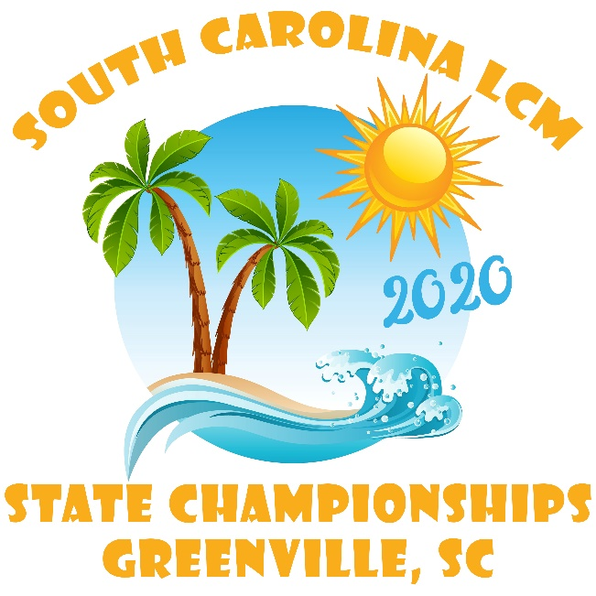

Host Hotel: Hampton Inn Greenville/ I-385 Haywood Mall
255 Congaree Road, Greenville, SC 29607. Group rate is $110.00 per night. Reservations must be received by June 5, 2020 for group rate. Call or use link to make reservations. The Group Name is: LCM State Championships, Greenville Splash. The Group Code: LCM. Phone: 864-527-6274.
Link: https://hamptoninn.hilton.com/en/hp/groups/personalized/G/GSPGHHX-LCM-20200619/index.jhtml?WT.mc_id=POG

Saturday Meet Social: Enjoy meeting new swim friends from all over. Join us Saturday evening for a night full of Greenville Splash fun. Information will be available at the meet. Everyone knows Greenville Splash puts on a really fun social, don’t miss it!

Hospitality: Hospitality for coaches and officials will be available.

Officials: Individuals wishing to officiate at this meet should contact: Amy Browning email:.agbrowning1@bellsouth.net. Officials will meet beginning one hour prior to the start of competition.

Timers: Individuals that are available to help time please contact: Kristin Knowles at kekworks@gmail.com. Letters of service hours can be provided for those that need verification.

Warm-up Procedures: Pull-buoys, kick boards, fins, and hand paddles are not allowed in the competition pool or warm-up pool. Swimmers must enter the pool feet first in a cautious and controlled manner. Diving shall be permitted only in designated lanes and at designated times.

Yeah That Greenville: Visit this link to find things to do, information about Greenville, events and more places to stay in Greenville: https://www.visitgreenvillesc.com/

2020 South Carolina LCM State Championships
Online Entries Only

Saturday Morning Session Warm-up 8:00 am
Start 9:00 am

- 1500 Free (limit to 24 entries)

- 800 Free Relay Men and Women (one heat only)

- 800 Free Relay Mixed (one heat only)

Saturday Afternoon Session Warm-up 11:00 am (or upon conclusion of the 800 Free Relays)
Start 12:15 am

- 200 I.M.

5 50 Free

6 100 Breast

7 200 Back

8 200 Mixed Free Relay

9 400 Mixed Free Relay

10 100 Free

11 50 Back

12 100 Fly

13 200 Women’s Medley Relay

14 200 Men’s Medley Relay

15 400 Women’s Medley Relay

16 400 Men’s Medley Relay

Sunday: Warm-up 8:00 am, Start 9:00 am

17 50 Breast

18 200 Fly

19 100 Back

20 200 Mixed Medley Relay

21 400 Mixed Medley Relay

22 200 Breast

23 50 Fly

24 200 Free

25 200 Women’s Free Relay

26 200 Men’s Free Relay

27 400 Women’s Free Relay

28 400 Men’s Free Relay

29 400 IM

30 400 Free

PARTICIPANT WAIVER AND RELEASE OF LIABILITY, ASSUMPTION OF RISK AND INDEMNITY AGREEMENT

For and in consideration of United States Masters Swimming, Inc. (“USMS”) allowing me, the undersigned, to participate in any USMS sanctioned or approved activity, including swimming camps, clinics, and exhibitions; learn-to-swim programs; swimming tryouts; fitness and training programs (including dryland training); swim practices and workouts (for both pool and open water); pool meets; open water competitions; local, regional, and national competitions and championships (both pool and open water); and related activities (“Event” or “Events”); I, for myself, and on behalf of my spouse, children, heirs and next of kin, and any legal and personal representatives, executors, administrators, successors, and assigns, hereby agree to and make the following contractual representations pursuant to this Waiver and Release of Liability, Assumption of Risk and Indemnity Agreement (the “Agreement”);

- I hereby certify and represent that (i) I am in good health and in proper physical condition to participate in the Events; and (ii) I have not been advised of any medical conditions that would impair my ability to safely participate in the Events. I agree that it is my sole responsibility to determine whether I am sufficiently fit and healthy enough to participate in the Events.

- I acknowledge the inherent risks associated with the sport of swimming. I understand that my participation involves risks and dangers, which include, without limitation, the potential for serious bodily injury, sickness and disease, permanent disability, paralysis and death (from drowning or other causes); loss of or damage to personal property and equipment; exposure to extreme conditions and circumstances; accidents involving other participants, event staff, volunteers or spectators; contact or collision with natural or manmade objects; dangers arising from adverse weather conditions; imperfect water conditions; water and surface hazards; facility issues; equipment failure; inadequate safety measures; participants of varying skill levels; situations beyond the immediate control of the Event organizers; and other undefined, not readily foreseeable and presently unknown risks and dangers (“Risks”). I understand that these Risks may be caused in whole or in part by my own actions or inactions, the actions or inactions of others participating in the Events, or the negligent acts or omissions of the Released Parties defined below, and I hereby expressly assume all such Risks and responsibility for any damages, liabilities, losses or expenses that I incur as a result of my participation in any Events.

- I agree to be familiar with and to abide by the Rules and Regulations established by USMS, including any safety regulations. I accept sole responsibility for my own conduct and actions while participating in the Events.

- I hereby Release, Waive and Covenant Not to Sue, and further agree to Indemnify, Defend and Hold Harmless the following parties: USMS, its members, clubs, workout groups, event hosts, employees, and volunteers (including, but not limited to, event directors, coaches, officials, judges, timers, safety marshals, lifeguards, and support boat owners and operators); the USMS Swimming Saves Lives Foundation; USMS Local Masters Swimming Committees (LMSCs); the Event organizers and promoters, sponsors and advertisers; pool facility, lake and property owners or operators hosting the Events; law enforcement agencies and other public entities providing support for the Events; and each of their respective parent, subsidiary and affiliated companies, officers, directors, partners, shareholders, members, agents, employees, and volunteers (individually and collectively, the “Released Parties”), with respect to any liability, claim(s), demand(s), cause(s) of action, damage(s), loss or expense (including court costs and reasonable attorneys’ fees) of any kind or nature (“Liability”) which may arise out of, result from, or relate in any way to my participation in the Events, including claims for Liability caused in whole or in part by the negligent acts or omissions of the Released Parties.

- I further agree that if, despite this Agreement, I, or anyone on my behalf, makes a claim for Liability against any of the Released Parties, I will indemnify, defend and hold harmless each of the Released Parties from any such Liabilities which any may be incurred as the result of such claim.

I hereby warrant that I am of legal age and competent to enter into this Agreement, that I have read this Agreement carefully, understand its terms and conditions, acknowledge that I will be giving up substantial legal rights by signing it (including the rights of my spouse, children, heirs and next of kin, and any legal and personal representatives, executors, administrators, successors, and assigns), acknowledge that I have signed this Agreement without any inducement, assurance, or guarantee, and intend for my signature to serve as confirmation of my complete and unconditional acceptance of the terms, conditions and provisions of this Agreement. This Agreement represents the complete understanding between the parties regarding these issues and no oral representations, statements, or inducements have been made apart from this Agreement. If any provision of this Agreement is held to be unlawful, void, or for any reason unenforceable, then that provision shall be deemed severable from this Agreement and shall not affect the validity and enforceability of any remaining provisions.

Last Name | First Name | MI | Sex (circle)  M F |  | Date of Birth (mm/dd/yy)
Street Address, City, State, Zip
Signature of Participant |  |  |  | Date Signed

