Emergency Action Plan
CBJ Parks & Recreation
Aquatics Division
Dimond Park Aquatic Center

Facility Address:
3045 Dimond Park Loop
Juneau, AK 99801

INTRODUCTION DPAC

Purpose

This Emergency Action Plan (EAP) is based on city policies, applicable regulations, and facility-specific knowledge and experience. It is designed to outline procedures for evacuation and emergency situations. This guideline is also an effort to prevent injuries, minimize property damage and facilitate return to normal operation.

Industry Standards

There is a need to demonstrate the ability to provide prudent care for patrons as needed and when called upon and to be prepared to defend actions and programs. All job responsibilities include proper orientation as well as in-service training and certification to be held periodically throughout the year. It is a requirement for all staff to be certified in CPR/AED and First Aid; staff responsible for specific training, such as group exercise instructors and swim instructors, are required to have appropriate certifications as well.

Duty to Act

The Aquatics Division Staff has a duty to act when an emergency occurs. It is the expectation that staff will keep the safety of all patrons paramount, prevent injuries from occurring and respond to people in need. When called upon to act, staff is expected only to act within their scope of practice. This scope of practice is the skills and knowledge that was acquired in training and that was authorized by certification; it establishes the limit of care one can legally provide. The Good Samaritan Law warrants legal protection for those who attempt to provide proper care.

Negligence

Negligence is the failure to do what a reasonably careful and prudent person would have done under the same circumstances. Negligence includes:
- Failing to provide care.
- Providing care beyond your scope of practice.
- Providing inappropriate care.
- Failing to control or stop any behaviors that could result in further injury or harm.

Consent

Before providing care to a conscious victim, one must first obtain his or her consent. For a minor, you must obtain consent from a parent or guardian. When a parent/guardian is not present, one can assume implied consent for minors who need emergency assistance. Someone who is unconscious, confused, or seriously ill or injured may not be able to grant consent. In these cases, the law assumes the victim would give consent if he/she were able to do so (implied consent).

Call Out List DPAC

Emergency Contact List
*ALL EMERGENCIES CALL 9 911*
Emergency *9 911
Juneau Police Dept. *9 586-0600
Capital City Fire Dept. *9 586-5322
Alaska State Police *9 465-400
Controller’s Office x5216

Administrative Staff Contact List

Name Position Office Phone Cell Phone
Kollin Monahan Aquatics Manager x0472 (AGB) x0839 (DPAC) 907-321-6535
Noelani Kamahele DPAC Supervisor x0835 907-321-0557
Seth Cayce AGB Supervisor x0471 907-321-7665
Machelle Wilkinson Admin. Assistant x5315

City & Borough of Juneau Resources
Parks & Rec Main Office x5226
Human Resources x0964
Payroll x5213
Capital Transit *9 789-6901
School District *9 523-1700
Libraries x5249
Emergency Response - Whistle Blows DPAC
The Head-Lifeguard is responsible for contacting or delegating someone to contact the appropriate personnel and administrative staff in an emergency situation. In the event that there is a Life Threatening Emergency resulting in communication of Juneau Authorities, the Head-Lifeguard shall contact the appropriate staff member who is responsible for that particular area or personnel. If he/she cannot be reached, attempt to contact another administrative staff member.
Staff is required to utilize whistles for communication purposes. Whistling is the primary mode of communicating with one another for an emergency, therefore duration of whistle blows should be concise and precise.
Whistle Blow Codes are as follows:
- Short Blasts
  - 1 Short Blast: to get a patron’s attention
  - 2 Short Blasts: to get a Lifeguard’s attention
- Long Blasts
  - 1 Long Blast: active rescue (any active rescue that stops you from doing regular scanning).
  - 2 Long Blasts: Passive rescue, suspected spinal, unconscious victim (H20 or land), head injury, life threatening condition
Life Threatening Emergency
Summon more Advanced Medical Personnel if you find anyone with the following Life Threatening Conditions:

- Unconsciousness or Disorientation
- Breathing problems
- Chest discomfort
- No pulse
- Severe bleeding
- Abdominal Pain or pressure
- Suspected head, neck or back injuries

- Severe allergic reactions
- Stroke
- Seizures
- Vomiting blood
- Severe burns
- Suspected broken bones
- Suspected poisoning
- Sudden severe headache
Perform the Initial Assessment
- Size up the Scene - Make Sure the Scene is SAFE! ( DO NOT approach the victim if the scene is hazardous. Wait until the scene becomes safe or emergency personnel arrive.)
    - Put on appropriate Personal Protective Equipment before caring for the victim
    - Determine what caused the injury or illness
    - Determine the number of patrons injured
    - Move the victim ONLY if necessary. (If the victim appears to have a head, neck, or spinal injury avoid moving them to prevent further injury.)
Emergency Response (continued) DPAC
- Check Victim for Consciousness
  - If the victim is conscious YOU MUST obtain consent before providing care
  - If the victim is found unresponsive, immediately summon Advanced Medical Personnel (Via the Nearest Emergency Call Box, Radio, or Phone) AND Secondary Rescuers to the Scene with the AED! Tap the victim on the shoulder saying, “Are you ok?” to see if he or she responds
  - CONFIRM THAT 911 HAVE BEEN CALLED AND THE AED IS ON THE WAY!
- Look, Listen, and Feel for Breathing
  - Open the victim’s airway and quickly check for breathing and a pulse for no more than 10 seconds
  - If victim is not Breathing, perform Two Initial Rescue Breathes
  - If the breaths do not go in re-tilt the head and try again
- Check for a pulse
  - If victim has a Pulse, but is not Breathing, perform Rescue Breathing
- Adult: 1 breath every 5 seconds
- Child or Infant: 1 breath every 3 seconds
  - If victim does not have a Pulse, and is not Breathing, perform CPR and attach the AED as soon as it is available
- Adult, Child, and Infant CPR (1 rescuer) : 30 chest compressions and 2 breaths
- Adult CPR (2 rescuers) : 30 chest compressions and 2 breaths
- Child and Infant CPR (2 rescuers): 15 chest compressions and 2 breaths
- Check for Severe Bleeding
  - Make a visual check for severe bleeding. Be sure to check to victim head to toe to ensure there is not bleeding.
  - If the victim is bleeding severely, have additional staff (Lifeguards, Aquatic Attendants) help stop or control the bleeding until Emergency Medical Personnel arrive on scene
  - Make sure appropriate Personal Protective Equipment is on before handling any type of body fluid
- Place victim in Recovery Position until Emergency Medical Personnel arrive on the scene
- Instruct a Secondary Rescuer to meet Emergency Medical Personnel at the appropriate entry point and escort them to the location of the incident
- Provide necessary care until Emergency Medical Personnel arrive and take over
- Additional Secondary Rescuers await Instructions and/or assist in Providing Care

Follow-up Responsibilities
- Clean up and dispose of any blood soaked items or any other contaminated items
  - If the spill is large, or the employees are uncomfortable with the clean-up, Environmental Safety can be contacted to be consulted
- All Rescuers involved, including Aquatic Attendant, MUST complete an Incident/Accident/Injury Report by following these guidelines:
  - Be as Descriptive as possible, i.e. Who, What, When, Where, Why, and How
  - If possible, the signature of the Victim and Unbiased Witnesses is required

Emergency Response (continued) DPAC
  - Do not insert any information that is unnecessary, i.e. Facts Only (No Speculation)
  - Do not blame or claim fault
  - Write neatly and use correct grammar
- Contact Administrative Staff specific to the area where the incident occurred. If there is no answer, leave a detailed message, then call another Administrative Staff member
- Debrief with Direct Supervisor
Non-Life Threatening Emergency
Any situation not deemed a Life Threatening Emergency, i.e. Rolled Ankle, Pulled Muscle, Small Cut or Bruise, or Active Drowning Victim
Perform the Initial Assessment
- Size up the Scene - Make Sure the Scene is SAFE! (DO NOT approach the victim if the scene is hazardous. Wait until the scene becomes safe or emergency personnel arrive.)
- Put on appropriate Personal Protective Equipment
- Determine injury status and number of victims
- Check for Consciousness, Breathing, Pulse, and Severe Bleeding
If the situation is determined to be NON-LIFE THREATENING (I.E. Is Conscious, Is Breathing, Has a Pulse, and is Not Severly Bleeding):
Guidelines When Calling 911:
*WHEN CALLING *9 911, ENSURE CORDLESS PHONE IS USED. PASS TO PRIMARY RESCUER UPON ARRIVAL*
- Tell the operator your NAME and LOCATION
- “Hello, my name is (Name), I am calling from the Dimond Park Aquatic Center We have a(n) (Victim Condition, Age, Gender, etc.) patron and are in need of an ambulance.”
- Provide the operator with as much information as possible
- Common Life Threatening Conditions:

- Unconsciousness or Disorient
- Breathing problems
- Chest discomfort
- No pulse
- Severe bleeding
- Abdominal Pain or pressure
- Suspected head, neck or back injuries

- Severe allergic reactions
- Stroke
- Seizures
- Vomiting blood
- Severe burns
- Suspected broken bones
- Suspected poisoning
- Sudden Severe Headache
- Be as SPECIFIC as possible when informing the operator of the SITUATION
- Speak LOUDLY and CLEARLY
Emergency Response (continued) DPAC
- Follow any INSTRUCTIONS that the operator gives you
- Hang up Phone only after the operator hangs up
- Inform others that 911 has been called and is EN ROUTE
Activate the Emergency Action Plan:
- Summon Help: “This is (Name and Position), I have a (Victim Condition) patron in (Location).”
- If the Building Supervisor is not the Primary Rescuer, request them to the scene immediately
- If needed, request additional Staff support and/or equipment
- Administer necessary First Aid
- Fill out appropriate reports
- Determine if the victim is able to leave the facility on their own
- If the victim’s condition worsens, refer to the Life Threatening Emergency Procedures
Secondary Rescuers Await Instructions from Primary Rescuer or Head-lifeguard
Follow-up Responsibilities
- Clean up and dispose of any blood soaked items or any other contaminated items
  - If the spill is large, or the employees are uncomfortable with the clean up, Environmental Safety can be contacted to be consulted
- All Rescuers involved, including Welcome Desk Representative, MUST complete an Incident/Accident/Injury Report by following these guidelines:
  - Be as Descriptive as possible, i.e. Who, What, When, Where, Why, and How
  - If possible, the signature of the Victim and Unbiased Witnesses is required
  - Do not insert any information that is unnecessary, i.e. Facts Only (No Speculation)
  - Do not blame or claim fault
  - Write neatly and use correct grammar
- Only if URGENTLY needed contact Administrative Staff specific to the area where the incident occurred. If there is no answer, leave a detailed message, and then call another Administrative Staff member.
- Debrief with Direct Supervisor

Emergency Exits/Assembly Points DPAC
Building Access for Emergency Medical Personnel
- South Entrance - Main Access Point
- Emergency Exit - (North Side)
*Staff member MUST be at the Main Access Point ready for Emergency Medical Personnel to arrive
- Important Locations
North Emergency Exit
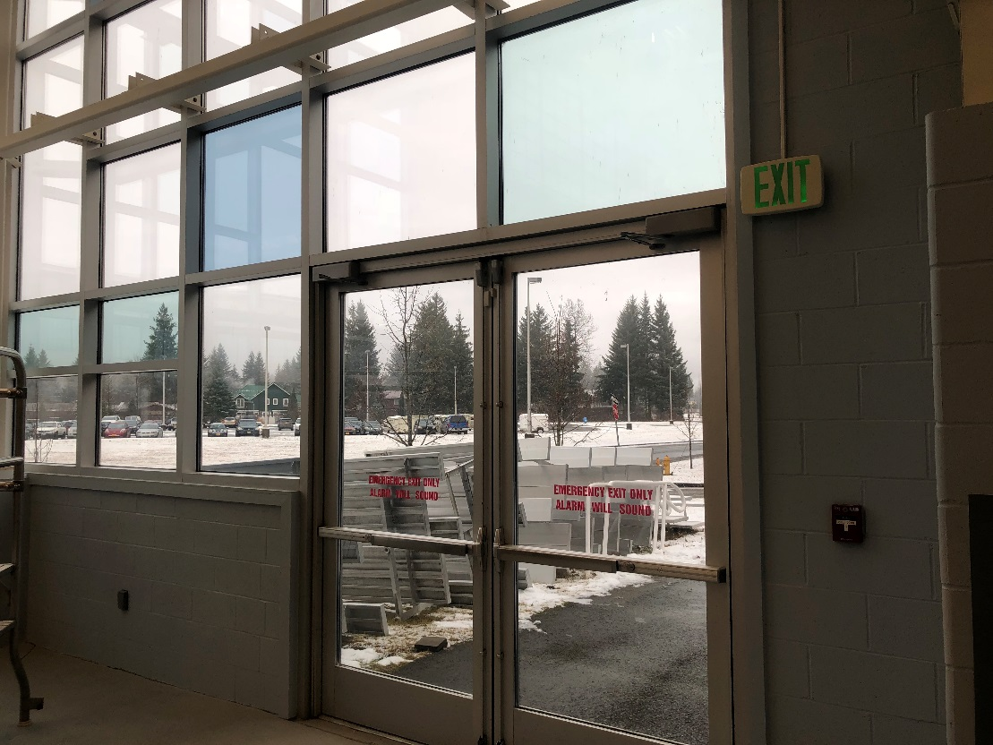

Emergency Exits/Assembly Points (continued) DPAC
East Emergency Exit
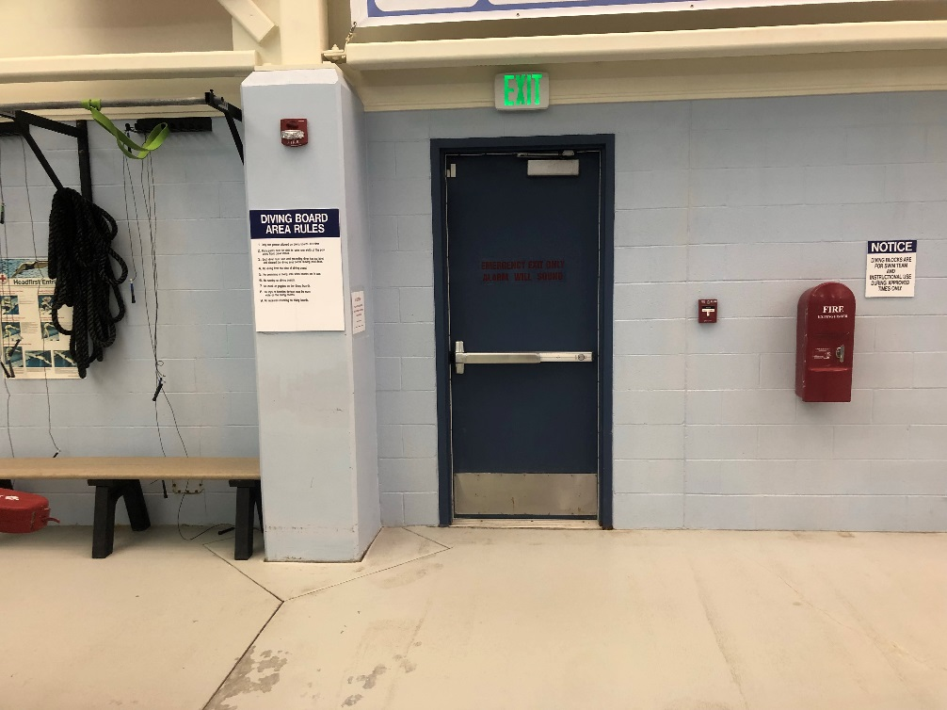
South Emergency Exit
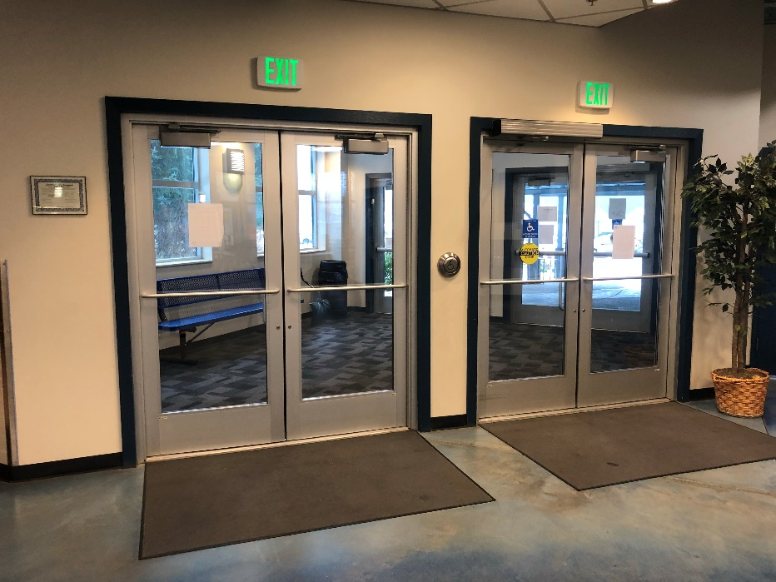

Emergency Exits/Assembly Points (continued) DPAC
West Emergency Exit
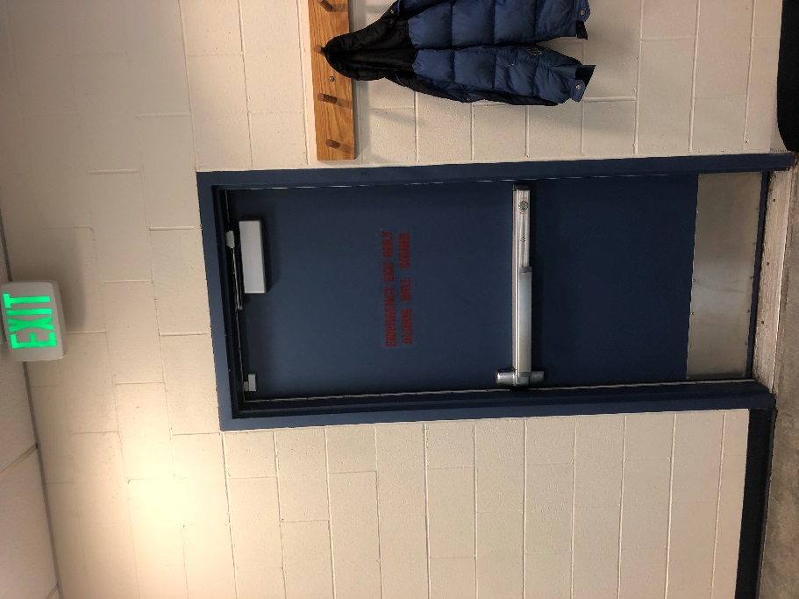
Main Assembly Point
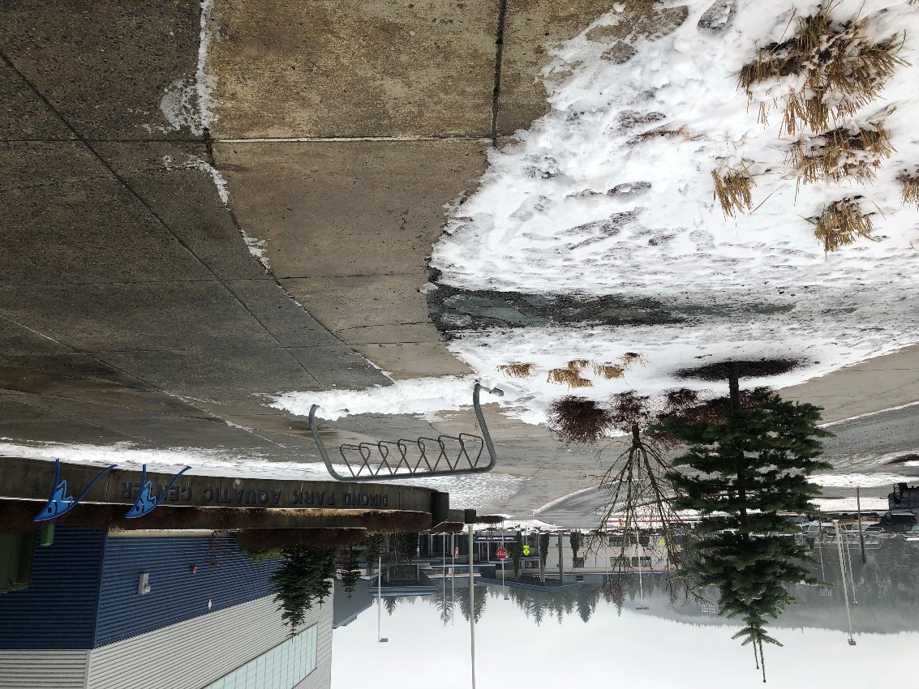
Emergency Exits/Assembly Points (continued) DPAC
- Evacuation
  - Assembly points
    - Fair weather - the from entrance past the awning on sidewalk
    - Poor weather – Thunder Mountain High School
      - Front entrance to front lobby of high school
- Congregation - Men’s and Women’s Locker Rooms
AED Locations
- Front desk, next to employee hallway entrance
- Head guard office
Fire Alarm Locations
- Manual Pull Switches Located beside All Exit Doors
Flashlight Locations
- Welcome Desk
- Head Lifeguard Office
- Pool Supervisor Office
- Aquatic Manager Office

Evacuation Procedures (Fire Emergency, Bomb Threat, etc.) DPAC
Building Supervisor Responsibilities
Activate the Emergency Action Plan and Evacuate Patrons in facility
- Instruct all Aquatic Division Employees to clear their areas, lead patrons to the Nearest Exit outside to the appropriate Assembly Point.
- Check all areas to inform ALL Patrons there is an Emergency in the facility and everyone must evacuate
- Lead ALL patrons to the Nearest Exit to the appropriate Assembly Point
- If Patron Refuses to Evacuate:
  - Insist that there is an Emergency in the building and they must evacuate as quickly and as safely as possible
  - Note their description and last seen location to relay to Advanced Medical Personnel
- Exit the building when all areas have reported an “ALL CLEAR”
Lifeguard Responsibilities
Evacuate Patrons in Pool, Hot tub, and Locker Rooms from the building through closest emergency exits:
- Check Pool, Hot tub, and Locker Rooms and inform ALL patrons there is an Emergency in the building
- Ask all patrons to exit the water, exit the pool, and lead them to the Nearest Emergency Exit leading from the Pool to the Assembly Point
  - Lifeguards must ensure that all patrons have exited the pool
- If Patron Refuses to Evacuate:
- Insist that there is an Emergency in the building and they must evacuate as quickly and as safely as possible
- Note their description and last seen location to relay to Advanced Medical Personnel
- Evacuate the building
Aquatic Attendant Responsibilities
Evacuate Patrons in Office Suite and East Entrance Bathrooms from the Building:
- Check East Entrance Bathrooms, Event Rooms, and GSC Rooms and inform ALL Patrons there is an Emergency in the facility and everyone must evacuate
- Assist in Leading ALL patrons out through Main Entrance to the appropriate Assembly Point
  - If Main Entrance (East or South Side) is blocked, evacuate patrons through Outdoor Rec Area (South End) to the appropriate Assembly Point
- If Patron Refuses to Evacuate:
  - Insist that there is an Emergency in the building and they must evacuate as quickly and as safely as possible
  - Note their description and last seen location to relay to Advanced Medical Personnel

Fire Emergency DPAC
If the Fire Alarm sounds, real or false, all employees and patrons must exit the building in a quick and safe manner. No employee should put themselves in harm’s way and try to fight the fire.
Activate the Emergency Action Plan
- Building Supervisor: Instruct All Employees to begin Evacuation Procedures
- Begin evacuating patrons in presently designated areas
- Explain to them there is a Fire in the building and lead them to the Nearest Exit to the appropriate Assembly Point
- If Patron Refuses to Evacuate:
- Insist that there is a fire in the building and they must evacuate as quickly and as safely as possible
- Note their description and last seen location to relay to advanced emergency teams
- Evacuate the building

Follow-up Responsibilities
- All Rescuers involved complete an Incident/Accident/Injury Report by following these guidelines:
  - Note the Specific Date and Time
  - Be as Descriptive as possible, i.e. Who, What, When, Where, Why, and How
  - Do not insert any information that is unnecessary, i.e. Facts Only (No Speculation)
  - Write neatly and use correct grammar
- If Fire is Real, contact Kollin Monahan at 907-321-6535 IMMEDIATELY. If there is no answer, leave a detailed message, then call Noelani Kamahele at 907-321-0557.
- If Fire is False, contact Noelani Kamahele & Kollin Monahan only if URGENTLY needed
- Debrief with Direct Supervisor

Power Outage DPAC
The Emergency Generator and Safety Lighting is set to turn on if a Power Outage should occur, however, there is a delay before the Emergency Generator will turn on. Aquatic Division employees will need to make removal announcements in each area. If patrons wish to leave they may, but if they would like to remain in the facility they must accompany employees to the designated areas. If the Power Outage lasts longer than 20 minutes, then patrons can be asked to retrieve their belongings and leave the premises. Flashlights are located at the Welcome Desk, Lifeguard Office, Office Suite, Membership Services, and Fitness Area.
Activate Emergency Action Plan
- Once the Power Outage/Failure occurs, communicate with the building supervisor
- Building Supervisor: Instruct all Employees to obtain Flashlights and begin removal announcements
- Begin removing patrons in presently designated areas
- Explain to them there is a Power Outage and lead them to the nearest area with ample lighting
- If Patron Refuses to accompany employees:
  - Insist that there is a Power Outage and it would be in their best interest to wait in the designated area until Power is regained
  - Escort all other patrons to the designated area
*Once Power is regained, check the entire building for Injured or Missing Patrons*
Follow-up Responsibilities

- All Rescuers involved complete an Incident/Accident/Injury Report by following these guidelines:
  - Note the Specific Date and Time
  - Be as Descriptive as possible, i.e. Who, What, When, Where, Why, and How
  - Do not insert any information that is unnecessary, i.e. Facts Only (No Speculation)
  - Write neatly and use correct grammar
- Immediately contact Kollin Monahan at 907-321-6535 to inform him of the Power Outage/Failure. If there is no answer, leave a detailed message, and then call Noelani Kamahele at 907-321-0557.
- Debrief with Direct Supervisor

Disruption or Undesirable Conduct DPAC
If there is any type of disruption or undesirable conduct of a patron or trespasser, first evaluate the situation; second, keep yourself and other patrons at a safe distance. If conduct heightens but does not require emergency response, contact Juneau Police Dept. at x0600. Do not attempt to intervene in the situation. If there are injuries, treat the situation as a medical emergency. If situation arises, call *9 911 immediately (Be sure to have a description of all parties involved to communicate to the 911 Dispatcher) and call for more staff members to report to the scene.
Activate the Emergency Action Plan
- Summon Help: “Building Supervisor this is (Name and Position), there is a (Situation) in the (Location)”
  - Summon *9 911 if the situation has become violent or has the potential for violence - Be sure to have a description of all parties involved to communicate to the Public Safety Dispatcher
  - CONFIRM THAT 911 (PUBLIC SAFETY) HAS BEEN CALLED!
  - Call for additional supervisors/employees to report
- Facilitate termination of the activity only if it is safe to do so. Separate the parties as needed. DO NOT PLACE YOURSELF IN DANGER!
- Greet the individuals politely
- Identify yourself as a staff member
- State the infraction clearly and request the undesirable behavior to cease
  - If undesirable behavior ceases, and is not severe enough to report to the authorities, thank the individuals for their cooperation and leave them. Be watchful that the disruption does not continue
  - If undesirable behavior does not cease, immediately summon authorities via 911. Be sure to have a description of all parties involved communicating to the 911 Dispatcher - AND Secondary Rescuers to the Scene and attempt to stall all individuals involved until they arrive - CONFIRM THAT 911 HAS BEEN CALLED!
- If conduct does not cease and the authorities have been summoned, ALL RESPONDERS are to watch the incident and take mental notes - officers will interview/take reports from witnesses.
Follow-up Responsibilities
- All Rescuers involved complete an Incident/Accident/Injury Report by following these guidelines:
  - Note the Specific Date and Time
  - Be as Descriptive as possible, i.e. Who, What, When, Where, Why, and How
  - Do not insert any information that is unnecessary, i.e. Facts Only (No Speculation)
  - Write neatly and use correct grammar
- Debrief with the authorities if their assistance was needed
- If 911 was called, contact the Administrative Staff. If there is no answer, leave a detailed message, then call another Administrative Staff member
- Debrief with Direct Supervisor
Hostile Intruder DPAC
Hostile Intruder is defined as a person(s) actively causing death or serious bodily injury, or the threat of imminent death or serious bodily injury to staff and/or patrons within the building.
When in Contact with the Intruder:
- Remain Calm
- Cooperate with instructions without endangering yourself
- Offer NO resistance
ALL AQAUTIC DIVISION STAFF should follow these guidelines to avoid contact with intruder:
- If safely possible, try to escape the area quickly
- If attempting to escape, do not carry phones or other objects in your hands. These could be mistaken for weapons
- As you move through open areas, keep your HANDS ELEVATED with OPEN PALMS visible, especially if encountering responding law enforcement officers. Follow all instructions officers may give you
- If you CANNOT SAFELY EXIT the building, seek shelter in a room where the doors can be locked or barricaded securely
- Close and lock windows, lower blinds, turn off lights and remain out of sight
- Once secured inside, take cover behind concrete walls, heavy desks or filing cabinets. Stay away from windows and doors
- Remain quiet and turn off cell phone ringers
- ONLY ONE PERSON from the room should call 911 and tell them where you are, where the intruder is and the condition of others with you. Follow their instructions. If you cannot speak, leave the line open so the dispatcher can hear what is going on in the room
- Do not respond to any unfamiliar voice commands until you can be sure that they are coming from the police
- Do not open the door until you can be positive that it is the police or a recognized campus official coming to help you
Follow-up Responsibilities
- All Rescuers involved complete an Incident/Accident/Injury Report by following these guidelines:
  - Note the Specific Date and Time
  - Be as Descriptive as possible, i.e. Who, What, When, Where, Why, and How
  - Do not insert any information that is unnecessary, i.e. Facts Only (No Speculation)
  - Write neatly and use correct grammar
- Cooperate with authorities and provide them with as much information as possible
- Immediately call Kollin Monahan at 812-201-6330. If there is no answer, leave a message, and then call Noelani Kamahele at 907-321-0557.
- Debrief with Direct Supervisor
Bomb Threat DPAC
A bomb threat is an effective means of disrupting business. The problems are intensified when the incident involves an actual explosive or incendiary device. Bombs and the threat of their use has become the primary weapon of terrorists. They are also used as a means of retaliation by employees with real or fancied grievances, as well as by criminal extortionists.
Instructions for the Staff taking the call:
- Remain calm and listen to what the caller is saying. Stay on the phone as long as possible
- Use the Report on Bomb Threat to gather as much information as possible
- Hold the line open. DO NOT hang up. Instruct another employee to call 911 to report that we have a Bomb Threat
- Activate the Emergency Action Plan by informing the Building Supervisor of the threat
- Once evacuated, all patrons and employees need to get as far away from the building as possible
- There will be no re-entry into the building until authorization is given from proper authorities
Activate the Emergency Action Plan
- Once the Aquatic Attendant is informed of the Bomb Threat, ALL Aquatics Division Employees begin evacuation procedures, lead patrons to the Nearest Exit (Via North, South, or East Exits; or Emergency Exits) to appropriate Assembly Point.
- If a Patron Refuses to Evacuate:
  - Insist that a Bomb Threat has been received and they must evacuate as quickly and as safely as possible
  - Note their description and last seen location to relay to Advanced Medical Personnel
  - Evacuate the building
Follow-up Responsibilities
- All Rescuers involved complete an Incident/Accident/Injury Report by following these guidelines:
  - Note the Specific Date and Time
  - Be as Descriptive as possible, i.e. Who, What, When, Where, Why, and How
  - Do not insert any information that is unnecessary, i.e. Facts Only (No Speculation)
  - Write neatly and use correct grammar
- Cooperate with authorities and provide them with as much information as possible
- Immediately call Kollin Monahan at 907-321-6535. If there is no answer, leave a message, then call Noelani Kamahele at 907-321-0557
- Debrief with Direct Supervisor

Chemical Hazard or Accident DPAC
There are harmful or potentially harmful substances in and around the facility. For any Chemical Emergency, consult the Material Safety Data Sheet Binder located in the administrative work space.
Activate the Emergency Action Plan
- Summon help: “This is (Name and Position), I have a patron with a chemical accident in (Location)”
- Escort patron to the nearest Eye Wash Station and/or First Aid Kit to care for the accident
  - Consult Material Safety Data Sheet located in the administrative work space
  - Only if needed, immediately summon Advanced Medical Personnel (Via the Nearest Emergency Call Box, Radio, or Phone) AND Secondary Rescuers to the Scene with the AED
  - CONFIRM THAT 911 HAS BEEN CALLED AND THE AED IS ON THE WAY!
- If the Building Supervisor is not the Primary Rescuer, request them to the scene immediately
Secondary Rescuers Assist in Providing necessary Fist Aid if needed
- Retrieve any necessary equipment such as additional First Aid supplies
- Fill out necessary reports, obtain victim’s and any unbiased witness signatures
- Other Secondary Rescuers assist in Providing Care and meet Emergency Medical Personnel at the appropriate entry point to escort them to the location of the incident if they were called
Follow-up Responsibilities
- All Rescuers involved complete an Incident/Accident/Injury Report by following these guidelines:
  - Note the Specific Date and Time
  - Be as Descriptive as possible, i.e. Who, What, When, Where, Why, and How
  - Do not insert any information that is unnecessary, i.e. Facts Only (No Speculation)
  - Write neatly and use correct grammar
- If An Emergency or an Evacuation has taken place: Call Kollin Monahan at 812-201-6330. If there is no answer, leave a message, then call Noelani Kamahele at 907-321-0557.
- Debrief with Direct Supervisor

Missing Person(s) DPAC
In the event of a missing person, obtain as much information about the person as possible. If the person is not found within 10 Minutes (Minor) or 20 Minutes (Over 18), 911 must be called.
Activate the Emergency Action Plan
- If an individual reports that a person is missing, obtain a detailed and accurate description of that person

- Gender
- Race
- Height
- Weight
- Mental Capacity
- State of Mind
- Clothes worn
- Age
- Eye and Hair Color
- Distinguishing Characteristics
- Location or area last see

Begin Search
- Describe the person’s physical features and clothing
- Indicate to the designated student employees to monitor ALL Entrances while other employees begin looking for the person within the building
- If missing person is a child:
  - If child is not found within 10 minutes immediately summon Advanced Medical Personnel
  - If the child is found and appeared to have been merely lost, the child shall be reunited with their Parent/Guardian
  - If the child is found accompanied by someone other than a Parent/Guardian, attempt to delay their departure without putting the child, staff, or patrons at risk or in harm’s way. Law Enforcement should be notified and provided with a detailed description of the person accompanying the child
- If the person is not located within 20 minutes, immediately summon Advanced Medical Personnel

Follow-up Responsibilities
- All Rescuers involved complete an Incident/Accident/Injury Report by following these guidelines:
  - Note the Specific Date and Time
  - Be as Descriptive as possible, i.e. Who, What, When, Where, Why, and How
  - Do not insert any information that is unnecessary, i.e. Facts Only (No Speculation)
  - Write neatly and use correct grammar
- If authorities were called, cooperate with them and provide as much information as possible
- If missing longer than 10+ minutes, call Kollin Monahan 907-321-6535. If there is no answer, leave a message, then call Noelani Kamahele 907-321-0557.
- Debrief with Direct Supervisor

*Updated 04/15/19 KM

