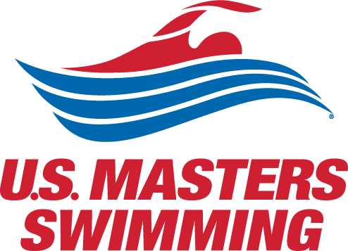
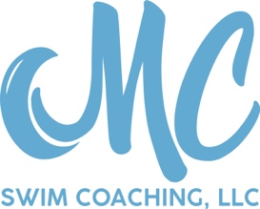
September Super Soaker 2019:
SCM Masters Swim Meet
Saturday, September 28, 2019 ---- Joplin, MO
Sanctioned by the Missouri Valley LMSC for USMS, Inc.

Administered by: MC Swim Coaching, LLC

Location: Missouri Southern State University Pool 3950 E. Newman Road Joplin, MO 64801

Facility: 6 lane, 25 meter indoor pool

Meet Conduct: Current USMS rules will govern the conduct of the meet.

Eligibility: The meet is open to anyone 18 and older. We want to support all of our swimmers who would like to try their hand at competition, so swimmers do not have to be a member of USMS. If you are not currently a USMS member, you will just need to fill out a one-event form. The USMS fee for one-event registration is $20. If you want to register for USMS, the annual fee is $55, and you can register online.

Entry Fee: $25 entry fee for all current USMS members
$45 entry fee for non-USMS members ($25 for meet, and $20 for one-event fee as described above)
Payment and entries will be processed through signupgenius.come.
Your credit card will be charged by signupgenius for this swim meet.

Deadline: Online entries are due no later than midnight Thursday, September 26, 2019 CST

Event Seeding: We will try to seed events according to pre-entered seed times for each swimmer, regardless of age or gender. In the event of multiple heats, the slower heats will be swim first. All no-time (NT) entries shall be placed in the slower heats.

Warm up starts at 7:00am, with a meet start time of 8:00am. Entry into the pool must be feet first in a cautious manner. Diving shall be permitted only in the designated sprint lanes during the meet warm-up.
The primary timing system will be a manual timing system with two watches.

This meet is sanctioned by Missouri Valley LMSC for USMS Inc. Sanction number is: ___ The length of the competition course without a bulkhead is in compliance and on file with USMS in accordance with articles 105.1.7 and 107.2.1.

There will be a social after the meet at a local restaurant. For more information or questions, contact Megan Cameron at megancameron91@gmail.com or 417-499-0504.

September Super Soaker 2019: SCM Masters Swim Meet
Saturday, September 28, 2019 --- Joplin, MO
Sanctioned by the Missouri Valley LMSC for USMS, Inc.

Name: ___________________________________ Gender: ___ Age: __ DOB:________

Address: _________________________________________________________________________

Phone: ____________________ Email: _______________________________________________

USMS #: (if applicable) _______________ USMS Club (if applicable): ______________

Circle the event # you wish to swim and enter seed time or “NT” for no time. Limit of 5 events.

Event # | Event (Short Course Yards- SCM) | Seed Time
Warm up 7:00-8:00am
1 | 100 M IM | ___:___.___
2 | 200 M Fly | ___:___.___
3 | 50 M Breaststroke | ___:___.___
4 | 400 M Freestyle | ___:___.___
5 | 50 M Back | ___:___.___
6 | 200 M Breaststroke | ___:___.___
7 | 100 M Butterfly | ___:___.___
8 | 1500 M Freestyle | ___:___.___
9 | 100 M Free | ___:___.___
10 | 50 M Butterfly | ___:___.___
11 | 200 M Backstroke | ___:___.___
12 | 400 M IM | ___:___.___
13 | 50 M Freestyle | ___:___.___
14 | 200 M IM | ___:___.___
15 | 100 M Back | ___:___.___
16 | 800 M Freestyle | ___:___.___
17 | 100 M Breast | ___:___.___
18 | 200 M Fresstyle | ___:___.___

Swimmers may enter up to 5 events. Depending on the number of swimmers entered, we might take additional rests between events.

