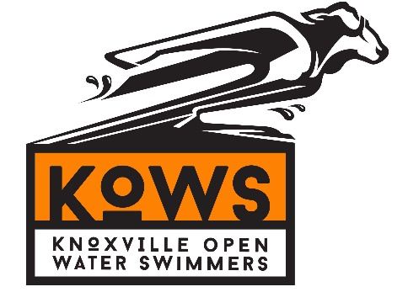
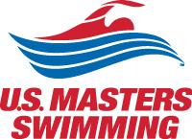
2019 Bridges to Bluffs
Saturday, September 22nd 2019
10k Open Water downstream swim

Registration Schedule
 | Open | Close
Swimmer Registration | Fri, March 1, 2019 12:00 PM EST | Sun, September 8, 2019 11:59 PM EST

Sanctioned by the Southeastern Masters Swimming for United States Masters Swimming, Inc.,

HOSTED BY: Knoxville Open Water Swimmers (KOWS).
Event Directors: Jack McAfee, Blaik Ogle. Email: knowx.ows@gmail.com.

COURSE: “Bridges to Bluffs” is the 2019 USMS Marathon Distance National Championship. It is a 10k down current swim in the Tennessee River. Swimmers will begin by jumping from the “Star of Knoxville” Riverboat at Suttree Park. Each swimmer is required to have a kayaker (pilot). The first 5k will take swimmers by the University of Tennessee Neyland Stadium, Thompson Boling Arena, a spectacular downtown skyscape, and below 5 historic bridges. The last 5k will see a transition from a downtown/urban environment to beautiful river bluffs, antebellum homes, and historic Sequoyah Hills Park. A relay option will be available (wetsuit legal). Relay teams will consist of a swimmer and kayaker, transitioning at the 5k mark. Our course is unique -- the exact 5k point is in a spectator friendly and easily accessible location, opposite the University of Tennessee Sorority Village, Armstrong Lockett Civil War Home, the Buck Karns Alcoa Highway Bridge (with pedestrian lane for spectator viewing) and the Cherokee Farms Greenway. The finish will be at the Sequoyah Hills Park, which consists of 87 acres of green space and 4 miles of trails.

REGISTRATION: Registration will open on March 1 via Club Assistant. Registration is capped at 115 (total swimmers). You will be able to submit your projected finish times, use a secure site for payment of fees, sign the standard USMS waiver electronically, and have your USMS membership verified through this system. Your credit card statement will show a charge from "ClubAssistant.com Events".

ENTRIES: There are 2 different swimming options for this event. The 10k individual open water swim, or the 10k relay open water swim. The relay is a 10k open water swim divided equally with a 5k midpoint for swimmers to swap. There is no 5k individual open water swim option! Relays are wetsuit legal. Swimmers participating in the 10k who choose to wear a wetsuit will start last and be ineligible for awards. All 10K swimmers are required to provide a pilot for this race. Stand Up Paddle Boards/kayaks can be rented from our sponsor, Billy Lush Boards and Brew. One pilot per swimmer, no exceptions.

RELAYS: Relays allow swimmers who are not ready for a full 10k to still participate in the event. Each relay will be made up of 2 swimmers, each of whom will swim a 5k. The first leg swimmer will jump off the riverboat, while the second swimmer assists the first swimmer via kayak support. At the 5k point, the swimmer and kayaker will switch positions; the second leg swimmer will finish the swim while the first leg swimmer assists the second leg swimmer via kayak support.

ENTRY FEES: $250 entry for all individual 10k open water swim entries, increasing every 2 months by $25. The 10k 2-person relay open water swim entry fee is a $175 per person, increasing $15 every 2 months. Both relay participants must register. Entry fee covers a pre and post-race meal along with a t-shirt for both the swimmer and pilot.

DEADLINE FOR ENTRIES: The online entry system will not allow late entries. Entry deadline for entries is 11:59 p.m. Eastern Standard Time on Sunday, September 8, 2019.

ELIGIBILITY: All swimmers must be registered for 2019 with United States Masters Swimming, Inc. If you are not already registered with USMS, online registration will allow you to register with USMS when you register for the race. You will not be able to register online without being a USMS member. One-Event registration is available. Per USMS guidelines, all swimmers must be 18 years of age or older.

SEEDING: Each swimmer must submit an estimated finish time for their 10k open water swim. There is a 4 hour cutoff for this event! Swimmers will be assigned a number based on their seeded time and swimmers will start in a time trial fashion with the lowest numbers starting first. Results will be tabulated by gender age groups.

SCHEDULE: Check-in will begin at 5:00pm on Saturday, September 21st, 2019 for the mandatory pre-race briefing. If you cannot attend this briefing, do not sign up for the race. It is required per USMS rules. The race will begin at 9:00am on Sunday, September 22nd, 2019 at the Star of Knoxville. Swimmers will begin boarding the riverboat at 8:00am for an 8:45am departure. At 9:00am, swimmers will begin the 10k open water swim by jumping off the riverboat! Following the race, all swimmers, kayakers, and families will be invited to Sequoyah Hills Park for a post-race meal.

INDIVIDUAL AWARDS: The top 3 overall males and females will receive an award. 1st-6th overall males and females in each age group will receive a championship medal. Each age group winner will receive a champion patch. Every swimmer, regardless of place will receive a finisher award. Awards will be locally crafted with a taste of Eastern Tennessee. Shirts and swim caps will be given to each competitor.

DIRECTIONS TO STAR OF KNOXVILLE: Approaching Knoxville via I-75/I-40 N from the South, take the TN-158 W Exit 388A. Continue of 158 W for approximately 0.8 miles. Take a left at the stoplight on Walnut Street. Take another left towards Calhoun’s on the River, continue to the end of the parking lot where you will see the Star of Knoxville riverboat.

