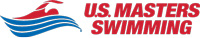
Willoughby Swim 2019
USMS Sprint and Long Distance National Championships

Hosted by Kingdom Games, Inc. and Northeast Kingdom Open Water Association
Sanctioned by NE-LMSC for USMS, Inc., Sanction # sanction pending
August 16 and 17, 2019
Lake Willoughby
Westmore. Vermont

www.kingdomgames.co

Name _______________________________ Age ______ DOB__________

M/F __ USMS Member # ______________ 5 mile ___ 1 mile swim ___

Fee: Long Distance (5 Mile) $200 Fee: Sprint (1 Mile) $75
Address _________________________________________________________
Street/PO Box City/Town State Zip Code
Phone: _____________________ Email __++________________________

Kayaker _______________ Email _______________ Phone ____________

Emergency Contact: _____________________ Phone ________________

Team or Club Name:___________________ T Shirt Sizes ____ Yacker ___

PARTICIPANT WAIVER AND RELEASE OF LIABILITY, 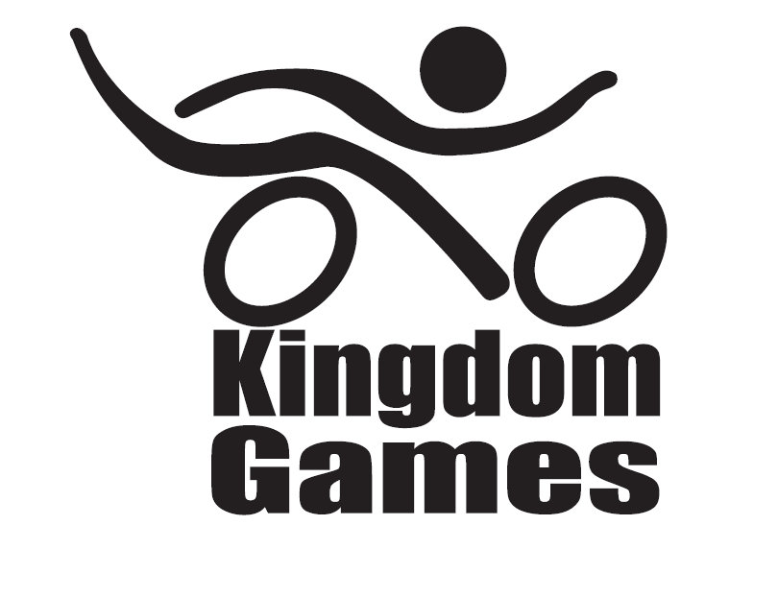
ASSUMPTION OF RISK AND INDEMNITY AGREEMENT

For and in consideration of United States Masters Swimming, Inc. (“USMS”), NE-LMSC, and Kingdom Games, Inc. d/b/a Kingdom Swim, allowing me, the undersigned, to participate in any USMS sanctioned or approved activity, including swimming camps, clinics, and exhibitions; learn-to-swim programs; swimming tryouts; fitness and training programs (including dryland training); swim practices and workouts (for both pool and open water); pool meets; open water competitions; local, regional, and national competitions and championships (both pool and open water); and related activities (“Event” or “Events”); I, for myself, and on behalf of my spouse, children, heirs and next of kin, and any legal and personal representatives, executors, administrators, successors, and assigns, hereby agree to and make the following contractual representations pursuant to this Waiver and Release of Liability, Assumption of Risk and Indemnity Agreement (the “Agreement”);

- I hereby certify and represent that (i) I am in good health and in proper physical condition to participate in the Events; and (ii) I have not been advised of any medical conditions that would impair my ability to safely participate in the Events. I agree that it is my sole responsibility to determine whether I am sufficiently fit and healthy enough to participate in the Events.

- I acknowledge the inherent risks associated with the sport of swimming. I understand that my participation involves risks and dangers, which include, without limitation, the potential for serious bodily injury, sickness and disease, permanent disability, paralysis and death (from drowning or other causes); loss of or damage to personal property and equipment; exposure to extreme conditions and circumstances; accidents involving other participants, event staff, volunteers or spectators; contact or collision with natural or manmade objects; dangers arising from adverse weather conditions; imperfect water conditions; water and surface hazards; facility issues; equipment failure; inadequate safety measures; participants of varying skill levels; situations beyond the immediate control of the Event organizers; and other undefined, not readily foreseeable and presently unknown risks and dangers (“Risks”). I understand that these Risks may be caused in whole or in part by my own actions or inactions, the actions or inactions of others participating in the Events, or the negligent acts or omissions of the Released Parties defined below, and I hereby expressly assume all such Risks and responsibility for any damages, liabilities, losses or expenses that I incur as a result of my participation in any Events.

- I agree to be familiar with and to abide by the Rules and Regulations established by USMS, including any safety regulations. I accept sole responsibility for my own conduct and actions while participating in the Events.

- I hereby Release, Waive and Covenant Not to Sue, and further agree to Indemnify, Defend and Hold Harmless the following parties: USMS, NE-LMSC, and Kingdom Games, Inc. d/b/a Kingdom Swim, their members, clubs, workout groups, event hosts, employees, and volunteers (including, but not limited to, event directors, coaches, officials, judges, timers, safety marshals, lifeguards, and support boat owners and operators); the USMS Swimming Saves Lives Foundation; USMS Local Masters Swimming Committees (LMSCs); the Event organizers and promoters, sponsors and advertisers; pool facility, lake and property owners or operators hosting the Events; law enforcement agencies and other public entities providing support for the Events; and each of their respective parent, subsidiary and affiliated companies, officers, directors, partners, shareholders, members, agents, employees, and volunteers (individually and collectively, the “Released Parties”), with respect to any liability, claim(s), demand(s), cause(s) of action, damage(s), loss or expense (including court costs and reasonable attorneys’ fees) of any kind or nature (“Liability”) which may arise out of, result from, or relate in any way to my participation in the Events, including claims for Liability caused in whole or in part by the negligent acts or omissions of the Released Parties.

- I further agree that if, despite this Agreement, I, or anyone on my behalf, makes a claim for Liability against any of the Released Parties, I will indemnify, defend and hold harmless each of the Released Parties from any such Liabilities which any may be incurred as the result of such claim.

I hereby warrant that I am of legal age and competent to enter into this Agreement, that I have read this Agreement carefully, understand its terms and conditions, acknowledge that I will be giving up substantial legal rights by signing it (including the rights of my spouse, children, heirs and next of kin, and any legal and personal representatives, executors, administrators, successors, and assigns), acknowledge that I have signed this Agreement without any inducement, assurance, or guarantee, and intend for my signature to serve as confirmation of my complete and unconditional acceptance of the terms, conditions and provisions of this Agreement. This Agreement represents the complete understanding between the parties regarding these issues and no oral representations, statements, or inducements have been made apart from this Agreement. If any provision of this Agreement is held to be unlawful, void, or for any reason unenforceable, then that provision shall be deemed severable from this Agreement and shall not affect the validity and enforceability of any remaining provisions. Finally I specifically acknowledge that I am aware of all the risks inherent in open water swimming and agree to assume those risk”

I acknowledge that United States Masters Swimming (“USMS”), NE-LMSC, and Kingdom Games, Inc. may compile and use mailing and e-mail addresses and may take, use, and disseminate photographs and videos of me and other participants and consent to such uses; I hereby waive all rights to compensation.

Participants Signature _____________________Date ____________

The mission of Kingdom Games, Inc. is to organize, promote, and host running, biking, swimming, triathlon, kayaking, and ice skating events in the Northeast Kingdom of Vermont. Contact: Phil White, Director, Kingdom Games, Inc. PO Box 310, Newport, VT 05855 – Tel: 802-249-9100; phw1948@gmail.com

