Thermal Plan for Cold Water Swims
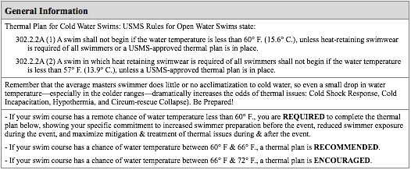

The following methods are among the ways you can do this:
1. Emphasize & stress on entry information of possible cold water swim conditions.
2. Require prior cold water swim experience.
3. Require swimmer cold water preparation plan.
4. Refuse entry if swimmer is not acclimated to cold water swimming.
What method(s) of swimmer preparation will you take:
The water temperature at Coney Island on June 29, 2019 is estimated to be within the broad range of 69º–80ºF (though, based on the past five years’ data, the low 70s are most likely). Based on this target, we will implement Method 1 from the above list: “Emphasize & stress on entry information of possible cold water swim conditions.”
We will communicate with all swimmers the week of the event (definitely by email, possibly by live conference call) informing them of the current and projected water temperatures. We will ask swimmers to consider their personal tolerance for cold water and provide them with local retailers who rent wetsuits and should they think they may need one.
The following methods are among the ways you can do this:
1. Cancel the swim(s).
2. Shorten swim(s) or institute/shorten time limits.
3. Encourage wetsuits for all swimmers.
4. Require wetsuits for all swimmers.
Explain your plan of action:
There is very little chance the water will be below 60ºF, and will likely be at or above 66ºF on race day. Therefore, I do not anticipate canceling or shortening the swim or requiring wetsuits due to water temperature. We will, of course, be monitoring the temperature in the week preceding the race and will adjust for any seasonal anomalies.
The following methods are among the ways you can do this:
1. Bring in more emergency trained medical personnel and/or ambulances.
2. Bring in more volunteers to assist medical personnel.
3. Bring in more emergency craft and first responders on the course.
4. Increase warm beverages before the swim and at feeding stations.
5. Have special procedures (different than normal) for removing swimmers from the water & venue. 6. Increase warm beverages after the swim.
7. Increase thermal treatment gear (blankets, hot water bottles, etc.)
8. Make warm showers available on-site.
9. Make warming facilities (buildings, tents, vehicles, etc.) available on-site.
10. Other: Specify
Specify what extra listed items you will provide:
We will be appropriately staffed with medical personnel for all likely race-day conditions given our race field (approx. 130 swimmers) and race course (1/2 mile). We will take the additional precautions if the water has been 66ºF or less for multiple days the week of the race:
4. Warm beverages (coffee and tea will be available at check-in regardless of water temperature; will stock 2 safety vessels with warm beverages if cold water necessitates it)
7. Safety vessels and Start/Finish line will be stocked with thermal blankets regardless of water temperature. We will stock extra if the temperature is trending cold leading up to race day.
Comment on how you will be prepared to care for multiple medical issues:
Between our Event Safety Director, EMT (2 staff with an ambulance), and 4 lifeguards, we will be well equipped for all concurrent medical issues. As backup, we will have Red Cross–certified Swim Angels (a nonprofit group who supports open water swims) in the water and NYPD Harbor on patrol who can quickly facilitate extra backup if needed.
All emergency efforts will be coordinated by Edwin Roberts, Event Safety Director, by way of marine radio.
If the water temperature is below 72° F, will you be prepared to deal with cold water medical issues:
Yes. In our mandatory conference call for all safety personnel I will advise Event Safety Director and EMT to be prepared for cold water medical issues. All lifeguards will be prepared—as required by their hiring to NYC Parks—to be trained as first responders to hypothermia and other cold water issues. Swim Angels are all trained as first responders as well, and they, too, will be part of our support team.
Thermal Plan for Warm Water Swims
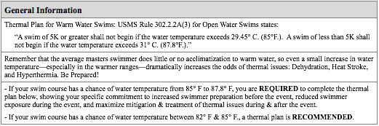
There is functionally 0 chance of the water at Coney Island being above 82ºF on June 29, 2019.
The following methods are among the ways you can do this:
1. Emphasize & stress on entry information of possible warm water swim conditions.
2. Require prior warm water swim experience.
3. Require swimmer warm water preparation plan.
What method(s) of swimmer preparation will you take: Click here to enter text.
The following methods are among the ways you can do this:
1. Cancel the swim(s).
2. Shorten swim(s) or institute/shorten time limits.
3. Remind all participants to stay well hydrated.
4. Remind swimmers to select appropriate pace.
5. Make swim caps optional or use Lycra swim caps.
Explain your plan of action: Click here to enter text.
The following methods are among the ways you can do this:
1. Bring in more emergency trained medical personnel and/or ambulances.
2. Bring in more volunteers to assist medical personnel.
3. Bring in more emergency craft and first responders on the course.
4. Increase cool beverages before, during and after the swim (for swimmers and staff, including extra cool beverages on watercraft and feeding stations)
5. Increase heat exhaustion and heat stroke treatment gear (iced water, ice chips, cold water bottles, misting tents/fans, etc.)
6. Make cool showers available on-site.
7. Make shade and cooling facilities (buildings, tents, etc.) available on-site.
8. Other: Specify
Specify what extra listed items you will need to provide: Click here to enter text.
Comment on how you will be prepared to care for multiple medical issues: Click here to enter text.
If the water temperature is above 82° F, will you be prepared to deal with heat-related medical issues: Click here to enter text.

