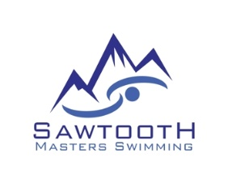
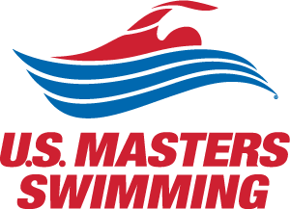

Broadside Harbor Open Water Swims
1 mile and 2 mile
June 1, 2019
Caldwell, Idaho
Sanctioned by Snake River Masters for USMS: #______________

Meet Information

Location: Broadside Harbor Ski Lakes, 21600 Look Ln, Caldwell ID 83607

Directions: From Boise, travel west on l-84. Take exit 26. Turn left (towards Notus/Parma) on Hwy 20/26 and follow for approximately 0.5 mile. Turn left on Look Lane. Follow Look Lane over the railroad tracks and turn left on Broadside Harbor Lane (dirt road – about ¼ mile). Follow to the lakes. Please park in the dirt lot to the west of the house. The owner of the lake is the owner of the house.

Races:
•One-mile swim
•Two-mile swim - 2018 NW Zone OW Championship

Eligibility: This event is open ONLY to US Master Swimming members or foreign equivalents. Registrants will be required to accept the US Masters PARTICIPANT WAIVER AND RELEASE OF LIABILITY, ASSUMPTION OF RISK AND INDEMNITY AGREEMENT as part of the online registration process. USMS Rule 301.4 - Age is determined as of Dec 31, with exception of 18 year olds, who must be at least 18 on day of swim. One day USMS eligibility is available for purchase and part of the online registration process.
Registration: Online registration only at sawtoothmaster.org.

Rules: Current USMS rules will govern this event.
Two divisions - Non-wetsuit and Wetsuit

Start/finish: Swimmers will start in the water and will finish by going through a chute from the water to land.

Water Temperature: Approximately 70⁰F.

Course: The 1-mile race will be around the perimeter of the lake. The 2-mile race will be two times around the perimeter of the lake. The lake is ½ mile long.

Age Groups: 18-24, 25-29, 30-34, and so on in 5-year increments.

Awards: It’s a Surprise!!
Results: Will be posted at the lake at the completion of each race and online at Sawtoothmasters.org.
Schedule:
10:30 a.m. Check-in opens
10:45 a.m. Mandatory pre-race meeting
11:00 p.m. Start of 1-mile swim
1:15 p.m. Start of 2-mile swim

Entry Fees (includes all races) and Deadlines:
Entries received on or before May 26, 2019: $35
Entries received on or after May 27, 2019: $45

Lodging: Hotels on I-84 at Exit 29:
La Quinta, 901 Specht Ave., Caldwell, ID 83605, (208) 454-2222.
Best Western Hotel & Resort, 908 Specht Avenue, Caldwell, ID 83605, (800) 780-7234

Camping: There will be primitive camping on-site. Some electrical hookups will be available ($10/day). Call Kristi Lee to arrange camping: 208-761-0006. Note: camping is within hearing range of train tracks.

Parking: Handicap parking available on the east side of the house.

Showers: There is a fresh water shower on the dock.

Dogs: No dogs are allowed on the dock. Dogs must be leashed and owners must clean up after their animals.

Post-race Potluck Picnic: Main dish, paper ware and non-alcoholic beverages will be provided. Please bring a side dish to share. Guests: Adults $5.00; Children free.

Questions: Event Director Jill Wright: 208-571-4254 swimjmw@msn.com

