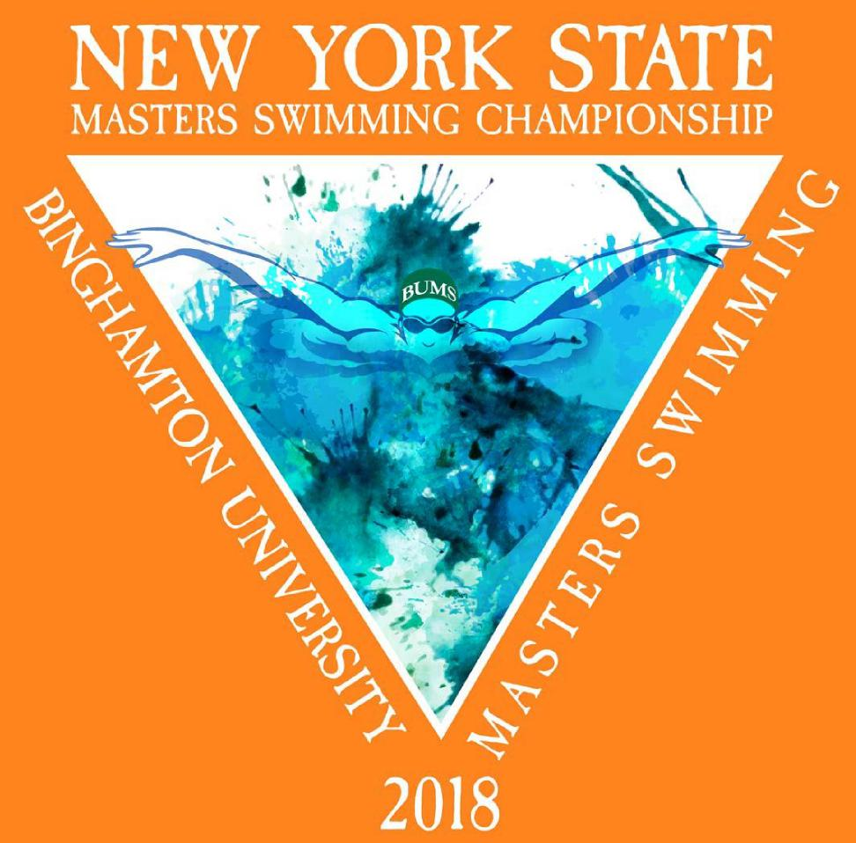
HOSTED BY: Binghamton University Masters Swim Club
Meet Directors: Steven Kristek, Dave Werner, and Matt Losinger Volunteers: The Binghamton University Varsity Swimming and Diving Team BU Head Coach: Brad Smith

Session 1 (4/13) Schedule: Warm up is from 4:00 pm to 4:50 pm, meet starts promptly at 5:00 pm.
Event # |  | Event Name
1 |  | Mixed 1650 Free
 | 15 Minute Break
2 |  | Mixed 400 IM

Session 2 (4/14) and Session 3 (4/15): Warm up is from 8:00 am to 8:50 am, meet starts promptly at 9:00 am
Session 2 (April 14th) |  |  | Session 3 (April 15th)
Event # | Event Name |  | Event # | Event Name
3 | Women’s 100 Fr |  | 23 | Women’s 400 Medley Relay
4 | Men’s 100 Fr |  | 24 | Men’s 400 Medley Relay
5 | Women’s 200 Fly |  | 25 | Women’s 200 Fr
6 | Men’s 200 Fly |  | 26 | Men’s 200 Fr
7 | Mixed 400 Fr Relay |  | 27 | Women’s 100 IM
8 | Mixed 200 Medley Relay |  | 28 | Men’s 100 IM
15 Minute Break |  |  | 29 | Mixed 400 Medley Relay
9 | Women’s 50 Br |  | 15 Minute Break
10 | Men’s 50 Br |  | 30 | Mixed 200 Fr Relay
11 | Women’s 200 IM |  | 31 | Women’s 50 Ba
12 | Men’s 200 IM |  | 32 | Men’s 50 Ba
13 | Women’s 500 Fr |  | 33 | Women’s 100 Br
14 | Men’s 500 Fr |  | 34 | Men’s 100 Br
15 Minute Break |  |  | 35 | Women’s 50 Fr
15 | Women’s 100 Ba |  | 36 | Men’s 50 Fr
16 | Men’s 100 Ba |  | 15 Minute Break
17 | Women’s 200 Br |  | 37 | Women’s 200 Ba
18 | Men’s 200 Br |  | 38 | Men’s 200 Ba
19 | Women’s 50 Fly |  | 39 | Women’s 100 Fly
20 | Men’s 50 Fly |  | 40 | Men’s 100 Fly
21 | Women’s 200 Fr Relay |  | 41 | Women’s 400 Fr Relay
22 | Men’s 200 Fr Relay |  | 42 | Men’s 400 Fr Relay
 |  |  | 43 | Women’s 200 Medley Relay
 |  |  | 44 | Men’s 200 Medley Relay

A Note on the 1650 Free:
Positive check in for the 1650 Fr before 4:30 pm is required. If there are a significant number of scratches in this event then we will re-seed the heats prior to the start of the meet. Please pay attention for this announcement.
Relay Entries:
- Entries for events 7 & 8 are due by 9 am
- Entries for events 21 and 22 are due by 12:00
- Entries for ALL Sunday relays are due by END OF DAY Saturday

