Winter Distance Meet
March 3, 2019 8am
UMBC Catonsville, MD

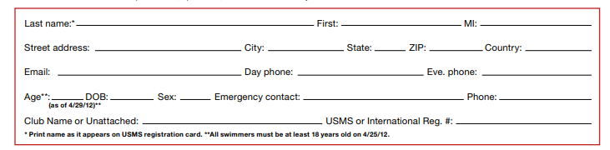

Warm ups 7:30am

Meet starts at 8am

Location: The University of Maryland, Baltimore County (UMBC) is located off Rt. 95 in Catonsville, MD. It has an 8-lane 25 yard pool with a 13x13 diving well. A fully electronic timing system will be used. The length of the competition course without a bulkhead is in compliance and on file with USMS in accordance with articles 105.1.7 and 107.2.1
Warm-up Times: The pool will be open for warm-ups on Sunday 7:30am to 8:00am. The meet will start promptly after warm-ups. Rules USMS rules will apply. The meet is open to any swimmer at least 18 years of age. Age groups are: 18-24, 25-29, 30-34, 35-39, …100-104. Age for the meet is determined as of 3/3/2019.
Seeding Ages and sexes will be combined. Faster heats will be swum first.
Final Results: Results will be posted on the Maryland LMSC website
Warm-up Procedures Swimmers must enter the pool feet first in a cautious manner. No diving is allowed at any time in either pool. Racing dives, including backstroke starts, are allowed only in the designated sprint lanes during the pre-meet warm-up sessions.
Entry Procedures Online Registration *Remember to update USMS registration for 2019 before the meet. Please register online Entry Fees = $15
Entry Deadline All entries must be received by Feb 28, 2019. Early deadline necessary for program compilation.
Please send registration to Erin Mathews 747 W Cross St Baltimore, MD 21230, checks payable to Maryland Masters Swim Club

LIABILITY RELEASE:I, the undersigned participant, intending to be legally bound, hereby certify that I am physically fit and have not been otherwise informed by a physician. I acknowledge that I am aware of all the risks inherent in Masters Swimming (training and competition) including possible permanent disability or death, and agree to assume all of those risks. AS A CONDITION OF MY PARTICIPATION IN THE MASTERS SWIMMING PROGRAM OR ANY ACTIVITIES INCIDENT THERETO, I HEREBY WAIVE ANY AND ALL RIGHTS TO CLAIMS FOR LOSS OR DAMAGES, INCLUDING ALL CLAIMS FOR LOSS OR DAMAGES CAUSED BY THE NEGLIGENCE, ACTIVE OR PASSIVE, OF THE FOLLOWING: UNITED STATES MASTERS SWIMMING, INC., THE LOCAL MASTERS SWIMMING COMMITTEES, THE CLUBS, HOST FACILITIES, MEET SPONSORS, MEET COMMITTEES, OR ANY INDIVIDUALS OFFICIATING AT THE MEETS OR SUPERVISING SUCH ACTIVITIES. In addition, I agree to abide by and be governed by the rules of USMS. Signature:____________________________________________________ Date: ________

To Enter enter you times for the 4 events (max)
EVENT | TIME
1650 FR
500 FR
400 Medley Relay
100 FR
200 BR
100 FLY
200 BK
800 FR RELAY
100 BR
200 FLY
100 BK
200 FR
200 IM
400 FR Relay
400 IM

