ALEXANDRIA MASTERS SWIMMING

Tropical Splash

SHORT COURSE YARDS SWIM MEET
Sunday, January 27, 2019

Sanctioned by Potomac Valley LMSC for US Masters Swimming, Inc. Sanction # pending
Welcome to the 15th annual Tropical Splash!
Enjoy our Tropics in the winter!

date & location

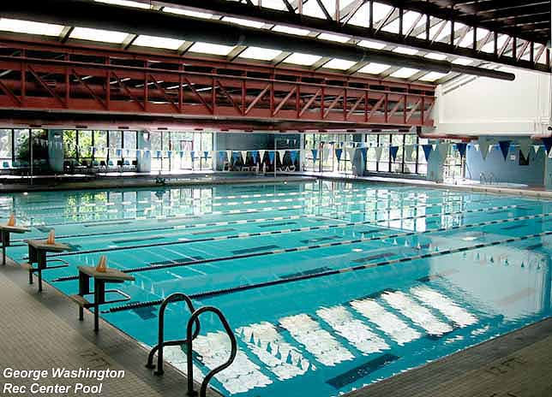 Sunday, January 27, 2019
George Washington Rec Center Pool
8426 Old Mt. Vernon Road
Alexandria, Virginia

Warm-ups start: 7:45 am
Warm-ups end: 8:35 am
Meet start: 8:45 am (estimated finish: 1:45 pm)
Weather updates will be posted on the meet web page.
facilities
9 lane x 25-yard pool. 7 lanes used for competition.
Automatic timing will be used.
A continuous 25-yard warm-up area will be available
Lap counter cards will be available for the 500-yd swim but you must provide your own counter.
Coin-operated lockers require a quarter.
The length of the competition course without a bulkhead is in compliance and on file with USMS in accordance with articles 105.1.7 and 107.2.1.

Meet is open to all US Masters Swimmers with valid 2019 registration.
rules
Swimmers may enter up to 4 individual events.
2019 United States Masters Swimming rules will apply.
Event 19 will be an unofficial, 3-person 150-yard Coconut Relay consisting of anyone entered in the meet.
Swimmers may swim only once in each relay event
Events will be combined men and women. Heats will be seeded slowest to fastest. Relays will be deck seeded.
entries
Online registrations will be available at www.ClubAssistant.com
Meet will be limited to the first 185 entries received.
No deck entries for individual events will be accepted.
Due to time constraints, the 500-yd freestyle will be limited to the first 28 entries received. If it is full when you register, you may contact the meet director to be placed on a wait list.
Relays will be deck entered. Only swimmers entered in the individual meet events are eligible for relays.
fees
Competitors may enter up to 4 individual events for a $30 fee, with no charge for relays.
$15 long sleeve meet tee shirts when pre-ordered BEFORE 1/15/2018. A small amount of tee shirts will be available at the door for $20. Preview the design at www.AlexandriaMasters.com.

Custom ribbon awards will be presented to first, second, and third places in individual events
awards
Results will be posted online at www.AlexandriaMasters.com
Printed results will be available by mail for $2 if requested

From Interstate 95/495 Capital Beltway: (additional directions & map are at www.AlexandriaMasters.com)
directions
Take “Route 1 South Ft. Belvoir” exit in Alexandria
Go 4.5 miles, turn left onto Route 235 Mt. Vernon Highway
Go 0.5 mile, bear right at the fork in the road onto Route 623 Old Mt. Vernon Road
After 0.3 mile, turn right into the entrance drive across from the high school stadium

Red Roof Inn, 5975 Richmond Highway (Route 1), Alexandria, 703-960-5200
overnight
Hampton Inn, 5821 Richmond Highway (Route 1), Alexandria, 703-329-1400
Holiday Inn Express, 6055 Richmond Highway, Alexandria, 571-257-9555
director
Stephanie Gauzens, stephanie.gauzens@gmail.com, (202) 540-8064
ALEXANDRIA MASTERS SWIMMING
Tropical Splash

SHORT COURSE YARDS SWIM MEET

George Washington Rec Center, Alexandria, VA

Sunday January 27, 2019 • 7:45 am warm-ups • 8:45 am meet start
Potomac Valley LMSC sanction for US Masters Swimming, Inc. Sanction Number # pending

order of events
500-yd Freestyle*
200-yd Breaststroke
100-yd Backstroke
50-yd Butterfly
200-yd Individual medley
50-yd Breaststroke
100-yd Freestyle
200-yd Butterfly
200-yd Medley Relay (deck entered)
----------break between events 9 & 10----------
200-yd Freestyle Relay (deck entered)
400-yd Individual Medley
200-yd Freestyle
100-yd Breaststroke
50-yd Backstroke
50-yd Freestyle
100-yd Butterfly
200-yd Backstroke
100-yd Individual Medley
150-yd Coconut Relay (deck entered)

*500 freestyle is limited to the first 28 entries received
PARTICIPANT WAIVER AND RELEASE OF LIABILITY,
ASSUMPTION OF RISK AND INDEMNITY AGREEMENT

For and in consideration of United States Masters Swimming, Inc. (“USMS”) allowing me, the undersigned, to participate in any USMS sanctioned or approved activity, including swimming camps, clinics, and exhibitions; learn-to-swim programs; swimming tryouts; fitness and training programs (including dryland training); swim practices and workouts (for both pool and open water); pool meets; open water competitions; local, regional, and national competitions and championships (both pool and open water); and related activities (“Event” or “Events”); I, for myself, and on behalf of my spouse, children, heirs and next of kin, and any legal and personal representatives, executors, administrators, successors, and assigns, hereby agree to and make the following contractual representations pursuant to this Waiver and Release of Liability, Assumption of Risk and Indemnity Agreement (the “Agreement”);

- I hereby certify and represent that (i) I am in good health and in proper physical condition to participate in the Events; and (ii) I have not been advised of any medical conditions that would impair my ability to safely participate in the Events. I agree that it is my sole responsibility to determine whether I am sufficiently fit and healthy enough to participate in the Events.

- I acknowledge the inherent risks associated with the sport of swimming. I understand that my participation involves risks and dangers, which include, without limitation, the potential for serious bodily injury, sickness and disease, permanent disability, paralysis and death (from drowning or other causes); loss of or damage to personal property and equipment; exposure to extreme conditions and circumstances; accidents involving other participants, event staff, volunteers or spectators; contact or collision with natural or manmade objects; dangers arising from adverse weather conditions; imperfect water conditions; water and surface hazards; facility issues; equipment failure; inadequate safety measures; participants of varying skill levels; situations beyond the immediate control of the Event organizers; and other undefined, not readily foreseeable and presently unknown risks and dangers (“Risks”). I understand that these Risks may be caused in whole or in part by my own actions or inactions, the actions or inactions of others participating in the Events, or the negligent acts or omissions of the Released Parties defined below, and I hereby expressly assume all such Risks and responsibility for any damages, liabilities, losses or expenses that I incur as a result of my participation in any Events.

- I agree to be familiar with and to abide by the Rules and Regulations established by USMS, including any safety regulations. I accept sole responsibility for my own conduct and actions while participating in the Events.

- I hereby Release, Waive and Covenant Not to Sue, and further agree to Indemnify, Defend and Hold Harmless the following parties: USMS, its members, clubs, workout groups, event hosts, employees, and volunteers (including, but not limited to, event directors, coaches, officials, judges, timers, safety marshals, lifeguards, and support boat owners and operators); the USMS Swimming Saves Lives Foundation; USMS Local Masters Swimming Committees (LMSCs); the Event organizers and promoters, sponsors and advertisers; pool facility, lake and property owners or operators hosting the Events; law enforcement agencies and other public entities providing support for the Events; and each of their respective parent, subsidiary and affiliated companies, officers, directors, partners, shareholders, members, agents, employees, and volunteers (individually and collectively, the “Released Parties”), with respect to any liability, claim(s), demand(s), cause(s) of action, damage(s), loss or expense (including court costs and reasonable attorneys’ fees) of any kind or nature (“Liability”) which may arise out of, result from, or relate in any way to my participation in the Events, including claims for Liability caused in whole or in part by the negligent acts or omissions of the Released Parties.

- I further agree that if, despite this Agreement, I, or anyone on my behalf, makes a claim for Liability against any of the Released Parties, I will indemnify, defend and hold harmless each of the Released Parties from any such Liabilities which any may be incurred as the result of such claim.

I hereby warrant that I am of legal age and competent to enter into this Agreement, that I have read this Agreement carefully, understand its terms and conditions, acknowledge that I will be giving up substantial legal rights by signing it (including the rights of my spouse, children, heirs and next of kin, and any legal and personal representatives, executors, administrators, successors, and assigns), acknowledge that I have signed this Agreement without any inducement, assurance, or guarantee, and intend for my signature to serve as confirmation of my complete and unconditional acceptance of the terms, conditions and provisions of this Agreement. This Agreement represents the complete understanding between the parties regarding these issues and no oral representations, statements, or inducements have been made apart from this Agreement. If any provision of this Agreement is held to be unlawful, void, or for any reason unenforceable, then that provision shall be deemed severable from this Agreement and shall not affect the validity and enforceability of any remaining provisions.

Last Name | First Name | MI | Sex (circle)  M F |  | Date of Birth (mm/dd/yy)
Street Address, City, State, Zip
Signature of Participant |  |  |  | Date Signed
Revised 07/01/2014

