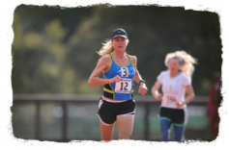
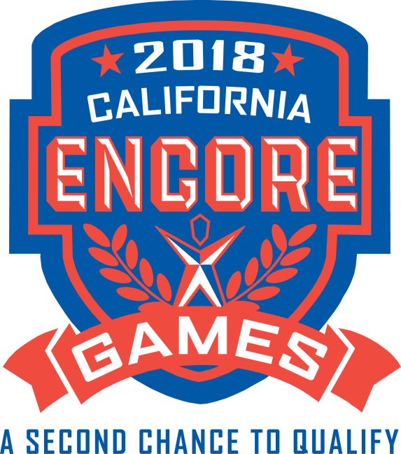
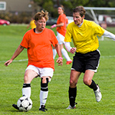
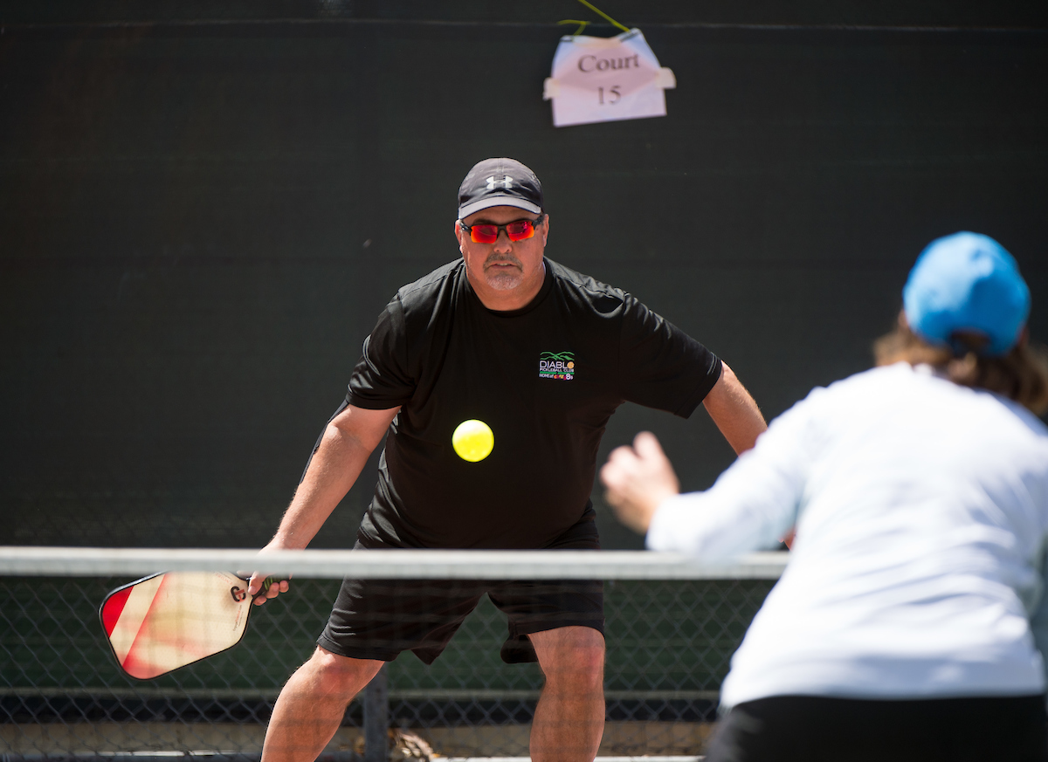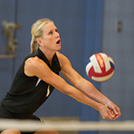
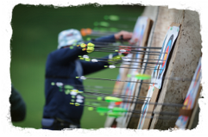
2018 Encore Games Registration
September 23- December 2, 2018
Palo Alto, San Mateo, San Francisco & other Bay Area Venues
General Information - Welcome to the registration package for the Encore Games ( A second chance to qualify for the 2019 Summer National Senior Games) presented by the Bay Area Sports Organizing Committee (BASOC) and the Bay Area Senior Games.

Eligibility - All participants must be at least 50 years of age on or before December 31, 2018. There is no upper age limit. Proof of age will be required at event check-in.
Age Divisions - Age divisions are in five-year age groups: 50-54, 55-59, 60-64, 65-69, 70-74, 75-79, 80-84 and up. A participant’s competition age will be based on his/her age as of Dec. 31, 2018. Age division for doubles and team competitions will be determined by age of the youngest player as of
Dec. 31, 2018. We reserve the right to combine age groups in any event due to insufficient entries or other conditions. Some sports may be conducted in ten-year increments. This is a qualifier for the 2019 Summer National Senior Games in Albuquerque, New Mexico.

How to Enter - Registration is available online at www.encoregames.org. Athletes may enter any sport or event subject to the entry limitations of that sport. All Athletes pay a $60 registration fee ( except soccer, pickleball, volleyball) plus an event fee for each individual event in which they compete. Fees are based on facility rental, officials, athlete awards, insurance and other expenses. Please see payment summary page for more details.

If you do not have a computer, please fill out this Entry Form, sign the Liability Release and mail it to: Bay Area Senior Games/ Encore Games • 2275 East Bayshore Road # 115 Palo Alto, CA 94303

Note: Please add an additional processing fee of $15 for paper registration. We are unable to process your registration without the $15 paper registration fee.
Please make sure not to register for overlapping events. No schedule changes will be made to accommodate multi-sport or multi-event entrants. Refunds will not be given.
Each partner in a doubles competition must submit an Individual Entry Form and enter the full name of his/her partner.
Team captains are required to review and approve their team roster before the final registration deadline. In order to complete registration, all athletes must sign the Waiver Form presented online or they will not be eligible to participate.
Medals
Gold, Silver and Bronze medals will be awarded after the expiration of a 30-minute protest period. Medals will not be mailed unless award winner pays postage and handling fee in advance ($5).
Benefits
Registration and event fees include: Event administration and organization, venue rental, officials and scorekeepers, permits and sanctions, emergency medical personnel, medals, security, liability insurance, entry confirmation, event T-shirt, and results administration.
Equipment and Uniforms
Participants are required to provide their own equipment, except as specified under the sport description. All athletes must wear the athletic apparel and shoes usual and customary for the sport in which they are competing. Team sports require like color and style and numbered uniforms. Inappropriate clothing, shoes or equipment may be cause for disqualification. Please mark your personal items and do not leave them unattended. The Encore Games is not responsible for the loss or damage of any athlete’s personal belongings.
Food and Transportation
Athletes are responsible for their own food and transportation. For venue information, see each sport landing page. www.encoregames.org/sports
Sportsmanship
Unsportsmanlike or disorderly conduct on the part of competitors or coaches will be grounds for immediate removal and disqualification without any refund of fees paid. Sports Commissioners and event staff reserve the right to disqualify any competitor.
Insurance
The Bay Area Senior Games/Encore Games has a General Liability Policy for the event. This insurance covers medical costs only when an accident or injury is caused by our negligence. It is expressly understood that this insurance does not cover: property loss, damage to the participant, or medical costs if an accident or injury occurs during the normal routine of competition or during travel to and from competition. Each participant is responsible for his or her own medical insurance.
Medical Assistance
Emergency medical assistance will be in place. If you must be transported by ambulance, it will be at your expense.

Volunteering
Athletes, friends and families are invited to volunteer at the event. For details, including job description and benefits, please www.encoregames.org . Please register on line after August 15th. Volunteers will receive the official Volunteer Tee-shirt.

Refund Policy - NO refunds will be made if an entrant fails to compete for whatever reason including: event rescheduling, or event cancellation due to inclement weather, war, terrorism, or an act of God. Games officials or the Encore Games/Bay Area Senior Games/BASOC Board of Directors reserve the right to cancel or postpone events to a later time. All times and venues are subject to change. Refunds of entry fees may occur only for:
1) Entries received over event capacity 2) Insufficient entries in event
3) Entries of non-qualified participants 4) Injury, if occurs prior to event
Refunds, if given, are subject to a processing fee.
Sports Rules
Competition format and rules for each sport are posted online at www.encoregames.org.
Confirmation
Athlete confirmations will be e-mailed when online registration is complete. Athletes will also receive a final event information mailing just prior to the event. (Please check your email inbox)
Check-In
All athletes must report to the check-in table/tent at their competition venue. The exact location, address and start times will be included in the final confirmation mailing.
Athlete Registration
Please complete all information and sign the Liability Release. NOTE: athletes will not be able to complete online registration until liability release is accepted and the box checked.

Last Name: ____________________________________
First Name: ____________________________________
Street Address: __________________________________
City: ______________________ State: ___ Zip: ________
Home Phone: ____________________ Cell:_________________
Email: ___________________________
Birth Date: _______________ Age on Dec. 31, 2018:_____
Employer/Company Name__________________________________
Self-Employed ___Yes ____No Retired ___Yes ____No
Shirt Size_S M L XL XXL (circle one) (Unisex type shirts)
Male ☐ Female ☐
Person to contact in case of emergency:
Name: _______________________ Phone: ____________

Liability Release - Must be signed in order to complete registration.
I, intending to be legally bound for myself, my heirs, executors and administrators, waive and release any and all rights and claims against the 2018 Bay Area Senior Games & Encore Games Local Organizing Committee and BASOC, City of Palo Alto, College of San Mateo, City of San Francisco Parks Dept., all other venue locations, sponsors, and any and all persons and organizations affiliated therewith, for any and all injuries suffered by me while traveling to and from, or participating in the 2018 Encore Games. I also give my permission for the free use of my name, likeness, voice and/or photograph in any broadcast, telecast, newsprint, website, marketing material or any other account of these events. I further state that I am physically fit and sufficiently trained for the events in which I will participate. I have read and understood the 2018 Encore Games Information.
Signature: _____________________________ PRINT Name:_________________________
Date: _________
Sport(s): __________________________________________________________________

Individual Sports
ARCHERY
Saturday, October 27 and 28 -San Francisco Archers located at Lundy Way & Rifle Range Rd, Pacifica, CA 94044
Bow Divisions:
Compound Release
Compound Fingers with sights
Compound Barebow no sights
Recurve with sights
Recurve no sights
Times:
Saturday, October 27–– Double 300 Round – 60 arrows at 20 years on 40cm target face
8:00 a.m. check –in – Shoot 9:00 a.m.

Sunday, October 28 - American 900 Round – 30 arrows at each distance of 60, 50 and 40 yards on 122 cm target face. 8:00 a.m. check –in – Shoot 9:00 a.m.

Water, soda and snacks are available for purchase.
Lunch will be provided to registered archers on Sunday only.
Registration Fee: $40.00 per person + $8.00 per event REGISTRATION DEADLINE: October 19, 2018

CYCLING
October 24th – Pescadero (fee $16.00 per event) Harley Goat Farm- Course Details are on website
Wednesday, Oct. 24th ☐ 5K Time Trial ☐ 20 K Road Race -Start Time 9:00 am. THIS IS ONE DAY ONLY.
Qualify in either 20KRoad Race or 5 K Time trial will automatically qualify you for the 20 K Time Trial or 40K Road Race for 2019 Summer National Senior Games.
REGISTRATION DEADLINE: Is October 15, 2018.

GOLF
October 22nd - 8:00- Shoreline Golf Links – Shoreline Golf Links 2940 North Shoreline Blvd. Mt. View (fee $20.00 per golfer includes cart, golf, gross awards plus standard $60 athlete registration fee)
Multiple flights by age groups: 50-54, 55-59, 60-64, etc. Cost Includes: tee-prize, and cart.. Awards: Gold, Silver and Bronze Olympic-style Medals for each age flight (gross only) Men and Women flights.

☐ 18-hole individual stroke play 8:30 AM check in 9:15 a.m. tee off. Please include your GHIN # when registering
GHIN #______. REGISTRATION DEADLINE: Is October 15th.

PICKLEBALL
October 26, 27,28 – Palo Alto Courts Mitchell Park- 600 E Meadow Dr, Palo Alto, CA 94303
(fee $5 each event plus athlete registration fee) registration closes October 24 . Registration is at this separate link: ____________________________________________________
Mens ☐ Singles ☐ Doubles – Women’s ☐ Singles ☐ Doubles Mixed ☐ Doubles

POWERWALK (Part of Track & Field event registration)
Nov 18- College of San Mateo 1700 West Hillsdale Ave. San Mateo (Fee $30 athlete registration $6 event fee)
☐ 1500 M- on the track 10:45 am ☐ 5000M Powerwalk 8:00 a.m.
REGISTRATION deadline is November 12th

RACEWALK ( Part of Track & Field event registration)
November 18- College of San Mateo 1700 West Hillsdale Ave. San Mateo (Fee $7.00 per event)
☐ 1500M – Track 9:40 a.m.
REGISTRATION DEADLINE: Is Nov. 12th.
RACQUETBALL
Nov 3rd. Elks Club - 4249 El Camino Real Palo Alto 94306 - 9:00 a.m. ( Fee $8.00 per event)
☐ Singles ☐ Doubles Partner’s Name: ___________________________
REGISTRATION DEADLINE: is October 26th
5K ROAD RACE ( in partnership with __________________)
Date TBD REGISTRATION DEADLINE: IS TBD

SWIMMING (Short Course yards)
DATE TBD- Location TBD 8:00 a.m. Open 9:00 a.m. Start
(Fee $6 per event) -5 event maximum
Event #1 ☐ 100 Butterfly ________ Event #2 ☐ 200 Free ________
Event #3 ☐ 50 Breastroke _________ Event #4 ☐ 100 Back ________
Event #5 ☐ 400 IM___________ Event #6 ☐ 100 Breastroke ________
Event #7 ☐ 200 Back _______ Event #8 ☐ 100 IM ________
Event #9 ☐ 50 Free______ Event#10 ☐ 200 Butterfly________
Event #11☐ 50 Back ________ Event #12 ☐ 200 IM ________
Event #13☐ 50 Butterfly________ Event #14 ☐ 100 Free_________
Event #15☐ 200 Breastroke_________ Event #16☐ 500 Free________
(Place your best swim entry time in the space provided next to the event.)
REGISTRATION DEADLINE: is TBD
TABLE TENNIS
TBD - ( fee $6 per event)
☐ Singles, 1:00 pm
☐ Doubles, 3:00pm Partner’s Name: _____________________
☐ Mixed, 3:30pm Partner’s Name: _____________________
REGISTRATION DEADLINE: IS ___________

RICK MILAM MEMORIAL TRACK & FIELD MEET
November 18th at College of San Mateo Track – 1700 West Hillsdale Ave. San Mateo 8:00 AM
(Fees $6.00 per event.)
☐ 5K 8:00am POWERWALK
☐ Javelin 8:00 am ☐ 50m 8:30am
☐ Shot Put 9:00am ☐ 800m 9:00am
- Pole Vault 9:00 am ☐ 100m 9:30am
- Long Jump 10:00am ☐ 1500m 9:40am RACEWALK
☐ Hammer 10:00 am
☐ Discus 11:00 am ☐ 400m 10:00 am
☐ High Jump 11:30am ☐ 1500m 10:45 a.m. POWERWALK
☐ Triple Jump 12:00 ☐ 200m 11:15 am
☐ 1500 m 11:40 am

TIME SCHEDULE MAY BE CHANGED, SUBJECT TO NUMBER OF ENTRIES. COMPETITORS WILL RECEIVE FINAL TIME SCHEDULE AFTER ENTRIES CLOSE. REGISTRATION DEADLINE: is November12th

Team Sports
All tournaments will feature both men and women’s competition.
(Note: Teams not fielding the minimum number of athletes will incur a surcharge.) However, captains must review & confirm their team roster by the entry deadline and confirm that each athlete has registered and signed the insurance waiver. During athlete online registration, the competitor can designate his/her team from the drop down menu.
Captains, please submit your team name/your name as captain as early as possible, so individual competitors can select their team. The Team name and captain will be listed on the on-line registration drop down menu.
Soccer: (Men and Women) REGISTRATION DEADLINE: October 8th 2018 – REGISTRATION FEE ( $68.00 per player- no team fee)
Basketball: (Men & Women): ($60 athlete fee- no team fee) Registration Deadline Sept. 14th
Volleyball: (Men and Women) REGISTRATION DEADLINE: October 26, 2018 (athlete registration $40 no team fee)
Enter your TEAM NAME and CAPTAIN’S NAME below. Team must be named and cannot be changed.
Team Name: _________________________ Captain Name:______________________
I am acting as the captain of a team in the sport listed below (check box).
Age of youngest player (as of 12/31/18): _____
☐ Basketball- Men’s (3 vs. 3), Sept. 23rd Cubberley Community Center, 4000 Middlefield Rd. Palo Alto
(7 members max.)
☐ Basketball-Women’s (3 vs. 3) September 23rd Cubberley Community Center 4000 Middlefield Rd. Palo Alto
(7 members max.)
☐ Soccer (8 vs. 8), Saturday, October 20 & Sunday Oct 21st 9 AM - Greer Park -1098 Amarillo Ave,
(at West Bayshore Rd) Palo Alto (14 player max.)
☐ Volleyball, Nov. 3rd (Men & Women) 9:00 AM - Cubberley Community Center, 4000 Middlefield Rd Palo Alto
(15 members max.) Reduced athlete registration fee $40 per person (no team fee)

Captains: Please review your team roster with Senior Games office to be sure all players have registered. Any questions call 650-323-9400.

SPORT_____________________________ Captain Name________________________

Contact #______________________ Team Name_______________________________

ALL COMPETITION TIMES ARE APPROXIMATE - CHECK WEBSITE FOR UPDATES! www.encoregames.org 650-323-9400

FEE SUMMARY
ITEM | FEE | # of Events Entered | Amount Due
Basic Athlete Registration  Per athlete | $60 (unless otherwise noted) |  | $60
SPORTS | Plus PER EVENT FEE |  | +++
Archery | $40 total fee+ $8 event fee
Basketball Women’s | $60 athlete registration
Basketball Men’s | $60 athlete registration
Cycling | $16 per event + athlete fee
Golf | $20 + $60 athlete fee
5 K |  | TBD
Pickleball | $5 per event plus $55 |  | Register at______
Powerwalk | $6 event fee + registration fee |  | Register at Track & field page
Racewalk | $6 + athlete fee + registration fee |  | Register at Track & field page
Racquetball | $8 + athlete fee + registration fee
Soccer | $68.00 athlete registration fee per person - no team fee
Swimming | $6 per event + athlete registration fee
Table Tennis | $6 + athlete registration fee
Track & Field | $6 per event + athlete registration fee
Volleyball | $40 athlete fee only
GRAND TOTAL
Of Registration & Events fees

PAYMENT INFORMATION
Basic Athlete Registration Fee: $ 60.00 (unless otherwise noted)
PLUS Individual Sport Event Fees: $______
(Multiply number of checked boxes x $ event fees)
Additional if mailed paper registration fee $15.00 $_________

Donation to Bay Area Senior Games (non-profit) $________

GRAND TOTAL: $_______ (7-5-18)

THANK YOU!
Please make checks payable to: BASOC/ Encore Games
2275 East Bayshore Road Suite #115, Palo Alto, CA 94303 ( Tax ID # 94-3052945)

Credit Card: ☐ VISA ☐ MasterCard (ONLY)
Card Number: _ _ _ _ _ _ _ _ _ _ _ _ _
Expiration Date: _ _ /_ _ Security code ____ Billing Zip Code_____
Contact Information: Bay Area Senior Games Headquarters hmendel@basoc.org 650.323.9400

