SWIM DEVIL MASTERS SWIMMING
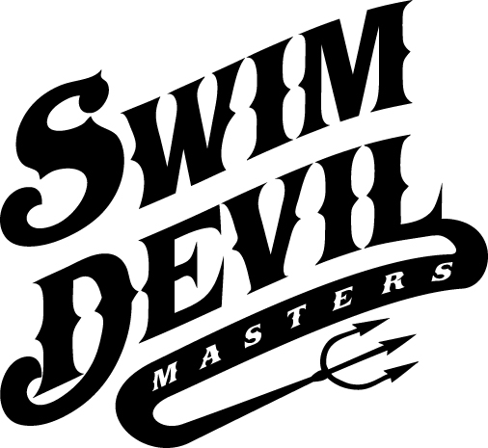

2018 RON JOHNSON INVITATIONAL

ARIZONA STATE CHAMPIONSHIP

SHORT COURSE METERS MEET
NOVEMBER 17 - 18, 2018

Meet Director: Katy James, katyjamesswims@hotmail.com, 480-897-6411

Sanction: Held under the sanction of U.S. Masters Swimming and the Arizona Local Masters Swim Committee (AZLMSC), sanction #488-S00?

Facility: Competition will be held at Mona Plummer Aquatic Center at 601 N College Ave, Tempe, AZ. The facility is an outdoor 25 meter, 8 lane pool operated at 80 F with non-turbulent lane lines and electronic timing. The length of the competition course is in compliance and on file with USMS in accordance with articles 105.1.7 and 107.2.1, but as a bulkhead course, is subject to length confirmation. Eligibility of times for USMS Top 10 and records will be contingent on verification of bulkhead placement. There will be a 25 yard course available for warm-up and loosen-down during the actual meet.

Parking: Parking is available adjacent to the facility in the parking structure to the pool for a fee.

Rules: 2018 USMS rules apply. All events are timed finals. There is a limit of seven (7) individual events total and no more than four (4) per day. Your age as of December 31, 2018 determines your age group for the meet.

Relay Entries: A USMS-registered swimmer who wishes to only swim relay events must enter the meet before the start of event #1, by paying the $10.00 relay-only entry fee and must sign a consolidated entry card. There is no limit on relays, but swimmers may swim only one relay (men, women, or mixed) per event. Relay entries are due for Saturday’s 400 free relays at the end of Event #1, 800 free, Saturday’s 200 medley relays at the end of Event 8, 400 mixed free relay, Sunday’s 400 medley relays at the end of Event 16, 1500 free and Sunday’s 200 free relays at the end of Event 23. Mixed 400 medley relay. It is much appreciated if coaches can send their proposed relays to the meet director before the start of the meet at katyjamesswims@gmail.com.

Entries/ Fees: Entries must be received by November 12, 2018. Late entries will not be accepted. There is a $50.00 fee for the meet IF YOU ENTER ONLINE. The meet info can be found at www.azlmsc.org by clicking on “EVENTS”.

Swimmers are encouraged to enter online. This covers all events that a swimmer wishes to enter. Use this link:
Swimmers may still choose to mail their entry for a fee of $55.00. Please use the new Arizona Consolidated entry card for this method. Fill it out completely and be sure to enter seed times for all the events that you wish to swim. You must also send a copy of your USMS registration card. There will be no deck entries. Make checks out to Sun Devil Masters Swimming.
Mail your entry card, check and photocopy of your USMS Card to:

Katy James
723 East Diamond Drive
Tempe, AZ 85283

If you need an Arizona Consolidated entry card or USMS application, go to www.azlmsc.org and look under forms.

Seeding: All events will be pre-seeded (women & men swim together) by time, slowest to fastest.

Long Distance: The1500 free will be limited to the first 24 entries received. There will be a maximum of 3 heats in the 1500. Swimmers may enter either the 800 free or the 1500 free but not both. Swimmers will be responsible for providing their own counters. Please contact the meet director if you need help in obtaining a counter.

Results: During the meet, results will be posted. At the conclusion of the meet, results will be listed at www.azlmsc.org.

Social: There will be a social for all participants and friends on Saturday evening after the conclusion of Saturday’s events. We will celebrate the coaching of the founder of Swim Devil Masters, Ron Johnson. Multiple world record holder and author, Karlyn Pipes, will be offering a FREE inspirational talk. In 2000, Ron wrote an article titled “The New Australian Crawl” and it changed her life. She went to the pool and made changes to her stroke that very day. Karlyn got a lot faster and posted lifetime bests in both freestyle and butterfly in her 40s thanks to Ron’s influence. She has graciously offered to share that story with us.
Don't miss this amazing event...and please tell a friend! (More details to follow)

Karlyn Pipes is an inspirational speaker and the author of The Do-Over, a story about recovery, hope and second chances. Drawing from the challenges she faced to rise from the depths of addiction and self-destruction to her induction into the International Swimming Hall of Fame in 2015, Karlyn’s odds-defying comeback story will inspire, engage and entertain audiences of all ages and from all walks of life.
For more information about Karlyn Pipes, please visit https://en.m.wikipedia.org/wiki/Karlyn_Pipes

Order of Events

Saturday, November 17, 2018

Session 1 Events: Warm-up 11:00 PM/ Start 12:00 PM
Order | Event
1 | 800 Free
2 | 100 Fly
3 | 50 Breast
4 | 200 Free
5 | 100 Back
6 | 400 W Free Relay
7 | 400 M Free Relay
8 | 400 Mixed Free Relay
9 | 100 Breast
10 | 200 Fly
11 | 50 Free
12 | 400 IM
13 | 200 W Medley Relay
14 | 200 M Medley Relay
15 | 200 Mixed Medley Relay

Sunday, November 18, 2018

Session 2 Events: Warm-up 8:00AM/ Start 9:00AM
Order | Event
16 | 1500 Free
17 | 100 IM
18 | 50 Fly
19 | 200 Back
20 | 400 Free
21 | 400 W Medley Relay
22 | 400 M Medley Relay
23 | 400 Mixed Medley Relay
24 | 200 IM
25 | 50 Back
26 | 200 Breast
27 | 100 Free
28 | 200 W Free Relay
29 | 200 M Free Relay
30 | 200 Mixed Free Relay

