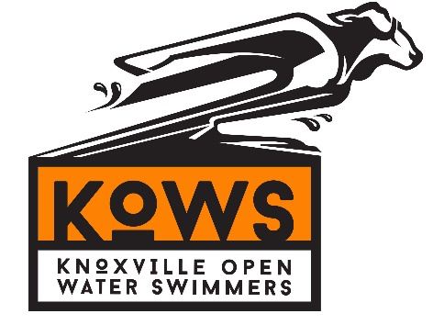
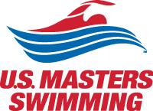
2018 Bridges to Bluffs
Saturday, September 30th 2018
10k Open Water downstream swim

Registration Schedule
 | Open | Close
Swimmer Registration | Mon, April 2, 2018 12:00 AM EST | Sun, September 16, 2018 11:59 PM EST

Sanctioned by the Southeastern Masters Swimming for United States Masters Swimming, Inc.,

HOSTED BY: Knoxville Open Water Swimmers (KOWS).
Event Directors: Jack McAfee, Blaik Ogle. Email: knowx.ows@gmail.com.

SPONSORS: Tennessee Aquatics, 5 Ring Photo, Podium Sports Medicine, Pilot, Visit Knoxville, LB Endurance.

COURSE: “Bridges to Bluffs” is a 10k down current swim in the Tennessee River. Swimmers will begin by jumping from the “Star of Knoxville” Riverboat at Volunteer Landing. The first 3 miles will take swimmers by the University of Tennessee Neyland Stadium, Thompson Boling Arena, a spectacular downtown skyscape, and below 5 historic bridges. The last 5k will see a transition from a downtown/urban environment to beautiful river bluffs, antebellum homes, and historic Sequoyah Hills Park. A relay option will be available (wetsuit legal). Relay teams will consist of a swimmer and kayaker, transitioning at the 5k mark. Our course is unique -- the exact 5k point is in a spectator friendly and easily accessible location, opposite the University of Tennessee Sorority Village, Armstrong Lockett Civil War Home, the Buck Karns Alcoa Highway Bridge (with pedestrian lane for spectator viewing) and the brand new Cherokee Farms Greenway. The finish will be at the Sequoyah Hills Park, which consists of 87 acres of green space and 4 miles of trails.

REGISTRATION: Registration will open on April 2 via Club Assistant. Registration is capped at 200 (total swimmers). You will be able to submit your projected finish times, use a secure site for payment of fees, sign the standard USMS waiver electronically, and have your USMS membership verified through this system. Online entries will reduce the workload associated with putting the event together. Your credit card statement will show a charge from "ClubAssistant.com Events".

ENTRIES: There are 2 different swimming options for this event. The 10k individual open water swim, or the 10k relay open water swim. The relay is a 10k open water swim divided equally with a 5k midpoint for swimmers to swap. There is no 5k individual open water swim option! Relays are wetsuit legal. Wetsuits worn for the 10K will start last and be awards ineligible.

RELAYS: Relays allow swimmers who are not ready for a full 10k to still participate in the event. Each relay will be made up of 2 swimmers, each of whom will swim a 5k. The first leg swimmer will jump off the riverboat, while the second swimmer assists the first swimmer via kayak support. At the 5k point, the swimmer and kayaker will switch positions; the second leg swimmer will finish the swim while the first leg swimmer assists the second leg swimmer via kayak support.

ENTRY FEES: $225 entry for all individual 10k open water swim entries, increasing every 2 months by $25. The 10k 2-person relay open water swim entry fee is a $150 per person, increasing $20 every 2 months. Both relay participants must register. Entry fee covers pre and post-race meal and t-shirt for swimmers and pilot.

DEADLINE FOR ENTRIES: The online entry system will not allow late entries. Entry deadline for entries is 11:59 p.m. Eastern Standard Time on Sunday, September 16, 2018.

ELIGIBILITY: All swimmers must be registered for 2017 with United States Masters Swimming, Inc. If you are not already registered with USMS, online registration will allow you to register with USMS when you register for the meet. You will not be able to register online without being a USMS member. Per USMS guidelines, all swimmers must be 18 years of age or older.

SEEDING: Each swimmer must submit an estimated finish time for their 10k open water swim. There is a 4 hour cutoff for this event! Swimmers will be assigned a number based on their seeded time and swimmers will start in a time trial fashion with the lowest numbers starting first. Results will be tabulated by gender.

SCHEDULE: Check-in will begin at 5:00pm on Saturday, September 29th, 2018 at the Star of Knoxville. All participants will be invited to board the Star of Knoxville riverboat for registration, followed by dinner and a river cruise to preview the course.
The race will begin at 9:00am on Sunday, September 30th, 2018 at the Star of Knoxville. Swimmers will begin boarding the riverboat at 8:00am for an 8:45am departure. At 9:00am, swimmers will begin the 10k open water swim by jumping off the riverboat!
Following the race, all swimmers, kayakers, and families will be invited to Sequoyah Park for a post-race meal.

INDIVIDUAL AWARDS: Every swimmer who finishes the event will receive a finisher award. Awards will be locally crafted with a taste of Eastern Tennessee. 1st-5th overall male and females will receive additional awards. Shirts and swim caps will be given to each competitor.

DIRECTIONS TO STAR OF KNOXVILLE: Approaching Knoxville via I-75/I-40 N from the South, take the TN-158 W Exit 388A. Continue of 158 W for approximately 0.8 miles. Take a left at the stoplight on Walnut Street. Take another left towards Calhoun’s on the River, continue to the end of the parking lot where you will see the Star of Knoxville riverboat.

