Name: ___________________________________ *USMS#: _____ - _________
Street: ___________________________________ Birth(mm/dd/yy) _________
City: ___________________________________ State: ___ Zip: ___________
Email: _____________________________________ Phone: _______________
Emergency Contact: __________________________ Phone: _______________
Event choice (circle): 1.2 mile 2.4 mile Gender (circle) M F

Fee Calculation:
Entry Fee (prior to 06/06/18)
1.2 mile: $55.00
2.4 mile: $60.00
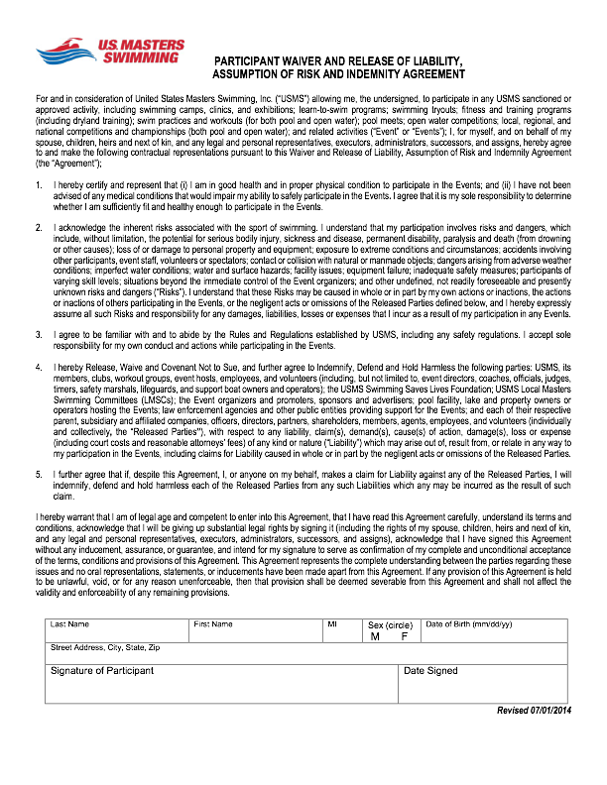
Late entry Surcharge (after 06/06/18) $10.00
One-Event USMS fee ($22) ______
Total Fees _________

Online registration and additional race info: available at www.whidbeyadvedntureswim.org.
Additional online registration information available at clubassistant.com.

Make checks payable and mail to:
SWPAF
PO Box 157
Freeland, WA 98249

**All entries must include a signed and dated participant waiver, found on the following page.

*USMS, Canadian, or foreign Masters Registration is required. For paper entries, non-PNA swimmers must enclose a photocopy of their current registration. Those without current Masters registration must pay the $22 One-Event USMS entry fee.
Event: 1.2 and 2.4-mile open water swim along the shores of Langley Washington in the waters of Saratoga Passage in Puget Sound. Both events will start in the water and finish on the beach. Swimmers will self seed with faster swimmers to the front. **WETSUITS ARE REQUIRED. WATER TEMPERATURE IS EXPECTED TO BE 55 DEGREES OR BELOW**

SCHEDULE for June 9th 2018: Seawall Park – Langley
Noon — 1:30 Pre-Race Check-in
1:30 — 1:45 Mandatory Competitors' Meeting for ALL swimmers.
2:00 Estimated start time for 1.2 and 2.4 swim group start.

Eligibility: 18 years of age or older as of June 9, 2018; USMS or foreign registration for 2018 or $22 One-Event USMS Registration fee.

Entry Fee: $55.00 (1.2 distance) and $60.00 (2.4 distance) *US or Canadian. Late or Race Day registration is $65.00 and $70.00 respectively. Fee includes official race swim cap, which must be worn during the swim and commemorative sports towel.

Entry Deadline: Advance registration must be received by June 6 , 2017.

Rules: Current USMS rules will govern the event. Neoprene wetsuits are required.

Awards: No participation awards. A participation raffle will take place during post race festivities.

Safety: Lifeguards and safety boats will monitor the entire racecourse. Swimmers must wear the swim cap provided and their race number on their hand and upper arm or leg. Swimmers MUST attend the pre-race meeting in order to compete.

Results: Results will be posted 15 minutes after the completion of the final event and will be available on the Whidbey Adventure Swim www.whidbeyadventureswim.org and PNA http://www.swimpna.org/ websites shortly after event.

Questions: Contact Race Director at info@swhidbey.org or visit www.whidbeyadventureswim.org for more details.

Directions: From the Clinton Ferry travel northbound on SR 525. Turn north onto Langley Rd and travel to Langley. Location is Seawall Park at 1st Street and Anthes.

