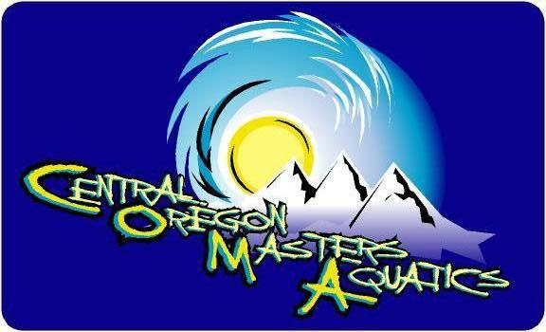

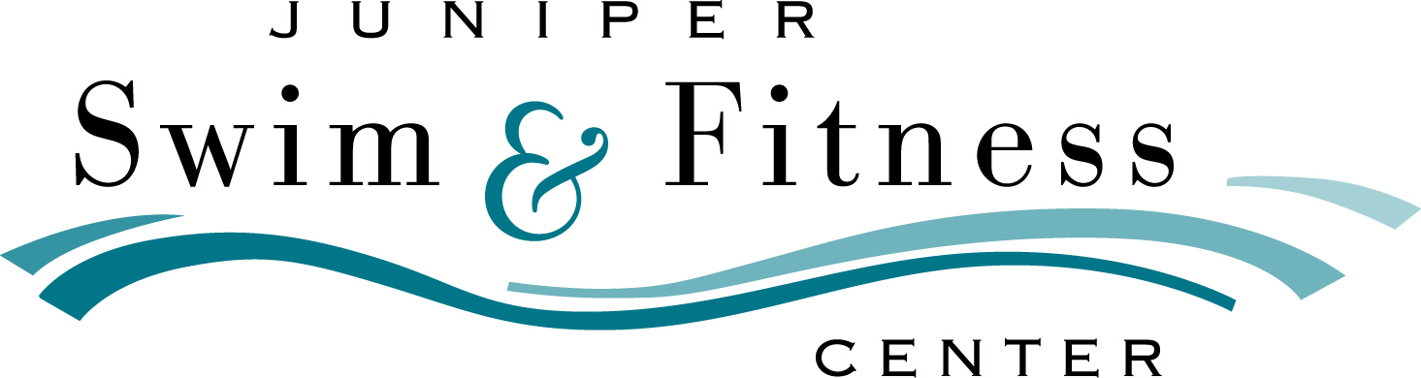

7th Annual LAKE JUNIPER BUOY SWIM
1200-meter Swim at Juniper Swim & Fitness Center in Bend, Oregon
Sunday, May 20, 2018
Hosted by Central Oregon Masters Aquatics
Sanctioned by Oregon LMSC for U.S. Masters Swimming, Inc.
In partnership with the Bend Park & Recreation District

WONDERFUL WATER WEEKEND:

This swim weekend is comprised of two unique events at the same site on the same weekend. Double your fun by participating in both events and enjoy spending a weekend with us in Bend!
- A long-course pool meet on Saturday afternoon; and
- A pool open water swim on Sunday morning with a special brunch celebration following the swim.
The Pool Meet & the Buoy Swim are different events for logistical reasons, and thus require separate entry. For information about the pool meet, visit http://swimoregon.org/events/.

BUOY SWIM INFORMATION
SITE: Juniper Swim & Fitness Center, 800 NE 6th St., Bend, OR, in the JSFC 50-meter pool (also known as ‘Beautiful Lake Juniper’ for this event). Pool should be outdoors by then, and expected water temperature is 80-81 degrees F.
1200-METER SWIM: This is a pool open-water-style swim, 12 loops of a rectangular 100-meter course marked with buoys. Swim direction will be clockwise this year and reversed annually. This is the open water equivalent of short track speed skating and is planned to be an early-season open water learning experience & fun challenge for first time racers & experienced competitors alike!
SCHEDULE (subject to change due to conditions):
6:45 am JSFC doors open for entrants & volunteers
7:00 am Check-in opens for Buoy Swim
7:10 am Warm-up begins on the course
7:45 am Check-in closes!
7:50 am Warm-up closes temporarily for swimmer meeting
8:00 am Mandatory Pre-race Swimmer Meeting
8:15 am Start of Heat #1
8:45 am Start of Heat #2; subsequent heats as needed
At the end Brunch & Awards
ELIGIBILITY: Open ONLY to 2018 USMS members or foreign equivalents. Eligibility will be automatically verified through the online entry system. USMS “One-Event” membership is available for adult non-members for $21.
RULES: Current USMS open water rules will govern this event. Swim Caps are not required. Propulsive devices (such as fins & paddles) and flotation aids (such as pull-buoys & neoprene suits) are not allowed.
SEEDING: Swimmers will be seeded into heats & waves fastest to slowest by 1000-yard pool times. ‘No Time’ entries will not be accepted and seeding changes will not be allowed after the heat sheet is posted. To ensure fairness, enter an accurate time, not a predicted time!
COUNTERS: Swimmers are strongly encouraged to bring someone to count laps for them, although this is not required.
START & FINISH: The swim will start in-water in seeded heats (12-20 swimmers each) & waves (3-5 swimmers each). The swim will finish with an in-water touch at poolside.
RESULTS: Results will be posted at the event site, and at www.comaswim.org and www.swimoregon.org.
RECORDS: Yes, we have event records. See the event website for the current records.
AWARDS: Finishers placing 1st to 3rd in their age group (18-24, 25-29, 30-34, and so on in five-year increments) will be awarded ‘Beautiful Lake Juniper’ custom race ribbons.
OREGON OPEN WATER SERIES: The swim is a featured swim for the Series (22-18-16-14-12-10-8-6-4-2 pts).
BRUNCH: After the swim, all swimmers, officials, & guests are invited to stay for our all-you-care-to-eat brunch on the pool deck. This hefty & tasty brunch features eggs, pancakes, sausage, coffee, juice, and other fixings. Swimmers, officials, and event staff free. Guests $10 each with your entry—it’s considered good form to feed your counter if you bring one!
DIRECTIONS (Google: Juniper Swim & Fitness Center): From North or South, take Business 97 (3rd St.). Do not take the Bypass Parkway. Turn left on Highway 20 (Greenwood Av.), traveling east. Turn right on 6th St. and go south two blocks to the pool. Park in the upper lot or on the adjacent streets.
EVENT WEBSITE: www.comaswim.org
EVENT DIRECTOR: Bob Bruce coachbobbruce@gmail.com 541-317-4851

REGISTRATION & FEE INFORMATION
REGISTRATION: https://www.clubassistant.com/club/meet_information.cfm?c=1756&smid=????
ENTRY DEADLINE: Deadline May 14, 2018 (the same as the deadline for the associated pool meet). No late entries due to logistic needs. Please don’t even ask!
FEE: $25. Fee includes the swim, pre-swim snacks & drinks, and the post-swim brunch.

