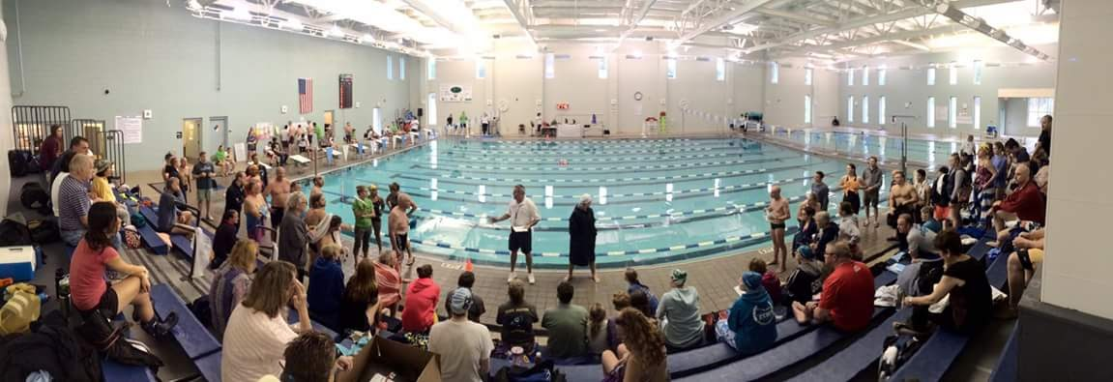

Coastal Masters Invitational

Date: Saturday, April, 28, 2018

Sanctioned: North Carolina LMSC for USMS, Inc

USMS Sanction #: TBA

Location: Dinah E. Gore Fitness and Aquatic Center
At Brunswick Community College
210 College Dr.
Bolivia, NC 28422

Meet Directors: Kristen Jeno - kbs1011@gmail.com, (252) 412-5453,
Alicia Uhl - auhl@ec.rr.com, (910) 547-7575

Meet Referee: Bill Luse - wclswim@ec.rr.com. (910) 376-1575

Course: 8 lane indoor heated pool, 25 yards, 8 competition lanes to be used. The Colorado System 6 will be used along with stopwatch timing with two watches per lane. The length of the competition course without a bulkhead is in compliance and on file with USMS in accordance with USMS articles 105.1.7 and 107.2.1.

Schedule: Warm-ups start at 7:30am. Meet session starts at 8:45am. No swimming equipment (paddles, kickboard, etc.) will be allowed during warm-up. The conclusion of the 500 will be around 9:45am.

Rules: USMS rules will govern this meet. A current USMS card is required. Swimmers must be registered with USMS for 2017. One day USMS registration will be available. When warming up, you must enter the pool feet first except in sprint lanes. No paddles or kickboards are allowed. NO DIVING will be allowed during the 10 minute breaks.

One-event registration is strictly for insurance coverage for the event. One-event participants are not eligible for Event Rankings, Top 10, USMS records, or other honors (either individual or relay) achieved in that event. Per Article 301.3.1 of the USMS Rule Book.

Additional Information: The 25’s will start from the blocks and be hand timed. The times recorded from the 25’s are not eligible for USMS records.

Entries: Online entries only by 11:59pm EST Tuesday April 24, 2018. No paper entries will be accepted, and no deck entries will be accepted at the meet.

Fees: $35.00 flat fee which includes a FREE USMS cap and sticker. No extra charge for relays. There will be no refunds unless the meet is cancelled, in which case $20.00 of the fee paid will be retained and $15.00 will be refunded. If inclement weather occurs, the staff at BCC will determine by 2:00 pm Friday April 27, if the center will or will not open the following morning. If it opens, the meet will be held.

Seeding: All events will be seeded by time from slow to fast. The 500 will be capped at 56 swimmers and will include a positive check-in which will close at 8:00am.

Scoring: Points will be awarded as follows:
Individuals: 9-7-6-5-4-3-2-1
Relays: 22-18-16-14-12-10-8-6-4-2
All team awards must be picked up from Clerk of Course the day of the meet. No awards will be mailed.

Limit and Order of Events: Limit is eight individual events and 2 relay events.
W M Event Seed Time
1 1 500y Free
15 Minute Break
2 2 200y IM
3 3 50y Breast
4 4 100y Fly
5 5 50y Free
5 Minute Break
6 6 100y Back
7 7 100 Breast
8 8 200y Free
9 9 100y IM
5 Minute Break
10 10 50y Fly
11 11 100y Free
12 12 50y Back
10 Minute Break
13 13 25y Breast
14 14 25y Fly
15 15 25y Back
16 16 25y Free
10 Minute Break
17 17 100 Medley Relay
5 Minute Break
18 18 100 Free Relay

