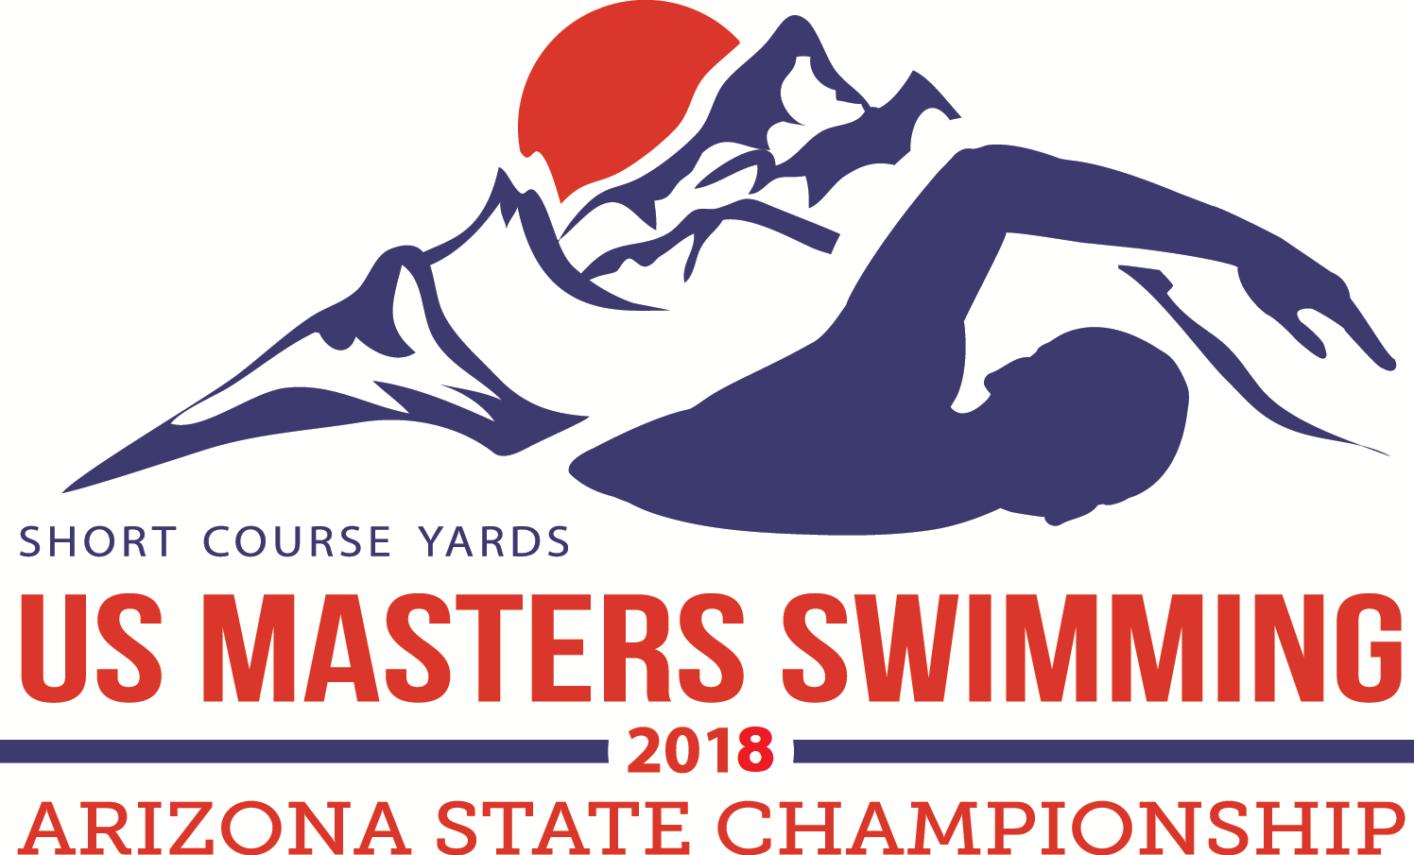

AZ LMSC SC Yards State Championship
April 6-8, 2018, Oro Valley, AZ

Meet Director: Jim Stites
Meet Referee: Judy Gillies
Sanction: Sanctioned by AZ LMSC for USMS Inc. Sanction Number 488-S002.

Rules: 2018 USMS rules apply. All events are timed finals. Swimmers are limited to a total of 8 individual events for the entire meet and no more than 5 per day, not including relays. Age on April 6, 2018 determines the age group of the swimmer for the meet.

Timing: The primary timing system will be automatic timing. Times may be submitted for USMS records and USMS Top 10 consideration.

Long distance events: The 1650 will be seeded fastest to slowest based on entry times. Positive check-in is required for the 1650 and 1000 events. Check-in for the 1650 and 1000 will close 30 minutes after the start of warm-up for that session.

Seeding: All events (except the 1650 & 1000) will be pre-seeded. All events besides the 1650 will be seeded slowest to fastest. All individual events are mixed. No deck entries or late entries will be accepted.

Eligibility: Any swimmer with a valid 2018 USMS registration. International entries must include a copy of the swimmer’s FINA-recognized Masters Swimming registration card and fees in U.S. dollars. Each swimmer must submit a copy of their 2018 USMS registration card or FINA-recognized Masters Swimming card. Failure to submit proof of registration will result in the entry being rejected. For further information on registration contact Jim Stites at swim1@qwest.net .

Affiliation: A swimmer’s team affiliation as stated on online registration will apply throughout the meet, except that a swimmer may become unattached at any time.

Individual Awards: Male and female high point awards for each age group will be awarded. Individual Points will be awarded as follows: 9,7,6,5,4,3,2,1 and doubled for relays.

Team Awards: Team awards for 1st and 2nd by team size based on USMS 2017 membership registration. The team awards are as follows: Large 50+ members, Medium 25-49 members and Small 1-24 members.

Results: Available through Club Assistant at www.clubassistant.com

Entries and fees: Flat entry fee of $50 for online entries. Fee includes a meet T-shirt.
No deck entries, mail or fax entries will be accepted.

- For online registration please visit https://www.clubassistant.com/club/meet_information.cfm?c=1085&smid=9787
- Online registration closes on April 3, 2018.

REMINDER:
The entry fee includes a meet T-shirt. Please indicate your T-shirt size on your Club Assistant entry form.

Facility: The Oro Valley Aquatic Center (OVAC) is located next to Canyon del Oro High School in the James D. Kriegh Park, 23 W. Calle Concordia, Oro Valley, AZ 85704. OVAC is an outdoor 18-lane 25-yard pool operated at 80º F with non turbulent lane lines and electronic timing. The length of the competition course without a bulkhead is in compliance and on file with USMS in accordance with articles 105.1.7 and 106.2.1. We will run 8 lanes for competition and set aside additional lanes for warm-up.

Location: Directions from I-10: Ina Rd. exit #125, east on Ina to Oracle Rd., left (north) on Oracle to Calle Concordia, left (west) on Calle Concordia, pool is on your right in ¼ mile. There is a parking lot available directly east of the pool off of Calle Concordia.

Meet Sessions and Order of Events

Friday April 6, 2018
Warm-ups start at 3:00pm, meet starts at 4:00pm. The 800 free relay will be seeded fastest to slowest. Relay cards are due by the beginning of warm up. Check-in required for the 1650 by 3:30 pm! The 1650 free will start 30 minutes after the last 800 free relay is finished. Men & Women seeded together, fastest to slowest.
Event Number | EVENT
1 | Women 800 FREE RELAY
2 | Men 800 FREE RELAY
3 | MIXED 800 FREE RELAY
4 | MIXED 1650 FREE (Must check in by 3:30pm)
Saturday April 11, 2015
Warm-up starts at 9:00am, meet starts at 10:00am. All events are seeded slowest to fastest. The 400 medley relay entry cards are due prior to Event 6, the 100 free. The 200 free relay entry cards are due prior to Event 10, the Women’s 400 medley relay.
 | EVENT
5 | 400 IM
6 | 100 FREESTYLE
7 | 50 BACKSTROKE
8 | 200 BUTTERFLY
9 | 500 FREESTYLE
10 | Women 400 MEDLEY RELAY
11 | Men 400 MEDLEY RELAY
12 | MIXED 400 MEDLEY RELAY
13 | 100 IM
14 | 200 BACKSTROKE
15 | 100 BREASTSTROKE
16 | 50 BUTTERFLY
17 | Women 200 FREE RELAY
18 | Men 200 FREE RELAY
19 | MIXED 200 FREE RELAY

Sunday April 12, 2015
Sunday Warm-up starts at 9:00 am. Meet starts at 10:00 am. All events are seeded slowest to fastest. The 400 free relay entry cards are due prior to Event 21, the 100 fly. The 200 medley relay entry cards are due prior to Event 25, the Women’s 400 free relay.

 | EVENT
20 | 1000 FREESTYLE
21 | 100 BUTTERFLY
22 | 200 BREASTSTROKE
23 | 50 FREESTYLE
24 | 100 BACKSTROKE
25 | Women 400 FREE RELAY
26 | Men 400 FREE RELAY
27 | MIXED 400 FREE RELAY
28 | 50 BREASTSTROKE
29 | 200 FREESTYLE
30 | 200 IM
31 | Women 200 MEDLEY RELAY
32 | Men 200 MEDLEY RELAY
33 | MIXED 200 MEDLEY RELAY

