Swim Fort De Soto
Saturday, October 28, 2017
Race and Safety Plan
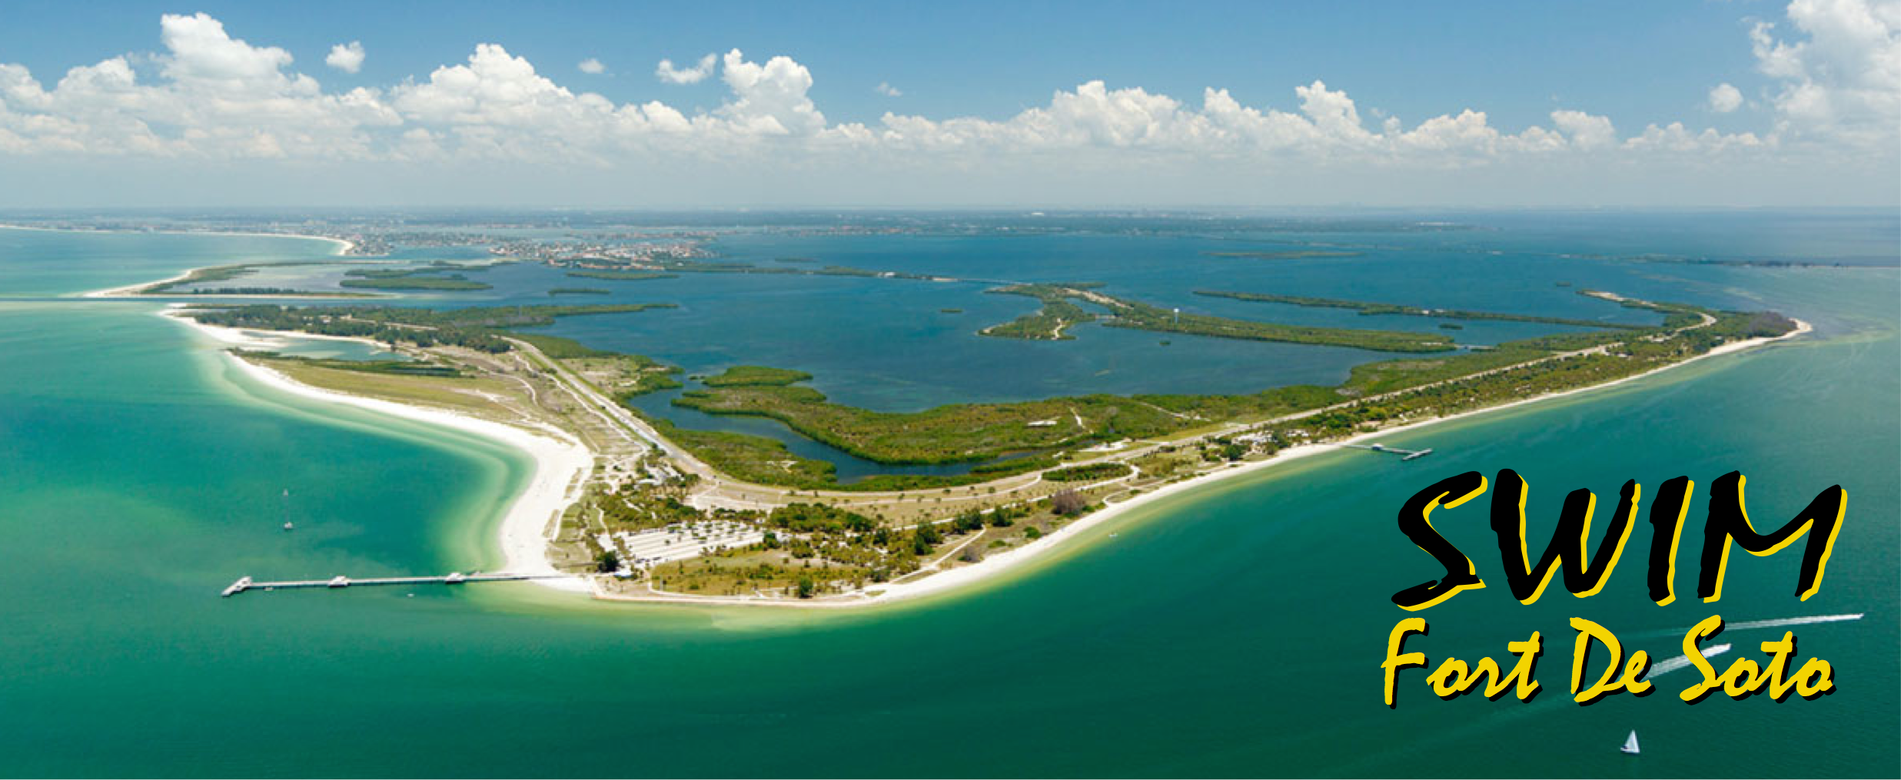
This document outlines the details about the race and safety plans for our 10K+ (6.5 miles) open water race on Fort De Soto park, Florida. It contains the following:
- Race Plan
- Safety Plan
- Emergency Plan
- Contingency Plan
- Water Quality Plan
RACE PLAN
Swim Without Limits, Inc. will host the Swim Fort De Soto open water event. The date for the race is Saturday, October 28, 2017. The race will be offered at one distance of 10K+ (6.5-miles) with male, female, and 2-person relay divisions. The race will start at the Fort De Soto boat ramp on Mullet Key Bayou and traverse Bunces Pass and into the Gulf of Mexico. It will finish at Shelter #14 in the Gulf of Mexico. The race will go around three sides (north, west, south) of the island of Fort De Soto Park. Each swimmer will have or be provided with an escort pilot (kayaker) who will provide safety, navigation, and nutrition for the swimmer. Relay teams must take turns swimming and paddling, meaning that each person swims a portion of the race and paddles the kayak a portion of the race. Relay swimmers cannot have a dedicated pilot. Relay teams can swap between paddling and swimming as often as they want on course. To make the exchange, relay teams must have the pilot exit the kayak and maintain contact and control of the kayak until the swimmer makes the exchange by hand-to-hand touch. At this moment, the finishing swimmer becomes the pilot and the only team member permitted contact with the kayak. The pilot may then use the sea bottom if needed for assistance to enter the kayak and process as the team pilot. A pre-race safety meeting will take place on Saturday, November 5 prior to the race and is mandatory for all swimmers and pilots.
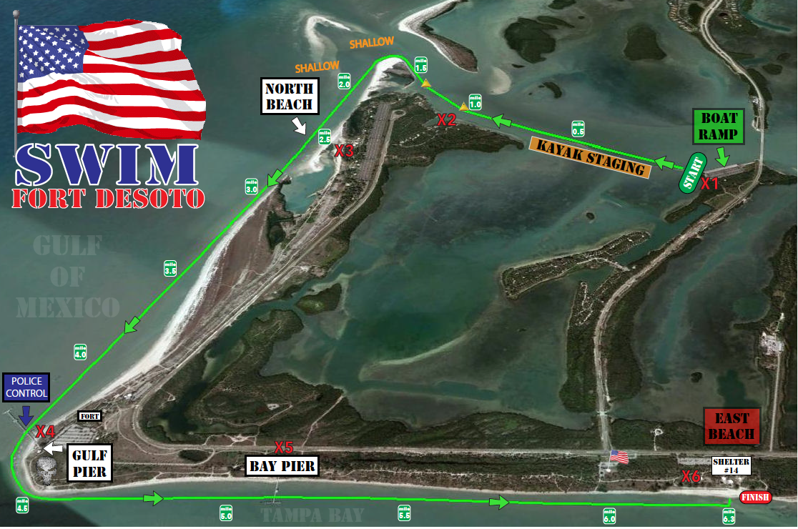
Water safety will be provided by the swimmer escort pilots (kayakers), powerboats, jet skis, police boat, and EMTs that will be patrolling the course. Pilots will be instructed on how to seek assistance. An EMT will be available on the water as well as at the start/finish line. Safety personnel will be instructed on how to assist a distressed swimmer and trained medical personnel will be available to assist in emergency situations.
St. Pete PD will be providing a police boat whose role will be to help keep public boat traffic away from the swimmers/pilots by operating towards the front of main race field. The boat officer will intercept potential public boaters and instruct them on operating their boat safely in the area to avoid contact or disruption of the event.
We will be providing up to three powerboats and three jet ski for the event. Each powerboat will have a dedicated swim spotter onboard. Each power craft will be marked with an orange flag indicating that they are part of the event. We will have one powerboat with the lead field, one in the middle of the field, and one at the end of the field of swimmers/pilots. The jet skis will be roaming the entire field as needed.
All boat and jet ski operators, police boat, and personnel at the start/finish line will be monitoring VHF channel 83A where all race communication will take place.
Swimmers will start the race at the Fort De Soto boat ramp. It will be in in-water start just to the southwest of the boat ramps. Pilots will be waiting for their swimmer just off to the left of the course staying to the outside of the pack of swimmers until they can get contact with their swimmer. Pilots will remain with their swimmer the entire race. The course will take the swimmer west through Bunces Pass inlet and into the Gulf of Mexico. Swimmers will then head south and around the end of Fort De Soto Park taking them east to the finish line at Shelter #14.
The race will follow the English Channel swimming rules. This means no swimsuits below the knees or shoulders. No suits that provide any type of buoyancy. No wetsuits. No other swimming aids. No hanging onto your pilot's boat. No touching other people. No standing on the bottom or making forward progress using the bottom.
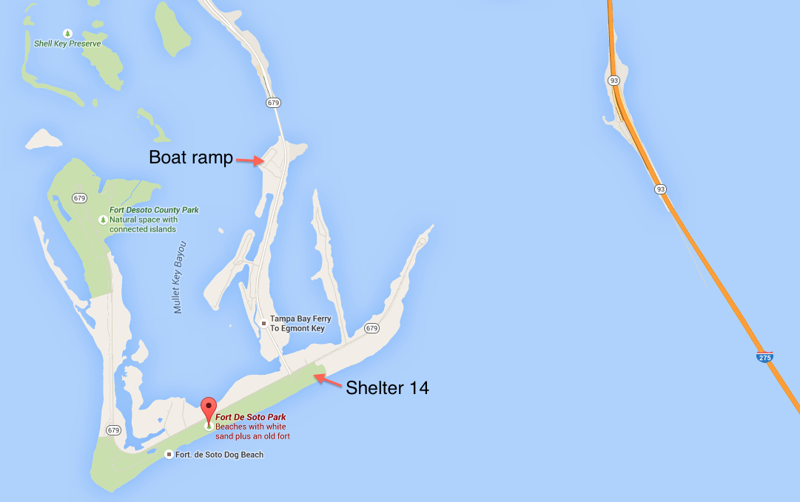
Swimmers must be able to complete the swim in less than 5 hours. Swimmers should be able to swim 1 open water mile in under 42 minutes. If swimmers are not approaching the final 500 yards of the swim within five hours, they may be pulled by the motorboat pilots and shuttled to the finish line. If they are close, they will not be pulled.
Timing for every swimmer will be handled by personnel recording the time each swimmer crosses the finish line using a computer based system application.
Prior to the race, an Athlete and Pilot Guide will be sent to each swimmer and pilot with complete race and safety details. A mandatory pre-race safety meeting will take place prior to the race instructing each swimmer and pilot, powerboat and jet ski captains on the course layout, starting and finishing procedures, contingency plans, safety plans with instructions on how to ask for help on the course, and what to do if they abandon the race. A question and answer period is allotted so that each swimmer has the ability to get their questions answered. A course map will also be available for swimmers and pilots to view. Each swimmer will be provided a colored swim cap and body marked with their swim number providing additional accountability means.
SAFETY PLAN
- Each swimmer will be escorted by a pilot boat (kayaker) providing safety, navigation, and nutrition for the swimmer. Each pilot will be given the following diagram instructing him or her on how to seek assistance while on the water.
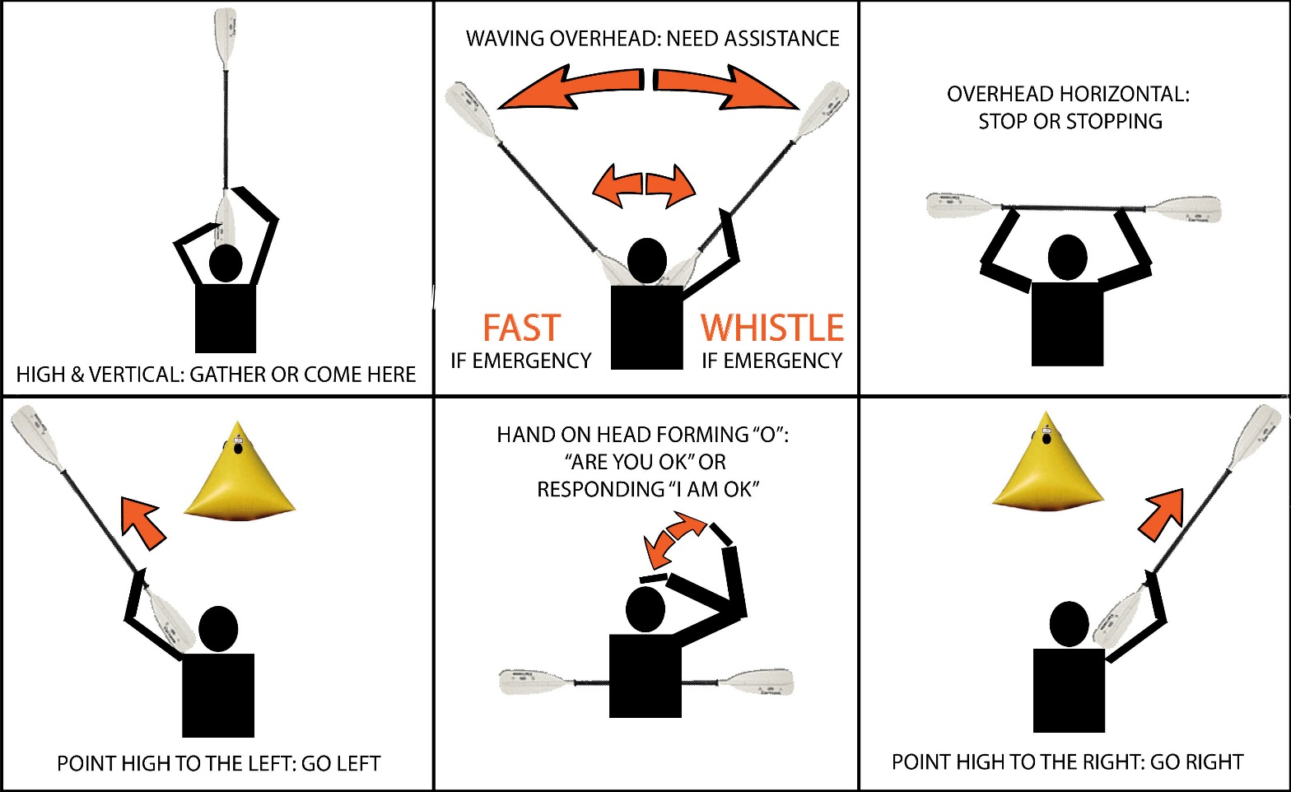
- Pilots will be instructed on how to and where to position themselves with respect to their swimmer. The following diagram will be provided to each swimmer and pilot.
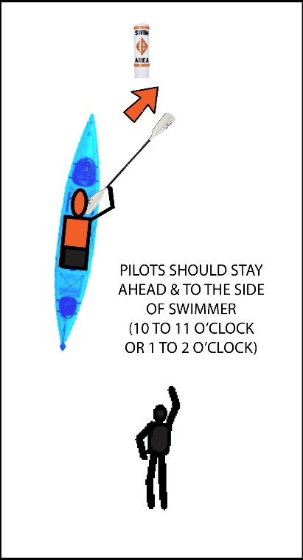
- Emergency services will be provided by EMTs, one on the beach at the start/finish line and one on a powerboat with a designated spotter patrolling the course and will be equipped with Basic Life Support gear and an AED.
- Two-three powerboats (each with a dedicated swimmer spotter) and 2-3 jet skis will patrol the course and will all be in communication with each other as well as the race directors. Each powerboat and jet ski will be marked to indicate that they’re part of the race.
- The powerboats and jet skis will have radio communication with on-shore staff and the Race Directors. Radio communication is directly linked to 911 services.
- St. Pete Beach Fire Department is located 12 miles from Fort De Soto, the race venue, with full Emergency Services including ambulances. Response time would be about 20 minutes.
- A police power boat will be on course to help keep any boat traffic away from the swimmers as they traverse the course.
- A distressed swimmer would be identified by a pilot escort blowing a whistle or waving their paddled over their head until recognized. Personnel on the powerboats or jet skis should be on site within minutes. The swimmer will be placed on the powerboat or jet ski and transported to shore where resuscitation by trained personnel will begin if necessary.
- A briefing of the course and conditions will be held on the beach prior to the swim. All participants will be checked in the morning of the race. They will be checked back in as they finish the race. Swimmers that withdraw from the race will be instructed to report to the finish area to be accounted for. Contact information for all swimmers will be recorded as part of the registration process.
- A mandatory safety briefing will be held for all swimmers, pilots, and safety personnel prior to the start of the race so that they understand how to handle a distressed swimmer and know where to be positioned on the course.
- A mandatory boaters meeting will be held prior to the race so that each powerboat and jet ski boat captain and spotter understand their role and what to do in case of an emergency or inclement weather.
- Fort De Soto beach lifeguards, the local marine police, and the coastguard will be informed of the race so that they are aware of the swimmers and pilots who will be traversing the area.
EMERGENCY PLAN
- Swimmer in distress: Swimmers in distress will be identified by their escort pilots and the support craft on the course. Pilots will alert personnel on the powerboats or jet skis by blowing a whistle or waving their paddle over their head until recognized. If the swimmer must be evacuated from the course, they will be loaded onto the powerboat or jet ski and brought to shore. Once on shore, the swimmer will be evaluated and treated if necessary by EMT personnel. Swimmers requiring evacuation via ambulance will be transported to Bayfront Health Hospital 14.1 miles from the race venue. Transit time is approximately 20 minutes.
- Missing swimmer: Before the race begins, all swimmers will be checked in. They will be checked back when they finish the race. Swimmers who abandon the race will be instructed to check in at the finish area by personnel on the beach. Cell phone number and emergency contact information will be gathered at registration for each swimmer. If a swimmer is determined missing, safety personnel will follow protocol for said event.
CONTINGENCY PLAN
- Any one of the following individuals is empowered to order the race to be abandoned due to unsafe conditions.
A. Race Director – David Miner
B. Race Director and Safety Coordinator – Steve Butler
- If the race is abandoned, Race Control will communicate via radio to all support craft to signal abandonment. Swimmers and pilots will be ordered to the beach.
- Swimmers and pilots will be instructed to proceed to the finish area to check in.
- If lightning is present in the area, all swimmers and pilots will be instructed to leave the beach and/or the course immediately and move to a protected area. If swimmers and pilots must abandon the course due to lightning, they will remain safely onshore until the powerboats and jet ski personnel give the all-clear signal to continue the race. If a significant amount of time passes and the weather does not clear, all swimmers will be instructed that the race is over and must stay in place until race personnel can pick them up and transport them back to the start/finish area.
WATER QUALITY
Fort De Soto water quality is tested and posted on FloridaHealth.gov. In the rare instance that the water quality was poor, the beach is generally closed to swimmers.
The average water temperature at Fort De Soto for the period of this race is 75 to 81 F degrees.

