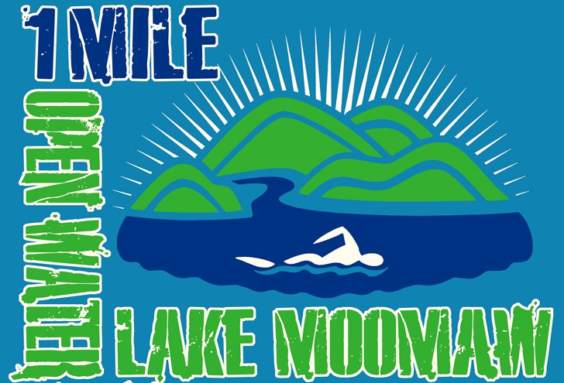 Lake Moomaw 1- Mile Swim 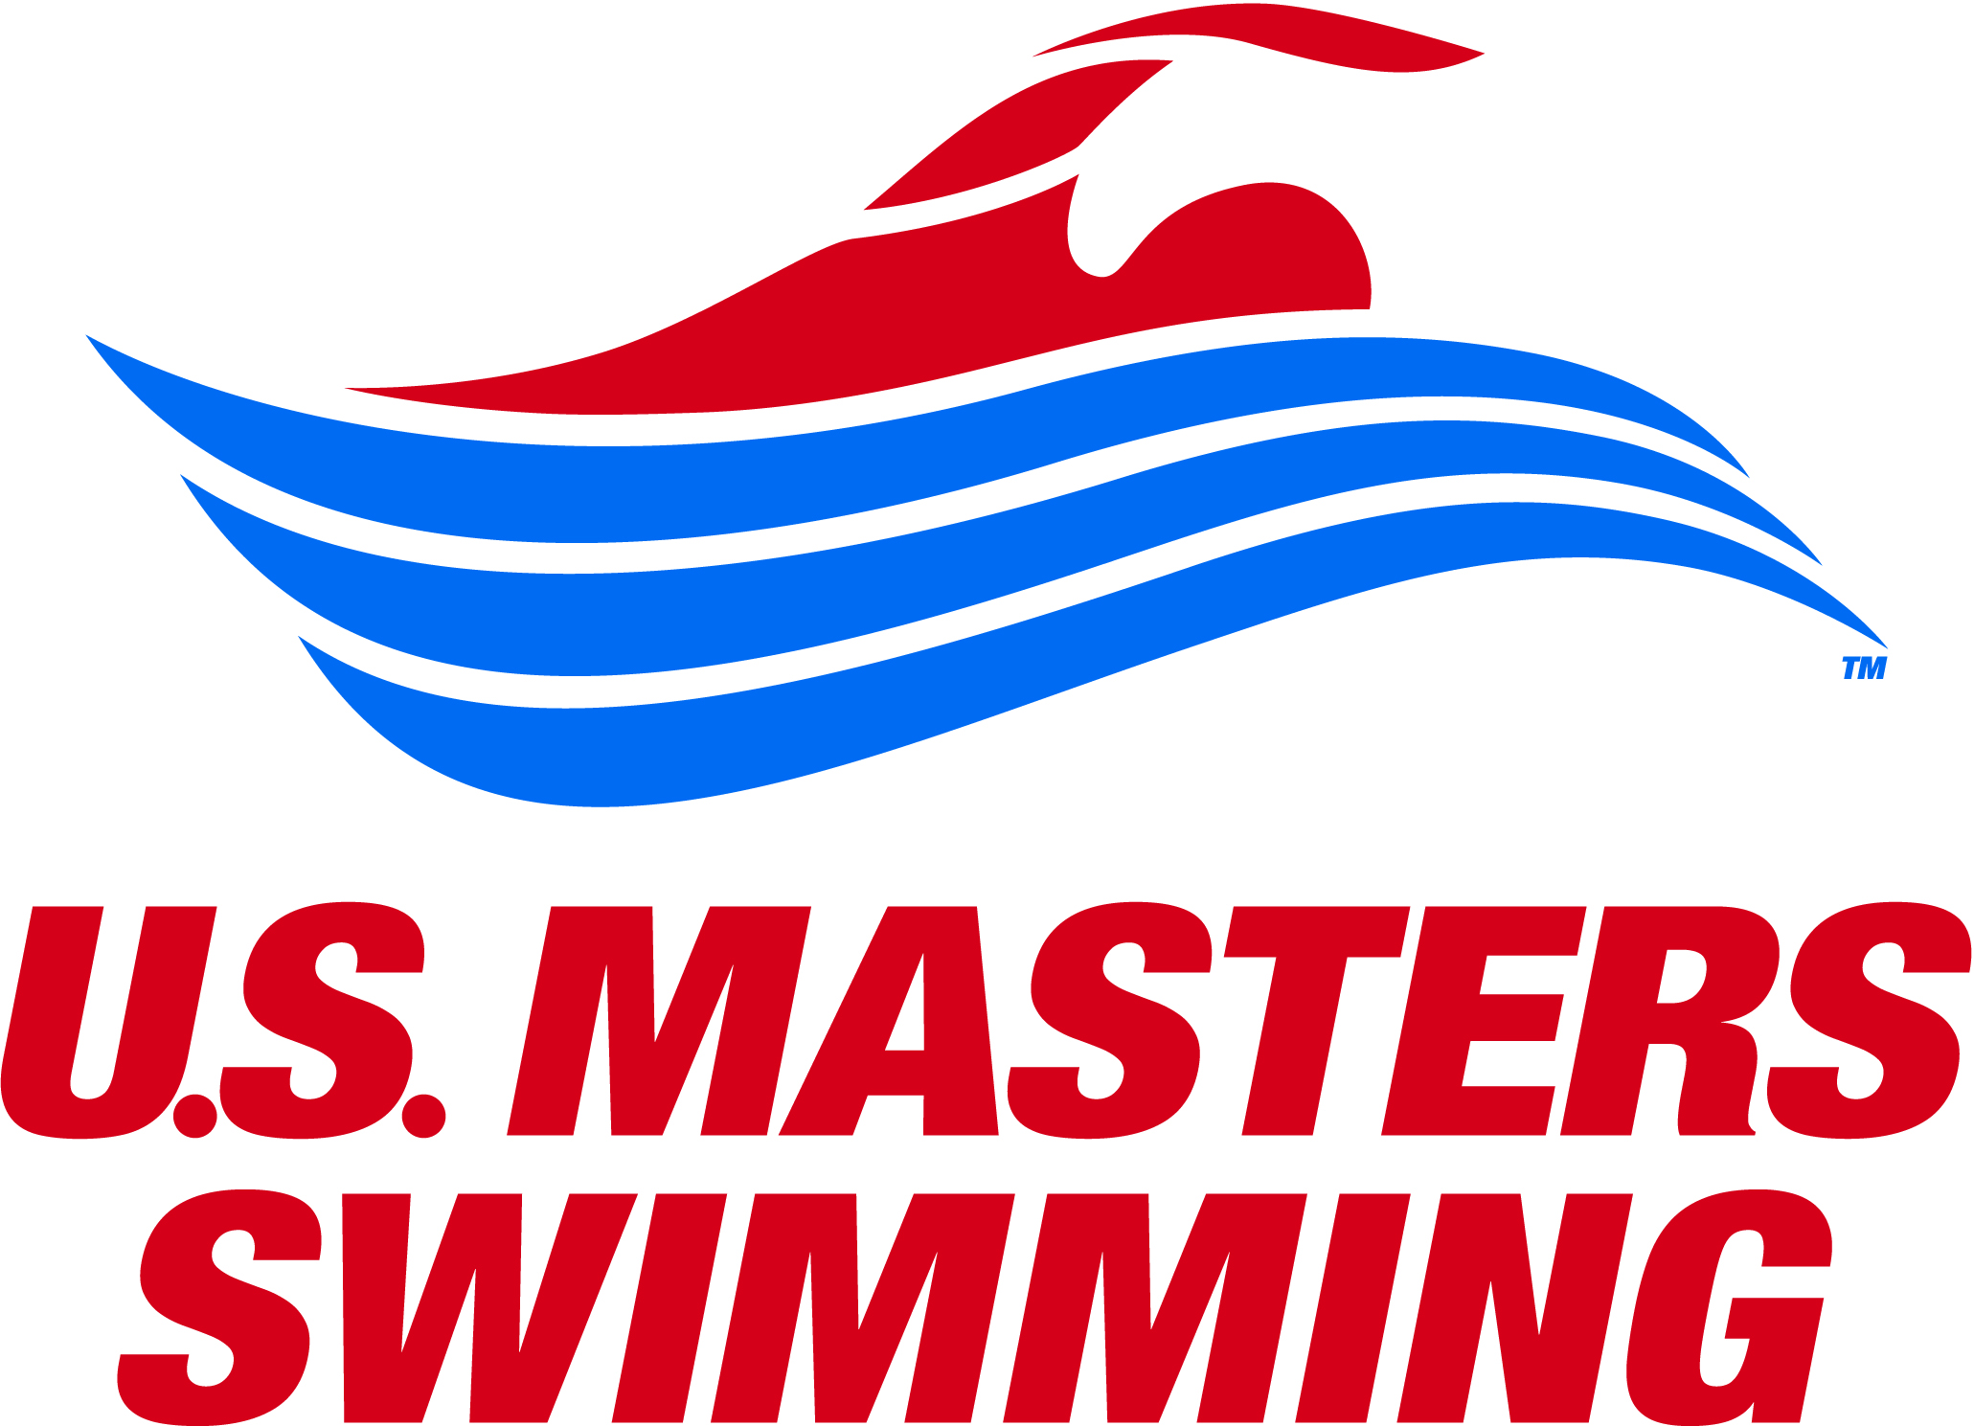
Alleghany County, Virginia, Saturday, August 5, 2017
Sponsored by: The Virginia Masters Swim Team, The Alleghany Highlands YMCA, The Alleghany Highlands Chamber of Commerce and The Alleghany Foundation.
Sanctioned by: LMSC of Virginia for USMS Inc.
SAVE PAPER, SAVE TIME, AND AVOID ERRORS: REGISTER ONLINE at: https://www.clubassistant.com/club/meet_information.cfm?c=2402&smid=8967

Your credit card will be charged to “ ClubAssistant.com Event Billing “

EVENT: There will be a one-mile race at 9:00am. The start and finish is on the beach at Cole’s Point, clearly visible to the spectators and race personnel. The course runs along the shore to the south, approximately 50 yards out and continues east and north around buoys that will be clearly visible. The swimmers will reach the turn-around point inside the “no wake zone” in the inlet and turn counter- clockwise around a buoy and swim back to the beach via the same route. Buoys will remain to the swimmer’s left. A 2x 3 foot poster of the course diagram will be posted at the lake, and the current water and air temperature will be posted at 8am. Swimmers will depart from the beach in waves of 10 people or fewer, 1 minute apart.
Warm-up begins at: 7:45am Check-in Closes at: 8:45am Race begins at: 9:00am
Eligibility: Open to all swimmers 18 years & older. Paper entries must include a copy of your 2017 USMS card. Online entries will be verified automatically. “One Event” is available through online registration for an additional fee of $31.50. To renew or join USMS online, visit usms.org/reg.
Rules: Current 2017 USMS rules will govern the race.
Entries: All snail mail entries must be postmarked by July 28, 2017. Online entries will close at 11:59pm Eastern Time on August 1, 2017. Late or race day entries will NOT be accepted. Online entry is strongly encouraged. Entry fee is $42.00. To be guaranteed a free t-shirt, enter online by 5pm on July 14, 2017.
Safety: For safety reasons, swimmers who cannot complete 1 mile in one hour should NOT enter. Swimmers still on the course after the time limit will be stopped and listed DNF in the results. In the event of inclement weather, the race director may close the course and thereby prevent swimmers from completing the race. The WestRock water rescue team will be on site with boats, rescue boards, and rescue squad.
Seeding: Swimmers will be seeded fastest to slowest according to 1650 seed time and will be started in waves of 10 swimmers, staggered at 1-minute intervals. “No Time” entries will be seeded in the final wave. Seeding changes and additions will not be allowed on race day.
Age Groups: 18-24, 25-29, 30-34, etc. in five year increments, forboth men/women.
Awards/ Social: Awards will be given to the top 3 men & women finishers in each age group. The awards ceremony will take place on the beach following the race.
Accommodations: Please call Susan Knick at the Alleghany-Highlands Chamber of Commerce at 540-962-2178 for information.
Directions: Google Map “Coles Point Drive, Hot Springs, VA 24445”.
Race Directors Contact: Dave Holland 804-467-2425 (VMST) ; Susan Knick 540-962-2178 (Chamber)

PLEASE STAPLE A LEGIBLE COPY OF YOUR 2017 USMS CARD HERE:
TRIM THE COPY AND COMPLETE THE FOLLOWING:
Emergency Contact Name:____________________________________________
Emergency Contact Phone:___________________________________________
Significant medical conditions to be shared with WestRock Rescue Squad
(i.e. seizures, diabetes, asthma, etc.)______________________________
______________________________________________________
1 Mile Seed  Time → | 1650 yd Time:  _____(min) : _____(sec)

AVOID THIS FORM: REGISTER ONLINE AT WWW.VASWIM.ORG |  | PAPER ENTRY CHECKLIST | DID YOU REMEMBER…?
$ 42 | 1- Mile Entry Fee per swimmer |  | Completed entry form
$ FREE | T-Shirt Included free if entry postmarked by 7/12 (or online by 7/14). A few shirts may be available on race day, first-come. |  | Copy of USMS card
$ 42 per swimmer | Total Enclosed (check or money order  Payable to VMST) |  | Signed waivers (next page)
T-Shirt Size: (please circle) S M L XL XXL XXXL

Please use the checklist above to ensure that your entry is complete!!!

Mail this completed form with check or money order payable to VMST, postmarked by July 28, 2017 to:
Dave Holland, 1773 Robins Nest Ct., Henrico, VA 23238

Name:_______________________________ Email address:_____________________________________________

Phone Number: ___________________________ Age on August 5, 2017: ____________________

YOU MUST READ AND SIGN 2 WAIVERS (BELOW & NEXT PAGE).
INCLUDE THIS PAGE AND THE NEXT WITH YOUR ENTRY.

LAKE MOOMAW RELEASE BY PARTICIPANT FROM LIABILITY:

AS A CONDITION OF MY PARTICIPATION IN THIS EVENT AND ANY ACTIVITIES INCIDENT THERETO, I HEREBY WAIVE ANY AND ALL RIGHTS TO CLAIMS FOR LOSS OR DAMAGES, INCLUDING ALL CLAIMS FOR LOSS OR DAMAGES CAUSED BY THE NEGLIGENCE, ACTIVE OR PASSIVE, OF THE FOLLOWING: THE ALLEGHANY HIGHLANDS CHAMBER OF COMMERCE AND TOURISM, THE UNITED STATES GOVERNMENT, WESTROCK CORPORATION AND THE WESTROCK WATER RESCUE STAFF, EVENT SPONSORS, EVENT STAFF, OR ANY INDIVIDUALS OFFICIATING AT THE EVENT OR SUPERVISING SUCH ACTIVITIES.

_______________________________________ ___________________________________
SIGNATURE OF PARTICIPANT DATE SIGNED

 PARTICIPANT WAIVER AND RELEASE OF LIABILITY,
ASSUMPTION OF RISK AND INDEMNITY AGREEMENT

For and in consideration of United States Masters Swimming, Inc. (“USMS”) allowing me, the undersigned, to participate in any USMS sanctioned or approved activity, including swimming camps, clinics, and exhibitions; learn-to-swim programs; swimming tryouts; fitness and training programs (including dryland training); swim practices and workouts (for both pool and open water); pool meets; open water competitions; local, regional, and national competitions and championships (both pool and open water); and related activities (“Event” or “Events”); I, for myself, and on behalf of my spouse, children, heirs and next of kin, and any legal and personal representatives, executors, administrators, successors, and assigns, hereby agree to and make the following contractual representations pursuant to this Waiver and Release of Liability, Assumption of Risk and Indemnity Agreement (the “Agreement”);

- I hereby certify and represent that (i) I am in good health and in proper physical condition to participate in the Events; and (ii) I have not been advised of any medical conditions that would impair my ability to safely participate in the Events. I agree that it is my sole responsibility to determine whether I am sufficiently fit and healthy enough to participate in the Events.

- I acknowledge the inherent risks associated with the sport of swimming. I understand that my participation involves risks and dangers, which include, without limitation, the potential for serious bodily injury, sickness and disease, permanent disability, paralysis and death (from drowning or other causes); loss of or damage to personal property and equipment; exposure to extreme conditions and circumstances; accidents involving other participants, event staff, volunteers or spectators; contact or collision with natural or manmade objects; dangers arising from adverse weather conditions; imperfect water conditions; water and surface hazards; facility issues; equipment failure; inadequate safety measures; participants of varying skill levels; situations beyond the immediate control of the Event organizers; and other undefined, not readily foreseeable and presently unknown risks and dangers (“Risks”). I understand that these Risks may be caused in whole or in part by my own actions or inactions, the actions or inactions of others participating in the Events, or the negligent acts or omissions of the Released Parties defined below, and I hereby expressly assume all such Risks and responsibility for any damages, liabilities, losses or expenses that I incur as a result of my participation in any Events.

- I agree to be familiar with and to abide by the Rules and Regulations established by USMS, including any safety regulations. I accept sole responsibility for my own conduct and actions while participating in the Events.

- I hereby Release, Waive and Covenant Not to Sue, and further agree to Indemnify, Defend and Hold Harmless the following parties: USMS, its members, clubs, workout groups, event hosts, employees, and volunteers (including, but not limited to, event directors, coaches, officials, judges, timers, safety marshals, lifeguards, and support boat owners and operators); the USMS Swimming Saves Lives Foundation; USMS Local Masters Swimming Committees (LMSCs); the Event organizers and promoters, sponsors and advertisers; pool facility, lake and property owners or operators hosting the Events; law enforcement agencies and other public entities providing support for the Events; and each of their respective parent, subsidiary and affiliated companies, officers, directors, partners, shareholders, members, agents, employees, and volunteers (individually and collectively, the “Released Parties”), with respect to any liability, claim(s), demand(s), cause(s) of action, damage(s), loss or expense (including court costs and reasonable attorneys’ fees) of any kind or nature (“Liability”) which may arise out of, result from, or relate in any way to my participation in the Events, including claims for Liability caused in whole or in part by the negligent acts or omissions of the Released Parties.

- I further agree that if, despite this Agreement, I, or anyone on my behalf, makes a claim for Liability against any of the Released Parties, I will indemnify, defend and hold harmless each of the Released Parties from any such Liabilities which any may be incurred as the result of such claim.

I hereby warrant that I am of legal age and competent to enter into this Agreement, that I have read this Agreement carefully, understand its terms and conditions, acknowledge that I will be giving up substantial legal rights by signing it (including the rights of my spouse, children, heirs and next of kin, and any legal and personal representatives, executors, administrators, successors, and assigns), acknowledge that I have signed this Agreement without any inducement, assurance, or guarantee, and intend for my signature to serve as confirmation of my complete and unconditional acceptance of the terms, conditions and provisions of this Agreement. This Agreement represents the complete understanding between the parties regarding these issues and no oral representations, statements, or inducements have been made apart from this Agreement. If any provision of this Agreement is held to be unlawful, void, or for any reason unenforceable, then that provision shall be deemed severable from this Agreement and shall not affect the validity and enforceability of any remaining provisions.

Last Name | First Name | MI | Sex (circle)  M F |  | Date of Birth (mm/dd/yy)
Street Address, City, State, Zip
Signature of Participant |  |  |  | Date Signed
Revised 07/01/2014

