John Shrum Memorial Cable Swim 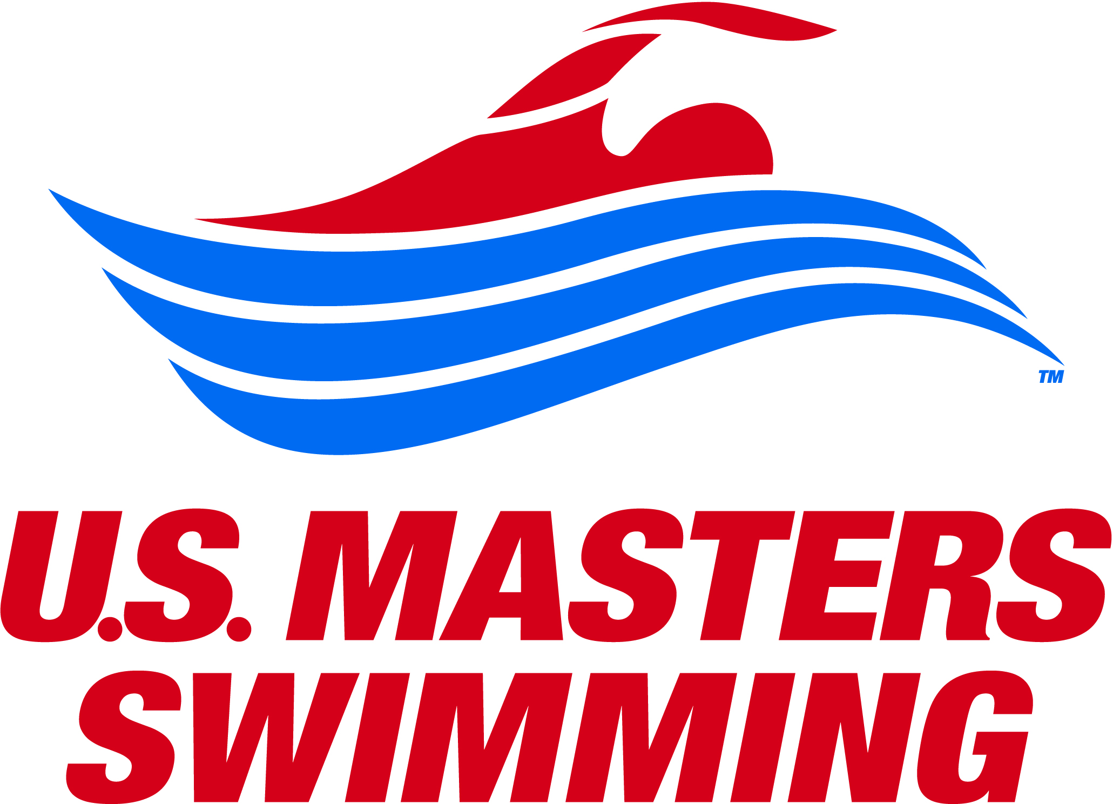
Charlottesville, Virginia, Saturday, July 8, 2017
Sponsored by: Virginia Masters Swim Team and Albemarle County Parks and Recreation
Sanctioned by: LMSC of Virginia Inc. for USMS Inc.
SAVE PAPER, SAVE TIME, AND AVOID ERRORS: REGISTER ONLINE at www.cableswim.org
Your credit card will be charged to “ClubAssistant.com Event Billing”

Event: There will be two races: a 2-mile cable swim at 8:30 am and a 1-mile cable swim beginning at 10:30 am. The 2-mile swim will consist of 4 laps in a clockwise direction around a ¼-mile straightaway cable, with start and finish in the water. The 1-mile race will consist of 2 laps around the ¼-mile cable in a counter-clockwise direction. Both the 1- and 2-mile distances are certified and qualify for national records. No splits or premature finishes will be eligible for records. The lake opens at 7am and warm-up on the cable course will be available from 7:15-8:15am.
• Anticipated water temp: 78° to 82°
• NO WETSUITS ALLOWED

Check-in Closes at:
2-Mile: 8:15 AM 1-Mile: 10:15 AM

Eligibility: Open to all swimmers 18 years & older as of July 8, 2017. Paper entries must include a copy of your 2017 USMS card. Online entries will be verified automatically. “One Event” is available through online registration for an additional fee of $31.50. To renew or join USMS online, visit www.usms.org/reg

Rules: Current 2017 USMS rules will govern both races.

Entries: All snail mail entries must be postmarked by June 30, 2017. Online entries will close at 11:59pm Eastern Time on July 5, 2017. Late or race-day entries will NOT be accepted. You may enter both events. Online entry is strongly encouraged. Entry fee is $39/ $49.

Safety: For safety reasons, swimmers who cannot complete 1 mile in 1 hour or 2 miles in 2 hours should NOT enter. Swimmers still on the course after the time limit will be stopped and listed as DNF in the results. In the event of inclement weather, the race director may close the course and thereby prevent swimmers from completing the race. The Charlottesville-Albemarle rescue/dive team will be on site with boats, scuba divers, and a rescue squad.

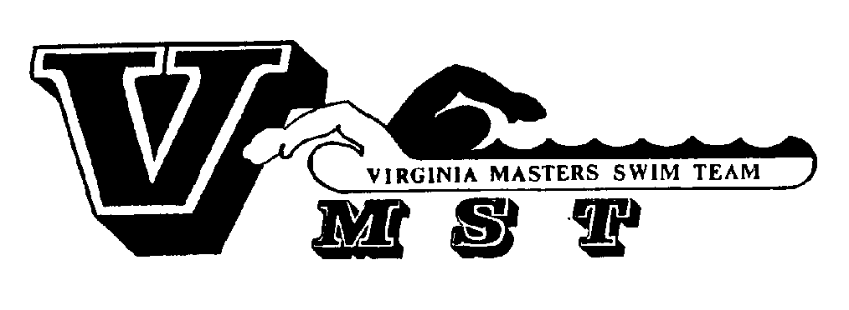
Seeding: Swimmers will be seeded fastest to slowest according to 1650 seed time and will be started in waves of 10 swimmers, staggered at 30-second intervals. “No Time” entries will be seeded in the final wave. Seeding changes will not be allowed on race day.

Age Groups: 18-24, 25-29, etc. in 5-year increments, for both men/women. Your age as of 12/31/17 will be used.
Awards/ Social: For both races, custom awards will be given to the top 3 men & women finishers in each age group. The awards ceremony will take place on the beach following the 1-mile race. Drinks and snacks will be provided.

Accommodations:
Courtyard Marriott Double Tree Hotel
(8.5 miles from lake) (6 miles from lake)
638 Hillsdale Dr. 990 Hilton Heights Rd.
Ch’ville, VA 22901 Ch’ville VA 22901
(434) 973-7100 (434) 973-2121
Or check www.cableswim.org for other options

Directions: (mapquest “Chris Greene Lake Park”)

from Washington, D.C:
(Distance: 115 miles, Drive Time: ~ 2 to 2.5 hours)
Take Rt. 29 toward Charlottesville, VA. In Earlysville, turn right onto Airport Rd. (Rt. 649). Travel 7/10 mile toward airport. At roundabout, bear right onto 606. Go 1.2 miles and turn left onto Chris Greene Lake Rd. Proceed past guardhouse and follow the road downhill and around the lake to the parking lot at the end of the road.

from Richmond, VA:
(Distance: 75 miles, Drive Time: ~ 90 minutes)
Take I-64 West to exit 124, Charlottesville/Shadwell, (U.S. 250 West), to U.S. 29 North. Follow U.S. 29 North approximately 6 miles to Airport Rd. (Rt. 649). Turn left onto Airport Rd., go 7/10 mile toward airport and follow the underlined directions above.

from Waynesboro, VA:
(Distance: 34 miles, Drive Time: ~ 45 minutes)
Take l-64 East to exit 118B, Charlottesville/Culpeper, (U.S. 29 North Bypass), to U.S. 29 North. Follow U.S. 29 North approximately 6 miles to Airport Rd. (Rt. 649). Turn left onto Airport Rd., go 7/10 mile toward airport and follow the underlined directions above.

Race Director Contact:
Kate Stephensen (530) 574-4498
Email: kands606@gmail.com

2017 John Shrum Memorial Cable Swim ENTRY FORM
Avoid this form, avoid errors by registering online at www.cableswim.org PLEASE INSERT SEED TIME
FOR EVENT(S) YOU ARE ENTERING

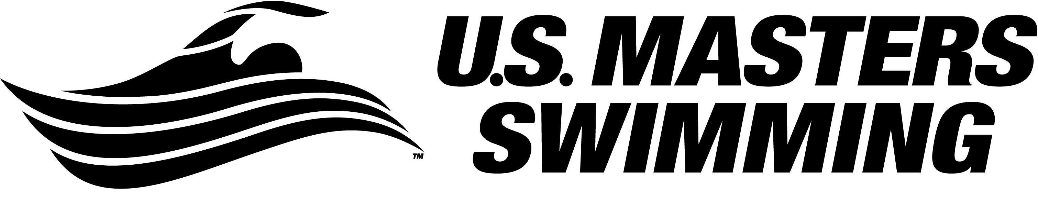 PLEASE STAPLE A LEGIBLE COPY OF YOUR 2017 CARD HERE. TRIM YOUR CARD AND COMPLETE THE FOLLOWING:
Emergency Contact Name: ____________________________________
Emergency Contact Phone: ____________________________________
Significant medical conditions to be shared with Albemarle Rescue (i.e. seizures, diabetes, asthma, etc.): _________________________________

2- MILE  8:30 am | Clockwise | 1650 yd time:  ____ : ____
1- MILE  10:30 am | Counter-Clockwise | 1650 yd time:  ____ : ____

 |  |  | CHECKLIST
$______ | $ 39.00 1-Mile Cable Entry Fee | □ | Completed entry form
$______ | $ 49.00 2-Mile Cable Entry Fee | □ | Copy of USMS card
$______ | T-Shirt: included free with entry; $ 3.00 charge for XXL or XXXL | □ | Check or money order payable to VMST
$______ | Additional T-Shirt: $15.00 each S-XL, $18.00 for XXL or XXXL | □ | Signed Waiver (next page)
$______ | Total Enclosed (Check or money order payable to VMST) | □ | T-Shirt Size Below

T-Shirt Size: (please circle) S M L XL XXL XXXL
Additional T-Shirts: indicate quantity and size:_________________________________

Please use the checklist above to ensure that your entry is complete!!
Mail this completed form with check or money order payable to VMST, postmarked by June 30, 2017 to:
Kate Stephensen, (address here)

Name:_______________________________ Email address:_____________________________________________

Phone Number: ___________________________ Age as of Dec. 31, 2017: ____________________

YOU MUST READ AND SIGN THE WAIVER (NEXT PAGE).
INCLUDE THIS PAGE AND THE NEXT WITH YOUR ENTRY.

 PARTICIPANT WAIVER AND RELEASE OF LIABILITY,
ASSUMPTION OF RISK AND INDEMNITY AGREEMENT

For and in consideration of United States Masters Swimming, Inc. (“USMS”) allowing me, the undersigned, to participate in any USMS sanctioned or approved activity, including swimming camps, clinics, and exhibitions; learn-to-swim programs; swimming tryouts; fitness and training programs (including dryland training); swim practices and workouts (for both pool and open water); pool meets; open water competitions; local, regional, and national competitions and championships (both pool and open water); and related activities (“Event” or “Events”); I, for myself, and on behalf of my spouse, children, heirs and next of kin, and any legal and personal representatives, executors, administrators, successors, and assigns, hereby agree to and make the following contractual representations pursuant to this Waiver and Release of Liability, Assumption of Risk and Indemnity Agreement (the “Agreement”);

- I hereby certify and represent that (i) I am in good health and in proper physical condition to participate in the Events; and (ii) I have not been advised of any medical conditions that would impair my ability to safely participate in the Events. I agree that it is my sole responsibility to determine whether I am sufficiently fit and healthy enough to participate in the Events.

- I acknowledge the inherent risks associated with the sport of swimming. I understand that my participation involves risks and dangers, which include, without limitation, the potential for serious bodily injury, sickness and disease, permanent disability, paralysis and death (from drowning or other causes); loss of or damage to personal property and equipment; exposure to extreme conditions and circumstances; accidents involving other participants, event staff, volunteers or spectators; contact or collision with natural or manmade objects; dangers arising from adverse weather conditions; imperfect water conditions; water and surface hazards; facility issues; equipment failure; inadequate safety measures; participants of varying skill levels; situations beyond the immediate control of the Event organizers; and other undefined, not readily foreseeable and presently unknown risks and dangers (“Risks”). I understand that these Risks may be caused in whole or in part by my own actions or inactions, the actions or inactions of others participating in the Events, or the negligent acts or omissions of the Released Parties defined below, and I hereby expressly assume all such Risks and responsibility for any damages, liabilities, losses or expenses that I incur as a result of my participation in any Events.

- I agree to be familiar with and to abide by the Rules and Regulations established by USMS, including any safety regulations. I accept sole responsibility for my own conduct and actions while participating in the Events.

- I hereby Release, Waive and Covenant Not to Sue, and further agree to Indemnify, Defend and Hold Harmless the following parties: USMS, its members, clubs, workout groups, event hosts, employees, and volunteers (including, but not limited to, event directors, coaches, officials, judges, timers, safety marshals, lifeguards, and support boat owners and operators); the USMS Swimming Saves Lives Foundation; USMS Local Masters Swimming Committees (LMSCs); the Event organizers and promoters, sponsors and advertisers; pool facility, lake and property owners or operators hosting the Events; law enforcement agencies and other public entities providing support for the Events; and each of their respective parent, subsidiary and affiliated companies, officers, directors, partners, shareholders, members, agents, employees, and volunteers (individually and collectively, the “Released Parties”), with respect to any liability, claim(s), demand(s), cause(s) of action, damage(s), loss or expense (including court costs and reasonable attorneys’ fees) of any kind or nature (“Liability”) which may arise out of, result from, or relate in any way to my participation in the Events, including claims for Liability caused in whole or in part by the negligent acts or omissions of the Released Parties.

- I further agree that if, despite this Agreement, I, or anyone on my behalf, makes a claim for Liability against any of the Released Parties, I will indemnify, defend and hold harmless each of the Released Parties from any such Liabilities which any may be incurred as the result of such claim.

I hereby warrant that I am of legal age and competent to enter into this Agreement, that I have read this Agreement carefully, understand its terms and conditions, acknowledge that I will be giving up substantial legal rights by signing it (including the rights of my spouse, children, heirs and next of kin, and any legal and personal representatives, executors, administrators, successors, and assigns), acknowledge that I have signed this Agreement without any inducement, assurance, or guarantee, and intend for my signature to serve as confirmation of my complete and unconditional acceptance of the terms, conditions and provisions of this Agreement. This Agreement represents the complete understanding between the parties regarding these issues and no oral representations, statements, or inducements have been made apart from this Agreement. If any provision of this Agreement is held to be unlawful, void, or for any reason unenforceable, then that provision shall be deemed severable from this Agreement and shall not affect the validity and enforceability of any remaining provisions.

Last Name | First Name | MI | Sex (circle)  M F |  | Date of Birth (mm/dd/yy)
Street Address, City, State, Zip
Signature of Participant |  |  |  | Date Signed
Revised 07/01/2014

