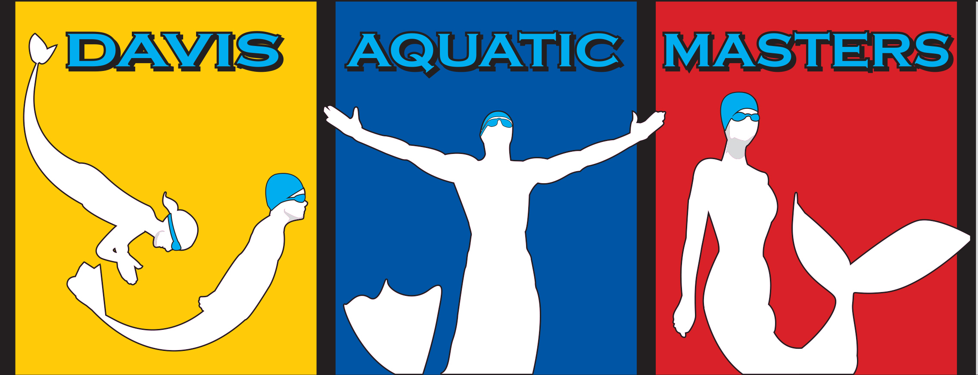
35th DAM Lake Berryessa Swim
Saturday, June 3, 2017

Open Water Registration

Sanction: Sanctioned by Pacific Masters Swimming for US Masters Swimming. (#pending)
Location: Steele Canyon Campground, Lake Berryessa, Napa, CA
Course: 1-mile, and 2-mile single loop
Host: Davis Aquatic Masters. Event website: DAM Lake Berryessa Swim
Facebook: fb-DAMLake Berryessa Swim
Info: Race Director: Stuart Kahn berryessa@damfast.org
Timing and Scoring: Big Sky Endurance Sports, Reno, NV
Rules: This event will be governed by 2017 USMS Rules for Open Water Swimming.
Conditions/Safety: Expected water temperature is 65-70 degrees F; air temperature average is 70-80 degrees F. Each course is patrolled by safety craft. Individual escorts are not allowed. All swimmers must wear the provided swim cap and follow all USMS rules. Mandatory safety briefings will be held at 9:00 a.m. and at 10:45 a.m. at the information kiosk. The Event Safety Plan will be posted at the registration desk on race day and is available prior to race day by request from berryessa@damfast.org.
Start: Deep water, wave starts (see below)
Finish: Onshore
Course: 1-mile, and 2-mile single loops, freshwater lake. Course cutoff times are 1 hour for the mile mile races and 2 hours for the 2 mile races.
Eligibility: This event is open to USMS registered swimmers or members of an equivalent FINA organization (for foreign swimmers). To register for the event, you must provide proof of current membership. You may register for a USMS One-Day Event Membership during the online entry process.
Entry deadline: Online registration closes Wednesday, May 31, 2017 at 11:59 PM (Eastern time); paper entries must be received by Thursday, May 25, 2017.
Entries: Online entry at: www.clubassistant.com For a paper entry form, email berryessa@damfast.org.

Fees:
Early Bird (ends 5/4/2017) Regular (ends 5/31/2017) Race Day (6/3/2017)
$40 1 or 2 mile $45 1 or 2 mile $50 1 or 2 mile
$55 Both swims $60 Both Swims $65 Both swims
$5 USMS Insurance surcharge (once per swimmer)
Additional processing fees (approximately 2% of total charges) are applied to online entries.
Entry fees are non-refundable and non-transferable.
Online entry is paid by credit card to “ClubAssistant.conm Events”
Fees include:
- Swim cap
- Official Berryessa Mug (guaranteed only for Early Bird and Regular entrants. Race Day mugs subject to availability.
- Post Race refreshments
- Online Race Results
Awards: Awards will be presented to the top 3 swimmers in each age and gender group for each of the other events, except the Combined. The top male and female finishers in the combined event will receive a separate award.
Other Event Details:
Snacks, water, and sports drink will be provided to all competitors
Commemorative t-shirts may be purchased during online or mail-in registration
Two Food Trucks will be onsite to provide race-day purchased lunches.
Limited quantities of merchandise and meals may be available for purchase at the event.
Lodging: Primitive (no water or electricity) campsites are available at Steele Canyon, contact Stuart Kahn for reservations. Full hookup camping sites are available at Pleasure Cove Marina (http://goberryessa.com, click on “Forever Resorts Marinas”). Nearest hotels are in Napa, Vacaville, or Fairfield.
Anticipated timeline:
Check-in and Race Day registration open at 7:30 a.m.
Check-in and Race Day registration close at:
9:15 a.m. for USMS, Category 1, 2-mile
9:45 a.m. for USMS, Category 2, 2-mile
10:30 a.m. for USA-Swimming 1-mile
11:05 a.m. for USMS, Category 1, 1-mile
11:30 a.m. for USMS, Category 2, 1-mile
(note: Category 1=non-wetsuit or approved FINA swim suit. Category 2=wetsuit or unapproved FINA swim suit)

Swim Schedule
Wave | Age Group | Event | Start Time | Race Close Time
1 | 18-39 Men | USMS 2-mile, Category 1 | 9:30 a.m. | 11:30 a.m
2 | 18-39 Women | USMS 2-mile, Category 1 | 9:35 a.m. | 11:35 a.m.
3 | 40&Up Men | USMS 2-mile, Category 1 | 9:45 a.m. | 11:45 a.m.
4 | 40&Up Women | USMS 2-mile, Category 1 | 9:50 a.m. | 11:50 a.m.
5 | Men & Women | USMS 2-mile, Category 2 | 10:00 a.m. | 12:00 p.m.
6 | 18-39 Men | USMS 1-mile, Category 1 | 11:20 a.m. | 12:20 p.m.
7 | 18-39 Women | USMS 1-mile, Category 1 | 11:25 a.m. | 12:25 p.m.
8 | 40&Up Men | USMS 1-mile, Category 1 | 11:30 a.m. | 12:30 p.m.
9 | 40&Up Women | USMS 1-mile, Category 1 | 11:35 a.m. | 12:35 p.m.
10 | Men & Women | USMS 1-mile, Category 2 | 11:40 a.m. | 12:40 p.m.
DAM is a 501(c)(3) organization that supports local swimming related organizations and swimmers with donations and scholarships. All proceeds support the DAM mission.

