YMCA Masters National Meet

MAY 4-7, 2017

Selby Aquatic Center
Evalyn Sadlier Jones Branch
8301 Potter Park Drive
Sarasota FL 34238
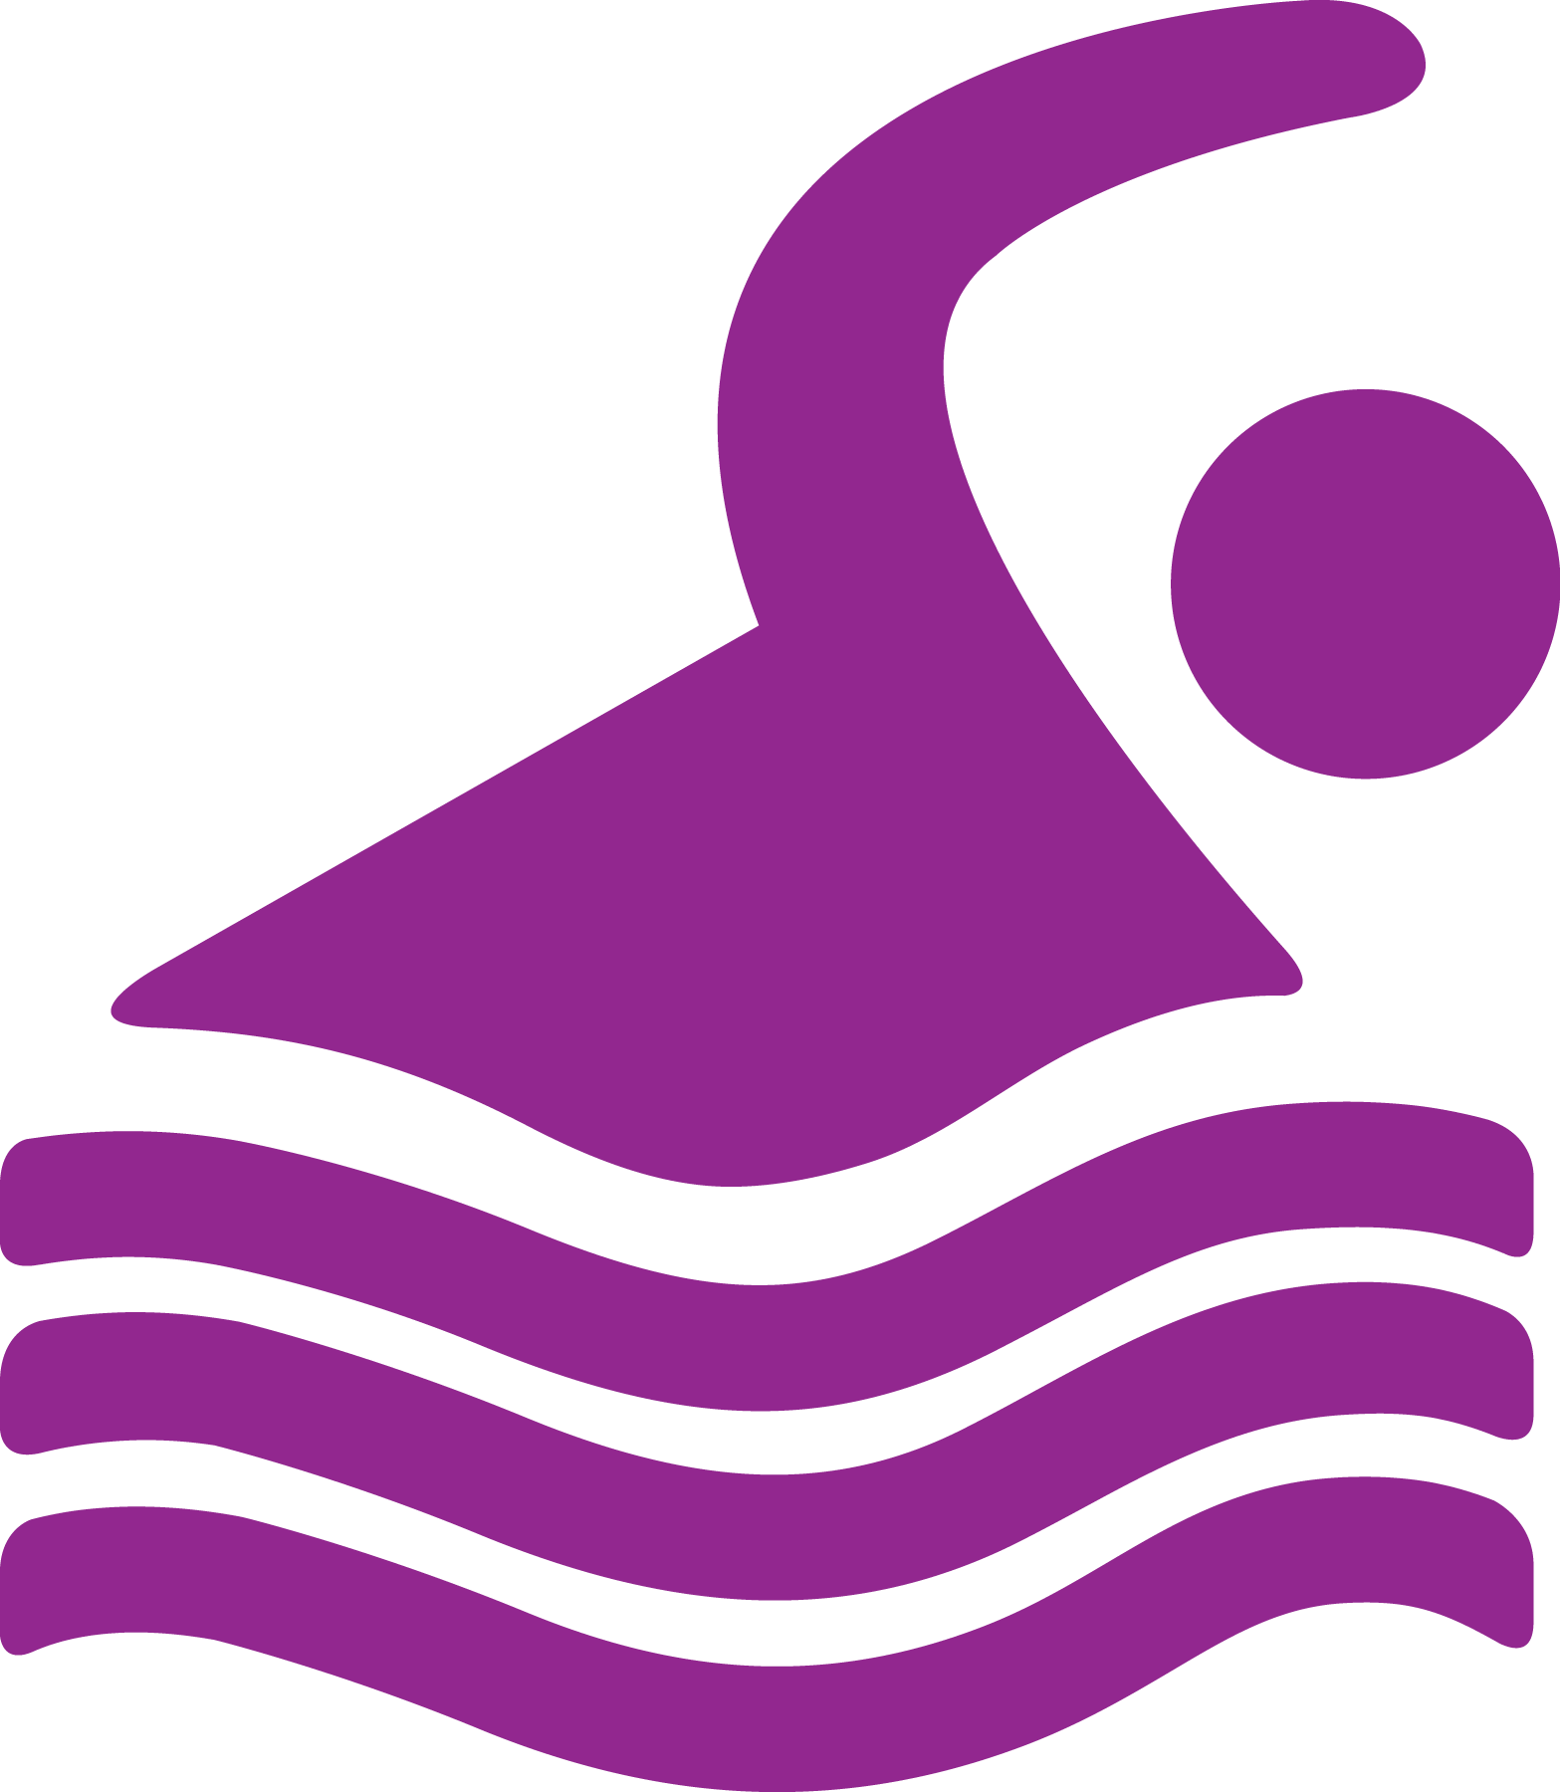

2017 Notes

Entries ARE due ON OR bEFORE Thursday, April 13, 2017

ALL Entries MUST BE COMPLETED online with Club assistant
https://www.clubassistant.com/club/meet_information.cfm?c=1709&smid=2950

When entering, ALL swimmers (you) should choose your YMCA from the drop down list. Please verify the address for your YMCA. If the address is missing, please supply the address.

Eligibility (Membership) - You must be a member of the YMCA that you are representing on April 7, 2017 and the membership must be valid (in good standing) through May 7, 2017. During the entry process, you will be asked for an electronic signature verifying the above.

National Council of Young Men's Christian Associations of the United States of America (YMCA of the USA, we or us) is allowing 5 individual events per day and 12 total individual events per meet.

Relays - You may enter relays prior to the meet or at the meet. Send relay entries prior to the meet to Claudia Multer (claudiam@fioptics.com). Relay entries must be received by April 20, 2017.

All relay entries are due by 1 PM the day before they are swum - Only swimmers on the roster on or before April 13, 2017 are eligible for relays. The relay cards will be available the next morning. Pick them up and take them to the blocks. Names can be changed on the card. The cards will be picked up at the blocks after the event and changes will be made in the computer.

All pools – Open only to participants in the 2017 YMCA Masters meet during specified warmup, warm down and competition hours.

Social – The Meet Social for 2017 will be held at the beautiful and #1 ranked beach in the world (2011) - Siesta Beach, FL (http://www.bestbeaches.org/best-beaches/siesta-key-beaches/). Guests will enjoy food, drink and socializing in the newly renovated picnic area then relax and view the fabulous sunsets Siesta is known for.

The Social will start at 6pm with sunset approximately around 7:55pm - don’t miss it! The address for Siesta Beach is 948 Beach Road, Sarasota, FL 34242. Parking is free.

Tickets for the Social are $25 – tickets should be ordered as you complete your entry.

We hope to see you there!

YMCA MASTERS NATIONAL MEET
May 4-7, 2017

Approved and hosted by the YMCA National Swimming and Diving Advisory Committee.
Recognized by Florida Gold Coast for United States Masters Swimming, Inc.

MEET  FACILITY | Conducted at the Sarasota YMCA – Selby Aquatic Center. The facility consists of:  - A 16 lane, 50 meter Olympic size pool  - Separate warm-up/warm down lanes available throughout the meet.  - Colorado Timing System to be used as the primary time, with a backup and a watch time on each lane.  - Ample covered stadium seating for those who wish to use it.
RULES | Current “Rules That Govern YMCA Competitive Sports” will apply.  Current USMS technical rules will apply unless otherwise noted in this meet information.
DISABILITY | Swimmers with hearing or sight concerns should confer with the starter/referee prior to their events in order that assistance may be provided. Swimmers with physical disabilities may assume a starting position prior to other participants in a heat.
ELIGIBILITY | Every athlete MUST be a current member of the YMCA that they are representing and that membership must be effective April 4, 2017 through May 7, 2017.  A swimmer must be an amateur athlete in the competitive season in swimming and be age 18 or older on the last day of the meet.  All swimmers are strongly encouraged to have a physical examination/medical evaluation prior to competing in the meet.
CERTIFICATE OF LIABILITY INSURANCE  Check the website for correct wording.  The athlete must inform the YMCA that they need the Certificate of Insurance.  WAIVER  SIGNATURE | YMCA TEAMS THAT DO NOT COMPLY WITH THE CERTIFICATE OF LIABILITY INSURANCE REQUIREMENT WILL NOT BE ALLOWED TO SWIM AT THE MEET.  Each team, consisting of one or more individuals, must submit a “Certificate of Liability Insurance” from their YMCA in the minimum amount of $1,000,000/$2,000,000. The certificate must name the YMCA of the USA as the Certificate Holder (see sample).  The “Certificate of Liability Insurance” must be sent directly to the YMCA of the USA as soon as possible, but no later than April 13, 2017. Send it to:  YMCA of the USA  Attn: Robin Lee  101 North Wacker Drive  Chicago, IL 60606  You will be asked for an electronic signature twice in the entry process.  One signature is the following liability release that used to be on the paper entry form:  Liability Release  I, the undersigned participant, intending to be legally bound, hereby certify that I am physically fit and have not been otherwise informed by a physician. I acknowledge that I am aware of all the risks inherent in Master's swimming (training and completion) including possible permanent disability or death, and agree to assume all of those risks. I hereby waive any and all rights to claims for loss or damage arising out of my participation in the YMCA Masters swimming program or any activities incident thereto against the YMCA of the USA, the YMCA National Swimming and Diving Advisory Committee, the Sarasota YMCA or their respective officers, meet committee, employees, agents and directors, or any individuals officiating, as a condition of my participation in the 2017 YMCA Masters National Swimming Meet to be held May 4-7, 2017.
MEMBERSHIP  SIGNATURE | You will also be asked for an electronic signature with the following statement verifying that your membership is current and will be through May 7, 2017.  Membership statement  I verify that I am a current member of ______________ YMCA, Association I.D. Number __________ and my membership will be in good standing through May 7, 2017.

Photo  Release | By registering for this meet, you hereby agree to the following release:  For my participation in this meet and activities to be conducted by the National Council of Young Men's Christian Associations of the United States of America (YMCA of the USA), I give my consent, now and for all time, to YMCA of the USA, and collaborating third parties to make, reproduce, edit, broadcast or rebroadcast:  - video film or footage of me  - sound track recordings of me  - photo reproductions of me any narrative account of my experience  My consent gives permission to use the above materials for publication, display, sale or exhibition in promotions, advertising, education and legitimate business uses. Use includes reproductions in any form and media, adaptations and/or revisions, throughout the world and forever.  I understand and agree there may be no compensation for this, and I will not make any claim for payment of any kind. I may, or may not be, identified in such reproductions; however, my name will not be used to endorse any particular commercial products or commercial services.  Ownership, Confidentiality, and Shared Use. With respect to any of the above uses, I further agree:  - All uses shall belong to YMCA of the USA and they may share them with others;  - There is no obligation of confidentiality  - YMCA of the USA and collaborating third parties will not be liable for any use or disclosure to a third party  - YMCA of the USA shall exclusively own all known or later existing rights to the uses worldwide.  - YMCA of the USA can use any video film, footage, sound track recordings and photo reproductions of me and/or my narrative account for any purpose and without compensation to me.  Release from Liability. I agree that my consent is irrevocable. I hereby release and discharge YMCA of the USA and related parties and those they have given permission to use the above, from any and all claims, actions, lawsuits or demands of any kind arising out of my consent, the use, or the shared use of the above materials.

YMCA of the usa PHOTO release form
 | INDIVIDUAL  ENTRIES |  | A swimmer may enter no more than five (5) individual events per day, and no more than twelve (12) individual events for the entire meet.  Individual Event Entry Fee - $8.50  A swimmer’s age group is determined by that swimmer’s age on the last day of the meet, April 13, 2017. Age groups are as follows: 18-24, 25-29, 30-34, 35-39, 40-44, 45-49, 50-54, 55-59, 60-64, 65-69, 70-74, 75-79, 80-84, 85-89, 90-94, 95-99, and 100+.  There are no qualifying time standards for this meet. A swimmer should enter his/her best achieved time for each event entered. An entry time of “NO TIME” will NOT be accepted.  A swimmer interested in USMS records must submit a current USMS membership number.
 | RELAY ENTRIES |  | All members of a relay must be from the same YMCA in order to compete. Women’s relays must consist of four women. Men’s relays must consist of four men. Mixed relays may be made up of two women and two men or three women and one man. Mixed relays going for a USMS record must be two women and two men. All relay competitors must be on the roster April 13, 2017. Relays going for a USMS record must be registered on the same USMS team.  Relay Event Entry Fee $20.00  Teams wishing to enter relays prior to the meet may submit them by emailing claudiam@fioptics.com.  Coaches will be able to see their team roster on Club Assistant
 | REGISTRATION |  | ALL PARTICIPANTS MUST REGISTER BEFORE THEY CAN SWIM IN THE MEET. Heat sheets and tickets for the social will be distributed at registration. Coaches may also pick up their relay cards at registration.  Registration will be conducted at Sarasota Complex from 4:00 PM to 6:30 PM, Wednesday, and registration will continue on Thursday through Sunday from 7:00 AM to 11:00 AM (or until the conclusion of competition).
 | WARM-UP TIMES |  | All pools – competition and warm-up warm-down areas are reserved for participants in the 2017 YMCA Masters meet.  Wednesday 4 PM to 7 PM  Thursday-Sunday 7 AM to end of session  Warm-Up/Warm-Down lanes will be specified  The meet starts at 8 AM each day
 | SCRATCHES |  | Any swimmer failing to report to the proper lane in the correct heat of an event shall be scratched from that event and shall not be permitted to swim that event at another time.
 | SCORING &  AWARDS  AWARDS WILL NOT BE MAILED  TEAM AWARDS |  | Medals will be awarded for 1st through 8th place in both individual and relay events.  PICK UP AWARDS PROMPTLY. Medals that have not been picked up will not be mailed.  We do not promise to remain at the pool more than 30 minutes after the meet. The medals will be packed up and can no longer be accessed.  Team awards will be given to the first place men’s team, first place women’s team, and first through fifth place combined teams. (No large and small team divisions)
 | RECORDS |  | YMCA records are posted on the web site. Records for each event will be updated automatically. Lead-off splits of relays will be automatic. Initial splits will be recognized if you stop at the starter’s podium on your course and fill in the information on the spreadsheet.
 | SPLITS |  | Relay lead off splits will be automatic. Initial splits can be requested by seeing the referee on each pool.  They will keep a list on the clipboard which will be turned in to the scoring room.
 | PARKING |  | There is ample parking at the facility. All parking is free.
RESULTS |  | Final results will be posted in printable format on the web site www.ymcaswimminganddiving.org.  Results will also be found on SwimPhone and Meet Mobile.
HOUSING |  | Check the website for housing information. The Stay With Us program does benefit the swimming program. Last year, some of the funds helped fund swimmers who could not afford to attend nationals (age group). Learn to Swim programs have received help from the funds raised by Stay with Us. Please consider using the hotels we’ve listed on the website.

YMCA MASTERS NATIONAL MEET
2017 ORDER OF EVENTS
WOMEN | MEN | EVENT
THURSDAY, MAY 4, 8:00 AM
101 | 102 | 1650 | YARD | FREESTYLE * (see note below)
103 | 104 | 1000 | YARD | FREESTYLE * (see note below)
FRIDAY, MAY 5, 8:00 AM
201 | 202 | 400 | YARD | INDIVIDUAL MEDLEY * (see note below)
203 |  | 200 | YARD | MIXED MEDLEY RELAY
205 | 206 | 50 | YARD | BACKSTROKE
207 | 208 | 200 | YARD | BREASTSTROKE
209 | 210 | 200 | YARD | FREESTYLE
211 | 212 | 50 | YARD | BUTTERFLY
213 | 214 | 400 | YARD | FREESTYLE RELAY
SATURDAY, MAY 6, 2017 8:00 AM
 | 302 | 500 | YARD | FREESTYLE (MEN)* (see note below)
 |  |  |  | (15 MINUTE WARM-UP)
303 | 304 | 200 | YARD | FREESTYLE RELAY
305 | 306 | 100 | YARD | BREASTSTROKE
307 | 308 | 200 | YARD | BUTTERFLY
309 | 310 | 200 | YARD | BACKSTROKE
311 | 312 | 50 | YARD | FREESTYLE
313 | 314 | 100 | YARD | INDIVIDUAL MEDLEY
315 | 316 | 200 | YARD | MEDLEY RELAY
SUNDAY, MAY 7, 8:00 AM
401 |  | 500 | YARD | FREESTYLE (WOMEN) * (see note below)
 |  |  |  | (15 MINUTE WARM-UP)
403 |  | 200 | YARD | MIXED FREESTYLE RELAY
405 | 406 | 100 | YARD | BACKSTROKE
407 | 408 | 200 | YARD | INDIVIDUAL MEDLEY
409 | 410 | 100 | YARD | BUTTERFLY
411 | 412 | 50 | YARD | BREASTSTROKE
413 | 414 | 100 | YARD | FREESTYLE
*These events will be seeded by time, slowest to fastest. All other events
will be seeded by age group and then by time, slowest to fastest.

