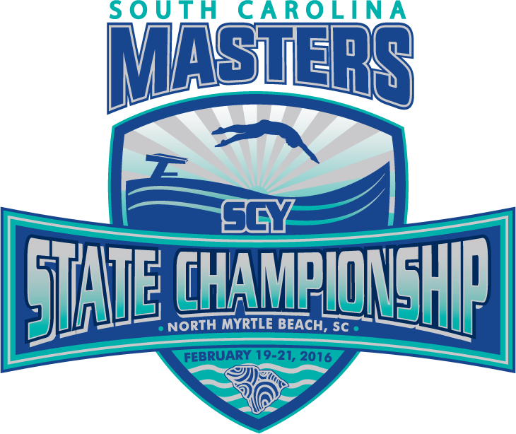
South Carolina SCY Championship
February 10-12, 2017

Meet Location: North Myrtle Beach Aquatic & Fitness Center, 1100 2nd Avenue South,
North Myrtle Beach, SC 29582 843/281-3737

Host: The North Myrtle Beach Aquatic & Fitness Center & Grand Strand Masters Swimming

Sanction: Sanctioned by South Carolina LMSC for USMS, Inc. Sanction:

Meet Director: Diane Bartlett, dcbartlett@nmb.us

Facility: Indoor facility with an eight-lane 25-yard competition pool and a separate 4 lane warm down pool. Six lanes will be reserved for swimming events; two lanes will be used as warm-up and cool down lanes. Fully automatic Colorado timing system and display. Non-turbulent lane lines; KDI Paragon starting blocks. Deck space and some bleacher seating available. Please bring your own chairs. Website: www.nmb/afc
Entry Limit: Ten (10) individual events total, max of five (5) individual events per day, plus relays. The 1650 Free WILL BE LIMITED TO THE FIRST 48 ENTRIES RECEIVED. Each swimmer entered in the 1650 is responsible for providing a person to count his/her laps. The 1000 split will be recorded.
Rules: The meet will be conducted according to 2017 U.S.M.S. rules and this meet information. The length of the competition course without a bulkhead is in compliance and on file with USMS in accordance with articles 105.1.7 and 107.2.1. Men and women will swim together.

Warm-up Procedures: Pull-buoys, kick boards, fins, and hand paddles are not allowed in the competition pool or warm-up pool. Swimmers must enter the pool feet first in a cautious and controlled manner. Diving shall be permitted only in the designated lanes and at designated times.

Eligibility: This meet is open to all USMS swimmers registered for 2017. When registering for this meet, your USMS membership will be verified instantly online. The eligibility of a participant for a particular age group will be determined by the age as of the last day of the meet. One-event registrants will be considered unattached and agree to be governed by the rules and regulations of USMS, except that their times shall not be considered for state records, Top Ten tabulation, USMS or world records, All-American status, or any other USMS special awards.

Fees: $40.00 flat fee per swimmer. No charge for relays. Deck entries will be accepted for available lanes only at $5.00 per event plus the $15.00 swimmer surcharge. Online meet entries are paid by Visa, MasterCard, or Discover. Your credit card statement will reflect a charge by
"ClubAssistant.com Event Billing."

Entries:
Online entries required at Club Assistant must be completed by midnight eastern time on
February 5, 2017. A psych sheet will be posted at www.sportstiming.com on or before Tuesday,
February 7th. Corrections will be accepted until 2:00pm on Wednesday, February 8th. IT IS YOUR RESPONSIBILITY TO CHECK THE WEBSITE FOR ERRORS WITH YOUR ENTRY. THE MEET WILL NOT
BE RE-SEEDED AFTER February 8th.
Time of Meet: Warm-up Friday for 1650 Free at 5:00pm. Meet starts at 6:00pm. Warm-up Saturday starts at 8am. Meet starts at 9:00am. Warm-up Sunday at 8:00am. Meet starts at 9:00am.

Awards: Individual event ribbons 1st-8th place in each age group. High point award for each age group (minimum of at least five events to qualify). Team awards to the top 3 teams in and out of state.
Team Points will be awarded by age group with men and women being scored separately.
Individual: first through eighth: 9-7-6-5-4-3-2-1
Relays: first through eighth: 18-14-12-10-8-6-4-2

T-Shirt: A commemorative long and short sleeve dri-fit will be available.

Seeding: Heats will be seeded from slowest to fastest using submitted yard times. Ages and sexes will be combined for competition but separated for awards. No time (NT) entries will be seeded in early heats. All events 400 yards and longer will be deck seeded fastest to slowest. Positive Check-in for the 1650, 500 and 400IM is required and will close 30 minutes before the start of the event/meet. Swimmers not checked in will be scratched.
Hotels: The North Myrtle Beach Aquatic & Fitness Center has special arrangements with the following resort for this swim meet:
Avista Resort. This oceanfront property located at 300 North Ocean Blvd in North Myrtle Beach is less than 3 miles from the Aquatic & Fitness Center. They will offer room rates beginning at $61.00+ taxes/fees per night. The group code is 2202610. To make your reservation call 877-238-4487 between 7am and midnight. The cutoff date for booking is 1/10/17.

SATURDAY NIGHT SWIM SOCIAL
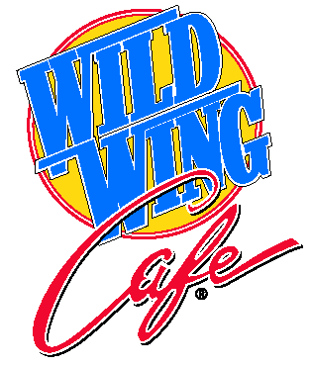
Swimmers, Coaches, Officials,
Volunteers, Families & Friends

Join everyone at the WILD WING CAFÉ at
Barefoot Landing 6:30pm until ????

South Carolina 2017 SCY Championships

Name_________________________________________Sex_____Age_____ DOB _________

Address_____________________________________________________________________

Team ____________________________________Abbreviation _______ U.S.M.S. #_________

Daytime Phone_______________Evening Phone____________Email_____________________

Friday February 10, 2017
Warm-up 5:00 pm; Meet starts at 6:00pm

#1 1650 Freestyle** (limited to the first 48 entries, seeded fast to slow, 8 lanes)

Saturday February 11, 2017 Sunday February 12, 2017
Warm-up 8:00am; Meet starts at 9:00am Warm-up 8:00am; Meet starts at 9:00a
#2 500 Free** #13 400 IM**
#3 100 IM #14 50 Fly
#4 50 Back #15 200 Breast
#5 100 Fly #16 100 Free
#6 200 Men’s Free Relay #17 200 Men’s Medley Relay
#7 200 Women’s Free Relay #18 200 Women’s Medley Relay
5 Minute Break 5 Minute Break
#8 200 Back #19 50 Breast
#9 100 Breast #20 100 Back

#10 50 Free #21 200 Free

#11 200 Mixed Medley Relay #22 200 Mixed Free Relay
#12 200 IM #23 200 Fly

*All events, except the 1650, 500 and 400IM, will be seeded by time slow to fast regardless of age or gender.
**POSITIVE CHECK-IN REQUIRED AND CLOSES 30 MINUTES PRIOR TO START OF EVENT
Total Event Charges
Meet Registration $40.00
USMS One Day Event Registration $15.00 (for non USMS registered swimmers only)

Total Enclosed =____________

Release from Liability: I, the undersigned participant, intending to be legally bound, do hereby certify that I am physically fit and have not been otherwise informed by a physician. I acknowledge that I am aware of all the risks inherent in Masters Swimming (training and competition) including possible permanent disability or death, and agree to assume all of those risks. AS A CONDITION OF MY PARTICIPATION IN THE MASTERS SWIMMING PROGRAM OR ANY ACTIVITIES INCIDENT THERETO, I HEREBY WAIVE ANY AND ALL RIGHTS TO CLAIMS FOR LOSS OR DAMAGES, INCLUDING ALL CLAIMS FOR CLAIMS FOR LOSS OR DAMAGES CAUSED BY NEGLIGENCE, ACTIVE OR PASSIVE, OF THE FOLLOWING: UNITED STATES MASTERS SWIMMING, INC., THE LOCAL MASTERS SWIMMING COMMITTEES, THE CLUBS, HOST FACILITIES, MEET SPONSORS, MEET COMMITTEES, OR ANY INDIVIDUALS OFFICIATING AT THE MEETS OR SUPERVISING SUCH ACTIVITIES. In addition, I agree to abide by and be governed by the rules of USMS. (Rule Book Article 203.1)

SIGNATURE: ________________________________________________________________________ DATE:______________________
(Waiver must be signed in order to participate)

