THE 11th ANNUAL DAYTON AREA SHARKS
MASTERS SWIM MEET AND PENTATHLON
(SHORT COURSE YARDS)
Saturday, December 3, 2016
Sanctioned by Ohio LMSC and USMS, Inc. Sanction TBD

HOST TEAM Dayton Area Sharks

CONTACT Meet Director Barb Riazzi barbriazzi@hotmail.com

LOCATION Dayton Raiders Aquatic Center
560 Grange Hall Rd.
Beavercreek, OH 45430
937-426-9622

FACILITY
DRAC offers a 25-yard by 8-lane pool. Six lanes will be used for the competition. Two lanes will be available for continuous warm up/warm down. Lockers are available to swimmers (bring your own lock).

ELIGIBILTY
Open to all swimmers who are registered with USMS. Each swimmer is responsible for his/her USMS card and will be required to show it upon request by officials.

AGE
The age reported on your entry form must reflect your age the day of the meet, December 3, 2016.

ENTRY FEES AND REGISTRATION
A fee of $30 will be charged for advance entries using Club Assistant. Advance entries must be received on or before midnight Thursday, December 1. Deck entries will be accepted between12:30 PM and 1:15 PM the day of the meet. A flat fee of $45 will be charged for deck entries. Each swimmer can sign up for a maximum of five individual events and three relay events.

PENTATHLON
Those swimmers interested in racing in the sprint pentathlon must sign up for all five individual events of the pentathlon (Event #2, #5, #8, #11, and #14). Pentathlon swimmers are still allowed to swim up to three relay events in addition to the five individual pentathlon events. The pentathlon final results shall be created by adding each swimmer's time in the 50 fly, 50 back, 50 breast, 50 free, and the 100 IM to result in one final pentathlon time.

Looking for more of a challenge?? Enter the middle distance pentathlon (100s of each stroke and 200 IM) or the Super Pentathlon (200s of each stroke and 400 IM)

You are not required to enter any of the pentathlon combinations – choose any events you wish to swim.

AWARDS
Individual and relay awards will be given for first through third place by gender and age group for 18-24, 25-29, 30-34, 35-39, 40-44, etc... Spectacular Bobble-head Trophies will be given to sprint pentathlon winners in each of these age groups. Those participants who pre-enter the middle distance pentathlon or the super pentathlon and complete all 5 events will receive a special prize.
RELAYS
All relays are deck entered. Relay categories may include men (all male participants), women (all female participants), and mixed (a minimum of two female participants). The youngest age of the four relay team members shall determine the age group (e.g. 18+, 25+, 35+, 45+, etc…). Official relay cards are to be picked up from the timing table and then filled out by a team representative. Relay cards shall be returned to the timing table by 12:30 PM on the day of the meet.
Event 9 – the 200 freestyle relay will be a social relay. Interested swimmers will sign up upon arriving at the meet and be randomly assigned to a relay. Don’t be shy – join the fun!

SEEDING & LANE ASSIGNMENTS
Each event will be seeded by the pre-entered seed time of each swimmer, with the slower heats first. Event 17, the 400 IM will start with the fastest heat and end with the slower heats. Due to time constraints, the 400 IM may be limited to the first 18 entrants. The meet will be deck seeded according to times submitted, regardless of age and gender. No Times (NT) will be seeded in the slower heats. Swimmers are responsible to report to the blocks on time for their appropriate heat and lane for each event.

Heat and lane assignments for all events will be posted by 1:50pm on the day of the event (participants should double check for accuracy).

ORDER OF EVENTS

# | Event | # | Event
1 | 400 Medley Relay | 10 | 200 Individual Medley
2 | 50 Butterfly (Pentathlon Event #1) | 11 | 50 Freestyle (Pentathlon Event #4)
3 | 100 Backstroke | 12 | 100 Freestyle
4 | 200 Breaststroke | 13 | 200 Butterfly
5 | 50 Backstroke (Pentathlon Event #2) | 14 | 100 Individual Medley (Pentathlon Event #5)
6 | 100 Butterfly | 15 | 100 Breaststroke
7 | 200 Freestyle | 16 | 200 Backstroke
8 | 50 Breaststroke(Pentathlon Event #3) | 17 | 400 IM
9 | 200 Freestyle Relay (social relay)

Note: Several breaks of 5-10 minutes will be inserted at the discretion of the meet director and will be announced during the meet.
WARM-UP & COOL-DOWN
Entry into the pool must be feet first in a cautious manner with one hand in contact with the deck. Diving shall be permitted only from the blocks in the designated sprint lanes during warm-up. Warm-up and cool-down lanes will be provided. No diving will be permitted in these lanes. Instructions given by an official must be obeyed at all times. A swimmer may be disqualified at the discretion of the Meet Director or Meet Official for failure to comply with these rules.

MEET TIME-LINE
12:30 PM Deck Registration and Check in Open
1:00 PM Warm-Up Begins
1:15 PM Deck Registration Closes
1:30 PM Relay Cards Due
1:50 PM Warm-Up in Competition Lanes Ends
Heat Sheets Posted
2:00 PM Meet Begins
DIRECTIONS

Dayton Raiders Aquatic Center
560 Grange Hall Rd
Beavercreek, Ohio 45430

From East or West 70 – 675 South to Indian Ripple, east to Grange Hall Rd, north to YMCA
From the North on 75 – 70 east to 675, then as above.
From the South on 75 – 675 North to Indian Ripple, east to Grange Hall Rd, north to YMCA

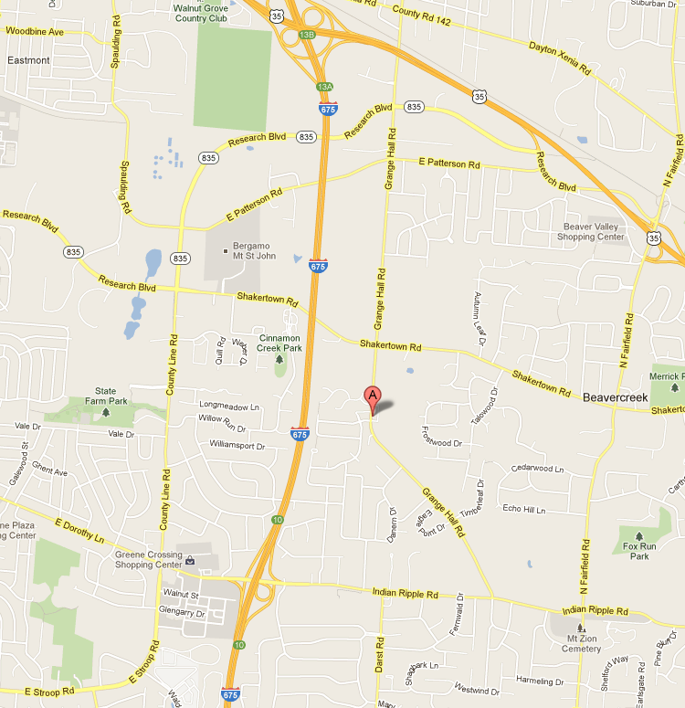

THE 11th ANNUAL DAYTON AREA SHARKS
MASTERS SWIM MEET AND SPRINT PENTATHLON
Saturday, December 3, 2016
Sanctioned by Ohio LMSC and USMS, Inc. Sanction TBD

USE THIS FORM ONLY FOR DECK ENTRIES-ALL PRE-ENTRIES ARE THROUGH CLUB ASSISTANT

NAME (as it appears on USMS card)________________________________________ GENDER________
BIRTHDATE_______________________ AGE _____________________
USMS Number _____________________ TEAM_____________________
ADDRESS______________________________________________________
CITY, STATE__________________________________ ZIP______________
HOME PHONE (___)____________ BUSINESS PHONE(___)____________
E-MAIL________________________________________________________
INCLUDE A COPY OF CURRENT USMS CARD

Circle the event numbers in which you would like to be entered and show your seedtime to the hundredth of a second. If you do not enter a time you will be entered with a “NT.”

# | Entry Time | Event | # | Entry Time | Event
1 |  | 400 Medley Relay | 10 |  | 200 Individual Medley
2 |  | 50 Butterfly (P) | 11 |  | 50 Freestyle (P)
3 |  | 100 Backstroke | 12 |  | 100 Freestyle
4 |  | 200 Breaststroke | 13 |  | 200 Butterfly
5 |  | 50 Backstroke (P) | 14 |  | 100 Individual Medley (P)
6 |  | 100 Fly | 15 |  | 100 Breaststroke
7 |  | 200 Freestyle | 16 |  | 200 Backstroke
8 |  | 50 Breaststroke (P) | 17 |  | 400 IM
9 |  | 200 Freestyle Relay
 |  | (social relay)

(P) Marks a Pentathlon Event (Pentathlon participants must sign up for all five pentathlon individual events but you can enter any events you choose without doing the pentathlon).

ADVANCE ENTRIES (Through Club Assistant 12/1/16): $30 per swimmer for the meet including three relays _____
DECK ENTRIES (due by 1:15 PM 12/3/16) $45 per swimmer for the meet including three relays _____

RELEASE TO BE SIGNED ON NEXT TWO PAGES

 PARTICIPANT WAIVER AND RELEASE OF LIABILITY,
ASSUMPTION OF RISK AND INDEMNITY AGREEMENT

For and in consideration of United States Masters Swimming, Inc. (“USMS”) allowing me, the undersigned, to participate in any USMS sanctioned or approved activity, including swimming camps, clinics, and exhibitions; learn-to-swim programs; swimming tryouts; fitness and training programs (including dryland training); swim practices and workouts (for both pool and open water); pool meets; open water competitions; local, regional, and national competitions and championships (both pool and open water); and related activities (“Event” or “Events”); I, for myself, and on behalf of my spouse, children, heirs and next of kin, and any legal and personal representatives, executors, administrators, successors, and assigns, hereby agree to and make the following contractual representations pursuant to this Waiver and Release of Liability, Assumption of Risk and Indemnity Agreement (the “Agreement”);

- I hereby certify and represent that (i) I am in good health and in proper physical condition to participate in the Events; and (ii) I have not been advised of any medical conditions that would impair my ability to safely participate in the Events. I agree that it is my sole responsibility to determine whether I am sufficiently fit and healthy enough to participate in the Events.

- I acknowledge the inherent risks associated with the sport of swimming. I understand that my participation involves risks and dangers, which include, without limitation, the potential for serious bodily injury, sickness and disease, permanent disability, paralysis and death (from drowning or other causes); loss of or damage to personal property and equipment; exposure to extreme conditions and circumstances; accidents involving other participants, event staff, volunteers or spectators; contact or collision with natural or manmade objects; dangers arising from adverse weather conditions; imperfect water conditions; water and surface hazards; facility issues; equipment failure; inadequate safety measures; participants of varying skill levels; situations beyond the immediate control of the Event organizers; and other undefined, not readily foreseeable and presently unknown risks and dangers (“Risks”). I understand that these Risks may be caused in whole or in part by my own actions or inactions, the actions or inactions of others participating in the Events, or the negligent acts or omissions of the Released Parties defined below, and I hereby expressly assume all such Risks and responsibility for any damages, liabilities, losses or expenses that I incur as a result of my participation in any Events.

- I agree to be familiar with and to abide by the Rules and Regulations established by USMS, including any safety regulations. I accept sole responsibility for my own conduct and actions while participating in the Events.

- I hereby Release, Waive and Covenant Not to Sue, and further agree to Indemnify, Defend and Hold Harmless the following parties: USMS, its members, clubs, workout groups, event hosts, employees, and volunteers (including, but not limited to, event directors, coaches, officials, judges, timers, safety marshals, lifeguards, and support boat owners and operators); the USMS Swimming Saves Lives Foundation; USMS Local Masters Swimming Committees (LMSCs); the Event organizers and promoters, sponsors and advertisers; pool facility, lake and property owners or operators hosting the Events; law enforcement agencies and other public entities providing support for the Events; and each of their respective parent, subsidiary and affiliated companies, officers, directors, partners, shareholders, members, agents, employees, and volunteers (individually and collectively, the “Released Parties”), with respect to any liability, claim(s), demand(s), cause(s) of action, damage(s), loss or expense (including court costs and reasonable attorneys’ fees) of any kind or nature (“Liability”) which may arise out of, result from, or relate in any way to my participation in the Events, including claims for Liability caused in whole or in part by the negligent acts or omissions of the Released Parties.

- I further agree that if, despite this Agreement, I, or anyone on my behalf, makes a claim for Liability against any of the Released Parties, I will indemnify, defend and hold harmless each of the Released Parties from any such Liabilities which any may be incurred as the result of such claim.

I hereby warrant that I am of legal age and competent to enter into this Agreement, that I have read this Agreement carefully, understand its terms and conditions, acknowledge that I will be giving up substantial legal rights by signing it (including the rights of my spouse, children, heirs and next of kin, and any legal and personal representatives, executors, administrators, successors, and assigns), acknowledge that I have signed this Agreement without any inducement, assurance, or guarantee, and intend for my signature to serve as confirmation of my complete and unconditional acceptance of the terms, conditions and provisions of this Agreement. This Agreement represents the complete understanding between the parties regarding these issues and no oral representations, statements, or inducements have been made apart from this Agreement. If any provision of this Agreement is held to be unlawful, void, or for any reason unenforceable, then that provision shall be deemed severable from this Agreement and shall not affect the validity and enforceability of any remaining provisions.

Last Name | First Name | MI | Sex (circle)  M F |  | Date of Birth (mm/dd/yy)
Street Address, City, State, Zip
Signature of Participant |  |  |  | Date Signed
Revised 07/01/2014

