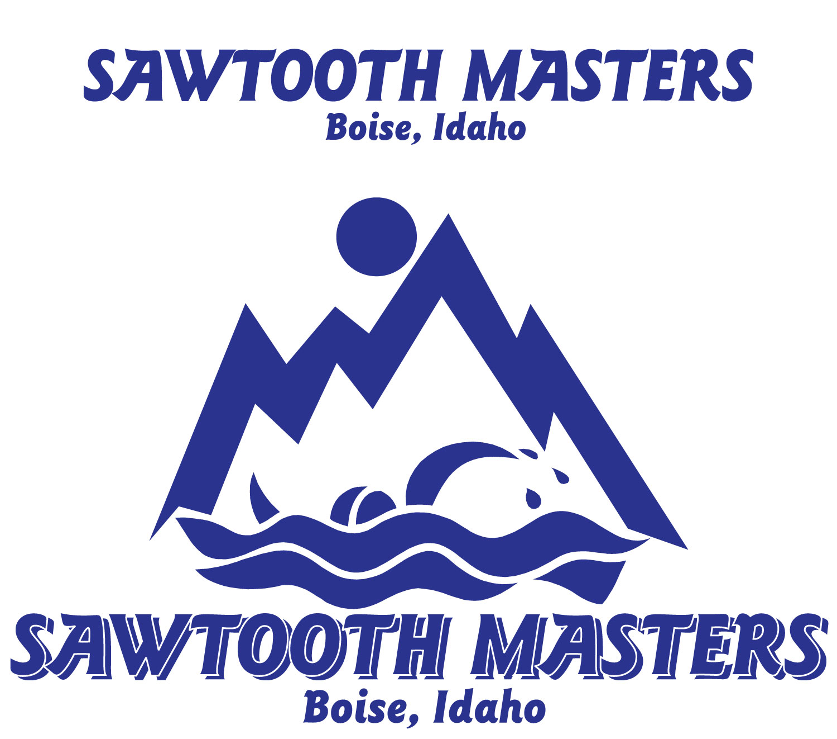
Sawtooth Masters Spring Meet
March 7, 2015
Boise, Idaho
USMS Sanction:
Short Course Yards
Meet Registration Form
LOCATION: West YMCA Boise Aquatic Center. 5959 N. Discovery Place, Boise, ID 83713
DIRECTIONS: From Airport- Interstate 84 West to Eagle Road Exit 46 (right) –North on Eagle Rd for 4.5 miles to Chinden Blvd. Turn Right (east)- at one stop light turn right ( south) on Discovery Place- YMCA is Approximately 2 blocks on the right side.
FACILITIES: Indoor 10-8 foot lanes, 25 yard by 50 meter pool equipped with 10 paragon-style starting blocks, backstroke flags, and 6’anti-wave lanes. Additional warm up and warm down lanes plus a 2 lane warmup/down Staring blocks meet USMS requirements. Electronic timing will be used.
MEET SCHEDULE: Saturday March 7th, 2015 warm ups at 10 am. Meets starts at 11am!
ENTRIES: Mail Entries to:
Oliver Cleaver
2001 N. Linder Rd
Eagle, ID 83616
*Mailed entries must be completely filled out on the meet entry form and accompanied by a copy of the swimmer’s USMS registration card. Failure to provide a USMS will result in a $3 look-up fee. Entries must be post marked by March 2nd 2015.
FEES: Mailed Event Entry fee: $25.00 for up to 5 event maximum.
CONTACT: Oliver Cleaver olivercleaver@gmail.com
RULES: Please submit short course yard times for proper seeding. All events will be seeded, according to submitted times and swum slowest to fastest. Heats may be combined and there will be breaks between some events.
2015 USMS Rules will govern the meet. All swimmers must be registered with a USMS club for 2015. Your age on 3/7/2015 will be the age you swim for the meet.
TIMERS/VOLUNTEERS: Teams 1-9 swimmers need to provide one volunteer. Teams with 10 or more swimmers need to provide at least 3 volunteers.
OFFICIALS: Any USA/USMS official who would like to help out would be greatly appreciated. Please contact Vicki Marsh 208-995-6029 if you are able to help.

ENTRY FORM AND WAIVER FOR MASTERS SWIMMERS
(2 PAGES)

2015 Sawtooth Masters Spring Meet

Date: Saturday March 7, 2015

Name:_________________________________________

Address:_______________________________________

City:__________________ State:____ Zip:___________
Phone:_________________________
USMS Number:_________________________________ (Include card copy w/ registration)
USMS Club:____________
Birthdate:_________________ Age:_____ Sex: M______ F______

Warm Ups at 10am Meet starts at 11am

EVENT Saturday March 7th, 2015
- 500 free/400 IM___:___.___ (circle one)
- 50 free___:___.___
- 200 back___:___.___
- 100 breast___:___.___
*Break*
5. 200 fly ___:___.___
6. 100IM__:___.___
7. 50 back___:___.___
8. 100 free___:___.___
*Break*
9. 1650 free___:___.___ (limited to two heats!)
10. 50 breast___:___.___
11. 200 free___:___.___
12. 100 fly___:___.___
*Break*
13. 100 back___:___.___
14. 50 fly___:___.___
15. 200 breast___:___.___
16. 200 IM ___:___.___

Relays will be done on a time trial basis if necessary.
Make Checks payable to: Sawtooth Masters Swimming
Mail to: Oliver Cleaver 2001 N. Linder Rd. Boise, ID 83616

