Inaugural Indy Open Water Challenge
Sunday, June 22, 2014
At beautiful Eagle Creek Park. Indianapolis, Indiana
Sanctioning Bodies:
- Greater Indiana LMSC (GRIN) for USMS, Inc. Sanction # Pending
Hosted by: Indy Aquatic Masters
Event Directors: Mel Goldstein / Dean Hawks 317-253-8289
Event Times:
6:00 a.m. Park Opens/Set Buoys
6:30 a.m. Check-in/Registration/Body Markings
7:00 a.m. Safety/Lifeguards/Officials meeting
7:45 a.m. Pre-race meeting on the beach
8:00 a.m. 15 Minute Warm up
8:20 a.m. Stage Elite Wave
8:30 a.m. Start Elite Waves 1-Mile & 2-Mile (<25 min mile)
8:35 a.m. Start General Waves 1-Mile & 2-Mile (>25 min mile)
10:30 a.m. Course Cleared/Awards/Collect Buoys
11:00 a.m. End of event
(Pre-race meeting and race start times are approximate)
About Eagle Creek: Eagle Creek Park is an urban park inside metropolitan Indianapolis, Indiana. It offers hiking, biking, boating and swimming, plus lovely wooded expanses throughout this largest of all the many parks in Indianapolis. Indeed, it is the sixth largest municipal park in the nation..

Indy Aquatic Masters OPEN WATER COURSE FOR 2014
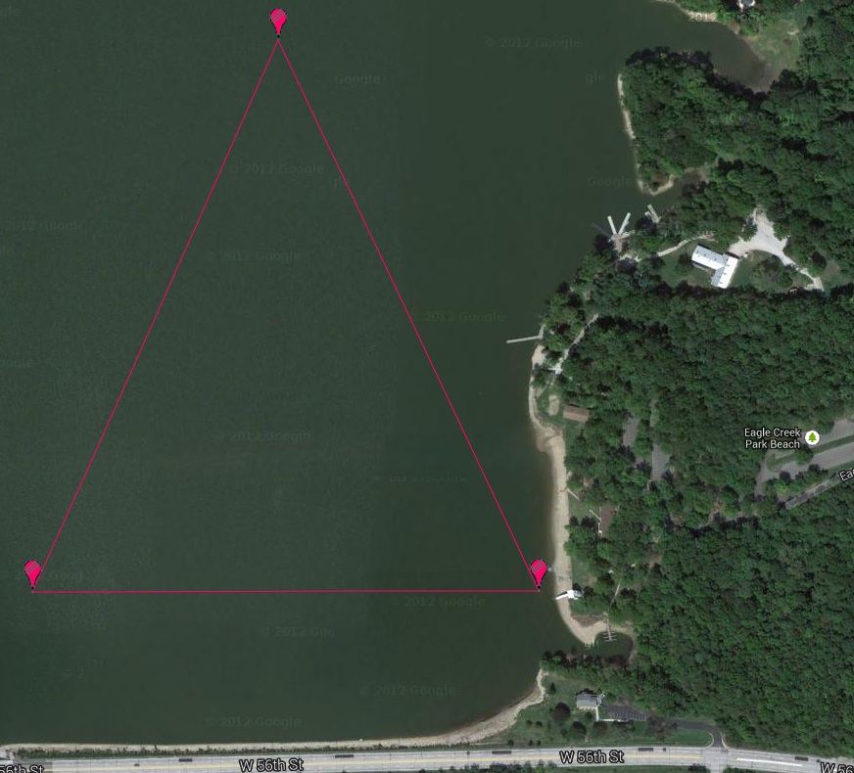
USMS Sanctioned race:
1-Mile In Water start 1 loop course beach finish
2-Mile In Water start 2 loop course beach finish
ADDITIONAL RACE DETAILS INFORMATION AND FACTS
Water Temperature: Expected to be 70-80 degrees.
Safety: Emergency personnel on watercraft will protect the course. Medical staff will be onsite. In case of inclement weather, or any other factors that may arise, an event committee composed of the event directors, referee, and a senior member of the Local Organizing Committee may modify starting times or cancel events. There will be NO REFUNDS for cancellation of the event due to weather or water quality issues that are out of our control.
Pre-race: A pre-race meetings will take place on the beach at approximately 7:45 a.m. All participants must attend. Please refer to course map.
Equipment: All participants will be provided with a swim cap, which must be worn during the race. Wetsuits are permitted but will not be awarded. Support craft other than designated event craft are not permitted. Persons allergic to latex should plan to wear a silicone cap beneath their race cap.
Check-In: Check-in will take place at the Eagle Creek Shelter prior to the pre-race meeting. Racing chips will be issued to all competitors. Please note that racing chips must be worn on your ankle when crossing the finish line in order for your time to be properly recorded. If you carry your chip in your hand, or any place other than your ankle, the equipment will not detect your finish time, and as a result, you will not receive a time or place.
Rules: Current 2014 U.S. Masters Swimming rules will govern the event. Final results will be posted by age group, gender, distance and wetsuit or non-wetsuit.
Eligibility: The race is open to all registered members of U.S. Masters Swimming. One-event forms must be completed by anyone not currently registered with U.S. Masters Swimming and waiver release signed.
Time Limit: Maximum time permitted to complete the race is 2 hours. Swimmers still in the water after 2 hours will be notified that the race is over and asked to leave the water. Results will show their time as DNF (did not finish).
Age: The age of the swimmer on the day of the swim will determine the age group.
Entries: Only first 500 entries accepted. Online entries will be accepted until Thursday June 19, 2014. NO RACE DAY ENTRIES. Only the first 100 entries are guaranteed a race T-shirt, unless received prior to the early registration deadline. Early registration entry deadline is Friday, May 30,2014. Entries will be accepted by Club Assistant at clubassistant.com
Results: Results will be posted at the Eagle Creek Shelter/awards area immediately following the completion and online at IndyAquaticMasters.com
Registration Fees:
- Early $50 (up to May 30, 2014) includes limited edition t-shirt
- Late $65 (May 30th to midnight June 19, 2014) includes post t-shirt if still available
Scoring: No team scores will be kept.
Awards: Awards will be given to the 3 places, male and female for each distance. All participants who finish will be awarded a finisher medal.
Presentation: Eagle Creek gazebo located near the wooded picnic area. Post-race food and beverages provided by Indy Aquatic Masters.
Race Referees: Lucy Duncan
Race Marshall: Dean Hawks
Safety Director: Bill Roach
Medical Director: Steve Hartsock
Directions: 56th Street West Exit off of I 465 , travel approximately ½ mile West, the park will be on your right.

First Name_____________ Last Name _______________________ MI ____

Male ____ Female _____ Date of Birth ______ Age as of June 22, 2014 ____

Address _______________________________________________________

City / State _____________________________________________________

Zip Code _______________________________

Email ___________________________________ Phone ________________

Distance 1 Mile ______________ 2 Mile ______________ ( Choose One)

Estimated Finish Time _________________

T Shirt Size S M L XL XXL (Circle One)

Emergency Contact Name _________________________________________

Emergency Contact Phone Number __________________________________

Entry Fee Prior To May 30, 2014 - $50
Late Entry Fee May 31-June 19, 2014 -$65

Only on line entry will be accepted… On Line entry Link…. TBA

Liability Release:

“I the undersigned participant, intending to be legally bound, hereby certify that I am physically fit and have not been otherwise informed by a physician. I acknowledge that I am aware of all the risks inherent in Masters swimming (training and competition) including possible permanent disability or death, and agree to assume all of those risks. AS A CONDITION OF MY PARTICIPATION IN THE MASTERS SWIMMING PROGRAM OR ANY ACTIVITIES INCIDENT THERETO, I HEREBY WAIVE ANY AND ALL RIGHTS TO CLAIMS FOR LOSS OR DAMAGES, INCLUDING ALL CLAIMS FOR LOSS OR DAMAGES CAUSED BY THE NEGLIGENCE, ACTIVE OR PASSIVE, OF THE FOLLOWING: UNITED STATES MASTERS SWIMMING, INC., THE LOCAL MASTERS SWIMMING COMMITTEES, THE CLUBS, HOST FACILITIES, MEET SPONSORS, MEET COMMITTEES, OR ANY INDIVIDUALS OFFICIATING AT THE MEETS OR SUPERVISING SUCH ACTIVITES. In addition, I agree to abide by and be governed by the rules of USMS.”
Signed ______________________________ Date _______________________
Swimmers Name

