Rice Aquatics Masters
March Madness Meet
Saturday, March 8th

Time: Saturday, March 8, 2014, 8:30am warm up; 9:30am start time.

Location: Rice University, Barbara and David Gibbs Recreation and Wellness Center, 6100 Main Street, Houston, TX.

Facility: The aquatic center is a 50 meter by 25 yard outdoor pool. The race course is an 8 lane by 25 yard section with a bulkhead. A fully automatic timing system and scoreboard will be utilized. Several lanes at the turn end of the pool will be available for continuous warm up and warm down throughout the meet.

Eligibility: Open to all registered masters swimmers holding valid 2014 USMS card.

Sanction: Sanctioned by Gulf LMSC for USMS, Inc.#####. Times achieved at the competition will be submitted for USMS Top Ten record considerations. The length of the competition course is in compliance and on file with USMS in accordance with articles 105.1.7 and 107.2.1, but as a bulkhead course, is subject to length confirmation. Eligibility of times for USMS Top 10 and records will be contingent on verification of bulkhead placement.

Rules: Current USMS rules will govern the conduct of this meet.

Entries/Fees: Entries must be received by Tuesday, March 4th, 2014. The entry fee is $35, this includes a cool meet t-shirt. Each swimmer may enter up to 5 events.
Entries may be submitted online through www.ClubAssistant.com. Please note that your credit card will be charged by ‘ClubAssistant.com Events’ for this swim meet
Or
Send in entry form and a copy of your USMS card. Mail your entry sheet, USMS card copy and fee to: Seth Huston, 710 Cheltenham, Katy, TX. 77450.
Make checks payable to: Rice Aquatics Masters.

Late entries and deck entries will be accepted until 9:00am, Saturday, March 8th for an additional $20 late fee

Seeding: All events will be pre-seeded (women and men swim together) by time slowest to fastest.

Results: Results will be posted during the meet on MeetMobile. Final results will be posted on the Gulf Masters web site; www.GulfMastersSwimming.org.

Directions: Rice University is located just across from the Texas Medical Center. From US 59 exit Shepherd/Greenbriar. Turn south on Greenbriar (one way) and proceed to Rice Blvd (3rd traffic light from 59). Turn left onto Rice Blvd. Make a right turn onto the Rice campus at entrance 17, one block east of the Shepherd traffic light.
Visitor paid parking is available in West Lot #1 immediately in front of the Alice Pratt Brown Building. The commuter lot West lot #4 may be open for free parking.

Here is a campus map http://www.rice.edu/maps/maps.html. The aquatic center is a short walk from the parking lot.

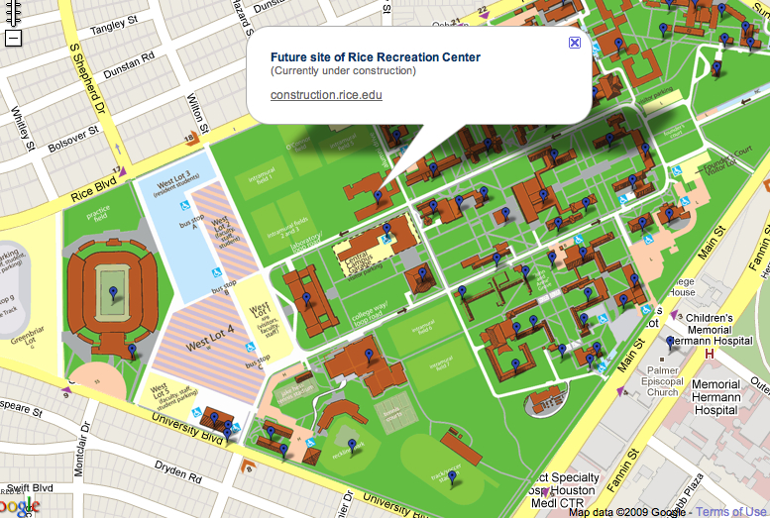

Rice Aquatics Masters
March Madness Meet
March 8, 2014
Entry Sheet
Name DOB Shirt
Address Age M or F
City State Zip
Phone E mail
USMS Club USMS #

Swimmers may enter up to 5 events in the meet. Please list a time or NT for no time next
to the event you plan to enter. Entries are due on Tuesday, March 4th, 2014. Please send this form, a copy of your 2014 USMS card and $35 entry fee. Late entries will be accepted until 9:00am the day of the meet with a $20 late fee. Make checks to Rice Aquatics Masters. Send to Seth Huston, 710 Cheltenham, Katy, TX. 77450.

Warm-up 8:30am Meet starts at 9:30am
Schedule of Events

# 1 100 breast # 9 200 back
# 2 200 IM # 10 200 free
# 3 50 free # 11 100 fly
#4 100 back 10 MINUTE BREAK
# 5 500 free # 12 50 back
#6 200 fly # 13 200 breast
# 7 50 breast # 14 100 free
# 8 100 IM # 15 50 fly
#9 200 back # 16 400 IM

USMS Waiver of Release
“I, the undersigned participant, intending to be legally bound, do hereby certify that I am physically fit and have not been otherwise informed by a physician. I acknowledge that I am aware of all the risks inherent in Masters swimming (training and competition) including possible permanent disability or death, and agree to assume all risks. AS A CONDITION OF MY PARTICIPATION IN THE MASTERS SWIMMINGPROGRAM OR ANY ACTIVITIES INCIDENT THERETO, I HEREBY WAIVE ANY AND ALL RIGHTS TO CLAIMS OR LOSS OR DAMAGES, INCLUDING ALL CLAIMS FOR LOSS OR DAMAGE CAUSED BY THE NEGLIGENCE, ACTIVE OR PASSIVE, OF THE FOLLOWING: UNITED STATES MASTERS SWIMMING, INC., THE LOCAL MASTER SWIMMING COMMITTEES, THE CLUBS, HOST FACILITIES, MEET SPONSORS, MEET COMMITTEES, OR ANY INDIVIDUALS OFFICIATING AT THE MEETS OR SUPERVISING ACTIVITIES. In addition, I agree to abide by and be governed by the rules of USMS.

Signed date
Sanctioned by Gulf Local Masters Swimming Committee, Sanction #

