2nd ANNUAL FLHS AQUATIC FUND RAISER
Short Course Yards Masters Meet
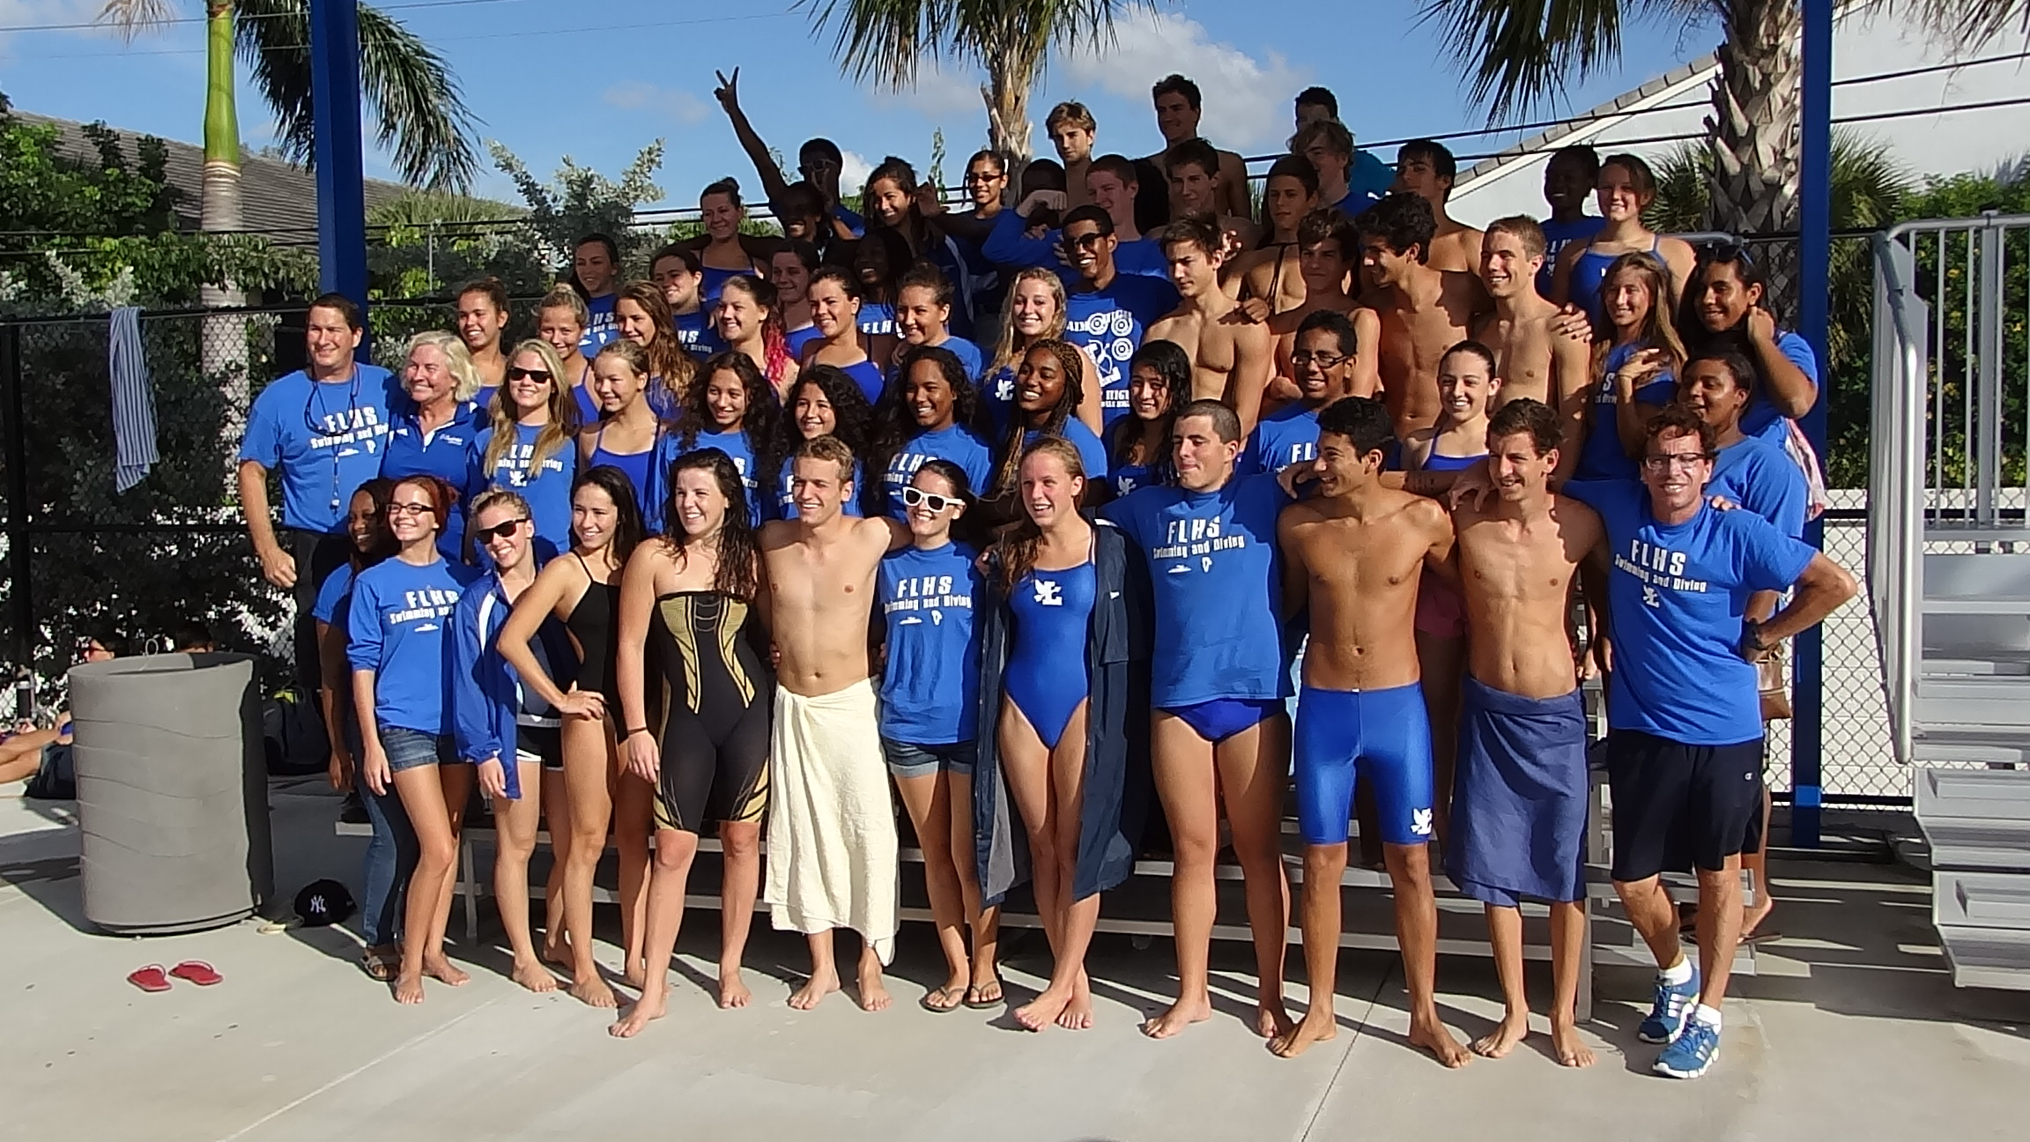
DATE & TIME: January 25, 2014

WARMUP 9:30AM ~ MEET START 10:30 AM

LOCATION: FT. LAUDERDALE HIGH SCHOOL AQUATIC CENTER
1701 FLYING “L” DRIVE(NE 4TH AVENUE)
FT. LAUDERDALE, FLORIDA 33305

SPONSORED BY: GOLD COAST MASTERS
All Proceeds will go directly to FLHS Aquatic Programs
SANCTIONED BY: Florida Gold Coast Masters for USMS, Inc #504-

FACILITY: 10 lane—25 yard course for competition
2 lanes will be used for warm-up and warm-down
Colorado Timing System

ELIGIBILITY: Open to all 2014 USMS registered athletes. Age as of January 25, 2014.

SEEDING: Entries will be seeded by time, slowest to fastest, women then men.

RULES: 2014 USMS rules govern. A copy of your 2014 USMS Card must be attached to the entry form.

ENTRIES AND RELAYS: Each swimmer may swim up to 5 individual events and 1 relay.

ENTRY FEE: $20.00 FLAT FEE FOR INDIVIDUAL EVENTS, $10.00 Per Relay.
Entries received with no payment will be charged a $10.00 late fee at the check in table.
Deck entries may be accepted for double the entry fee if space permits.

ENTRY DEADLINE: Entries must be received by Tuesday, January 21st, 2014

INFORMATION: LARRY CALDWELL (954)682-7220
e-MAIL: LARRYCALDWELL01@HOTMAIL.COM

SOCIAL: Gold Coast Masters will be offering a social immediately following the meet.

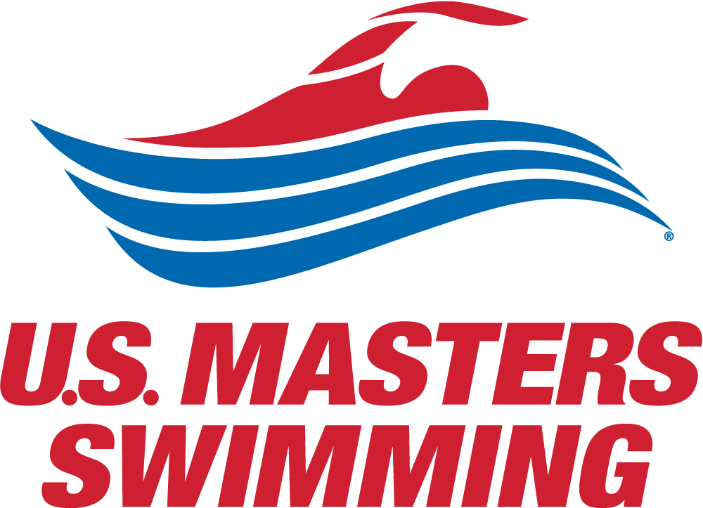
ATTACH COPY OF 2014 USMS CARD HERE: Phone:_________________________
E-Mail:_________________________

WOMEN | ENTRY TIME | EVENT | ENTRY TIME | MEN
EVENT # |  |  |  | EVENT #
1 |  | 50 FLY |  | 2
 |  | 10 Minute Break
3 |  | 50 BACK |  | 4
 |  | 10 Minute Break
5 |  | 50 BREAST |  | 6
 |  | 10 Minute Break
7 |  | 50 FREE |  | 8
 |  | 10 Minute Break
9 |  | 100 IM |  | 10
 |  | 10 Minute Break
11 |  | 400 MED Relay |  | 12
13 |  | 400 MX MED RELAY
15 | No charge | 4 x25 FUN RELAY | No charge
Meet Fees: $20.00 Mail Entries to: Larry Caldwell
Checks Payable to: 2248 Wilton Park Drive
GOLD COAST MASTERS Wilton Manors, Fl 33305

PLEASE READ AND SIGN THE MANDATORY RELEASE FROM LIABILITY:
I, the undersigned participant, intending to be legally bound, hereby certify that I am physically fit and have not been otherwise informed by a physician. I acknowledge that I am aware of the risks inherent in masters swimming (training and competition) including possible permanent disability or death, and agree to assume all of those risks. AS A CONDITION OF MY PARTICIPATION IN THE MASTERS SWIMMING PROGRAM OR ANY ACTIVITIES INCIDENT THERETO, I HEREBY WAIVE ANY AND ALL RIGHTS TO CLAIMS FOR LOSS OR DAMAGES, INCLUDING CLAIMS FOR LOSS OR DAMAGES CAUSED BY THE NEGLIGENCE, ACTIVE OR PASSIVE, OF THE FOLLOWING: UNITED STATES MASTERS SWIMMING, THE LOCAL MASTERS SWIMMING COMMITTEES, THE CLUBS, HOST FACILITIES, MEET SPONSORS, MEET COMMITTEES, OR ANY INDIVIDUALS OFFICIATING AT THE MEETS OR SUPERVISING SUCH ACTIVITIES. In addition, I agree to abide by and by governed by the rules and regulations of USMS. (see Rule Book Article 203.1)

SIGNATURE: ____________________________________ DATE: ____________________

