BOZEMAN BARRACUDA SWIM CLUB

hosts the

TEDDY BEAR CLASSIC
December 13th-15th, 2013 in Bozeman, Montana

Held under the Sanction of USA Swimming, Inc., issued by Montana Swimming, Inc. Sanction #.
This meet is dual sanctioned with Montana Masters sanction #

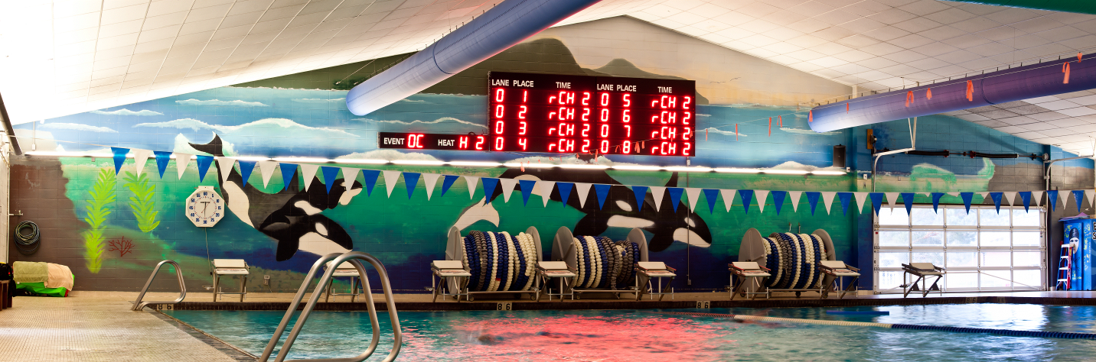

Meet Referee Meet Director Meet Registrar
Larry Johnson Tami Peters Nannette DuCuennois
(406) 763-4697 (h) (406) 209-5639 (c) (406) 582-0891 (h)
(406) 581-6626 (c) btpeters94@gmail.com (406) 920-1702 (c)
larrywjohnson@hotmail.com bozemanbarracudas@yahoo.com Bozeman Swim Club,
attn Nannette DuCuennois P.O. Box 804,
Bozeman, MT 59771

Facility The Bozeman Swim Center, located on the west side of Bozeman High School at 1211 West Main Street, is an 8-lane, 50-meter regulation long course pool. It is equipped with Kiefer non-turbulent Lane Lines and brand new Spectrum Xelerator starting blocks. The pool is 9 feet deep at the start end and 3.5 feet deep at the turn end. The altitude is 4793 feet. There is no separate warm-up and cool down facility therefore, the provision of a warm-up cool down lane and/or 10 minute warm-up breaks will be inserted into the meet schedule at the discretion of the Meet Referee. The competition course has not been certified in accordance with 104.2.2C(4). Montana Masters Swimming had it certified and we are in the process of completing the certification.

An Automatic Colorado Timing System will be used with touch pads at both ends, 3 backup times, and display will be on a new 8 line LED scoreboard. Each club will be responsible for providing at least two (2) timers at all times. A sign-up sheet will be posted at the announcer's table specifying lane assignments.

Directions: From I-90, arriving either east or west bound, take exit 306 onto N 7th Avenue. Turn south onto N 7th Ave and travel 1.2 miles to the tee intersection with West Main Street. Turn right (west) onto W Main Street. Bozeman Swim Center will be on your right in 0.5 miles, just past the Bozeman High School. OVERNIGHT PARKING OR CAMPING IS NOT PERMITTED IN THE PARKING LOTS ADJACENT TO THE SWIM CENTER.

Meet Format This will be a split session meet. Events will be swum 10 & Under in the early morning sessions and 11 & Over in the late morning/afternoon sessions. 1500 and 400 Free events will be available to 11 & Over swimmers. 400IM will be available to 13 & Over swimmers. On Saturday there will be a 15 min break at the completion of Event 35 (mixed 400 free relay) and before the 400 Free. Events will be swum as listed on the schedule of events. All events are timed finals.

Swimmers entered in the 1500 Free, the 400 Free, and the 400 IM must provide their own timers. Swimmers entered in the 1500 Free must also provide their own counters. Positive check-in will be required for all swimmers in these three (3) events.

The 1500 and 400 Free events will be seeded and swum as mixed heats, fastest to slowest. The 400 IM will also be seeded and swum fastest to slowest, but in alternating heats between women and men.

Warm-ups: In accordance with USA Swimming guidelines, there will be a published warm-up procedure for all swimmers and coaches attending the meet. The Marshal will ensure all teams, coaches, and swimmers follow all warm-up procedures. Meet Management reserves the right to change general warm-up times and general meet start times according to the number of entries. Check your program or the Barracuda Web Site (www.bozemanbarracudas.org) after Thursday, December 12th for the actual warm-up and start times.

An open warm-up session will be available to all swimmers on Friday from 4:00 - 4:45 p.m. All swimmers must have a certified coach overseeing them during this warm-up.

Based off the time line and for the benefit of the swimmers, the meet referee reserves the right to run the meet with 6,7, or 8 lanes, provide a warm-up/cool down lane, or insert 10 minute warm-up breaks throughout the meet.

FRIDAY Open 4:00 - 4:45 p.m.
Session 1 (1500 Free) Warm-up 4:45 - 5:20 p.m.
Meet: 5:30 p.m.
SATURDAY Session 2 (10 & under) Warm-ups 7:30 - 7:50 a.m.
Meet: 8:00 a.m.
Session 3 (11 & over) Warm-ups: Immediately after Event 17
Length: 45 minutes

(Warm-ups for Session 3 will start no earlier than 10:00 a.m. The meet will begin 10 minutes upon completion of the warm-up. Estimated start times will be set after entries are received & seeded.)

SUNDAY Session 4 (10 & under) Warm-ups 7:30 - 7:50 a.m.
Meet: 8:00 a.m.
Session 5 (11 & over) Start time: Immediately after Event 53
Length: 45 minutes

(Warm-ups for Session 5 will start no earlier than 10:00 a.m. The meet will begin 10 minutes upon completion of the warm-up. Estimated start times will be set after entries are received & seeded.)

Safety The Montana Swimming Safety guidelines are in effect for this meet and will be enforced. For circle swimming during warm-ups and cool downs, swimmers must enter the pool using a three point entry. Coaches are advised to closely supervise their swimmers at all times. NO running or horseplay will be tolerated. A safety marshal will be on deck.

Racing Starts Any swimmer entered in the meet, unaccompanied by an USA Swimming member coach, must be certified by an USA Swimming member coach as being proficient in performing a racing start or must start each race from within the water. It is the responsibility of the swimmer or the swimmer’s legal guardian to ensure compliance with this requirement. Any swimmers who must start in the water shall be listed in a separate document returned with the entries.

Rules The meet is approved by Montana Swimming and USA Swimming. 2013 USA Swimming Rules and Montana Swimming Rules will govern the conduct of the meet, except where rules therein are optional and exceptions are stated. The USA Swimming Code of Conduct and athlete protection provisions will be enforced. All persons acting in any coaching capacity on deck must be currently registered coach members of USA Swimming. Swimmer, official, and coach registration will be confirmed with Montana Swimming Registration Chairperson prior to the start of the meet. Use of audio or visual recording devices, including a cell phone, is not permitted in changing areas, rest rooms or locker rooms. Changing in or out of swimsuits is allowed in locker rooms or other designated areas only. Deck changing is not appropriate and is absolutely prohibited. No glass containers, tobacco, or alcoholic beverages are allowed in the swimming venue. This meet may be covered by the media, including photographs, video, web casting and other forms of obtaining images of athletes participating in the meet. Entry into the meet is acknowledgement and consent to this fact.

Eligibility All swimmers must be registered with USA Swimming Inc., the Canadian equivalent, or US Masters Swimming (USMS) prior to the entry deadline. Masters swimmers are welcome and encouraged to compete. There will be no on deck USA Swimming registration available at this meet. Teams entering swimmers who are not currently registered USA Swimming athlete members may be fined $25 per swimmer by the Montana Swimming Registration Chair. Age as of the first day of the meet (December 13th, 2013) shall determine the age group in which the swimmer must compete.

Swimmers with disabilities
The Bozeman Barracuda Swim Club welcomes all swimmers with disabilities as described in the USA Swimming Rules and Regulations, Article 106, to compete at the meet. Disabled swimmers or their coaches are required to provide advance notice in writing to the meet referee and meet director to arrange for any needed accommodations including personal assistants required and/or registered service animals by the meet entry date. It is at the discretion of the meet referee to determine whether the needed accommodations can be met by the meet resources. Failure to provide advance notice may limit the Bozeman Barracuda's ability to accommodate all requests.

Officials/Timers To the extent possible, teams are asked to provide timers and other certified meet officials. On deck training time will be available for those wishing to train as an official. E-mail the meet referee prior to the meet if you plan to officiate and sign in at the officials meeting each day in the hospitality room. Trainees should attend the pre-meet officials meetings daily and sign in. All officials on deck must be registered and certified with USA Swimming and registrations will be verified by the MT Swimming Registration Chair. Any official’s assistance will be greatly appreciated and will help to ensure a great meet for the swimmers.

Each club will be responsible for providing at least two (2) timers at all times. A sign-up sheet will be posted at the announcer's table specifying lane assignments.

The officials’ meetings will be held in the hospitality room at 4:45 p.m. Friday and at 7:30 a.m. on both Saturday and Sunday.

Coaches All coaches on deck must be registered and certified with USA Swimming. Coach registration will be verified with the MT Swimming Registration Chair.

A coaches' meeting will be held in the office Saturday at 7:10 a.m.. Other meetings may be held at the meet referee’s discretion. Meet Management requests that at least one coach representative from each team attend all coaches meetings.

Entry Fees An entry fee of $16.00 plus $2.00 per event will be charged. The relay fee is $5.00 per relay. Make checks payable to the Bozeman Swim Club. No entries will be accepted without payment of fees. There will be no refunds.

Entry Limits Each swimmer may compete in a maximum of nine (9) individual events with a maximum four (4) individual events on Saturday and four (4) individual events on Sunday.

Entry Format All entries may be submitted by e-mail (preferred) as a Team Manager file to: bozemanbarracudas@yahoo.com or by mail on the enclosed master sheet. Please include a printed copy of your entries with your payment. Also complete and return the USA Swimming Registration Confirmation, Waiver and Accounting Sheet with your entries (all enclosed in the entry packet).

Relays: Relay entries may be mixed gender and will be seeded and swum as such.

Entry Deadline All entries must be received in Bozeman no later than Wednesday, December 4th, 2013, either by email (preferred) or by mail.
All entry fees (and paperwork if entries are emailed) must be received no later than Saturday, December 7th, 2013.

E-mail entries to: bozemanbarracudas@yahoo.com.
Mail paperwork to: Bozeman Swim Club
attn: Nannette DuCuennois
P.O. Box 804
Bozeman, MT 59771

Entries must be made through the swimmer’s club with a team check. Unattached swimmers may make direct entries. Phone entries will be accepted until 5:00 p.m. Friday December 6th. Phone entries called in to Nannette DuCuennois at 582-0891 (h). Phone entries for entire teams will not be accepted. Late entries, if accepted, will require double entry fees.

Entry Verification An email will be sent to the person submitting the entry confirming receipt of the entry within 48 hours of receipt.

Age Groups 8&U, 9-10, 11-12, 13-14, 15 & Over. All events will be posted, scored, and awarded by age group. Age on December 13th shall determine the swimmer’s age group for the meet.

Seeding Each swimmer will be seeded according to age group and submitted times in meters. Failure to convert yard times before submitting could result in your swimmers being incorrectly seeded. Yard times will be entered as submitted and will not be converted. “No time” entries will be accepted. Deck seeding may be provided if there are open lanes and at the discretion of the meet referee. The 1500 Free, 400 Free, 400 IM will be seeded and swum fastest to slowest; the 1500 Free and 400 Free in mixed heats, the 400 IM in alternating heats between women and men.

Positive Check-in Positive check-in, located at the announcer's table, will be required 30mins before the start of each session for the following events:
- 11 & Over 1500 Free (Session 1)
- 11 & Over 400 Free (Session 3)
- 13 & Over 400 IM (Session 5)
Failure to check-in for these event by the stated deadline may result in the swimmer being scratched and not seeded.

Swimmers entered in the 1500 Free, the 400 Free, and the 400 IM must provide their own timers. Swimmers entered in the 1500 Free must also provide their own counters.
Scratches Coaches should report scratches on the scratch sheet or to the meet referee prior to the start of every session. There will be no penalty for swimmers who fail to scratch from an event.

Protests: All protests should be given to the meet referee.

Scoring Individual 20-17-16-15-14-13-12-11-9-7-6-5-4-3-2-1

Awards High point "teddy bear" awards will be given for 1st - 16th places for the following age groups:
8&U, 9-10, 11-12, 13-14, and 15 & Over.

Final Results Meet results will be posted to the Montana Swimming website at: www.mtswimming.com
Results will also be posted on the Bozeman Barracuda Web Site: www.bozemanbarracudas.org

Concessions Concessions will be available. Absolutely no glass containers are allowed in the locker rooms or deck areas.

Swim Shop Personalized meet t-shirts and/or clothing will be available for sale as well as an array of swim items and stocking stuffers at the Swim Shop.

Hospitality A hospitality room will be available for all coaches, officials, and volunteering meet personal.

Spectators The west and north sides of the deck (coaches side and start end) will be a "Closed Deck" area, open to coaches, swimmers, and meet officials only.

New Spectrum Xelerator starting blocks:

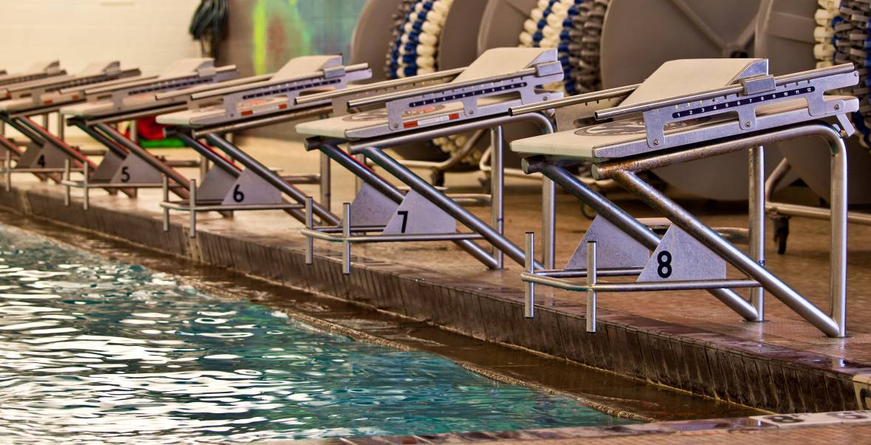

Hotel Information
Updated 11/9/13

Best Western Grantree Inn
1325 N. 7th Ave
587-5261
Double queen room $89/night**

City Center Inn
507 West Main Street
587-3158
Double queen room $60/night**

Comfort Inn
1370 N. 7th
587-2322
Deluxe queen room $82/night**
Rate good until November 30th, 2013

Hampton Inn
75 Baxter Ln.
522-8000
Double queen $109/night**
Rate good until December 1st, 2013

LaQuinta Inn
620 Nikles Drive
585-9300
Double queen $69/night**
Rate good until December 1st, 2013

My Place Hotel Bozeman
5889 East Valley Center Road
586-8228
Double queen room $74/night

Hilton Garden Inn
2023 Commerce Way
582-9900
Double queen $139/night**

Holiday Inn Express
2305 Catron
582-4995
Double queen $109/night**
Rate good until December 1st, 2013

Super 8
800 Wheat Dr., Bozeman
586-1521
Double queen $62/night

** Mention Barracuda Swim Meet when making reservation

Schedule of Events

Friday, December 13, 2013
Girls | Session 1 | Boys
1 | 11 & Over Mixed 1500 Free

Saturday, December 14, 2013 |  |  |  | Sunday, December 15, 2013
Girls | Session 2 | Boys |  | Girls | Session 4 | Boys
3 | 9-10 200 Free | 4 |  | 39 | 9-10 200 IM | 40
5 | 10 & U 50 Free | 6 |  | 41 | **8 & U 25 Free | 42
7 | **8 & U 25 Breast | 8 |  | 43 | 10 & U100 Free | 44
9 | 10 & U 100 Back | 10 |  | 45 | 10 & U 50 Back | 46
11 | 10 & U 50 Fly | 12 |  | 47 | **8 & U 25 Fly | 48
13 | **8 & U 25 Back | 14 |  | 49 | 9 & Over 100 Fly | 50
15 | 10 & U 100 Breast | 16 |  | 51 | 10 & Under 50 Breast | 52
17 | 10 & U Mixed 200 Free RELAY |  |  | 53 | 10 & U 200 Mixed Medley RELAY
 | Session 3 |  |  |  | Session 5
19 | 13 & Over 200 IM | 20 |  | 55 | 13 & Over 400 IM | 56
21 | 11 & Over 50 Fly | 22 |  | 57 | 11-12 200 IM | 58
23 | 11 & Over 200 Free | 24 |  | 59 | 11 & Over 100 Free | 60
25 | 11& Over 100 Back | 26 |  | 61 | 11 & Over 50 Back | 62
27 | 11 & Over 50 Free | 28 |  | 63 | 11 & Over 200 Breast | 64
29 | 11 & Over 200 Fly | 30 |  | 65 | 11 & Over 100 Fly | 66
31 | 11 & Over 100 Breast | 32 |  | 67 | 11 & Over 50 Breast | 68
33 | 11-12 Mixed 400 Free RELAY |  |  | 69 | 11 & Over 200 Back | 70
34 | 13-14 Mixed 400 Free RELAY |  |  | 71 | 11-12 Mixed 400 Medley RELAY
35 | 15-O Mixed 400 Free RELAY |  |  | 73 | 13-14 Mixed 400 Medley RELAY
 |  |  |  | 75 | 15-0 Mixed 400 Medley RELAY
37 | 11 & Over Mixed 400 Free

** These 25 meter events are NOT official times for USA swimming due to facility restrictions. Times will be hand timed and placed for the meet.
2013 TEDDY BEAR CLASSIC
Entry Fee Summary and Waiver/Release Form

Complete and email or mail this form along with entry fees to (checks payable to Bozeman Swim Club).
Mail entries to: Bozeman Swim Club E-mail entries to: bozemanbarracudas@yahoo.com
attn: Nannette DuCuennios
P.O. Box 804
Bozeman, MT 59771

Team Name
Club Code
Coach
Coach Phone
Coach Email
Team Address

Item | Total Number | Cost per | Total
Swimmer Surcharge |  | $16.00 per event
Individual Entries |  | $2.00 / swimmer event
Relay Entries |  | $5.00 per relay
Total Fees Due

Waiver, Acknowledgement and Liability Release:
I, the undersigned coach or team representative, verify that all of the swimmers and coaches listed on the enclosed entry are registered with USA Swimming. Swimmer and coach registration will be verified. I acknowledge that I am familiar with the Safety Rules of USA Swimming, Inc. and Montana Swimming, Inc. regarding warm-up procedures and meet safety guidelines, and that I shall be responsible for the compliance of my swimmers with those rules during this meet. Bozeman Barracuda Swim Club, Bozeman Swim Center, Montana Swimming, Inc., and USA Swimming, Inc., their agents, employees, and coaches shall be held free and harmless from any and all liabilities or claims for damages arising by reason of illness or injury to anyone during the conduct of this meet. I also acknowledge that by entering this meet, I am granting permission for the names of any or all of my team’s swimmers to be published on the internet in the form of Psych Sheets, Meet Results, or any other documents associated with the running of this meet. This meet may be covered by the media, including photographs, video, web casting and other forms of obtaining images of athletes participating in the meet. Entry into the meet is acknowledgement and consent to this fact.
We hereby submit our team’s entry sheets and fees for your upcoming meet and verify that the above named coaches will be in attendance. These coaches are current in all the requirements set forth by USA Swimming; Red Cross Safety Training for Swim Coaches or Lifeguard Training, First Aid and CPR.

_____________________________________________________________________________________
SIGNATURE (Coach or Club Representative) CLUB

_____________________________________________________________________________________
TITLE DATE

Master Entry Sheet
Club:________________________ Age Group__________ Coach:___________________
Contact:______________________ Phone:_______________
Name |  | Age  Sex | USA # | Event # | Event # | Event # | Event # | Event # | Event # | Event # | Fees
 |  |  |  | Time | Time | Time | Time | Time | Time | Time
Tally
Swimmers this sheet X $16.00= $________
Events this sheet X $ 2.00= $________
Total $ this sheet $________

