
2013 Short Course Meters Fall Invite

November 3rd, 2013
Sanction by Arizona Masters Swimming for USMS, Inc. Sanction #
Facility: Kino Aquatic Center, 848 N. Crismon, Mesa AZ 858203
Directions: From almost anywhere take the 202 Red Mountain Hwy to McKellips, exit and head east to Horne. Turn south on Horne until you arrive at Kino Junior High School, the pool is located on the northwest side of campus .
Parking: Free parking is available in the Kino Junior High School parking lot.
Course: Outdoor. Competition pool is 25 meters, 8 lanes will be used for competition, 8 short course yard lanes will be available for continuous warm-up.
Time: Warm‐ups begin at 8:00am. Meet begins at 9:00am
Entries: Swimmers are limited to a maximum of 3 events. The 400, 800, 1500 and 400IM will be limited to the first 24 entries received. Entries are due by Monday, October 28th. Email Entries to: erin@mesaswims.com, with: (a) name as registered with USMS, (b) USMS number, (c) team/club, (d) DOB, and (e) events with entry times. Then promptly send a check for $25 and a copy of your 2011 USMS registration card and the USMS Release of Liability Form (attached) to Mesa Aquatics Club, c/o Erin Shields, 1957 E. Fairmont Dr., Tempe, AZ 85282. You can also mail entries with using the consolidated entry form located at www.azlmsc.org

Check In: Positive check in is required for the 1500, 400 & 400 IM by 8:30am the day of the event. Swimmers in the 1500 must provide their own timer and lap counter.
Seeding: All events will be seeded slowest to fastest, by entered time, ages and sexes combined.
Entry Fees: There is a $25.00 flat fee per swimmer
Checks payable to: Mesa Aquatics Club. Mail consolidated entry card, a copy of your 2013 USMS card, and check to: Mesa Aquatics Club, 1957 E. Fairmont Dr., Tempe, AZ 85282
Rules: 2013 USMS/AZLMSC rules will govern the meet. All swimmers must be registered with USMS for 2013. Participants may be asked to assist in back up timing. Smoking is prohibited in the pool area.
Meet Referee: Judy Gillies jgillies2@cox.net
Meet Directors: Erin Shields: (602) 469-0400 erin@mesaswims.com
Paul Smith: (602) 228-9739 paul@mesaswims.com



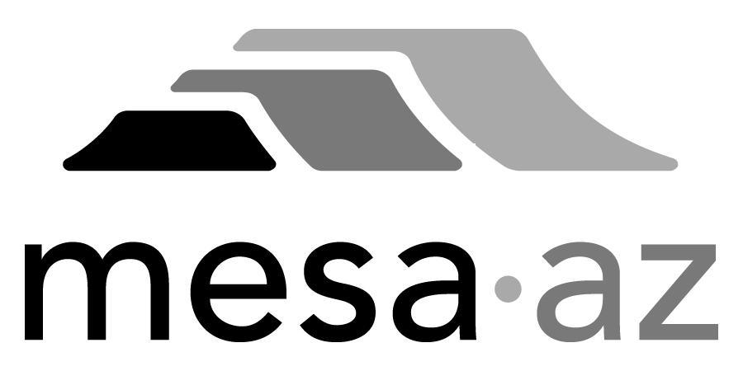

Sunday, November 4th, 2013
Warm-up at 8:00 a.m.
1500 m Freestyle starts at 9:00 a.m.
1. 1500 m Freestyle (limited to first 24 entries received)
Additional warm-up after 1500 m Freestyle
Event #2 will not start before start 10:30 a.m.
2. 100 m Freestyle
3. 200 m Butterfly
4. 50 m Backstroke
5. 200 m Individual Medley
6. 400 m Freestyle
7. 100 m Breaststroke
8. 200 m Backstroke
9. 50 m Butterfly
10. 200 m Freestyle
11. 50 m Breaststroke
12. 400 m Individual Medley
13. 100 m Butterfly
14. 200 m Breaststroke
15. 100 m Backstroke
16. 50 m Free
United States masters Swimming Release of Liability
PLEASE READ CAREFULLY: Late or incomplete entries (no fee, incomplete entry card, incomplete entry data, no copy of USMS Registration Card), or entries postmarked after the due date MAY BE REJECTED.
ALL Masters Swimmers will be required to send a photocopy of their USMS Registration Card along with their entry card. ALL Masters Swimmers may be asked to show their USMS card, if requested, at the meet. THERE WILL BE NO EXCEPTIONS.
"I, the undersigned participant, intending to be legally bound, hereby certify that I am physically fit and have not been otherwise informed by a physician. I acknowledge that I am aware of all risks inherent in Masters Swimming (training and competition) including possible permanent disability or death, and agree to assume all of those risks. AS A CONDITION OF MY PARTICIPATION IN THE MASTERS SWIMMING PROGRAM OR ANY ACTIVITIES INCIDENT THERETO, I HEREBY WAIVE ANY AND ALL RIGHTS TO CLAIMS FOR LOSS OR DAMAGES INCLUDING ALL CLAIMS FOR LOSS OR DAMAGES CAUSED BY THE NEGLIGENCE, ACTIVE OR PASSIVE, OF THE FOLLOWING: UNITED STATES MASTERS SWIMMING, INC., THE LOCAL MASTERS SWIMMING COMMITTEES, THE CLUBS, HOST FACILITIES, MEET SPONSORS, MEET COMMITTEES, OR ANY INDIVIDUALS OFFICIATING AT THE MEETS OR SUPERVISING SUCH ACTIVITIES. In addition, I agree to abide by and be governed by the rules of USMS."
Print Name:________________________________ Please Sign AND Date:__________________________________
Street Address:_______________________________________ City, State, Zip: ______________________________

