(Logo)
Swim for Alligator Lighthouse 2013
Sanctioned by World Open Water Swim Association.
Hosted by: Friends Of The Pool and Fighting Manatees Swim Club
http://www.swimalligatorlight.com
Produced by Board Up Productions, the creators of Swim Miami.

Sponsored By: TBD

Location: The Moorings 123 Beach Rd, Islamorada, FL 33036
Date & Time: The event will be held on Saturday, September 21, 2013. Each race will have appropriate waves, Male and Female within appropriate intervals. Projected start times are as follows:

    - 8 Mile Swim (8:00 AM)
      - Individual - $95.00 **
      - 2 Man Team - $75.00 per person
      - 4 Man Team– $50.00 Per person - 3 heats every 2 minutes
**Must show proof of completed 1650 or mile swim, proof of time: 35 minutes or under to compete in individual**

Start times listed are tentative. Meet Management, in conjunction with the approval of the Head Referee, may split or combine heats as deemed necessary to ensure safety and fairness for all competitors.

Time Limits: 6 Hours
Meet Referee may allow swimmers to finish race after allotted time limit if swimmer and safety officials are capable of escorting the swimmer to a safe and secure finish.

Eligibility: All swimmers, parents, triathletes, and weekend warriors are welcome at this meet. Any athlete with a disability will be accommodated. It is the swimmer’s or coach’s responsibility to notify the Meet Director and Meet Referee of any accommodations required.

Age Groups: Relays are all open and crossed gendered. Individual male & female 16 Under; 17-18; 18-24; 25-29; 30-34; 35-39; 40-44; 45-49; 50-54; 55-59; 60 and Over.
Race Course: Course Details – Large buoys will be placed at least every 1/2 mile. The course will be a down and back 4 mile. The passage requires swimmers keep buoy markers on their left shoulder. Every team or individual is required a support craft. The lead vessel will have an official Organizer uniform: a Swim For Alligator Lighthouse T-Shirt. There will be no “feed” stations available in this race. All teams and individuals must provide their own support.

It is the swimmer’s responsibility to coordinate with their coach or another individual for feeding purposes. No volunteers will be specifically available for this purpose. No objects, rope or wire may hang off of feed poles except banners or flags, but may not exceed the size of 30 cm x 20 cm. The start will be in an in water start designated by officials. The swimmers finish by under an archway on the beach.

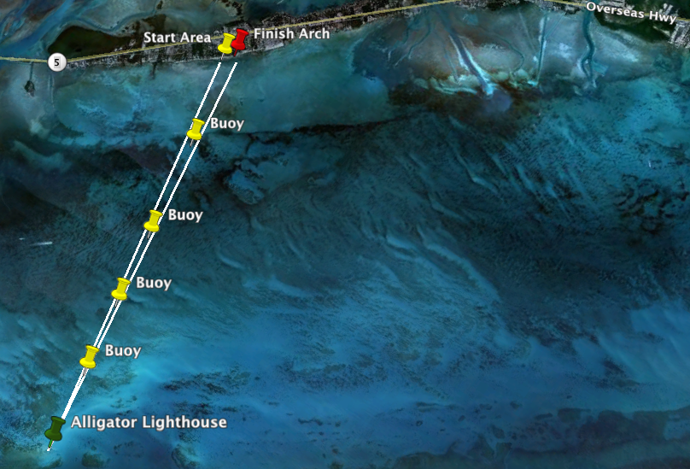

Rules: Open Water Source recommended rules will govern this meet. Safety rules as outlined by Open Water Source and as recommended by the referee, will be in effect.

Referee: (TBD)

Water Entry: This event will employ an in-water start and beach finish. The start area will be a designated shoot in order to count all swimmers entering the waterway; we will provide a wristband for entry via the archway. All entries will be feet first and controlled by the safety officer. There are no racing dives permitted.

Entry Procedures: Online registration is available via active.com. Offline entry forms are available at: http://www.swimalligatorlight.com

Entry Fee: Entry Fee per person: Individual $95.00, Two man team: $75.00 per person, Four man team: $50.00 per person (must be received by September 10, 2013). After September 10, 2013 all entry fees are as follows: Individual $150.00, Two man team: $100.00 per person, Four man team: $75.00 per person.

Entry Deadline: Registration and Check In will be available at Founders Park Swimming Pool from 4PM – 8PM on Friday September 20, 2013, should an athlete need to check in on race morning, he/she must be approved by the Race Director. A request must be made via email prior to September 10, 2013 for Race Day Check in..

Entry Corrections: Corrections and changes can be made until September 10, 2013. After this date all corrections and changes will incur a $10.00 charge unless the error was due to meet management and can be done online at active.com

Awards: Top 3 Male and Top 3 Female will receive awards for Overall placement. Finisher medals will be provided to those that accomplish the challenge.

Admission: Free to General Public.

Event Director: Jonathan Strauss – for questions call 305.273.1129 or email, thesportspromoters@swimgym.net

Parking: Parking will be available free of charge for all participants at The Moorings or venues nearby. Shuttle Service will be provided by some of the hotels used dependent on occupancy.

Schedule: Thursday September 19, 2013 - all swimmers invited to the Islamorada Artwalk. Lighthouse Larry will do a meet and greet with his 14' Alligator Lighthouse replica, give a speech on it's history, and do photos with swimmers. The event will have a lighthouse theme with many lighthouse paintings, photos and artwork.

Friday September 20, 2013 – 6:30 AM – 10:00 AM: All registered swimmers are invited to "Swim with the Manatee's", Fighting Manatees that is at Founder's Park Pool , 8-50meter lanes, with Coach Jon Olsen.

4:00PM – 7:00PM - Packet pick up and open water swim clinic with former Olympians Jon Olsen and Gary Hall Sr.

7:00PM - Morada Bay's famous Full Moon Party featuring specialty acts, junkanoo band and fireworks.

Saturday September 21, 2013 8:00AM – 2:00PM: Swim for Alligator Lighthouse

6:00PM – Sunset and Awards Celebration.

All proceeds of Swim For Alligator Lighthouse benefit the Friends of the Pool, a 501-C(3) non-profit organization. Committed to providing scholarships to those in need and preservation of marine historic landmarks.

Event Administration
Race Director
Jonathan Strauss
7605 NE 7th Court
Miami, FL 33138
305-273-1129
Fax: 305-273-1189
thesportspromoters@swimgym.net

Send all entry forms and fees to:
Attn. Jonathan Strauss
Friends of the Pool, Inc.
7605 NE 7th Ct.
Miami, FL 33138

Please make checks payable to:
Friends Of the Pool, Inc.

Hotel Accommodations
Check http://www.swimalligatorlight.com for updates on Hotel Accommodations and special rates.

Support Craft

Support Crafts (boats, kayaks, surfboards) must be provided by each swimmer or team. Event management is not responsible for on course feeding.

Race Updates

Please check http://www.swimalligatorlight.com periodically for more updates on the race, including course documents and pictures.

