|  |  |  |
| --- | --- | --- |
|  |  | **RICE Aquatics/Twin Lakes**  **2013 Open Water Swimming Carnival** |
|  |  | **Saturday, April 27th, 2013** |
|  |  | ***Benefitting Rice University Women’s Swimming Team*** |
|  |  | **USMS Sanction #** |
| **Location:** | Twin Lakes Scuba Park is a 31 acre aquifer fed lake. It is located on Highway 6 just 1.8 miles east of Texas 288 in | |
|  | Manvel, TX. 77578. | |
| **Directions:** | Coming from Houston, go south on Texas 288, past the Sam Houston Toll way about 8 miles, exit Highway 6 and go | |
|  | east (left). Twin Lakes Scuba Park is 1.8 miles down on the right side of the road. | |
|  | Entry into the park and parking is $5 per vehicle. There are no changing rooms available, but there are portable | |
|  | bathrooms. | |
| **Coaches:** | Jason Wedlick, RICE Aquatics | |
| **Meet Director:**  **Race Referee:**  **Safety Marshall:** | Amanda Caldwell 832-275-0035 acaldwell@rice.edu  Herb Schwab 281-242-1334 [herb.schwab@gmail.com](mailto:herb.schwab@gmail.com)  Mike Peron 832-620-5183 | | |
| **Eligibility:** | All participants must be currently registered with USMS to be eligible. Proof of eligibility must be provided with | |
|  | Entry including a copy of their USMS card. One day USMS registrations available for $15. | |
| **Warm Up:** | The race course will be open for warm up at 8:00 am start, once safety marshals are positioned. Only registered swimmers may enter the course. Warm Up closes at 8:45 am. | |
|  |  | |
| **Event Schedule:** There are three events offered are listed below. This is a dual sanction with USA swimming. Note all USMS  start times are in bold. | | |
| |  |  |  | | --- | --- | --- | |  | 1. 800 meter swim - **9:00 am USAS**, 9:15 USMS, check in 7:30 am to 8:30am | | |  | 2. 1 mile swim - **9:45 am USAS,** 10:15 USMS, check in 7:30 am to 9:15 am | | |  | 3 | 2 mile swim – both USAS & USMS at **11:00 AM** (staggered start),  check in 7:30-10:00AM. | | |  |  |  | | --- | --- | --- | |  | 1. 800 meter swim - 9:00 am USAS, **9:15 USMS**, check in 7:30 am to 8:30am | | |  | 2. 1 mile swim - 9:45 am USAS**, 10:15 USMS**, check in 7:30 am to 9:15 am | | |  | 3 | 2 mile swim – both USAS & USMS at **11:00 AM** (staggered start),  check in 7:30-10:00AM. | | |
|  | Please note for 2 mile race all USA swimmers will be started at the scheduled start time and USMS swimmers will begin | |
|  | 2 minutes afterward. There will be instructions given 10 minutes prior to each race. | |
| **Race Info:** | The race course will be 800meters. The race will start and finish in the water. It will be swum in a clockwise | |
|  | direction with buoys staying on your right shoulder. The finish will be a hand touch on the dock. | |
|  | USMS swimmers may wear a wet suit, but will not be eligible for awards. | |
| **Weather:** | The meet will be swam under all conditions except thunder and lightning. If there is hazardous weather in the area we will delay | |
|  | the meet 15 minutes per occurrence. We will make every attempt to swim the races. | |
| **Awards:** | All participants will receive a goody bag. All male and female first place finishers in each age group of each race will | |
|  | receive a race and age group champion award. We will have 1st awards available for male and female swimmers 19-24, 25-29, 30-34, etc….. | |
| **Entry Info:** | The entry deadline is Tuesday, April 23rd, 6:00pm for USMS Swimmers. The race entry fee is $30 for the first race and | |
|  | $10 for each additional race the swimmer enters. Late entries will be accepted through the end of race check-in for an | |
|  | additional $20 late fee. | |

Entries may be submitted online through [www.ClubAssistant.com](http://www.ClubAssistant.com). Please note that your credit card will be charged by ‘ClubAssistant.com Events’ for this swim meet

Or

Send in entry form and a copy of your USMS card. Mail your entry sheet, USMS card copy and fee to: Seth Huston, 710 Cheltenham, Katy, TX. 77450.

Make checks payable to: Rice Aquatics Masters.

**Safety:** Safety is our prime consideration. While there are no qualifying standards for this event, you should previously complete a one mile swim in 40 minutes or faster in order to swim in this event. You should be healthy and in reasonably fit swimming shape. Swimmers will be allotted 20 minutes per .5 mile to complete the course.

**Accounting for Swimmers –** Each swimmer will be given a race number during the check in phase of the meet. After the pre-race meeting the swimmers will enter the lake from one dock and check in with the volunteers in charge of tracking the swimmers. These volunteers will be taking the total number of swimmers entering the water and their race numbers. During the finish phase of the competition the swimmers will exit from the opposite pier and have the same volunteers record their finish time, race number and order finish.

**Location of Safety Marshall –** The safety marshal will be located on land at the start and finish location.

**Rescue Personnel and Equipment –** Rescue personnel will be in kayaks positioned at each turn buoy and at the start and finish of the race. There will also be a motorized platform that will follow the lead pack of the race. All rescue personnel will have lifesaving buoys throughout the race. Water will also be available for emergency situations on the platform.

**Location of First Aid and Safety Station-** The first aid kit is located at the registration table near the start and finish line. There will be safety stations set up on shore nearest to the turn buoys in the water.

**Medical Evacuation Plan-** If a swimmer is struggling or needs assistance they should swim to the nearest shoreline and wait for the safety staff to arrive. If unable to make it to the shore the swimmer should wave their hand and stay in the same location, rescue personnel will come to their assistance. Swimmers will then be transported to the nearest shoreline or finish line by kayak or motorized boat. The safety marshal will determine the severity of the situation and take the necessary action. The safety marshal will transport any swimmer needing to be driven to a medical facility.



|  |
| --- |
| **2013 RICE/Twin Lakes Open Water Swimming Carnival** |
| **Saturday, April 27th, 2013** |

**USMS #**

**Gulf Swimming Event Information:**

|  |  |
| --- | --- |
| **All swimmers will receive a goody bag, event winners in each age group will receive award.** | |
| **Entry Rules** |  |
| Type of Meet | Open Water |
| Max # of events | 3 |
| Swimmers Eligible | All Registered USMS swimmers. |
|  |  |
| Entry Times | None |
| Qualifying Times | None |
| Enter with no time | Yes |
| Gulf “three event” rule applies? | Does not apply |
| Gulf “up/down” rule applies? | Does not apply |
| Fees  Entry Due Date | 1st event $30, 2nd event $10, 3rd event $10  Tuesday, April 23rd, 2013, 6:00pm |

|  |  |  |
| --- | --- | --- |
| **Order of Events:** |  |  |
| **Event #** | **Age Group** | **Event** |
| 1-2 | Women and Men | 800 meter free |
| 3-4 | Women and Men | 1600 meter free |
| 5-6 | Women and Men | 3200 meter free |

Please note that events will be swum combined and scored separately for men and women by age groups



|  |
| --- |
| **RICE Aquatics/Twin Lakes**  **2013 Open Water Swimming Carnival** |
| **Saturday, April 27th, 2013** |

***Benefitting Rice University Women’s Swimming Team***

|  |  |  |  |  |  |  |
| --- | --- | --- | --- | --- | --- | --- |
|  | **USMS Sanction #** | | | | | |
| *Please type or print clearly* |  |  |  | Today’s Date __________________________ | | |
| First | Middle | Last |  |  |  |  |
| Name___________________________ Initial________________ | | Name_________________________________________________ | | | | |
| Mailing |  |  | Phone |  |  |  |
| Address______________________________________________ | |  | Number_______________________________________ | | | |
| City____________________________State__________Zip_____________ | | | Email _________________________________________ | | | |
| Birthdate |  |  |  |  |  |  |
| Month____Date____Year____ Team______________________ | | Gender (please circle) | | | Male | Female |
| USA Swimming ID |  |  |  |  |  |  |
| Or |  | T-shirt (please circle) | | |  |  |
| USMS Swimming ID____________________________________ | | adult sizes | | small | medium large | x-large |

USMS Waiver of Release

“I, the undersigned participant, intending to be legally bound, do hereby certify that I am physically fit and have not been otherwise informed by a physician. I acknowledge that I am aware of all the risks inherent in Masters swimming (training and competition) including possible permanent disability or death, and agree to assume all risks. AS A CONDITION OF MY PARTICIPATION IN THE MASTERS SWIMMINGPROGRAM OR ANY ACTIVITIES INCIDENT THERETO, I HEREBY WAIVE ANY AND ALL RIGHTS TO CLAIMS OR LOSS OR DAMAGES, INCLUDING ALL CLAIMS FOR LOSS OR DAMAGE CAUSED BY THE NEGLIGENCE, ACTIVE OR PASSIVE, OF THE FOLLOWING: UNITED STATES MASTERS SWIMMING, INC., THE LOCAL MASTER SWIMMING COMMITTEES, THE CLUBS, HOST FACILITIES, MEET SPONSORS, MEET COMMITTEES, OR ANY INDIVIDUALS OFFICIATING AT THE MEETS OR SUPERVISING ACTIVITIES. In addition, I agree to abide by and be governed by the rules of USMS.

|  |  |  |  |  |  |  |  |  |  |  |
| --- | --- | --- | --- | --- | --- | --- | --- | --- | --- | --- |
| Signed |  |  | | date | |  | |  |  | |
| Sanctioned by Gulf Local Masters Swimming Committee, Sanction # | | | | | | | | |  | |
| Please check races to be entered: | | **Race** | | **Entry** | | **Fees** | |  |  | |
| 800 meter swim | _______ | 1st race entered | | | |  | | $30 | ______ |  |
| 1 mile race | _______ | 2nd race entered | | | |  | | $10 | ______ |  |
| 2 mile race | _______ | 3rd race entered | | | |  | | $10 | ______ |  |
|  |  | Late Fee (4/22) | | | | | | $20 | ______ |  |
| Make check payable and mail forms to: | | One day USMS registration | | | | | | $15 | ______ |  |
| **Rice University Swimming**  **Seth Huston, Head Swim Coach**  **Rice University** | |
| **Attention: Twin Lakes Race** | | Total |  | | ______ | |
| **PO Box 1892, MS 548** | |
| **Houston, TX 77251** | |



|  |
| --- |
| **RICE Aquatics/Twin Lakes**  **2013 Open Water Swimming Carnival** |
| **Saturday, April 27th, 2013** |
| ***Benefitting Rice University Women’s Swimming Team*** |
| **USMS Sanction #** |

We are located on Hwy 6, just 1.8 miles East of 288 at 19230 Morris Ave.,

Manvel, TX 77578

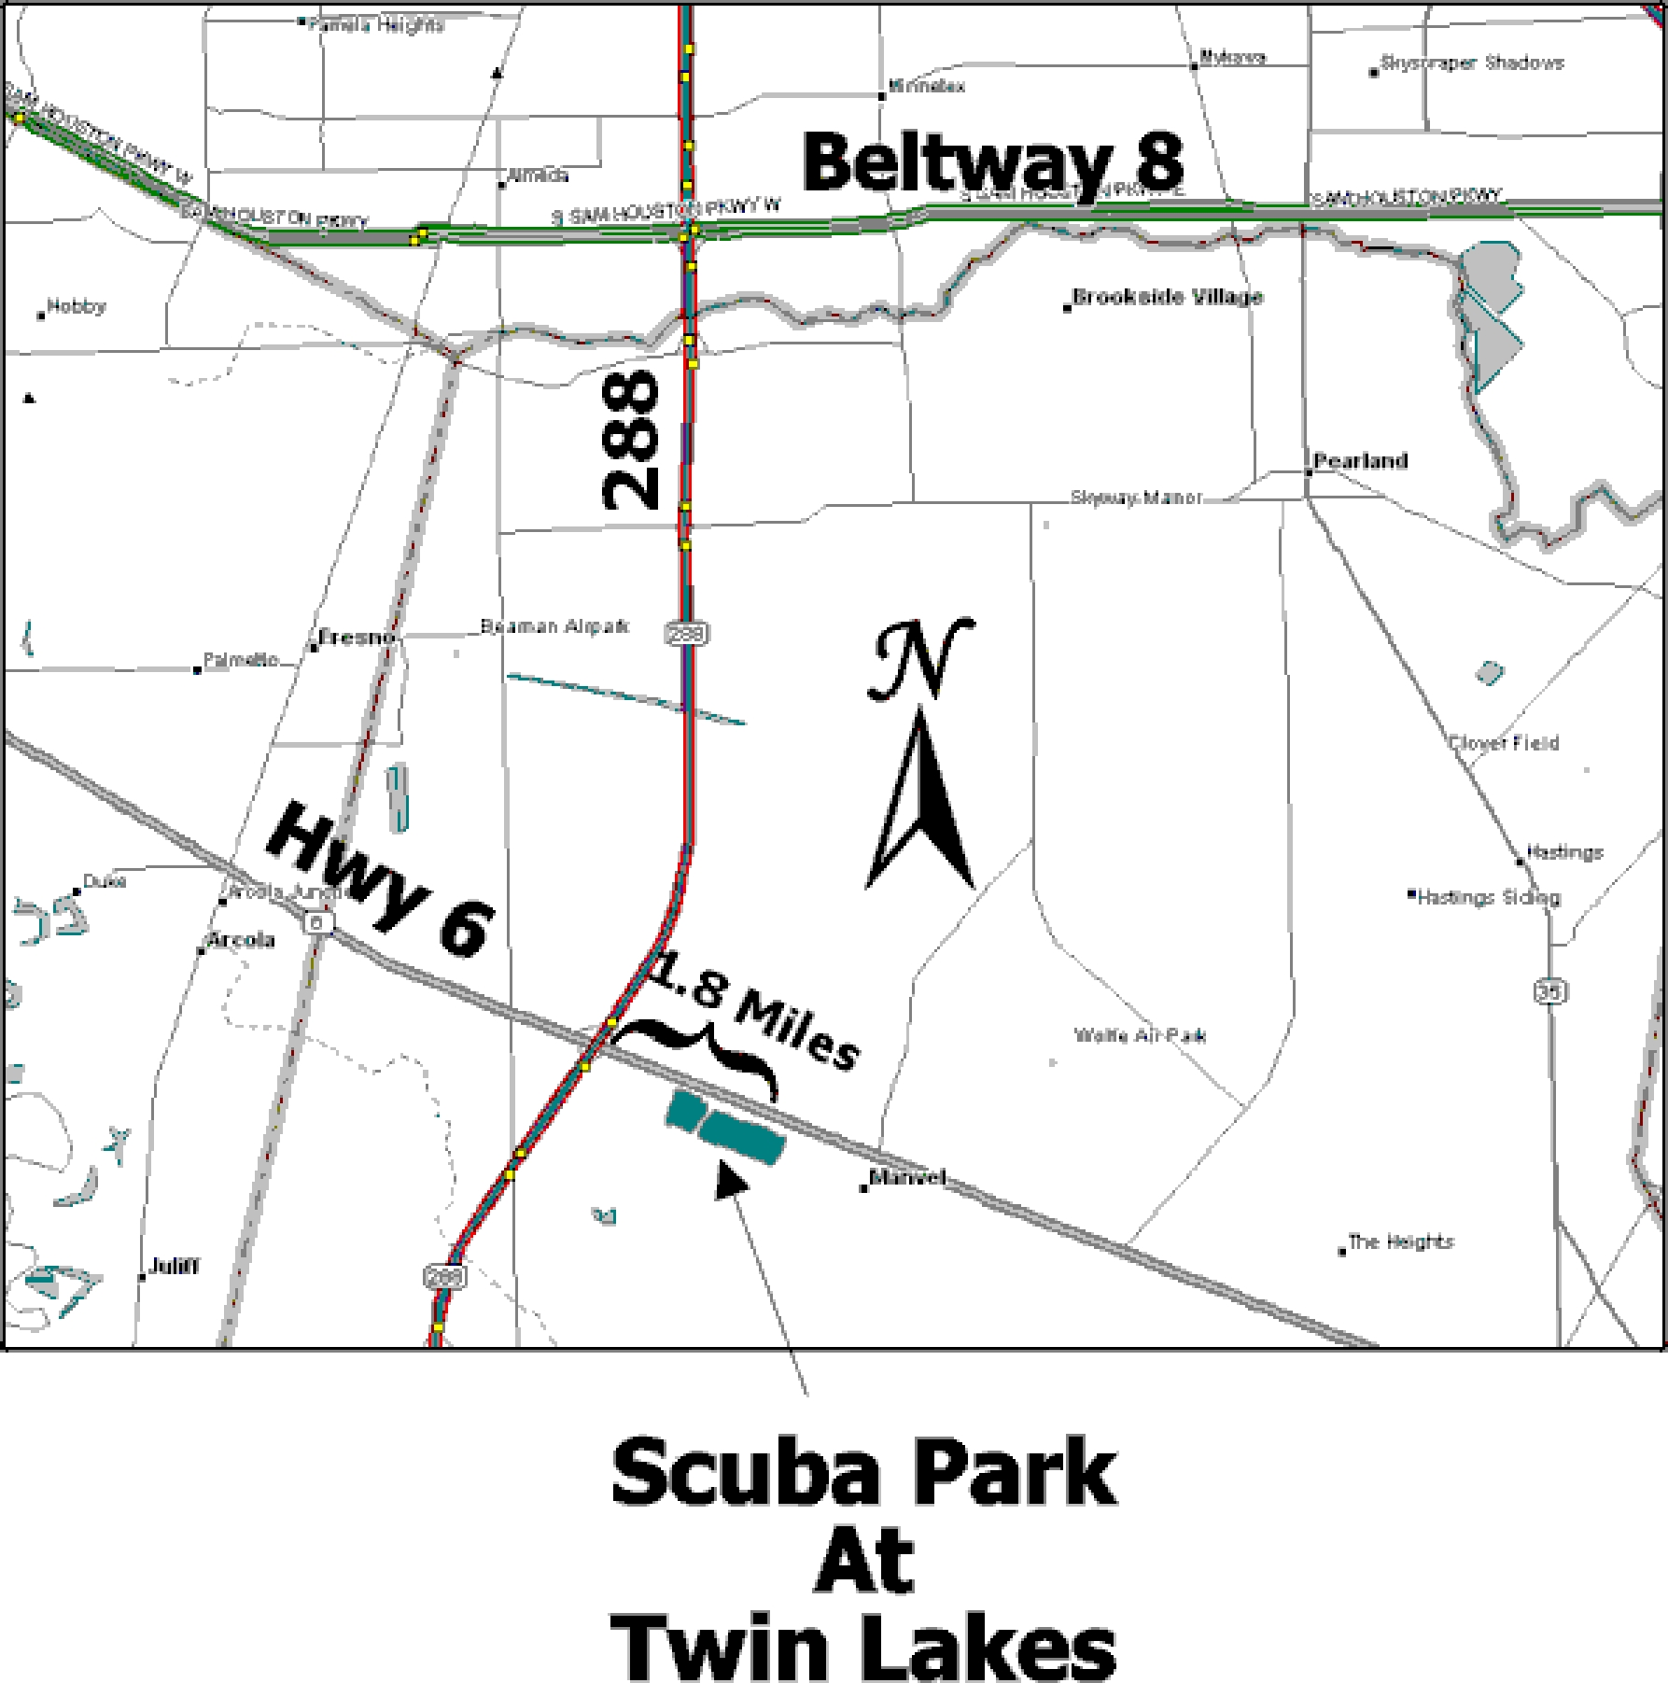



|  |
| --- |
| **RICE Aquatics/Twin Lakes**  **2013 Open Water Swimming Carnival** |
| **Saturday, April 27th, 2013** |
| ***Benefitting Rice University Women’s Swimming Team*** |
| **USMS Sanction #** |

**Twin Lakes RV****Resort**

. 19400 Texas 6

Manvel, TX 77578

(281) 489-4225

Show on Google Map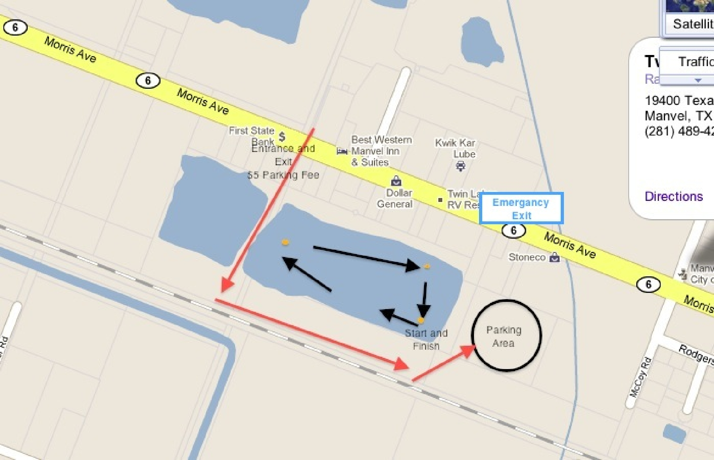

|  |
| --- |
| **RICE Aquatics/Twin Lakes**  **2013 Open Water Swimming Carnival** |
| **Saturday, April 27th, 2013** |
| ***Benefitting Rice University Women’s Swimming Team*** |
| **USMS Sanction #** |

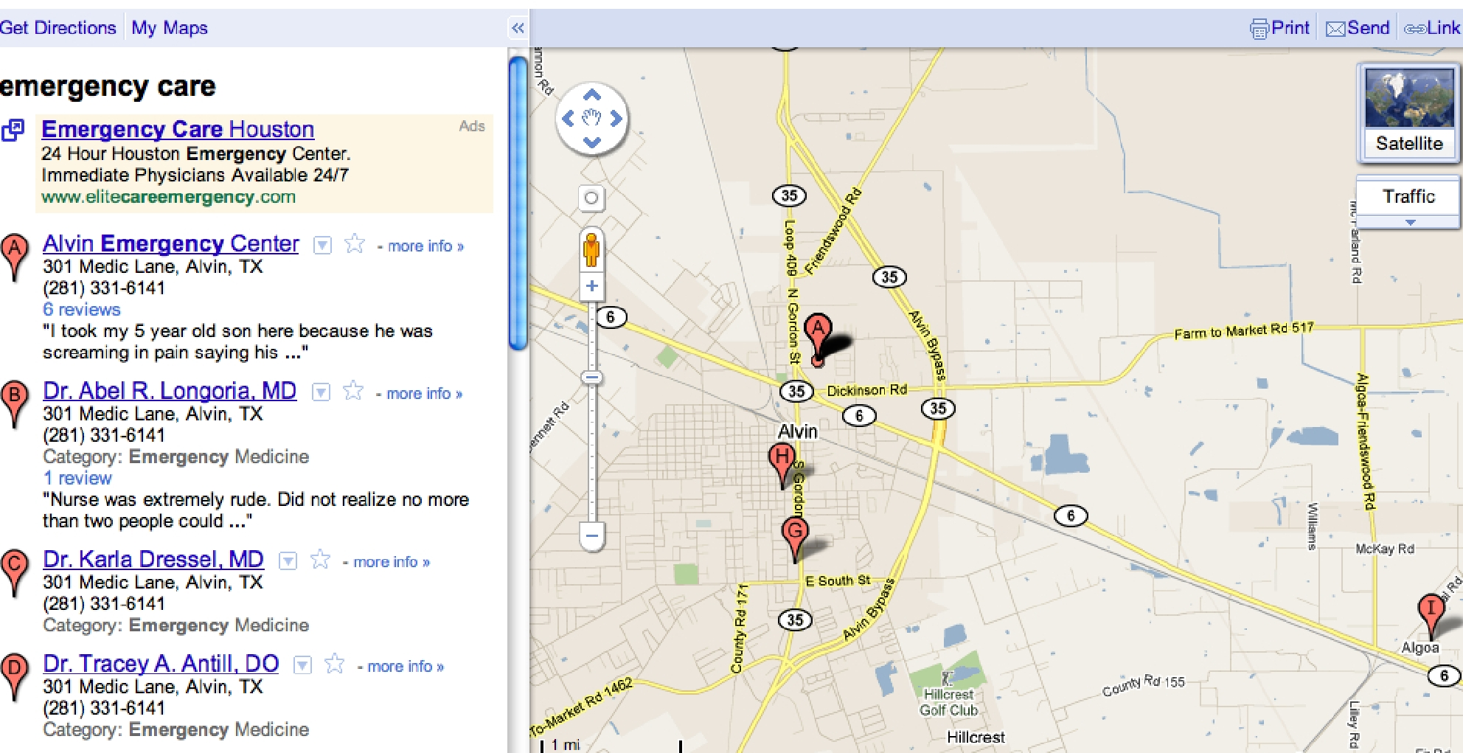

**Directions to Alvin Emergency Care Center**

**1. Head east on Tx-6 S/Morris Ave toward Wilson Dr. 2. Turn left at N Gordon St./Loop 409**

**3. Take the 1st right onto Diling St.**

**4. Take the 2nd left onto Medic Ln.**

**301 Medic Ln, Alvin Tx 77511**