Capitol Area Triathletes & Swimmers (CATS) Swim Meet
DeWitt High School Natatorium
Saturday, December 1. 2012

Sanction: Sanctioned by Michigan Masters/USMS
Schedule: Deck entries 10:00-10:30A.M., Warm-up 10:00-10:50. Events 11:00 a.m. Food & Social in cafeteria following the meet.
Facility: DeWitt High School Natatorium. The eight-lane pool has state-of-the art Paragon side step-up starting blocks, a Colorado timing system with a full matrix scoreboard, and seating for over 400 spectators.
Directions: From the east side of the State, take I-69 west following the signs to Fort Wayne/Grand Rapids. Exit onto DeWitt Road (exit 85). Turn left at the stop sign at the top of the exit. Continue south to Clark Road. Turn right onto Clark Road, and continue west less than a mile until you see the sign for DeWitt High School on the right-hand side of the road. Note: some people will need to take I-96 to 127 north (exit 106B) to get to I-69. Once on I-69 follow the above directions.
From the west side of the State, take I-69 east following the signs to Flint. Exit onto DeWitt Road. Turn right at the stop sign at the top of the exit. Continue south to Clark Road. Turn right onto Clark Road, and continue west less than a mile until you see the sign for DeWitt High School on the right-hand side of the road.
Events: | - 50 yard butterfly  - 200 yard freestyle  - 50 yard backstroke  Break: Plunge dive for distance/men  - 100 yard freestyle  - 50 yard breaststroke  Break: Plunge dive for distance/women  - 50 yard freestyle  Break: Goggle-flipping contest &  Consanguineous relay  - 100 yard IM  - 500 yard freestyle |  | Please enter either the crescendo, the pentathlon, or your choice up to five events  - Crescendo = 50 free + 100 free + 200 free + 500 free  - Pentathlon = 50 fly + 50 back + 50 brst + 50 free + 100 IM  Times will be added across your events to determine winners in each age group for men and women. The lowest total wins. We may need your help in calculating crescendo and pentathlon results.
Contests: | 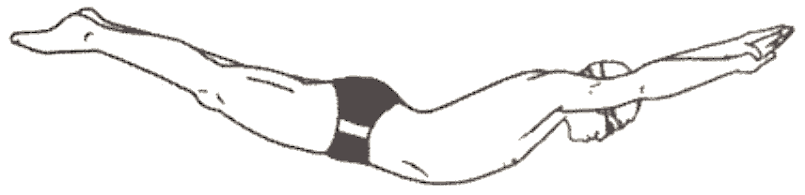 | Plunge dive for distance. The swimmer performs a standing dive for distance from either the starting block or edge of the pool. Kicking or pulling will be reason for disqualification.
 | 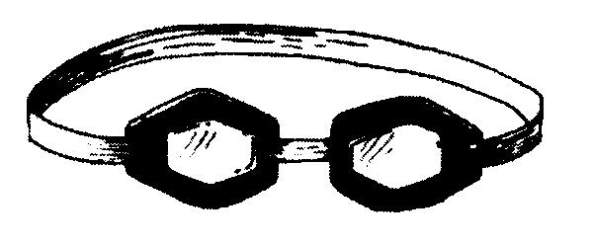 | Goggle-flipping contest. The swimmer may stand in the water (anywhere) or at the starting block end of the pool. The swimmer’s task is to flip her/his goggles in the air so that they land hanging from the backstroke flags.
Awards: Michigan Masters ribbons for the 1st, 2nd, and 3rd place winners in each event. Special prizes for the overall male and female winners of the plunge dive for distance and for first person to succeed in the goggle-flipping contest. Special Award: Consanguineous Plaque (two relatives, blood-related, and Masters swimmers on each team compete in a 100 yd. Relay). This award has been re-established by Dave Berger and Sue Berger-Mann.
Eligibility: Swimmers must have either a 2012 or 2013 registration with United States Masters Swimming. Standard masters swimming age groups: 19-24, 25-29, 30-34, 35-39, 40-44, … etc.
Entries & fees: Send entries to Gregg Brace , 5500 Maple Ridge Rd., Haslett, MI 48840. Mailed entries must be received by 5:00PM November 29th. (ENTRY FORM ON NEXT PAGE)
Mailed entries and fee is $20.00. Checks made out to Paul Chaffee.
Deck entries and fee is $25.00. PROCEEDS FROM MEET GO TO DEWITT SWIM TEAMS
Questions? The meet directors are Paul Chaffee (chaffeepa@frontier.com or 989/725-2863), Gregg Brace, Dewitt’s High School Swim Coach (work:517/367-3083 or home:517/347-1935), and Wally Dobler (517/372-8096). Starter: George Runciman (517) 281-6268.
---------------------------------------------------------------------------------------------------------------------------------------------------------
DECEMBER 1, 2012 MICHIGAN MASTERS SWIM MEET HOSTED BY
DEWITT HIGH SCHOOL BOYS/GIRLS SWIM TEAMS

NAME ______________________________________________ SEX: M F

USMS MEMBERSHIP NUMBER_____________________ AGE________ BIRTHDATE________________

PHONE #_____________________________ E-Mail Address____________________________________

Please circle event and list your seed time in the events you would like to enter:

EVENT #1 50 BUTTERFLY SEED TIME ______________

EVENT #2 200 FREESTYLE SEED TIME_______________

EVENT #3 50 BACKSTROKE SEED TIME_______________

BREAK: PLUNGE DIVE FOR DISTANCE/MEN

EVENT #4 100 FREESTYLE SEED TIME_______________

EVENT #5 50 BREASTSTROKE SEED TIME_______________

BREAK: PLUNGE DIVE FOR DISTANCE/WOMEN

EVENT #6 50 FREESTYLE SEED TIME_______________

BREAK: GOGGLE-FLIPPING CONTEST AND CONSANGUINEOUS RELAY

EVENT #7 100 INDIVIDUAL MEDLEY SEED TIME_______________

EVENT #8 500 FREESTYLE SEED TIME_______________

Mail your entry, copy of 2012 or 2013 USMS card, and check to: Gregg Brace, 5500 Maple Ridge Rd, Haslett, MI 48840. Remember to make checks out to “Paul Chaffee.”

