Butte Tarpon Swim Team
2012 BTST Mining City Classic
Approval # 0872

November 10th and 11th, 2012

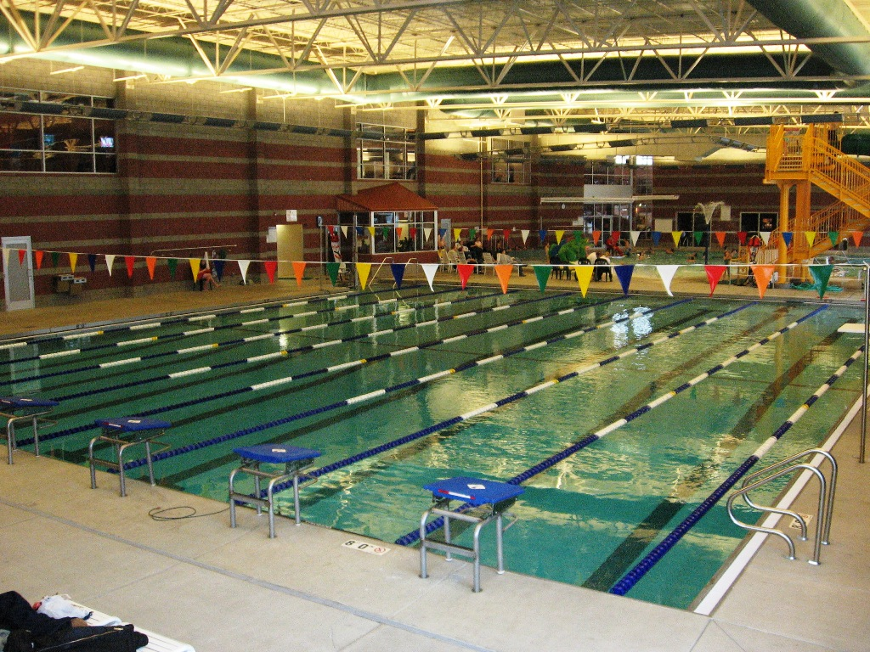

HOST: The Butte Tarpon Swim Team invites you to participate in the seventeenth annual Mining City Classic.

LOCATION: The meet will be held at the Butte Family YMCA which will also be this site for the 2013 Montana Short Course State Championships. This is an 8 lane, 25-yard regulation short course indoor pool with non-turbulent lane markers, and an 8 lane scoreboard. A separate warm-up /cool down pool is available.

DIRECTIONS: The facility is located at 2975 Washoe Street in Butte. Take the Montana Street exit into Butte, then turn south onto Montana Street. Continue south (straight) on Montana Street past the Town Pump on the left and the cemeteries on the right. Veer left at the end of the cemetery onto Hansen Road. Continue south along Hansen Road to the YMCA (copper and gray building on left).

RULES: This meet is approved by USA Swimming and Montana Swimming number 0872 and is sanctioned by Montana Masters. The 2012 USA Swimming and Montana Swimming rules will govern the conduct of the meet. Timing will be by Colorado Timing System with pads at each end of the pool or with manual watches. All events will be timed finals. Each team will be assigned lane timing assignments. A sign up sheet will be posted at the meet specifying lane assignments. Any swimmer entered in the meet, unaccompanied by a USA Swimming member coach, must be certified by a USA Swimming member coach as being proficient in performing a racing start or must start each race from within the water. It is the responsibility of the swimmer or the swimmer's legal guardian to ensure compliance with this requirement.

ELIGIBILITY: Age as of the first day of the meet shall determine the age group in which the swimmer must compete. All swimmers must be currently registered athlete members of USA Swimming or the FINA equivalent, or currently registered members of US Masters swimming. USA Swimming athlete and coach registrations will be verified by the MT Swimming Registration Chairperson prior to the meet.

FEES: An entry fee of $15.00 plus $2.00 per event will be charged for each swimmer competing in the meet. There will be a charge of $5.00 per relay team. Entry fees must accompany the entries in US dollars. Please make checks payable to BTST. Entries will not be accepted without payment of entry fees and proper paperwork. Waivers must be signed. There will be no refunds.

EVENTS: Individual events will be swum as noted on the event list. Events will be scored and awarded 8&U, 9-10, 11-12, 13-14, 15-16, and 17 &O. Swimmers age 17 and over will not receive individual event awards, but will be eligible to receive high point towels for the top three overall individual boys and girls. Disabled swimmers will be scored and awarded separately from able-bodied swimmers.

Swimmers in the 1000 Free, 500 Free and the 400 IM must provide their own timers, and swimmers in the 1000 and 500 Free must also provide their own counters. The 500 and 1000 free will be seeded and swum mixed fastest to slowest; the 400 IM will be seeded and swum mixed slowest to fastest, but all will be scored and awarded by age group for both girls and boys. If only a few swimmers are entered into an event, other events may be combined, seeded and swum as a mixed event at the meet referee’s discretion, but will be scored and awarded by sex and age group.

Relays will be seeded and swum as mixed. Teams may compete as all girls, all boys, or a mix of boys and girls. There are also 18 and under relays.

Disabled swimmers are welcome. All disabled swimmers will be awarded high point towels in each age group and sex as listed above. Disabled swimmers must contact the meet referee to arrange for any needed accommodations by November 2, 2012. It is at the discretion of the meet referee to determine whether the needed accommodations can be met by the meet resources.

Masters swimmers are welcome and encouraged to compete at this meet. Please enter with your Masters ID number and not a USA Swimming ID number.

LIMITATIONS: Each swimmer may compete in a total of ten (10) individual events with a maximum of five (5) individual events each on Saturday and five (5) on Sunday. Swimmers may compete in one (1) relay per day.

ENTRIES: Entries should be submitted as follows:
- Teams should e-mail entries to bwheel33@gmail.com using Hy-Tek or Team Unify software (preferred method) by November 2. Along with your meet entry file, include your team meet entry report (relay and individual entries) and team entry fee report from Team Manager or Team unify (in PDF, word or rich text format). Do not include relay swimmer names with your relay entries. Please e-mail all reports. Completed paperwork, signed waiver, team entry report, and entry fees must be received by November 5.
- Individuals (not teams) without access to Hy-Tek or Team Unify software may submit your entries on the enclosed master entry sheet. Hy-Tek Lite entry software may be downloaded for free from the Hy-Tek website to enter swimmers. Swimmers may also e-mail the entry data to the registrar.

DEADLINE: Entries must be received by: November 2, 2012
Mail entries to: Bill Wheeler, 91 Sapphire Lane, Butte, MT 59701.

Phone/e-mail entries for individuals only (not teams) will be accepted until 8:00 p.m., November 3, 2012. Send the individual entries to Bill Wheeler at 406- 490-1536 or bwheel33@gmail.com. Entry fees for the individual entries must be received prior to the start of the meet. Deck entries will only be allowed at the discretion of the meet referee and will be seeded as exhibition swims and are not eligible for awards. No text messages will be accepted for entries or entry questions.

START TIME: On Saturday, warm-ups for the 500 Free will start at 7:00 a.m. Following the 500 Free, there will be a general warm-up session before the beginning of the remaining events. On Sunday, warm-ups for the 1000 Free will start at 7:00 a.m. Following the 1000 Free, there will be a general warm-up session before the beginning of the remaining events.

Warm-up times are subject to change depending upon the number of entries. Teams will be notified of any changes by November 7th. Warm-up schedules will be e-mailed on Wednesday afternoon, November 7, 2012, to teams providing e-mail addresses and posted on the MT Swimming website.

SCORING: 20-17-16-15-14-13-12-11-9-7-6-5-4-3-2-1 points for individual events only.

AWARDS: Individual high point towels will be given for the top three places in each age group. 8 and under high point will receive medals in addition to towels. Ribbons for first through sixteenth will be awarded for each individual event through age 16 only. Swimmers ages 17 and over will only be awarded high point towels for the top three overall high point winners for both boys and girls, but will receive no individual event awards. There are no awards for relays. There will be no awards ceremony. Teams shall designate a responsible adult to pick up all awards after the meet.

SAFETY: Montana Swimming warm-up procedures and safety guidelines will be in effect for the duration of the meet. Each coach is responsible for informing swimmers of the provisions of the safety code before attending the meet. No diving is allowed from the turn end of the pool. A safety marshal will be on deck during the meet. The USA Swimming code of conduct and athlete protection policies will be enforced. Absolutely no glass containers are allowed in the building. No cameras of any type are allowed in the dressing rooms and the restrooms. No area of the building should be considered secure. BTST and Butte Family YMCA are not responsible for loss or damage of any items.

Spectators: Spectators may be seated in the spectator areas on the bleachers on the pool deck, on the bleachers on the balcony above the start end of the pool, and on the bleachers along the windows in the upstairs workout room. No spectators will be allowed along the west wall in the coach seating area. In the coach seating area only meet management, officials, and coaches may be in this area except that athletes may talk briefly with their coaches and then leave the area. We also ask that parents of 9 and over swimmers not be in the area behind the blocks.

SCRATCHES: There will be no clerk of course. Heat and lane assignments will appear in the program. Swimmers are responsible for taking their position behind the blocks. Coaches shall report scratches on the scratch sheet or to the meet referee prior to the start of the meet both days.

OFFICIALS: To the extent possible, teams are asked to provide timers and other certified meet officials.

CONCESSIONS: The BTST parents will be operating a concession stand and swim shop during the meet.

PROTESTS: All protests of any kind will be given to the Meet Referee.

RESULTS: Results will be posted to the Montana Swimming web site at http://www.mtswimming.com.

OFFICIALS MEETING: Saturday- 15 minutes after the conclusion of the 500 free; Sunday- 15 minutes after the conclusion of
the 1000 free.

COACHES MEETING: Saturday- Immediately after the conclusion of the general warm-up session.

PREFERRED HOTELS: Please see the attached list for preferred hotels for this meet and for the 2013 MT Swimming
Short Course State Championships March 1-3. Rooms have been blocked for both meets. Make
your reservations early.

MEET MANAGERS: Bob Whelan (406) 490-6590 rjwhelan6@gmail.com

MEET REGISTRAR: Bill Wheeler (406) 490-1536
91 Sapphire Lane, Butte, MT 59701 or bwheel33@gmail.com

MEET REFEREE: Susan Huckeby (406) 723-4800 or shuckeby@msn.com

2012 BTST Mining City Classic Events

SATURDAY SUNDAY

Girls |  |  | Boys |  | Girls |  |  | Boys
2 | 9 & Over | Mixed 500 Free  (seeded fastest to slowest)  (General Warm-ups follow the 500 Free) |  |  | 32 | 11 & Over | Mixed 1000 Free  (seeded fastest to slowest)  (General Warm-ups follow the 1000 Free)
4 | Open | 100 IM | 5 |  | 34 | 9 & Over | 200 IM | 35
6 | Open | 100 Fly | 7 |  | 36 | 8 & U | 25 Free | 37
8 | 8 & U | 25 Back | 9 |  | 38 | 9 & Over | 200 Free | 39
10 | 11 & Over | 200 Back | 11 |  | 40 | Open | 50 Fly | 41
12 | Open | 50 Breast | 13 |  | 42 | Open | 100 Back | 43
14 | Open | 100 Free | 15 |  | 44 | Open | 100 Breast | 45
16 | Open | 50 Back | 17 |  | 46 | Open | 50 Free | 47
18 | 8 & U | 25 Breast | 19 |  | 48 | 8 & U | 25 Fly | 49
20 | 11&Over | 200 Breast | 21 |  | 50 | 11 & Over | 200 Fly | 51
22 | 11&Over | Mixed 400 IM  (seeded slowest to fastest)
24 | 10&U | 200 Med Relay | Mixed |  | 52 | 10&U | 200 Free Relay | Mixed
26 | 11-12 | 200 Med Relay | Mixed |  | 53 | 11-12 | 200 Free Relay | Mixed
28 | 13-14 | 200 Med Relay | Mixed |  | 54 | 13-14 | 200 Free Relay | Mixed
30 | 15&Over | 200 Med Relay | Mixed |  | 55 | 15&Over | 200 Free Relay | Mixed
31 | 18&U | 200 Med Relay | Mixed |  | 56 | 18&U | 200 Free Relay | Mixed

Hotel Information

Rooms have been blocked at these motels for the Mining City Classic and the 2012 Montana Swimming Short Course State Championships March 1-3. Please make your reservations early. Ask for the rooms blocked for the Mining City Classic swim meet and state swim meet when you call to make your reservations.

Recommended hotels:

Hampton Inn - Gold Medal Sponsor
3499 Harrison Avenue or call 406-494-2250

Days Inn of Butte - Gold Medal Sponsor
2700 Harrison Avenue or call 406-494-7000

Best Western Butte Plaza Inn - Gold Medal Sponsor
2900 Harrison Avenue or call 406-494-3500

Please support these businesses that sponsor the Butte Tarpon Swim Team and thank them!
Hertz Rent-A-Car
Anderson Zurmuehlen Certified Public Accountants
Intermountain Construction Services
Amherst Animal Hospital
Joseph & Whelan, PLLP
Montana Orthopedics
Metals Sports Bar and Grill Granite Mountain Bank
Perkins Restaurant and Bakery
Steele’s Auto Magic
RD’s Travel Stop Pioneer Concrete
Butte Glass Montana Abstract and Title Butte GM Auto
Timothy C. Ballweber, DDS
El Taco Curtis K. Andrews, DDS Butte Floral
Miller Shoes and Boots Thread It Ink
Jim Gilman Excavating Conlin’s Furniture
Corette, Pohlman & Kebe, PC
Brooks Hanna Ford Montana Tech
Harrington Surgical Supply Pierce Flooring
Dr. Lisa Sessions and Dr. Jessie Kautzman
Western Meat Block US Bank
Silver Bow Pizza First Montana Bank Butte YMCA
Fran Johnson’s Sport Shop Duggan Dolan Mortuary

2012 BTST Mining City Classic Swim Meet

Entry Summary, Waiver and Registration Confirmation

Team Name Team Abbreviation:

Total number of swimmers at $15.00

______________________Total number of entries at $2.00 _____________________________

Total number of relays at $5.00

Grand Total in US Dollars $$

Waiver and Montana Swimming and USAS/FINA Registration Confirmation

In consideration of the acceptance of this entry, I/we the undersigned parent, guardian, swimmer, coach, or other responsible adult, hereby, for ourselves, our heirs, administrators, assigns, release and forever discharge any and all rights and claims for damages I/we have against the Butte Tarpons Swim Team, BTST Mining City Classic, Butte Family YMCA, Montana Swimming, USA Swimming, their agents, representatives, successors or assigns for any or all injuries arising of our travel to and from, or participating in said meet. The team (or individual in the case of an individual swimmer not part of a team) agrees to be responsible for any damages caused to facilities or equipment by any members of the team.

We further verify that all swimmers entered are currently registered members of either USA Swimming or the FINA equivalent or US Masters Swimming. Swimmer and coach registration will be verified.

We hereby submit our team’s entry sheets and fees for your upcoming meet and verify that the below named coaches will be in attendance. These coaches are current in all the requirements set forth by USA Swimming; Red Cross Safety Training for Swim Coaches or Lifeguard Training, First Aid and CPR. All USAS coach and athlete registrations will be verified through the MT Swimming registration chair.

Coach’s Name Phone: ______________________Email:____________________________

Coach’s Name Phone: ______________________Email:____________________________

Signature of club representative Date:

Printed name of club representative

Representative’s club position or title

E-mail address of club representative: _______________________________________Phone: __________________________

Club Mailing Address: __________________________________________________________________________

It is very important that the above information is completed and this form returned with your entries.

Meet Name: BTST Mining City Classic
Meet Date: Saturday, November 10; and Sunday, November 11, 2012
Location: Butte YMCA Pool, Butte, MT
Host Team: Butte Tarpon Swim Team

Mail payment and a copy of this form to Bill Wheeler at 91 Sapphire Lane, Butte, MT 50701 and e-mail this form to bwheel33@gmail.com.

MASTER ENTRY FORM
BUTTE TARPONS MINING CITY CLASSIC

Name: ____________________________________________ Date: November 10-11, 2012 Team Abbreviation: __________________

Club: _____________________________________________ Coach: __________________________________________________________

Address: __________________________________________ Phone: _______________________E-mail: _____________________________

Name | Age | Sex | USAS # | Event# | Event# | Event# | Event# | Event# | Event# | Event# | Event# | Fees
 |  |  |  | Time | Time | Time | Time | Time | Time | Time | Time

Total Swimmers this sheet: _________________x $15.00 = _______________

Total Events this sheet: ____________________ x $2.00 = _______________

Total Relays this sheet: ____________________ x $5.00 = _______________

Total Due this sheet: _______________

