Wave Ryder Swim Club
Presents

2012 WRSC Fall Frenzy

The Wave Ryder Swim Club warmly welcomes everyone to the WRSC Fall Frenzy!

Date October 13th & 14th

Location The Wave Aquatic & Fitness Center
1250 Baker Avenue
Whitefish, MT 59937

Approval #

Facility The Wave Aquatic & Fitness Center is a state-of-the-art fitness center. The pool is a regulation 25-yard indoor pool with six lanes that are enclosed by non-turbulent lane dividers. The gym will be open and available for the swimmers and families to use. Parking is available in the rear of the facility.

Timing Colorado Automatic Timing System with back up buttons and watches. All events are timed finals.

Meet Director Glenna Thon (406)862-2444 or glenna@whitefishwave.com

Co-Meet Referees Susan Huckeby (406) 723-4800 or shuckeby@msn.com
Merle Gunderson (406) 727-2724 mtgunders@msn.com
Patty Kump (406) 214-9034 kumph@bresnan.net

Eligibility All swimmers and coaches must be currently registered with USA Swimming or the Canadian equivalent or US Masters Swimming (USMS) to compete/coach at this meet. Masters swimmers are welcome and encouraged to compete at this meet. Please enter with your Masters ID number and not a USA Swimming ID number. Swimmer and coach registration will be confirmed with the Montana Swimming Registration Coordinator. Any swimmer entered in the meet, unaccompanied by a USA Swimming member coach, must be certified by a USA Swimming member coach as being proficient in performing a racing start or must start each race from within the water. It is the responsibility of the swimmer or the swimmer's legal guardian to ensure compliance with this requirement. Age group shall be determined by the swimmer’s age on the first day of the meet. No swimmer shall swim outside of the correct age group.

Entry Deadline The meet registrar must receive the completed entry form, reports, waiver and fees for teams by Thursday, October 4th, 2012. Swimmers will be seeded on the basis of their submitted times. Entrants shall submit their fastest officially recorded times in either yards or converted meters. “No time” entries will be accepted. No entries will be accepted without payment of fees. Please note any special requirements for disabled swimmers on the entry form.

Entries should be submitted as follows:
- Email entries (preferred method) using a Hy-Tek software file and attach a team entry report and a meet entry fee report both from Team Manager, and an electronically signed waiver/registration form (included with the meet information) in Word or Rich Text Format;
- Or record entries on the enclosed master entry form for teams without Hy-Tek software.

Deck entries for individual events made after the entry deadline will be allowed in open lanes only with the approval of the meet referee and will be scored as an exhibition swim.

Phone and e-mail entries for individuals only (not teams) will be accepted by the meet registrar until 7:00 pm on Saturday, October 6th, 2012.

Email team entries to: Ryan Mainard at rmainard@bresnan.net

Phone/e-mail entries to: Ryan Mainard at rmainard@bresnan.net or (406)270-2822 by 7:00
pm on Saturday, October 6th, 2012. (Individual entries only – not teams) or

Make all checks payable to “The Wave” in US dollars only.

Mail entry paperwork and checks to: Wave Ryder Swim Club
1250 Baker Avenue
Whitefish, MT 59937

Entry Limit On Saturday, swimmers may compete in five (5) individual events and one (1) relay. On Sunday, swimmers may compete in four (4) individual events and one (1) relay for a total of eleven (11) events.
Please note: 500 free is limited to the first 60 entrants.

Entry Fees An entry fee of $15.00 plus $2.00 per event will be charged for each swimmer competing in the meet. There will be a charge of $5.00 per relay team. Entry fees must accompany the entries. Please make checks payable to The Wave. Entries will not be accepted without payment of entry fees and proper paperwork. Waivers must be signed. There will be no refunds.

Rules 2012 USA Swimming Rules and Montana Swimming Rules will govern the meet. This meet is
approved by USA Swimming and Montana Swimming. All events are timed finals. Deck seeding may be provided if there are open lanes. There will be a safety marshal on deck. All 25-yard events will start from the blocks. Both the 200 freestyle relay and 200 medley relay will be swum mixed gender and age. Please notify the meet referee of any disabled swimmers upon arriving at the meet. This is a closed deck meet. Only athletes, coaches, certified officials, timers, and meet management may be on deck. Coach and officials must have their USA Swimming credentials visible and on their persons during the entire meet. Coach and official credentials will be checked at the meet. The USA Swimming code of conduct and athlete protection policies will be enforced. No cameras of any type are allowed in the dressing rooms and the restrooms.

Events Individual events will be swum as noted on the event list.

Swimmers in the 500 Free must provide their own timers and counters. The 500 free and 400 IM will be seeded and swum fastest to slowest and mixed, but scored by age group for both girls and boys. If only a few swimmers are entered into an event, other events may be combined, seeded and swum as a mixed event at the meet referee’s discretion, but will be scored by sex and age group.

Relays will be seeded and swum as mixed. Teams may compete as all girls, all boys, or a mix of boys and girls.

Disabled swimmers are welcome. Disabled swimmers must contact the meet referee to arrange for any needed accommodations by October 4, 2012. It is at the discretion of the meet referee to determine whether the needed accommodations can be met by the meet resources.

Spectator Seating: Spectators may be seated in the designated poolside seating area and in an upper observation deck located above the pool deck. The gym is also open and available for swimmers and families to use throughout the meet.

Schedule Open warm-up shall begin on Saturday, October 13th at 7:15 a.m. for the 500 Free with the 500 free race starting at 7:45 a.m. General Warm-ups will be held directly after the conclusion of the 500 Free. On Sunday October 14th warm-ups will begin at 7:30 a.m., with the first events starting at 8:30 a.m. There will be officials meetings Saturday after the conclusion of the 500 free and on Sunday at 8:00 a.m. Coaches meeting will be immediately after the conclusion of general warm ups on Saturday. The warm-up schedule will be posted on the Montana Swimming website.

Officials WRSC appreciates the assistance of all certified officials at this meet. To the extent possible, all teams are asked to provide timers.

Safety Montana Swimming warm-up and safety guidelines will be in effect for the duration of the meet. Each coach is responsible for informing swimmers of the provisions of the safety code before attending the meet. Per USA Swimming, no diving is allowed on the turn end of the pool.

Scratches Swimmers will be scratched at the blocks. Swimmers and their coaches are responsible for the swimmer being at the starting blocks before the start of their race.

Age Groups 8 & U, 9-10, 11-12, 13-14, 15-16, 17-18,19-21, 22 and Over. All combined events will be scored separately by age group.

Awards Participation awards will be given to each swimmer.

Results Meet results will be posted on the Montana Swimming web site at www.mtswimming.com

Concessions Concessions will be available each day. Absolutely no glass containers are allowed in the locker rooms or deck areas.

Swim Shop There will be a variety of swimsuits, goggles, caps, t-shirts, toys, and much more for sale at the swim shop. Pre-order meet t-shirts are available (see attached form).

General Rules The Wave Aquatic & Fitness Center is a private club with rules for all swimmers to follow. Please note especially that no one under the ages of 14 is allowed in the adult locker rooms. There are boys’ and girls' and family locker rooms available. We ask that the hot tub not be used until the end of each day. To comply with Montana State Law, there will be no eating allowed in the pool areas. This will be strictly enforced. Beverages will be allowed on the pool deck in plastic or paper containers. Since this is a private club, only members are allowed to use the facilities. The Wave will offer a ½ price daily use fee of $6.00 for visiting adults who would like to have a workout during the meet.

Officials Meetings: Officials meet Saturday immediately after the conclusion of the 500 free and on Sunday at 8:00 a.m. Opportunities will be available for on deck training for individuals interested in becoming an official. Trainees should attend the officials meetings each day. If there is interest, an officials clinic will also be offered at this meet. Contact the meet referees in advance if interested.

Coaches Meeting: The coaches will meet Saturday immediately after the conclusion of general session warm-ups.

Hotel/Motel: See listings on the bottom of the event page.

Questions Please call Glenna Thon at (406) 862-2444.

2012 WRSC Fall Frenzy Event List

SATURDAY SUNDAY

Girls |  |  | Boys | Girls |  |  | Boys
1 | 9 & Over | Mixed 500 Free |  | 23 | 10 & Over | Mixed 400 IM
(General Session Warm-ups to follow 500 Free)
2 | Open | 100 IM | 3 | 24 | 8 & U | 25 Free | 25
4 | Open | 100 Fly | 5 | 26 | 9 & Over | 200 Free | 27
6 | 8 & U | 25 Back | 7 | 28 | Open | 50 Fly | 29
8 | 10 &Over | 200 Back | 9 | 30 | Open | 100 Back | 31
10 | Open | 50 Breast | 11 | 32 | Open | 50 free | 33
12 | Open | 100 Free | 13 | 34 | Open | 100 Breast | 35
14 | Open | 50 Back | 15 | 36 | 8 & U | 25 Fly | 37
16 | 8 & U | 25 Breast | 17 | 38 | 10 &Over | 200 Fly | 39
18 | 10 &Over | 200 Breast | 19
20 | 9 & Over | 200 IM | 21
22 | Open Mixed | 200 Fr  Relay |  | 40 | Open Mixed | 200 Med Relay

Special hotel accommodations for the swim meet

Hotel/Motel | Phone  Number | Number of Rooms Blocked | Price/night | Block  Released
The Pine Lodge-Ray  2 queen beds, indoor/outdoor-heated pool; outdoor hot tub; continental breakfast; wireless internet; smoke free. | 406-862-7600 | 10 | $73.80 + tax | October 1
Best Western Rocky Mountain Lodge-Mary  2 queen beds or 1 king; outdoor heated pool and hot tub; exercise room; business center; complimentary deluxe combo breakfast (new items added to menu this year); laundry facility | 406-862-2569 | 10 | $86.39 + tax | October 1

We look forward to seeing you at the WRSC Fall Frenzy.

Don’t forget to pre-order your Fall Frenzy meet T-shirts!

WRSC Fall Frenzy

Entry Summary & Waiver

Team Name or Individual Name: ___ Team Abbrev____________

Team Representative ________________ Phone # - Best time to call _______

Number of Swimmers ______ x $15.00 (surcharge) = $ _____________________________

Number of Events _______ x $2.00 (individual event charge) = $_____________________________

Number of Relays _______ x $8.00 (Saturday relay) = $ _____________________________

Total $ __________

Waiver

In consideration of the acceptance of this entry, I/we the undersigned parent, guardian or coach, or individual adult swimmer, hereby, for ourselves, our heirs, administrators, assigns, release and forever discharge any and all rights and claims for damages I/we have against the Wave Ryders Swim Club, the Wave Fall Frenzy Invitational, The Wave Aquatic and Fitness Center, Montana Swimming, USA Swimming, their agents, representatives, successors or assigns for any or all injuries arising of our travel to and from, or participating in said meet. It is agreed that the team (or individual swimmer not a member of a team) shall be responsible for any damages caused to facilities or equipment by any members of the team.

______

Signature(s) of Club Official, Parent, Guardian, or Coach
______________

Street Address City State
______

Affiliation to Club E-mail address Date

Montana Swimming -- USA Registration Confirmation

We hereby submit our team’s entry sheets and fees for your upcoming meet and verify that the below named coaches will be in attendance. These coaches are current in all the requirements set forth by USA Swimming; Red Cross Safety Training for Swim Coaches or Lifeguard Training, First Aid, and CPR.

Coach’s Name

Coach’s Name

We further verify that all our entered swimmers are currently registered athlete members of USA Swimming, if competing on a USA Swimming member team, or Swim Canada, or US Masters Swimming.

Signature

Name

Club Position
Or Title

E-mail address of team representative: _________________________________________________________________

It is very important that the above information is completed and this form returned with your entries.

Meet Name: 2012 WRSC Fall Frenzy
Meet Date: October 13-14, 2012
Location: The Wave Aquatic and Fitness Center, Whitefish, MT
Host Team: Wave Ryder Swim Club

Fall Frenzy Shirt Preorder

Greetings Coaches, Swimmers, and Parents:

Wave Ryders have a new design for their Fall Frenzy shirts for the October 13-14th swim meet in Whitefish. These are available by preorder only. Orders must be received by Wednesday, September 26. You can pick up and pay for your shirt when you arrive at the meet (cash or check accepted). We will not have extras for sale at the meet--preorder only!

We have orange short sleeve T-shirts, long sleeve T-shirts, and hoody sweatshirts. The T-shirts are 100% cotton and the hoody sweatshirts are 50/50. They have an original screen printed design on the front and the back. Please see below to view design.

The following sizes are available:

Youth Short Sleeve T-Shirt: Small, Medium, Large, and Extra Large at $17.00 each
Adult Short Sleeve T-Shirt: Small, Medium, Large, and Extra Large at $20.00 each
Double Extra Large at $22.00 each

Youth Long Sleeve T-Shirt: Small, Medium, Large, and Extra Large at $20.00 each
Adult Long Sleeve T-Shirt: Small, Medium, Large, and Extra Large at $23.00 each
Double Extra Large at $25.00 each

Youth Hoody Sweatshirt: Medium, Large, and Extra Large at $28.00 each
Adult Hoody Sweatshirt: Small, Medium, Large, and Extra Large at $32.00 each
Double Extra Large at $35.00 each
Please e-mail your shirt preorder to: fallfrenzyshirt@optimum.net

Watch for a return e-mail confirmation to ensure that your order was received. If you do not receive an order confirmation, your order was not received!

Don’t miss out! Don’t be disappointed! Preorder by September 26! Shirt designs shown below: front--Halloween characters swimming the four IM strokes; back--pumpkin.
Thank you, and see you October 13-14 at the swim meet!
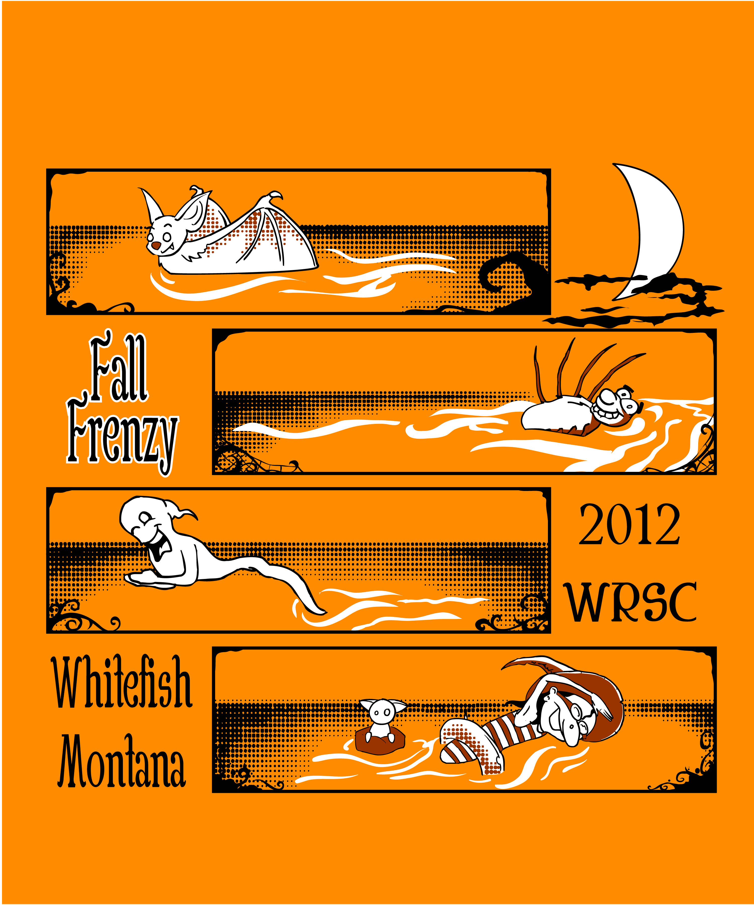

MASTER ENTRY FORM – WRSC Fall Frenzy

Name: _________________________________________ Date: October 13th -14th, 2012 Team Abbreviation:________ LSC: _________
Club: __________________________________________ Coach: _________________________________
Address: ______________________________________ Phone: __________________E-mail___________________

Name | Age | Sex | USAS # | Event# | Event# | Event# | Event# | Event# | Event# | Event# | Event# | Fees
 |  |  |  | Time | Time | Time | Time | Time | Time | Time | Time

