**Open Water Swimming**

Have a triathlon coming up? Want to try something different?

We have some upcoming opportunities to learn about Open Water Swimming.

|  |  |
| --- | --- |
| Learn some basic skills for Open Water Swimming: Sighting, Navigation, Buoys, and Pack Swimming  $25 for USMS Members,  $35 for non-members  **10am - Noon**  **October 6**  **Clinic** | An unstructured practice allowing training time in a controlled open water environment.  $10 per swim.  Saturday, October 13 – 10-12  Sunday, October 21 – 1-3  Saturday, October 27 – 10-12  Saturday, November 17 – 10-12  **Training Swims** |

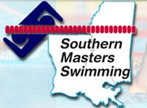

All events held at:

**18605 Barnett Road**

**Zachary, LA 70791**