Snapping Tortuga Open Water Swim
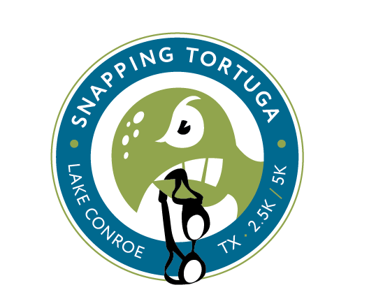

Sunday, April 15, 2012
Hosted by Magnolia Aquatics Club Masters

Sanctioned by Gulf LMSC for USMS, Inc. Sanction #: 252-W001

Location: Lake Conroe, Texas – Lake Conroe is a 21,000 acre lake in Montgomery County, Texas, United States. The race site
address is 14099 FM 830 Willis, Texas.

Directions: Coming from The Woodlands, go north on I- 45 for 15.3 miles, take exit #92/Seven Coves road, turn left on FM 830 and drive 5.4 mile. Arrive at race site.

Meet Director: Tim Floyd, Head Coach, Magnolia Aquatics Club Masters snappingtortuga2011@yahoo.com 713-834-7210

Meet Referee: Gary Baker, USA Swimming Meet Referee 281 467-3193

Eligibility: All participants must be currently registered with United States Masters Swimming. Proof of eligibility must be provided with entry.

Event Schedule: There are three events offered:
1. 7:30 am, 5k two (2) loop course
2. 7:45 am, 2.5k one (1) loop course
3. 9:30 am 500m out and back course

Staggered starts by age or sex may used at the discretion of the event referee dependent upon the number of swimmers entered in each event. There will be pre-race instructions given 10 minutes prior to each race.

Check In: All swimmers must check in with the clerk of course. All swimmers will be numbered by clerk of course for identification. Each swimmer must be numbered 30 minutes prior to the start of their race. Proof of USMS membership will be needed at check-in.

Race Info: The race course will be 2500 meters. The race will start and finish in the water. It will be swum in a clockwise
direction with buoys staying on your right shoulder. The finish shall take place in the water near the start and
will be marked by two floating turtles. All 5k competitors must show proof of ability to swim a mile in 35 mins.

USMS swimmers may wear a wet suit, but will not be eligible for awards.

Weather: The meet will be swum under all conditions except thunder and lightning. If there is hazardous weather in the area
we will delay the event 20 min per occurrence. We will make every attempt to swim the races.

Awards: We will have 1st place through 3rd place awards for male and female for the 500m, 2.5k and 5k division, junior and
masters divisions.

Entry Info: The entry deadline is Friday April 13, 2012 at 11:59pm PST. Late entries will be accepted through the end of
race check-in for an additional late fee. We cannot guarantee a T-shirt or Fit Kit for those that register race day

Make checks payable to Snapping Tortuga (10118 Clubhouse Circle Magnolia TX 77354) and inquiries to Tim Floyd
snappingtortuga2011@yahoo.com or call at 713-834-7210. Entry also available online at Active.com: The Snap is Back

Results: Results will be posted at www.snappingtortuga.com.
Snapping Tortuga Open Water Swim

Sunday, April 15, 2012
Hosted by Magnolia Aquatics Club Master
Sanctioned by Gulf LMSC for USMS Inc. Sanction number: 252-W001

Please type or print clearly Today’s Date __________________________

First Middle Last
Name___________________________Initial________________Name____________________________________________

Mailing Phone
Address______________________________________________ Number_______________________________________
City____________________________State__________Zip_____________Email_________________________________

Birthdate
Month____Date____Year____ Team______________________ Gender (please circle) Male Female

T-shirt (please circle)
USMS Registration #___________________________________ (Please Attach Copy) adult sizes small medium large x-large

USMS Waiver of Release
“I, the undersigned participant, intending to be legally bound, do hereby certify that I am physically fit and have not been otherwise informed by a physician. I acknowledge that I am aware of all the risks inherent in Masters swimming (training and competition) including possible permanent disability or death, and agree to assume all risks. AS A CONDITION OF MY PARTICIPATION IN THE MASTERS SWIMMING PROGRAM OR ANY ACTIVITIES INCIDENT THERETO, I HEREBY WAIVE ANY AND ALL RIGHTS TO CLAIMS OR LOSS OR DAMAGES, INCLUDING ALL CLAIMS FOR LOSS OR DAMAGE CAUSED BY THE NEGLIGENCE,ACTIVE OR PASSIVE, OF THE FOLLOWING: UNITED STATES MASTERS SWIMMING, INC., THE LOCAL MASTERSWIMMING COMMITTEES, THE CLUBS, HOST FACILITIES, MEET SPONSORS, MEET COMMITTEES, OR ANYINDIVIDUALS OFFICIATING AT THE MEETS OR SUPERVISING ACTIVITIES. In addition, I agree to abide by and be governed by the rules of USMS.

Signed ______________________________________

Date________________________________________

Emergency Contact Information: Name: __________________________________ Phone: _____________________
Please check race to be entered: Race Entry Fees

2.5k race entered before January 10th, 2012 - $35 __
2.5k race entered before April 8th, 2012 - $40 __
2.5K race late registration after April 8th, 2012 - $45 __

5k race entered before January 10th, 2012 - $60 __

5k race entered before April 8, 2012 - $70 __
5k race late registration after April 8th, 2012 - $80 __

500m race entered before January 10th, 2012 - $25 __
500M race entered before April 8th, 2012 - $30 __
500M race entered after April 8th, 2012 - $35 __

One day USMS registration $12 ______

Total Enclosed:__________ Make Check Payable: Snapping Tortuga 10118 Clubhouse
Circle Magnolia TX 77354

Snapping Tortuga Open Water Swim

Sunday, April 15, 2012
Hosted by Magnolia Aquatics Club Masters

Course Map

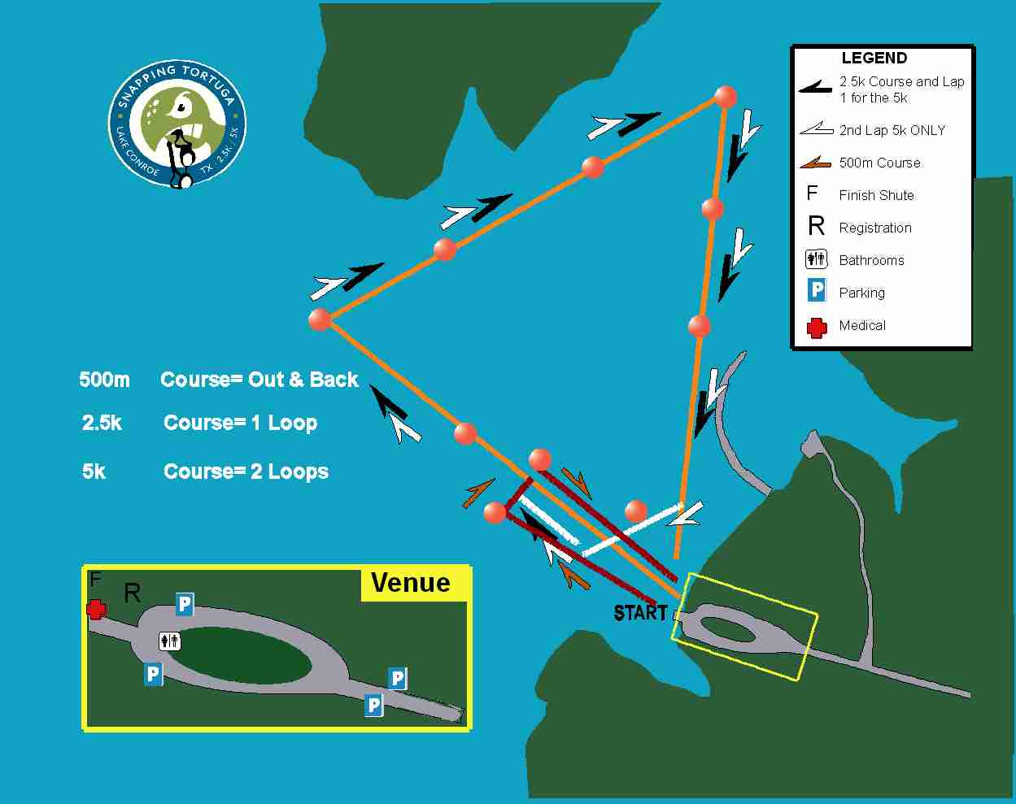

SNAPPING TORTUGA SAFETY PLAN

Meet Director: Tim Floyd 713-834-7210, snappingtortuga2011@yahoo.com

Safety Marshal: Lauren Soltau 720-936-0631

Safety: Safety is our prime consideration. For the 5k swim there will be a qualifying time standard. You should have previously completed a one mile swim in 35 minutes or faster in order to swim in this event. The 2.5k and 500m swim do not have a qualifying standard other than you should be healthy and in reasonably fit swimming shape. Swimmers will be allotted two (2) hours to complete the 5k swim, one and a half (1.5) hours to complete the 2.5k distance and twenty (20) minutes to complete the 500m distance.

Accounting for Swimmers – Each swimmer will be given a race number during the check in phase of the event.
After the pre-race meeting the swimmers will enter the lake from the beach entry chute and check in with the volunteers in charge of tracking the swimmers. These volunteers will be taking the total number of swimmers entering the water and their race numbers, which will be verified compared to the official check-in list that morning. During the finish phase of the competition the swimmers will exit the lake where they entered and have the same volunteers record their finish time, race number and order finish.

Location of Safety Marshall – The safety marshal will be located on land at the start and finish location.

Rescue Personnel and Equipment – Rescue personnel will be in kayaks positioned at each turn buoy, staggered between turn buoys and at the start and finish of the race. Lead kayakers will be given two way radios for better communication. There will also be motorized watercraft that will follow the lead pack of the race and monitor the course at all times. All rescue personnel will have life saving buoys throughout the race. Water will also be available for emergency situations on the motorized watercraft.

Location of First Aid and Safety Station- The first aid kit is located at the registration table near the start and finish line. There will also be an EMT at the first aid station.

Medical Evacuation Plan- If a swimmer is struggling or needs assistance they should swim to the nearest shoreline and wait for the safety staff to arrive. If unable to make it to the shore the swimmer should wave their hand and stay
in the same location, rescue personnel will come to their assistance. Swimmers will then be transported to the nearest shoreline or finish line by kayak or motorized boat. The safety marshal will determine the severity of the situation
and take the necessary action. The safety marshal will transport any swimmer needing to be driven to a medical facility.

Weather Evacuation Plan – The meet will be swum under all conditions except thunder and lightning. If there is
hazardous weather in the area, we will delay the meet 20 minutes per occurrence. We will make every attempt to
swim the races. If there is hazardous weather during the race foghorns, will be used to alert swimmers to exit the
lake at the nearest point. Swimmers are to meet back at the registration area.

Water Quality Testing – We will run water quality assessments in the days leading up to the race. A water testing
company, Northwest Water District Lab Services, has been retained and will perform the tests at various points on
the course.

Snapping Tortuga Open Water Swim

Sunday, April 15, 2012
Hosted by Magnolia Aquatics Club Masters

Directions to Conroe Regional Medical Center
Closest Emergency Medical Facilty

